Dictionary (Main Section)

A
ABBREVIATIONEITY (Abbreviational reading, Abbreviational vision) [abbreviaturnoe prochtenie, abbreviaturnoe zrenie] – an attitude towards the visual as towards a text that consists of abbreviations. The abbreviational perception of the world is conditioned by the existence of unconscious abbreviational structures in the depth of memory and language. (V. Tupitsyn, Moscow Communal Conceptualism, 1996 ; See also V. Tupitsyn Kommunal’nyi (post)modernsim: russkoe iskusstvo vtoroi poloviny XX veka. Moskva; Ad. Marginem, 1998).
ABSOLUTE PAINTING [absolutnaia kartina] – “Mona Lisa,” “Sistine Madonna,” “The Death of Marat,” “The Parable of the Blind” by Pieter Bruegel the Elder, Dürer’s “Melancholia” – all of these are absolute paintings. An absolute painting is that painting which, with maximal fullness and expressiveness, accumulates within itself the collective conscious and unconscious. It is also possible to say that the absolute painting not only accumulates but also forms the collective conscious and unconscious. These are paintings without which it is impossible to imagine the history of art. The overall number of these paintings – while compared with the ocean of art – is relatively small, about 50. This is only on the scale of European culture. It is possible, however, to locate absolute paintings within the temple-dome of individual national cultures, and these “regional” domes do not always overlap with the European ones. For example, the Russian list of absolute paintings must include, without fail, “Ivan the Terrible And His Son Ivan” [Ilya Repin, 1885] or the “The Bath of the Red Horse” [Kouzma Petrov-Vodkine, 1912] – paintings, which are not part of the main (European) culture. (V. Pivovarov. “Dachnaia tetrad’” iz zikla “Serye tetradi).

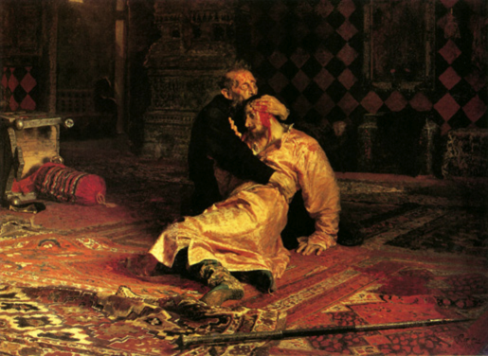
Ilya Repin, Ivan the Terrible And His Son Ivan, 1885 (Wikipedia)
AUTHOR [avtor] – the capitalized word “Author” conveyed, in the rhetoric of the PROGRAM OF WORKS, the pseudonym of the physical author Lev Rubinstein (compare to Vitaly Komar and Alexander Melamid’s collective pseudonym – “Famous artists of the 1970s of the 20th century”). The term “Author” also partially parodied the idea of the romantic author-demiurge. It was an important break between the existence of the Author and the radically authorless style of the texts in the PROGRAM. (L. Rubinstein, Raboty, 1975).
AGENT [agent] – refers to a particular state of abandonment and alienation from reality, a state in which the individual has the impression that he is the Agent of something which he does not comprehend, as if he had parachuted somewhere with no particular task to perform and with no knowledge whatsoever of under what agency he acts. The state of the Agent is not functional: he is alienated to the same degree from everything (“for the Agent all the stairs are slippery”). It is supposed that this state is the euphoric counter-version of paranoia. (Term by S. Anufriev 1989. The term was clarified by P. Pepperstein).
AGENT (AND AGENCY) OF DYSTOPIA [agenty (i agenstva) distopii] – semantic and visual turns (returneli) which both violate the one-directional character of utopian representation and de-structure [destrukturiruischie] the space of utopian anticipation. (M. Tupitsyn. “Playing the Games of Difference” in Artistas Rusos Contemporaneos, Sala de Exposiciones, Santiago de Compostela, 1991).
THE AGGRESSION OF THE SOFT [agressia myagkogo] – marks the inevitable dependency of the speaker on what seems to be fortuitously produced speech; the impossibility of occupying a completely external position. The emptiness is continuously filled with soft residues from speech acts that were once produced, and which are not directed towards the Other, but into EMPTINESS. The “Aggression of the Soft” – is the name of the performance by the group “Frame” (Rama), which took place on the 19th of February 1989 in the presence of 11 spectators. During this performance sound recordings of Mikhail Ryklin and Andrei Monastyrsky’s voices were superimposed. (M. Ryklin, A. Al’ciuk, RAMA. Performansy, Moskva; Obskuri Viri, 1994).
ALIA [Alia] – an intelligible state of things, the return to which generates realia. (S. Anufriev’s term, 1989. The term was clarified by P. Pepperstein).
ANALYTICAL TREE [Analiticeskoe drevo] – potentially, an endless process of self-generation of art objects by means of consecutive fragmentation. (I. Chuikov. Analitical tree [Stammbaum der Analyse], 1994).
“What then is the relationship between a fragment and its enlarged copy?” asks the artist in his painterly installation Analytical tree, a work that takes over one corner of the Stella gallery’s wall space. Here Chuikov enlarged a minuscule piece of a Soviet-time postcard covered in a flower pattern by one hundred times until it filled up the area of a separate canvas. He then took a tiny fragment of the latter and repeated the process until all parts of the initial painting turned into individual abstractions; literally blobs of color. Through the different mediums of acrylic, oil, graphite and photocopies, the artist equally distorts the original metric scale. To trace the order and development of the enlargements, Chuikov connects the pieces of Analytical tree by a number of black lines that are governed by a mathematical formula. Quite apart from its formal exploration, the installation could be read as a genogram of episodes that constituted life during the Soviet epoch: thin cardboard, cheap print and an inflated reality of an over-sized utopia.¹
ANTIGRAVITATIONAL MEASURES (AGM) [Antigravitazionnye meropriatia] – the plot of a “gradual” (not “instant”) expansion of the universe, manifested in various forms that alter each other (for example, “after the plants the AGM was conducted by the insects,” and so forth). (S. Anufriev, Na sklone gory, 1993).
APT–ART (from English “apartment” and “Art”) – the name of Nikita Alexeev’s gallery which later gave its name to a direction in Moscow conceptualism. (The term emerged in 1982 in a discussion between M. Roshal, N. Alexeev and S. Gundlakh).
…The original series of APT-ART exhibitions was held at the beginning of the 1980s in the single-room apartment of artist Nikita Alexeev. These domestic happenings were not only significant for the Russian cultural scene, but ranked among the most innovative art events held anywhere at the time. Filling a space no bigger than an average bathroom, a typical APT-ART show created a “total installation” of text-paintings, cartoon-inspired drawings, abstract graphics, collages, objects and photographs. Works by Alexeev and his friends covered the walls and ceiling, carpeted the floor, and hung in midair. Speaking at E.K. ArtBureau last week, amid some of the pieces originally shown two decades ago, Alexeev called the endeavor as much a way of life as a scheme to get work noticed. “It was free, and a place to have fun,” he said. “The official exhibition spaces were inaccessible to us. The only possibility was to create a structure for ourselves.” The exhibitions proved so popular that sometimes 500 people would visit over 10 days, despite the fact that the apartment near Leninsky Prospekt served as Alexeev’s sole living quarters. He even remembers that for a long time he didn’t have a bed, but slept “in an inflatable boat in the middle of the room.”… ²

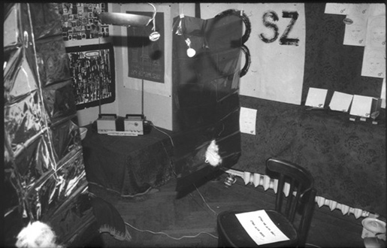
“A Chair” (text by N. Abalakova) Aptart Show (I Aptart Exhibition. October-November. Nikita Alexeev’s apartment. Moscow, 1982)

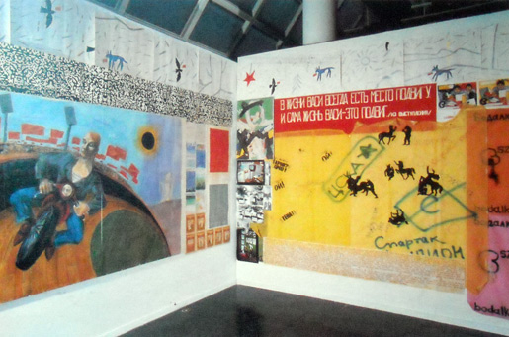
First Aptart Exhibition Reconstructed by Victor Tupitsyn at the New Museum of Contemporary
Art, New York 1986. (Image: M. Tupitsyn, Margins of Soviet Art, 1992)

ARTIFICATION (Artification caprice, artification distortion), [Artifikatsia, artifikatsonnyi kapriz, artifikatsonnoe iskazhenie] – statement (articulation) which looks like a “work of art.” (P. Pepperstein. Ideologizatsia neizvestnogo, 1998).
ATTRIBUTES (Atributy) – a class of conceptual object-gifts offered within the circle of NOMA and which were constructed in terms of schizo-analytical relations with regard to the “Hierarchy of the Monk Sergii.” (Introduced by A. Monastyrsky in 1992-94).

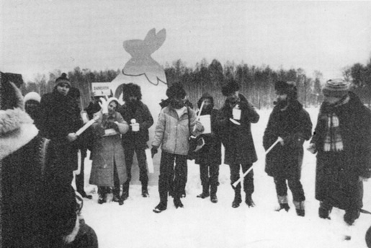
KD’s action Russian World, 1985
After the participants returned to the middle of the field they were handed out labeled “empty photographs” which depicted a gray sky and a black strip of the forest that stretched in the distance over the large white Kievogorskoe Field and a very tiny figure of somebody far in the distance emerging from the trees. It soon became a tradition of KD to give to their spectators, at the end of each action, “souvenirs” – a photograph or another token from the action, an artifact of the factographical discourse, also called “attributes.”³

Б
BACKSTEIN FUNCTION [Backstein funktzia] – universal operator of actuality within the circle of Moscow conceptualists during the nineties. (M. Ryklin, “Dva golubea” in Isskustvo kak prepiatsvie, Moskva; Ad Marginem, 1997, c. 150).
BALLARAT (Principle) – lateral, selective and literal illustration of certain secondary versions, of certain false ideas that phantasmatically emerge in the process of reading some texts (especially texts written in the detective or similar genres). The Ballarat Principle operates as if by fixing marginal, optional, short-time mental adhesives (slipania) conferring upon them a real and even a foundational (osnovopologayushchiy) status by means of this illustrative procedure. The name is related to an episode from a story by Arthur Conan Doyle, “The Boscombe Valley Mystery.” (Y. Leiderman. Ballaret i Konashevici, 1989; M.G. Taina Boskomskoi doliny - Inspektia Medizinskaia Medgermenevtika, Ideotekhnika i rekreazia, Moskva; Obscuri Viri, 1994).

…Sherlock Holmes took a folded paper from his pocket and flattened it out on the table. “This is a map of the Colony of Victoria,” he said. “I wired to Bristol for it last night.” He put his hand over part of the map. “What do you read?”
“ARAT,” I read.
“And now?” He raised his hand.
“BALLARAT.”
“Quite so. That was the word the man uttered, and of which his son only caught the last two syllables. He was trying to utter the name of his murderer. So and so, of Ballarat.”
“It is wonderful!” I exclaimed…⁴
BRN and BRN (The Big Rotten Novel and The Big Relational Narration) [BGR i BSP: bol’shoi gniloi roman i bol’shoe svyaznoe povestvovanie) – refers to two types of hyper-narratives: the literary and the historical. The first is regarded as dominant with respect to Russia and the second with respect to the West. (MG, Zona inkriminazii. Text-triada “Po povodu Bol’shogo Gnilogo Romana,” 1988. The term was introduced by P. Pepperstein).
WHITE CAT [belaya koshka] – refers to the possibility of slipping away, and in the same time to the refreshing impulse contained in the depth of this slipping away. Thanks to this, the White Cat appears as a guarantor of hermeneutical intrigue, and works as a spring in the biographical sideshow. White Cat – is the “spring gasket in the ditriumphation machine (mashina detriumfatsyi)” (P. Pepperstein. Passo i detriumfatsya, 1985-1986. P. Pepperstein. Belaya koshka, 1988).
WHITENESS OF THE PAPER OR OF THE PAINTING [beloe bumagi ili kartiny] – refers to an ambiguous meaning that depends entirely on the orientation, or the “accommodation” of the viewer’s consciousness: to regard this “whiteness” simply as nothing, as emptiness, as an uncovered surface that awaits text or a drawing, or as a screen, on whose surface – from an infinite depth – a bright “positive” light comes towards the viewer, shining from a mysterious source. (I. Kabakov, Rassujdenie o 3-x sloiakh… MANI N1, 1981. A-IA N6, 1984).
BIS–PUSTOTNIKI [bis pustotniki] – the term refers to those artists who attain minimal content by means of a paradoxical forcing of narrative allusions. To this category belong such artists as Konstantin Zvezdochetov, Perzy, Vadim Zakharov and others. (Y. Leiderman together with M. Skripkin, V. Kojevnikov. Svarschiki i Bis-Pustotniki, 1987).
BUKVARNOSTI [bukvarnost’] – one of the aesthetic categories of MG [Medgerminevtika] (related to the aesthetics of simplicity). The development of this category is demonstrated in Medgerminevtika’s book “Lateks.” (MG, Lateks, 1988).
FAKES (AND GRAPHOMANIA) [Butaphoria and Graphomania] – two poles of division in the genre of installation. Fakes (Butaphoria) refers to the heap of accumulated objects (paintings, ready-mades, and other artifacts) that lacks coherence or any justification of its story. Graphomania, on the other hand, refers to a homogenous background of various textual relations and interpretations, devoid of any objective supports but concerned instead only with continual self-reproduction within a chain of endless versifications. (Y. Leiderman, Butaphoria i graphomania. – Nailuchshee i Ocheni Somnitelinoe. Moskva, 1992).

B
WARUM-WARUM-like THINGS [Varum-Varumnye Dela] – refers to a dependency on cause-and-effect relations, that is, on explanatory discourses. The term is derived from the German Warum – “why.” (Y. Leiderman. Polet, ukhod, ischeznovenie – Flug entfernung verschwinden. Konzeptuelle moskauer Kunst, Gantz Verlag, 1995).
VIRTUAL [Virtualinyi] – as if existing. “As if” is a key phrase here, a phrase which by the way is very widespread within discourse. See also virtual particles (physics), virtual reality, and so forth. (I. Chuikov, Virtual sculpture, 1977).
STUCKO [Vliparo, from the Russian word Vlipat’ – to get stuck] – refers to immersion in a context. (Ural’skii uglozub [Uralian Cornertooth] is an identical combination of words for A. M. [Andrei Monastyrsky]). (V. Sorokin. Rasskaz “Pameatnik,” 1983).
HEC (Highest Evaluation Category) [VOK – Vyshaya Otsenochnaia Kategoria] – in the practice of MG [Medgerminevtika] an evaluation according to the HEC principle takes place spontaneously and cannot be interpreted rationally. It may be said that this evaluation demonstrates a refusal to evaluate and at the same time a realization of the impossibility of refusing. (MG, Inspectional Block Notes, 1988).
HACKING THE SETS [Vyrubanie Garniturov] – the process of revealing – on unfamiliar semantic territories – mechanisms that function simultaneously in such regimes as familiar (svoi), strange (chiuzhoi), and other (drugoi). (V. Zakharov, From the series of works from the early 1990s).

Г
GEISTPAARUNG (From Geist + Paarung) – spiritual pairing. Term by Elena Elagina, 1983. See Igor Makarevich Kniga prodolzhenyi 1983).
DUMBBELL SCHEMA [Gantelinaia shema] – is a demonstration element in the event, consisting of the event’s organizers and its spectators. (A. Monastyrsky. Foreword to the 2nd Volume of Journeys Outside the City, 1983).

See below, CATEGORIES KD.
SET [Garnitur] – the term refers to the semantic balance produced in a creative-temporal space that is both stylistically and ideologically precarious. A Set prevents some parts of this space from complete collapse. (Vadim Zakharov, From the series of work from the early 1990s).
Set “Saint Sebastian”
The image below is a set of genuine furniture. It was made while taking into consideration all the visual distortions that one would see in an icon. The set of furniture cannot practically be used as such because it is built on the principle of inverted perspective. And yet, this is furniture, or if you want it is a style of furniture.⁵

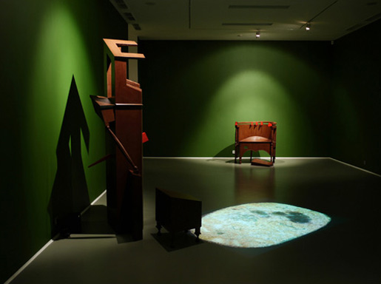
Vadim Zakharov, Set Saint Sebastian Near boiling porridge oats, 2008
ROTTEN BRIDO [Gniloe Brido] – the image of disintegrating matter, the entropy of the world. The term is derived from Vladimir Sorokin’s story Kiset [Tobacco-Pouch], 1983.
ROTTEN PINOCCHIO [Gnilye Buratino] – refers to the population that inhabits the “worlds and spheres of impermanence.” (Andrei Monastyrsky and Vladimir Sorokin. Hieromonk Sergii’s Foreword to the First Hierarchy, 1986).
ROTTEN SPOTS IN THE GOLDEN NIMBUS [Gnilye Mesta Zolotogo Nimba] – the aesthetic critique of the most sacred places of every ideology. (A. Monastyrsky, KD, Action “To Press on the Rotten Spots in the Golden Nimbus” in the 4th Volume of Journeys Outside the City, 1987).
While working on the “Behind KD” action, we discovered on the side of a road two blue silk curtains set onto a metallic framework. Such curtains are often used to cover the rear windows of the Soviet bureaucrats’ cars (the ministerial black ‘Volga’). The silk fabric was perfectly fresh and clean, with no signs of accident or anything.
Makarevich proposed to upholster with this silk the binding of the fourth volume of Journeys Outside the City. Panitkov agreed and he did so. Makarevich then suggested titling this action “Pressing on the rotten spots in the golden nimbus.”
March, 1987
I. Makarevich, N. Panitkov, A. Monastyrsky⁶

Behind KD, 1987. The binding of the fourth volume of Journeys Outside the City

ROTTEN TEXTS [Gnilye teksty] – texts that cannot “dry out” in temporal space. (Vladimir Sorokin. From conversations held in the early 1980s).
SUPPURATION [Gnoynoe] – state of metaphysical chaos. (Vladimir Sorokin, From texts and conversations held in the early 1980s).

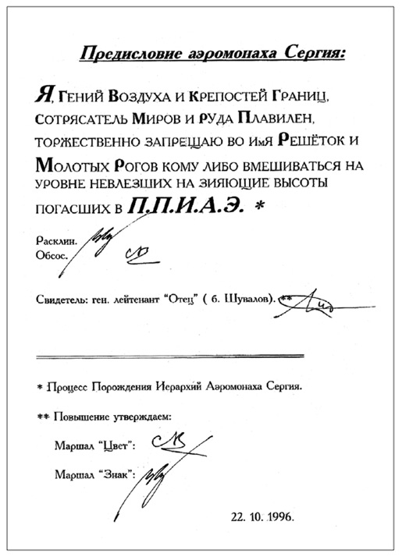
Hieromonk Sergii’s Foreword⁷
EPISTEMOLOGICAL THIRST [Gnoseologicheskaia zhazhda] – is a paradoxical combination of words that connects the intellectual necessity of knowing to physiological processes. It refers to the Russian “collective unconscious,” which may be regarded as a single undivided “body” that desperately seeks to know itself, to perceive what it is “in itself.” (Ilya Kabakov, “Epistemological Thirst,” 1983 in Ilya Kabakov, Nicola von Velsen, and Boris Groys. Ilya Kabakov: Das Leben Der Fliegen = Ilia Kabakov: Zhizn’ Mukh. The Life of Flies, [Cologne; Edition Cantz, 1993]).

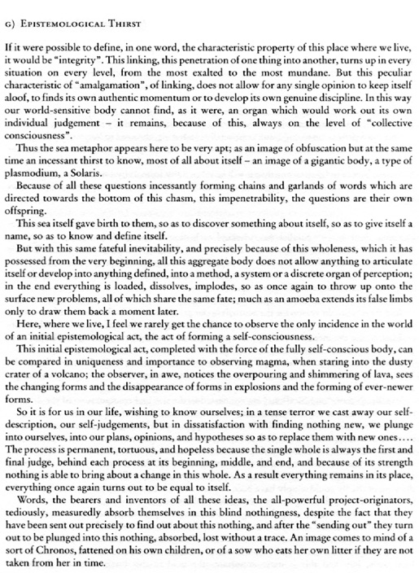
Fragment from Ilya Kabakov, The Life of Flies, Cologne, 1993
GARGANTUA(ING) (GARGANTUA FIELD) [Gorgonal’nost’ (Gorgonal’noe pole)] – refers to the “direct gaze,” which in its turns leads to “direct action” – this is the main intention in Western culture. (Sergei Anufriev. Pontogruel’ bokovogo zrenie, 1989).
GRAPHOMANY – see FAKES
GUGUTA SYNDROME [Guguta sindrom] – Syndrome of complete lack of understanding (compare with TEDDY SYNDROME). Guguta is one of the characters of the Moldovan writer Ion Druta [translator’s note: in fact the writer’s name is Spiridon Vangheli]. Guguta represents the state of sudden and complete inability to comprehend something, as in this story for children where this boy’s huge hat often covers his eyes, obstructing his vision of the world. Term by MG; see also TEDDY, 1988.

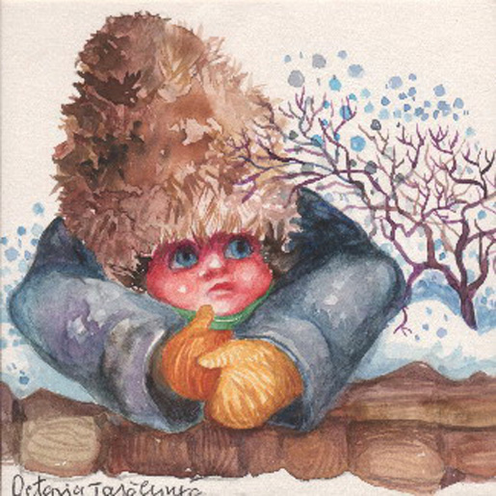
The character Guguta, Illustration by Octavia Taralunga⁸

Д
DOUBLE AFTER [Dvoinoe posle] – refers to the representation of unattractive scenes of city life in the work of post-Soviet photographers – of all of those whose “after” has expired with regard to the unattractive “before” which ended “after” the Revolution. (This first “after’ – is the most important rhetorical ingredient of Soviet photo-production of the 1920s and 1930s). (M. Tupitsyn. “Photography as a Remedy for Stammering” in Boris Mikhailov Unfinished Dissertation, Zurich/New York; Scalo, 1998).
…Mikhailov saw no point in providing an explicit critique of Soviet society, either through mocking it or through unmasking its endless vices. Instead, his goal was to preserve Soviet reality’s sense of totality, but without its layer of systematically sustained external joy. This construct of “totality from below” rather than “from above” was achieved through Mikhailov’s intrinsic rather than participatory identification with all Soviet inhabitants and all Soviet routine. The roots for this kind of identification or rather this slipanie (sticking) with the object of photography were established by early Soviet photographers.
For example, in the 1920s and 1930s Aleksander Rodchenko documented images of the Soviet “after,” to contrast with the oppressive “before” images of pre-Revolutionary Russia. He plunged into the street activities of Moscow but he stayed away from direct contact with the people and things he caught in his lens, believing he was connected to them by the higher force of socialist identification. Mikhailov attests to a similar identification with post-Stalin society by remarking, “In my work, I identify with the period and the process our country is going through.” To gather visual material for Unfinished Dissertation, Mikhailov revisited a Soviet city, in his case not the capital but provincial Kharkov, and returned with photos that can be identified as images of the “double after.” They are post-utopian with respect to the documentary photographs of the 1920s, and post-mythographic vis à vis the staged images of subsequent decades.⁹

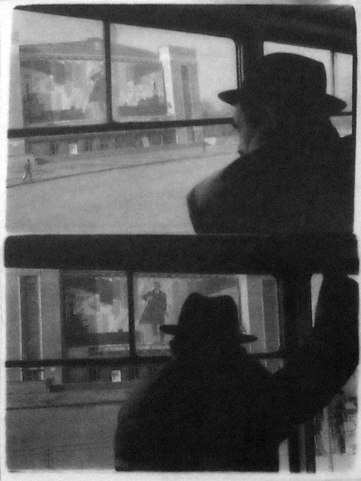
Boris Mikhailov, Unfinished Dissertation
DEMONSTRATIVE SEMIOTIC FIELD [Demonstratsionnoe znakovoe pole] – refers to a time-space continuum system of elements which is intentionally included by the authors in the construction of the text for a concrete work. The term is part of the correlative pair DEMONSTRATIVE
SEMIOTIC FIELD – EXPOSITION SEMIOTIC FIELD. In the discourse of KD [Collective Actions group] the formation of the relation between the two Fields is constructed around various elements of the event (part of the CATEGORIES KD) such as: walking, standing, lying in a pit, ‘people in the distance,’ moving along a straight line, ‘imperceptibility,’ light, sound, speech, group, listening to listening, etc. (A. Monastyrsky, Foreword to the First Volume of Journeys Outside the City. See in particular KD’s action “Earth Works” [Zemleanye raboty], 1987).
Another definition of this important element in the work of KD group – also known as Demonstrative Field [Demonstratsionnoe pole] – is: a dynamic center of the action constituted by the totality of psychic (subjective) and empirical (objective) fields.” [Journeys pp. 22-23]

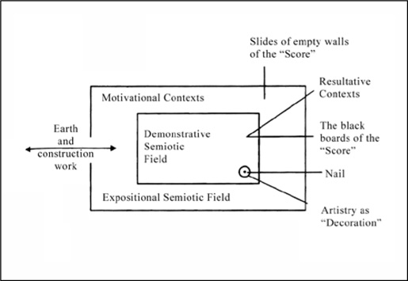
A. Monastyrsky, Earth Works, diagram, 1987, (reconstructed and translated)
So far I have discussed the action as if from the perspective of the spectators-participants, and although this is an indispensable category without which one cannot imagine this group, it is still only half of the action. The other half is comprised of the tools and devices the artists introduce in order to provoke in the viewer those “empty” states of “pre-waiting,” “waiting,” “looking,” “listening,” “understanding,” and so forth. KD often refers to the place where the action takes place as the [Demonstrative Semiotic Field] (Demonstrazionnoe znakovoe pole). This concept stands for the dynamic center of the action, which is constituted by the totality of psychic (subjective) and empirical (objective) elements.¹⁰ The “demonstrative field” totalizes all the elements engaged in the action within one common domain, and one can say that this is the action itself, or the action as planned by the authors. Those elements that constitute the demonstrative field include the eventful part (plot), the objects involved, the role of the spectators-participants and even those states that the latter have experienced in their ES [emotional space], from the moment when they received the invitation until the present where they hold their certificates. But these are only the subjective parts of the demonstrative field. The “objective” or empirical component of this field is the location of the action, namely the empty white snowy field at the outskirts of Moscow. The objective empirical emptiness of the real field and the empty states of expectation experienced by the spectators meet within the “demonstrative field.” “The real field undergoes a metamorphosis and at a certain moment it could be perceived as a continuation of the field of waiting…”¹¹
DE-TRIUMPH-ACTION [Detriumfatsia] – condition in which one or another thing frees itself from its existence in the state of being precisely that thing. It is as if the thing exits the state of its “triumph,” that is, the condition in which the thing occupies a determinate presence in the world. (P. Pepperstein. Passo i detriumfatsia, 1985-1986).
DISSIDENT MODERNISM [Dissidentskii modernism] – the term denotes the unofficial art of the 1960s. (M. Tupitsyn. Margins of Soviet Art: socialist realism to the present. Milan; Politi, 1989).
DOUBLETS [Duplety] – comical and downgraded myths produced by sots artists as a negative completion of the official mythology.
(M. Tupitsyn. “Sots art: The Russian De-constructive Force” in M. Tupitsyn, Sots Art, The New Museum of Contemporary Art, 1986).

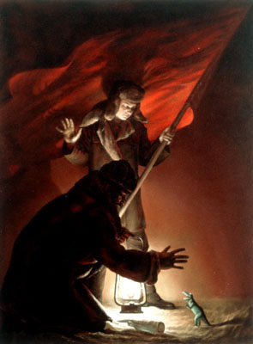
Komar & Melamid, Bolsheviks Returning Home After a Demonstration¹²

E
CHAMPS-ÉLYSÉES [Eliseiskie polea] – a dynamic socio-cultural space, which can be located only by knowing its stylistic-mythological topography. (V. Zakharov. Posledneia progulka po Eliseiskim poleam. Cologne Kunstvarein, 1995).

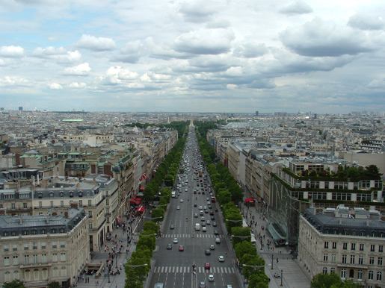
Champs-Élysées (Wikipedia)

З
BUNNIES and HEDGEHOGS [Zaichiki i ezhiki] – the highest ontological and “cultural” icons of children’s texts and illustrations. Like any icons, Bunnies and Hedgehogs are located beyond any transmutation, representing unperishable meta-columns within ontological vortexes. (V. Pivovarov, Metampsihoz, 1993).

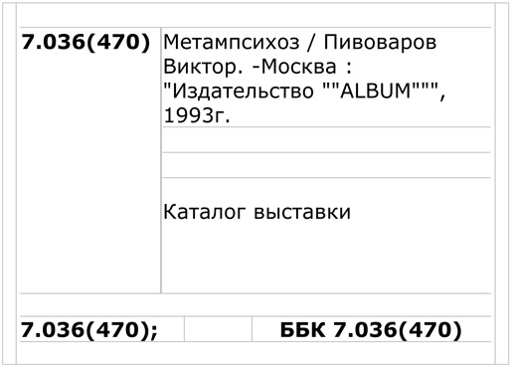
Library record of V. Pivovarov’s book Metapsihoz at the National Center for Contemporary Arts, Moscow.
WEST [Zapad] – emerges in the role of the superego with regard to RUSSIA. Russian culture’s constant opposition to the West, as well as its attempt to live outside the Western cultural norm, may serve as a confirmation of this. (B. Groys, Die Erfindung Russlands. München: Hanser, 1993).
For a more detailed discussion of this concept see its counterpart below, RUSSIA.
CONTAMINATION [Zarazhenie] – refers to the process of dissolving formal-stylistic canons while keeping the meaning unaltered. (V. Zakharov. See the work of the group “Infekzionnaia”, 1989).
PROBING (PROBE-WORK) [Zondirovanie (zond-raboty)] – instrumental activity (work) that fulfills one of the AUTHOR's tasks but which does not have a value of its own. (V. Zakharov, “Sloniki”, “Papuasy” and others. See MANI N3 and 4, 1982).

И
IDEODELIKA [Ideodelika] – “psychological” manipulations of ideas and ideological constructs, as well as the hallucinogenic or oneiromorphic layer which accounts for the composition of ideology. (P. Pepperstein. Vvedenie v ideotekhniku, 1989).
IDEOLOGICAL FACTURA [Ideologicheskaia faktura] – refers to the effect of superimposing Soviet ideological clichés on purely formal, technological aspects of painting, color, or material – on all that concerns the tradition of easel painting. (M. Tupitsyn. “Sots art: The Russian De-constructive Force,” in Sots Art, The New Museum of Contemporary Art, 1986).
IDEOTECHNIC [Ideotehnika] – registration and cataloging of technical devices employed in ideological production or ideological creation. (P. Pepperstein. Vvedenie v ideotekhniku, 1989).
THE HIERARCHY OF HIEROMONK SERGE [Ierarhia aeromonaha Sergia] – system of hierarchies within the circle MANI–NOMA. It was intrduced by A. Monastyrsky and V. Sorokin (with the participation of S. Anufriev); the word “Hieromonk” [aeromonk] was introduced by Y. Kisin in 1986 (the first hierarchy: “The transfer of obsosov [see OBSOSIUM] of the MANI military department to the residency [fixed-post spy] position”).
ILLUST [Illjust] – phantasm produced by various mechanisms of illustration. The Illust is a carrier of enjoyment (of lust) whose generator may be considered the “libido of illustration” (the libido of arbitrary visualization). (P. Pepperstein. Vvedenie v ideotekhniku, 1989).

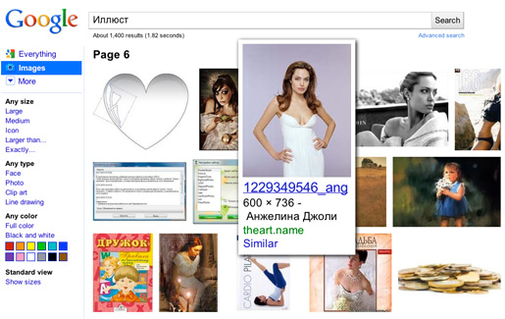
Image Google search result for the term “Illust” (Russian)
IMPERIAL CENTER [Imperskii zentr] – editorial authority in charge of elaboration of norms, materialization of speech and objectification of language. (See MG, Zona inkriminazii, 1988. Term by P. Pepperstein).
IM/PULSE TO HEAR [Im/puls proslushivania] – My addition to Rosalind Krauss's definition of visual modernism as “the im/pulse to see”. This addition emphasizes the fact that in contrast to the Western art, Soviet (post-bellum) modernism gravitated towards phonocentrism. (M. Tupitsyn, “About Early Soviet Conceptualism,” in Conceptualist Art: Points of Origin. New York; Queens Museum of Art, 1999).
INCITERS [Inspiratory] – refers to objects (or processes) on the EXPOSITION SEMIOTIC FIELD that generate various motivational contexts for aesthetic activity. Most often this term refers to elements (or processes) found on constructions [building sites], topographical, economical, and other sites that belong to the collective discourse. (A. Monastyrsky. Zemleanye raboty, 1987).
By the mid-eighties the “Collective Actions” group had constructed a system to which Monastyrsky sometimes refers using the phrase: “the totalitarian space of KD.”13 He used the word “totalitarian” in order to introduce the new concept of “inciters” (inspiratory). An example of an “inciter” in the aesthetic discourse of KD might be an avenue, a monument complex, a building, or any other imposing structure that projects totalitarian politics through the discourse of architecture. If an action takes place around one of these “inciters” then the structure incites new motivations and affects the context of the action; it is as if the “inciter” contaminates the work with its presence. An “inciter” is something too grand to be ignored, something that hovers over the exposition field of the action, dominating and controlling it, entrapping everything around it in its totalitarian nets [see also diagram under the term DEMONSTRATIVE SEMIOTIC FIELD].¹⁴

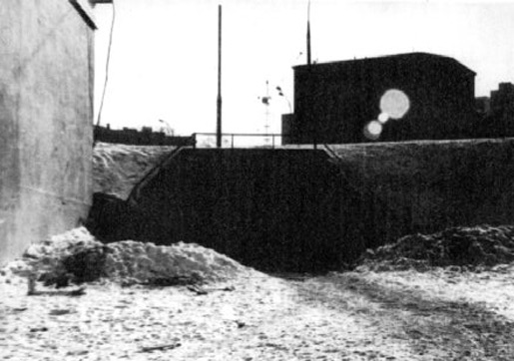
A. Monastyrsky. Zemleanye raboty, 1987

SIE (Space of Intellectual Evaluation [the spectators’ consciousness]) [IOP Intellektualino-ozenochnoe prostranstvo (soznanie zritelea)] – on the demonstrative field of KD's actions, the time vector of the intellectual perception of the action (the pre-eventful, eventful, and post-eventful parts). The spectator's attempt to rationally explain the event [i.e. KD's action]. (N. Panitkov. O tipakh vosprieatia, vozmojhnykh na demonstrazionnom pole akzii KD, 1985).
KD divides the SIE, or the Space of Intellectual Evaluation, into three parts: the three phases of the temporal space of their actions. The first phase is often called pre-eventful. For instance, taking the train and traveling outside of Moscow to the location of KD’s action (the Journey per se) is the pre-eventful part of the action. During these phases the spectators construct a frame of expectation. Over the years the artists of this group have worked to prove that a journey is for one of their actions what a frame is for a painting. One of the main aesthetical concerns of KD for decades has been the idea that while journeying to see an artwork, one must wait to see what will happen. KD owes this idea of “waiting as a frame” to the poet Vsevolod Nekrasov, who theorized that the sense of waiting for something surrounds or frames that which is about to take place. “In addition, Nekrasov believes that it is very difficult to locate this ‘frame;’ where it begins and where it ends.”¹⁵ In its work KD attempts to deal with this difficult task of establishing when an action begins – does it begin when the guests receive their invitations, or when they embark on the train, or in the train?
The eventful part of the action is the time when the action is taking place. Unlike other groups and artists who place the emphasis on the eventful part, or the action itself, KD did not specially treat this part. Monastyrsky writes that the action itself, or its scenario, is a decoy and that the mythical or symbolical content (which is sometimes itself called the “eventful part”¹⁶) is not important to the organizers. “We have no intention of ‘showing’ anything to the spectator; our task is to preserve the experience of waiting as an important, valuable event.”¹⁷ The eventful part of the action serves as mere preparation for opening up and activation of a series of empty or undefined psychic processes. The post-eventful part of the action relates to the process of interpretation, to writing the participants’ reports after attending the actions.¹⁸
IPS (Individual Psychedelic Space) [IPP Individualinoe psikhodelicheskoe prostranstvo) – refers to a horizon (which is almost unattainable) of aspiration of the MG [Medgerminevtika] group. Later IPS was described as attainable on multiple occasions and in multiple variants. (MG. V poiskakh IPP, 1988).
ART OF BACKGROUNDS [Iskusstvo fonov] – refers to an artwork constituted by the spectators’ consciousness, both in terms of the aesthetic act and of this artwork’s concrete existence. Most often these are artworks that focus on the notion of pause, artworks that consciously accentuate the pause, as for instance in the work of such artists as John Cage, Ilya Kabakov, and KD). (A. Monastyrsky. “Ob iskusstve fonov,” 1982-83. Text from KD’s action “Perevod” [Translation], 1985).

36. TRANSLATION (Archaeology of an empty action)
A text written prior to the action by Monastyrsky consisted of 22 small parts and was translated into German by Sabine Haensgen. A few days before the action, in two stages, the text was taped using a recorder. The recording was conducted in the following manner. The first part of the text was read aloud in Russian by Monastyrsky and then repeated in German by Haensgen. Then the second part was recorded, with its German translation having started some seconds before the ending of the Russian part, so that it was superimposed acoustically over the Russian part’s last phrase. This superimposition of German speech over Russian continued and with each part seized more and more of the Russian text, so that parts 11 and 12 were synchronized in both languages. After the 13th part the German text (which was translated from Russian) began running ahead, and by the 20th part the manner of reading turned to reverse. Thus, first the German text of part 20 was read aloud, then the Russian text. Both language versions of part 21 (an episode “Drugstore”) were synchronized, like parts 11 and 12. The last one, part 22, was recorded like part one: first Russian text, then its German translation.
In the second stage of preparatory recording Haensgen and S. Romashko vocalized the recorded text on one cassette and recorded it to another using the repetitive technique (see “Voices”). S. Haensgen repeated after Monastyrsky’s reading the Russian text, and vice versa. Thus, the second cassette was recorded, where Russian text by Monastyrsky was repeated by Haensgen, and its German counterpart (written by Haensgen) repeated by Romashko.
In the course of the action, which took place indoors (at Monastyrsky’s apartment), Haensgen and Monastyrsky sat at a table moved a few feet away from the audience, put on headphones and repeated after the second cassette’s recording: Haensgen repeated after her original translation dubbed by Romashko, while Monastyrsky repeated after his Russian text dubbed by Haensgen. During the playback of part 19 of the text which ended with words “What do you think?” the tape recorder was temporarily switched off and Haensgen “in her own words” (i.e. outside the repetition space) answered in German. Her answer was translated into Russian for the audience (and for Monastyrsky): “What else can be said, enough words have been said already”. Then the tape recorder was switched on again and the playback proceeded. During “The Drugstore” episode Romashko – synchronously with Haensgen and Monastyrsky – read this text aloud in Russian. Thus, it was simultaneously read aloud in three voices, two in Russian and one in German.
After the second cassette’s playback was over, Monastyrsky and Haensgen removed the headphones and turned off the tape recorder. Haensgen read aloud a beforehand-written text in German, while Romashko translated it into Russian. In the final part Romashko vocalized his own text titled “Afterward”. Besides the described above verbal sequence, the action also had an acoustic background, which was produced by a speaker and consisted of homogenous street noise, low-key hissing with occasional inclusions of mechanical sounds such as distant working air supply, and vaguely audible “Music Outside the Window”.
The visual sequence of the action consisted of an elongated rectangular black box with four (two paired) turned on electric torches protruding from the box’s front side. The box sat on the table, lamps facing the audience, and separated the participants (S.H., A.M. and S. R.) from viewers. Inside the box, invisible to the audience, there was a working tape recorder with a 45-minute-long tape. It was empty, with three occasional technical noises like clicks and humming: in the middle of the recording there was a sound of rewinding tape (about one minute long) and in the beginning and the end there were a couple of button clicks.
Behind participants’ backs in a windowpane there was a square black box (also used in the “Voices” action) with three electric torches of different shapes protruding from it (for description of these electric torches see text “Engineer Wasser and engineer Licht”).
In the room there were several black boards with letters and numbers, like those on car license plates.
Moscow
6th of February, 1985
A. Monastyrsky, S. Hänsgen, S. Romashko
Viewers: I. Kabakov, I. Bakshtein, I. Nakhova, Yu. Leiderman, A. Zhigalov, N. Abalakova, D. Prigov, V. Mochalova, L. Rubinstein, G.Witte, E. Dobringer, S.Letov + 3 persons ¹⁹

K
COPROMANCY [Kapromantiya] – divination using feces. In the figurative sense – the opnion that “fate” is contained in “waste”. (P. Pepperstein. Kapromantiya, 1987).
CATEGORIES OF KD [Kategorii KD] – a series of aesthetic methods and devices often used by the KD group for constructing the event in terms of the “Demonstration of Demonstration” (walking, standing, lying in a pit, “people in the distance,” moving along a straight line, “imperceptibility,” light, sound, speech, group, repetitions, listening to listening, etc.). The Categories of KD may also be autonomous, for instance in the series of objects made by A. Monastyrsky for the action ‘Discussion.’” (See text to KD’s action “Discussion” 1985. See also A. Monastyrsky’s foreword to the 2nd volume of the Journeys Outside the City, 1983).

“Discussion” (Obsujdenie)
This action, which took place in the apartment of A.M. [Andrei Monastyrsky], consisted of two parts. During the first 55 minutes of the action, the spectators listened to the phonogram of a text by A.M. called ‘TZI-TZI.’ During the reading of this text, another voice was announcing (every three minutes): ‘This is a reading of A.M.’s text TZI-TZI. The Tautology of Empty Action.’

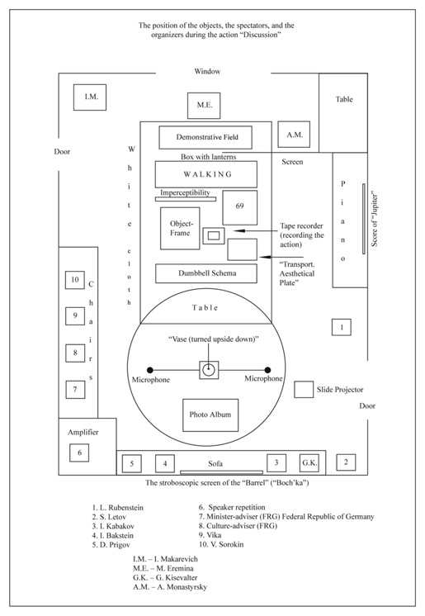
A. Monastyrsky, The Position of the Objects, the Spectators and the Organizers during the Action “Discussion,” diagram, 1985, (reconstructed and translated)
In the center of the room there were placed a series of objects called ‘Categories of KD’ (see Figure above). Eight out of ten objects were placed on a white cloth, which was spread on the floor, and two on a round table. One end of the cloth covered a long black box in which the organizers had placed four lanterns that shone through the white cloth. On the box covered by the cloth was placed a board called ‘Demonstrative Field’ (part of the series of objects ‘Categories of KD.’)… Next to the box, on the white cloth on the floor was placed the biggest object from the ‘Categories of KD’ – ‘Walking.’ On the upper side of ’Walking,’ on different parts of the board, were written with a black marker: ‘(KD, Categories, Black Men’s Overcoat (1 pc.). Walking. Moscow Region, next to the village Kievy Gorky. 1976-1985.)’
Closer to the table, under ‘Walking,’ was placed the object ‘Imperceptibility.’ To the right of ‘Imperceptibility’ was located the object ’69,’ represented by a mattress cover wrapped in a golden foil and fastened to two pieces of plywood. On the upper piece was glued a page from John Cage’s score ‘Water Music.’ This page also contained the itinerary of the 69th trolleybus – which goes from the ‘Southern gates of the VDNKh’ to the ‘Petrovskie Gates.’ Under ‘Imperceptibility’ was placed the ‘Object-Frame’ – a pile of numbered black cardboard pieces, which had been used, as part of the interior object-frame, during the action ‘Translation.’ On the right was placed the object ‘Transport. The Aesthetical Plate’ – an assemblage constructed out of pages from the German magazine Guten Tag, wooden frames, and metallic fittings in the form of wings and stars – all piled up together. On the back of this pile was glued a photograph from the action ‘Translation’ (Perevod).
In between the ‘Object-Frame’ and ‘Aesthetical Plate’ on a plastic support was placed a walkman, and on the walkman a tape cover was marked, as with the other objects, with the inscription: ‘Categories of KD. The Tautology of the Empty Action. DISCUSSION. (phonogram) 1985.’ The recording that the walkman was making was the object that would in the end to be produced by the action ‘Discussion.’ Finally, next to the table on the white cloth was placed the object ‘Dumbbell Schema,’ which was a long cardboard box fastened by ropes and which contained two winter hats, one 3 kilo dumbbell, and two enemas…
After the spectators had looked at the ‘Categories of KD’ objects, a screen was hung in between the piano and the white cloth. On the screen was written in black letters ‘KD.
Categories. The Perspectives of Speech Space. Discussion. 1985.’ The listening of the track was accompanied by slides from the actions ‘Russian World,’ and ‘Burrell,’ which were related to the content of the track TZI-TZI. When the track TZI-TZI ended, the discussion of the paper and the objects began after a five-minute break. The upper light was switched off and the ‘Vase (turned upside down)’ was switched on. On the screen was shown the first slide from the series ‘Fragments,’ and ‘Hidden City.’ At that point Kizevalter, who was in charge of showing slides, read a short introductory text (see the stenographic record). In the meantime this text was repeated through the speakers by A.M. who sat behind the screen so that he could not be seen by the spectators. On the other side of the screen A.M. was listening to the comments of the spectators and repeating them into the microphone, which was connected to a speaker on the other side of the room. A.M. never entered into discussion with the spectators (see stenographic record)…
Moscow
September 28th 1985
A. Monastyrsky, G. Kizevalter, M. Eremina, I. Makarevich”²⁰
CDC Collective Discourse of Childhood [KDD Kollektivnyi diskurs detstva] – childhood as a cultural niche which was serviced by various culture industries (children’s literature, book illustration, movies, TV shows for children, the production of toys, children’s magazines, design of playing fields, kindergartens, children’s shopping centers, children’s food and so forth). (Term by P. Pepperstein, see MG, Shubki bez shvov, 1989).
KLAVA Club of the Avantgardists [Klub avangardistov] – The term was introduced by S. Anufriev and S. Gundlakh in 1987. (KLAVA was the first officially registered artist association of Moscow artists. Translator’s note).

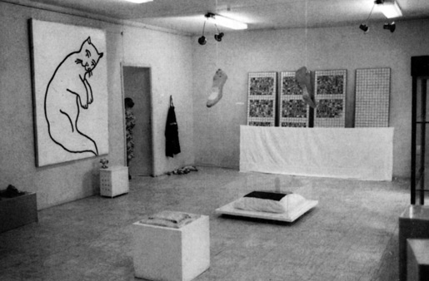
Exhibition Perspectives of Conceptualism. Club of the Avantgardists (KLAVA), Moscow 1989
BOOK AFTER BOOK [Kniga za knigoi] – Principle of text production and exhibiting strategy developed in the practice of the Medgerminevtika group. This principle presupposes that information blocks (e.g. books, series of texts and artworks) are not to be arranged in strict succession but must be divided by empty intervals which shall not exceed the size of the information block itself. The term was introduced by P. Pepperstein. (See MG, Obiekt. “Kniga za knigoi,” 1988. Vtoraia vystavka KLAVY).
COLLECTIVE BODIES [Kollektivnye tela] – refers to bodies which secure their unity on the level of speech and are thus unable to be degraded into individual components. The dimension of the body is not sufficiently examined, whereas the dimension of speech is overdeveloped. The ideology of communism was possible only within a climate in which these kinds of bodies prevailed. (see M. Ryklin Soznanie v rechevoi kul'ture, 1988. See also the series of essays in “Terrorologika” Moskva-Tartu, Eidos-Kul'tura, 1992).
KOLOBKOVOSTI [Kolobkovosti] – a mythological figure of “escape” in the aesthetic discourse of the Moscow Conceptual School. (I. Backstein, A. Monastyrsky. See introductory dialogue Komnaty to the Moscow Archive of New Art, MANI, 1986).
KOLOBOK [Kolobok] – refers to a baked dough ball, a character in many Russian fairy tales. Kolobok rolls constantly on the road running away from everyone who tries to eat it: the fox, the wolf, the bear, etc. Kolobok is a good image for someone who does not want to be identified, named, or regarded as attached to a particular role or to a particular place, of someone who is sliping away from all of this. (I. Kabakov, NOMA, Kunsthalle Hamburg, 1993).

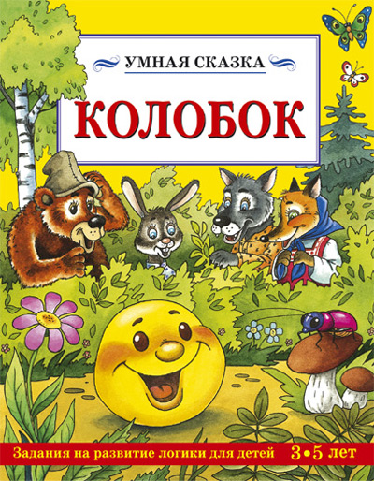
…“Kolobok, I will eat you,” said the Wolf.
“Don’t eat me, Wolf, I will sing you a song,” said Kolobok and began to sing: “I’m a happy Kolobok, with crunchy brown sides. In the oven I was baked, on the window sill cooled. From the old man I ran away, from the old woman too. I ran away from the Rabbit and will run away from you.” Kolobok rolled on his way and met the Bear…²¹
COLUMBARIUM MACHINES [Kolumbarnye mashiny] – objects, apparatuses, installations, called upon to stop the flow of interpretations and illustrations. The term shall be regarded as an alternative to “bachelor machines” (a term inspired by the French literary critic Michel Carrouges) responsible, according to Deleuze, for the “production of consumption” and offering to “hallucinations their object, and to delirium its content.” Columbarium Machines destroy any pre-given context (mainly by way of various temporal manipulations) returning it to the pure accidental quality of the text with its always missing author and inaccessible content. (See Y. Leiderman. Kolumbarnye mashiny. Imena elektronov. SPB, 1997).
COMMENTARIES [Komentarii] – refers to the displacement of interest in the process of making an “obejct” – a novel, painting, or a poem – to reflexion and creation of the discursive spheres around the object, to an interest in revealing the object's context. The conviction that the act of “commenting” is much deeper, more interesting, and more “creative” than the object of the commentary. (I. Kabakov, NOMA, Kunsthalle Hamburg, 1993).
RESTING ROOM [Komnata otdykha] – expositional space, in which crystal clear concepts, styles, and author's motivations turn into a complete dead end for the spectator. (S. Anufriev, V. Zakharov, Tupik nashego vremeni. – Pastor Zond Edition, Kel'n – Moskva, 1997).
KONASHEVICH (Principle) – refers to the multiple and consistent application of the BALLARET principle, the circumflex practice which creates meta-illustratory surfaces, striating an Individual Psychodelic space. The principle was named after the prominent Soviet illustrator of children books V. Konashevich. (Y. Leiderman. “Ballaret i Konashevich,” 1989; MG “Taina Boskomskoi doliny (Ballaret i Konashevich).” Medgerminevtika, Ideotekhnika i rekreazia, Moskva; Obscuri Viri, 1994).

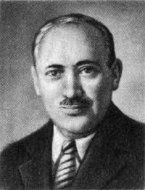
The children’s book illustrator Vladimir Mikhaylovich Konashevich (1888-1963)
THE END OF GEOGRAPHY [Konez geografii] – cause that has led to the contemporary perception of the “end of history”, since cultures, which were hitherto unknown to each other, have exhausted themselves. From one hand this explains the “end of progress” and the distruction of the idea of “humanity,” the reduction to worthlesness of such categories as “humanity” and “human history”; from another hand what now becomes clear is the apology for “personality” and “personal history” in contemporary society. (S. Gundlakh, Konez geografii, 1990).
CONCLUSIONS [Konkliuzii] – in the XVII-XVIIIth centuries in the religious seminaries in Western Ukraine there was in circulation a kind of engraved tablet, in which complex symbolic and metaphoric imagery was accompanied by extensive textual insertions. These tablets were called “conclusions” and they were used as theses that framed the religious disputes within the seminaries. In the early 1970s, when the genre of album did not have yet a firmly established name [among the Moscow Conceptualists], “conclusions” was one of the “working” names for this genre. (V. Pivovarov, Al'bom “Konkliuzii”, 1975).
CONCEPTUAL ANIMALISM (Zoomorphic Dicourse) [Kontseptualinyi animalism, zoomorfnyi diskurs] – zoological semantic convention, which appears within a conceptual work as an intermediary between “two texts”; it is an INCITER and a concrete demonstrative utterance. (A. Monastyrsky. Kontseptualinyi animalism, 1989. A. Monastyrsky. Fragment zoomorfnogo diskursa, 1991; archive MANI “Reki, ozera, poleany” and “O rabotakh, sveazannykh s 'Zoomorfnym diskursom,” 1996).
COMMUNAL UNCONSCIOUS [Kommunal'noe bessoznatel'noe] – psychological phenomenon, which provides an expanded scale of subjectivity, and which is determined by an extraordinary degree of stereotyping (not to be confused with Jung's “collective unconscious”). (V. Tupitsyn. Kommunalinyi (post)modernism. Moskva; Ad Marginem, 1998).
COMMUNAL BODIES [Kommunalinye tela] – refers to collective bodies in their early stage of urbanization, when their aggression is intensified under the influence of unfavorable environmnetal conditions. The works of I. Kabakov, V. Pivovarov, V. Sorokin and Medgerminevtika had a special importance for the emergence of this term, as did the discussions entertained between A. Monastyrsky and J. Backstein. (See M. Ryklin. Terrorologiki, Moskva; Eidos, 1992, pp. 11-70, 185-221).
COMMUNAL MODERNISM (CM) [Kommunal’nyi modernism (KM)] – set of aesthetic views and conventions, practiced by unofficial Soviet artists and writers from the end of the 1950s until the beginning of the 1970s. The communality of CM rests on these artists and writers’ association within various unofficial Collective Bodies [unions, associations and groups]. Their participation was not compulsory (institutional) but voluntary or contractual. Therefore one can speak of a “contractual communality.” ‘Communal Postmodernism’ (CPM) emerged at the beginning of the 1970s and from that moment it developed in parallel with Communal Modernism. Moscow Communal Conceptualism is part of Communal Postmodernism.” (V. Tupitsyn. Kommunal’nyi (post)modernism. Moskva; Ad Marginem, 1998).
Attempts have been made to articulate the conceptualist tradition into diverse terms. Beside the established Groys’ term “Moscow Romantic Conceptualism,” for example, several others have been suggested. For instance, Viktor Tupitsyn proposed “Moscow Communal Conceptualism,” putting the accent on the word “communal.” He suggested in this way that communality should be understood not as the “communist society” promoted by Marxism-Leninism, and neither as the traditional Russian village commune (obschina) – a social order regarded by the Slavophiles as the most suited for Russia – but as a “community of Moscow alternative artists involved in the creation of textual objects.”²² Thus V. Tupitsyn’s term places the emphasis on the relations among these artists, and makes “Moscow Communal Conceptualism” part of a larger category that Tupitsyn termed “Communal Postmodernism.” The latter branched off, in the early seventies, from the “Communal Modernism” of the fifties and sixties, and reached its peak towards the mid-seventies with the emergence, on the Moscow unofficial scene, of a new generation of artists and artists groups (i.e. KD, Nest, Mukhomor), often called the second generation of Moscow Conceptualism.²³
COSMONAUTS, TITANS, FIRE-BARS, RUNTS, AND GEORGIANS [Kosmonavty, titany, kolosniki, korotyshki, Gruziny] – five “incorporeal ranks” of the Soviet collective conscious, which are represented in the sacred architectural and sculptural discourse of VDNKh [the Moscow Exhibition of Achievements of the National Economy].(See A. Monastyrsky. VDNKh – stolitsa mira, 1986).

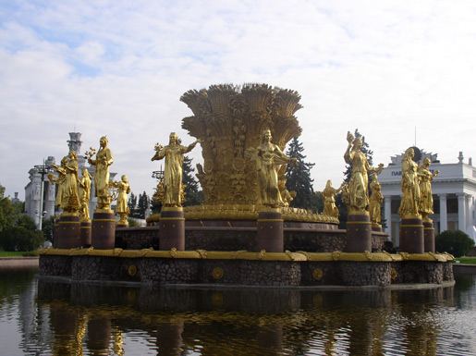
VDNKh Moscow (Wikipedia)
CPS – Collective Psychedelic Space [KPP Kollektivnoe Psychodelicheskoe Prostranstvo] – a grand reservoir of psychedelic effects, from which the “universal” [vseobschii] draws its necessary material in accordance with the requirements imposed by the phantasms’ conjunctures. In some cases CPS becomes visible from the platform of the IPS [see above INDIVIDUAL PSYCHEDELIC SPACE] sometimes even making partial self-inventories by means of these platforms. Term by P. Pepperstein. (Medgerminevtika, V poiskakh IPP, 1989 and Bokovoe prostranstvo sakral’nogo v SSSR, 1991).
LOCAL-LORE-NESS [Kraevedenosti] – figure of discourse which draws on the fact that during the late 1980s and early 1990s Moscow conceptualists were presented to the Western public in such a way that their displays resembled more traditional regional or ethnographical exhibitions (as might that of an exhibition entitled ‘Australian aboriginal artists’) than important representatives of contemporary art. Introduced by Monastyrsky & Hänsgen in 1992. (A. Monastyrsky, S. Hänsgen . Dva kulika, 1992).
FASTENERS – (“connectedness,” “case-ness,” “shop-window-ness,” “shelf-ness”) [KREPEJ, “sveazanosti”, “fulearnosti”, “vitrinosti”, “polochnosti”] – refers to works from which the discourse was “extracted,” works that contain “empty places of philosophizing” (in the style of “ETHICAL” CONCEPTUALISM). Artistic (plastic) objectivity of “technicisms” as a plan of content, which emerged in the aesthetics of late [Moscow] conceptualism by the mid-1980s (See for example, “Where are these white little men going?” by I. Kabakov, the notebook “And the Years Went By” (Shli gody) by Y. Leiderman, the series of works with rope “windings” by A. Monastyrsky – such as “The Music of Consent” (Muzyka soglasia), and others. (A. Monastyrsky, J. Backstein. TSO ili chernye dyry konzeptualizma 1986, in the compilation MANI N. 1 “Ding and Sich”, 1986. A.M. Zemleanye raboty, 1987 (p. 542 of the Journeys Outside the City).

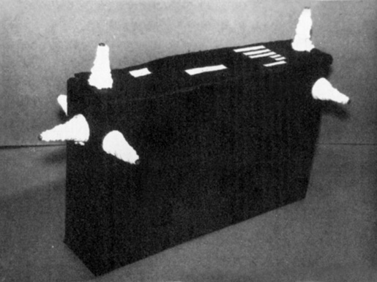
A. Monastyrsky, The Music of Consent, 1985
PEASANTS IN THE CITY [Krestiane v grode] – the term refers to those nomadic masses of peasants that flooded major Soviet cities during and after the enforced mass collectivization of the 1930s. This process led to a radical transformation of these cities’ economic and cultural infrastructure. The terror was not simply directed against these masses (which is clear at the level of common sense). Besides the trauma of forced industrialization it also led to a huge destructive potential when these masses of peasants came to the cities lacking the necessary skills for inhabiting an urban environment. (The term was used in discussions between Ryklin and Monastyrsky during their collaboration in 1986-1987 on the unpublished manuscript “Russian Public Consciousness” [“Rossiiskoe obschestvennoe soznanie”]. The Institute of Philosophy 1984-1986).

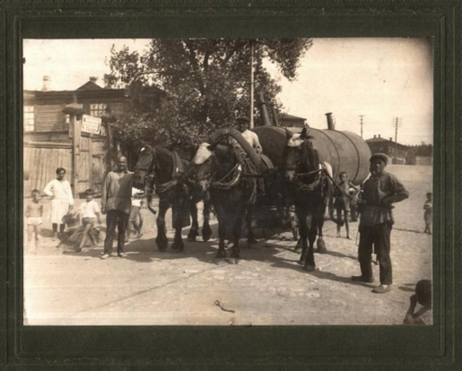
Soviet people during the collectivization²⁴
THE CIRCLE OF PEOPLE WITH INTERESTS AT STAKE [Krug zainteresovannykh litz] – this term is part of the PROGRAM OF WORKS; it was introduced in order to replace such words as “reader,” or “public” – words which made so little sense in those early days and in those contexts [mid-19170s]. It was assumed that the PROGRAM's basic ideas and artistic gestures had to be in use within this specific “Circle”. Besides, the more or less active participation of the Circle of People with Interests at Stake in the PROGRAM was the condition for its very existence. The role of the AUTHOR coincided in fact with the role of the initiator, of the instigator of an artistic action by the Circle of People with Interests at Stake. (L. Rubinstein. Raboty 1975).

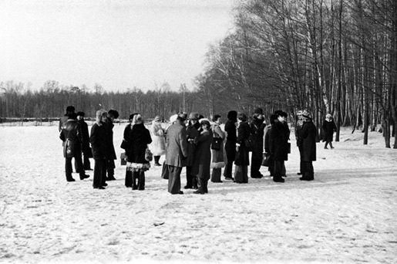
The Circle of People With Interests at Stake, Appearance, 1976.
In the description of one of the earliest actions by KD called “Appearance” (1976) there are mentioned 30 people who were invited to attend the perforamance. These 30 people constituted The Circle of People with Interests at Stake. Later this category became also known as “Spectator Participants” [translator’s note].
“Appearance” (Poiavlenie)
The spectators received invitations to attend the action “Appearance.” Five minutes after the spectators (30 people) gathered on the edge of the field, from the opposite side, from the woods, two participants [organizers] of the action appeared. They crossed the field, approached the spectators and handed them certificates (“Documentary Confirmation”), attesting their presence during the action “Appearance.”
Moscow, Izmailovsk Field.
March 13, 1976 A. Monastyrsky, L. Rubinstein, N. Alexeev, G. Kizevalter²⁵

Л
LIVINGSTONE IN AFRICA [Livingston v Afrike] – refers to Moscow Conceptualists’ cultural self-determination and to their attitude towards the world. The term originated in A. Monastyrsky’s conversations with J. Backstein. (See A. Monastyrsky’s Foreword to MANI archive entitled Komnaty [rooms], 1986).
I agree. I think that history is not about the past. It is about the reality of time, time as a dimension of responsible action. I want to remind you of a metaphor that Monastyrsky and I often used at the beginning of the 1980s. We called ourselves “Livingstone in Africa” – we felt like a kind of scientist who had been sent by the “Central Geographic Club located somewhere in the West” to the African countries to collect different material for future research. What we were doing was describing this strange country, feeling ourselves alien in our own society. However, among ourselves we were members of this “Central Geographic Club,” collecting all the data and anecdotes and reports to send to the center via our friends, diplomats or correspondents. That was an important aspect of our position. However, we also described our activities as an alternative and “second” culture. The first culture – official culture – had all the kinds of functions and abilities that every culture had, except one: the official culture was unable to describe itself. And we believed that the alternative culture had a responsibility to undertake this function. We did play a role of carrying out independent social reflection. It is difficult to describe it. Was it critique, or criticality? It is a very delicate point. Maybe you are right. However, at the same time, how could you think about yourself in terms of criticality if you are alien? For me this is another side of the metaphor of “Livingstone in Africa” but a much more metaphysical one.²⁶
SKIER [Lyjhnik] – one of two central discursive figures in “sliding without Cheating,” the second figure is KOLOBOK. (S. Anufriev. Na sklone gory, 1993).

M
MANI – Moscow Archive of New Art. At the end of the 1970s the term was introduced by Monastyrsky (with the participation of L. Rubinstein and N. Alexeev) in order to denote that circle of Moscow conceptualists who were active from the second half of the 1970s till the end of the 1980s, that is until the emergence of the term NOMA. (A. Monastyrsky, Pervaia papka MANI, 1981).
The second major samizdat project of the Moscow conceptualists (after Journeys Outside the City) was the archive MANI, launched in 1981. This archive – named after an acronym stood for the Moscow Archive of New Art (Moskovskii archiv novogo iskusstva) – consisted of four folders, each containing a varying number of envelopes. The first folder made by Monastyrsky with the assistance of Alexeev consisted of twenty envelopes that gathered together 125 photographs, 91 pages of written text and two original art works provided by Ivan Chuikov and Lev Rubinstein. Other members of KD contributed to the next three folders of the MANI archive, which grew by the fourth folder to comprise 648 photographs, 583 pages of text, and 80 original art works collected from artists, poets, and critics associated with Moscow Conceptualism. Both the volumes of KD’s Journeys and the MANI folders existed in four copies.
Monastyrsky, Kabakov and Panitkov each had one copy, and the fourth one circulated among the conceptualists, remaining most often in the hands of Vadim Zakharov and Anatoly Zhigalov. Often those authors who discuss the MANI archive do not make a distinction between the archive, which consisted only of four folders compiled until the middle of the eighties, and the MANI collection (sbornik) produced by Monastyrsky, with the assistance of Josef Backstein, since 1986. In 1988 Monastyrsky sold his copy of the MANI archive to Norton Dodge, the American collector of Soviet nonconformist art, and it is now part of the Norton and Nancy Dodge Collection of Soviet Nonconformist Art at Rutgers University. The Rutgers collection also contains one copy of the initial handwritten versions of the Journeys. The MANI collection (sbornik) consists of six bound books in A4 format. They contain text, photographs, drawing, and diagrams. Each of the MANI collection books is dedicated to a particular theme. There are four copies of these books distributed among Monastyrsky, Sabine Hänsgen, Ilya Kabakov, and Yury Leiderman. The copy of Panitkov is part of the “Russian Avant-Garde” fund in Moscow. ²⁷
MENTAL POP-ART [Mental’nyi pop-art] – just as Andy Warhol aestheticized and raised to the status of fine art banal and profane things, there are a number of completely idiotic and trivial ideas which were introduced in the field of serious philosophy. (S. Gundlakh. Personazhnyi avtor, 1984).
FLICKERING [Mertsatel'nosti] – refers to a strategy established in recent years, according to which the artist keeps away [otstoianie] from texts, gestures, and behaviors, which presupposes a temporary “entangling in” [vlipanie] language, gestures and behaviors but only for such an amount of time that it becomes impossible for the artist to be completely identified with them – and then the “flying away” [otletanie] from them into the meta-point of the stratageme and not “getting entangled” in them again for quite a long time, in order not to become completely identified with them: it is all of this that is called Flickering. Finding oneself in a zone between this point and the language, gesture or behavior constitutes a means of artistic manifestation called Flickering. (D.A. Prigov, Introduction to one of the [MANI] collections [sbornik] made in the early 1980s).
METABOLA [Metabola] – type of metaphor (in “postmodernist” poetics) which is given a priori the status of “excrement”, the status of “vital waste” (which requires the development of special drain for this “toxic” refuse). (Medgerminevtika. Text “Metabolika” in Latex, 1988).
METAPHORICAL BODY [Metaforiceskoe telo] – body that constantly turns into phantasm. It is a type of waste which is generated during the production and use of metaphors. P. Pepperstein. “The Metaphorical body of Ulianovs,” 1988. (P. Pepperstein. Seksopatologia metaforicheskikh tel, 1988).
METRODISCOURSE (Metrodiskurs) – a set of speech practices related to the construction of the Moscow subway, which was conceived by the Party as “the best in the world” and without precedent at the level of comfort and saturation with artistic artefacts. (See M. Ryklin, Luchshii v mire: diskurs moskovskogo metro; Russian version in Wiener Slavischer Almanach, 1995; German version in Lettre Internationale 1995; see also M. Ryklin, Metrodiskurs, 1996).
In his third volume of “Aesthetics” Hegel writes of “autonomous, symbolic architecture.” During certain historical eras the construction of this kind of building was part of the life of the nation. These buildings express in themselves the Absolute – the unique unmediated reality (which at that time was not yet perceived as the spiritual Idea of God as the supreme ruler, or that of the modern state). This is why they are symbolic, and must be distinguished from the “subjective ability to create illusions,” which is common to various art practices.
Hegel wrote that this kind of architecture must condition thinking; it must awaken a general presentation without being just a shell and an environment for meanings that have been already formed. Their form is therefore not merely semantic, but symbolic; the form itself points at those representations to which they must give rise. This confers on them an extraordinary diversity and variability, which is lacking in the more personalized artistic products that emerge later as “moments” of the autonomous subject.
If the first task of symbolic architecture was the unification of the people, then one can bring as an example not only the Tower of Babel (as does Hegel), but also the construction of the Moscow subway during the 1930s and the 1950s. But if the discourses that accompanied the construction of ancient buildings are limited to a few magic formulas carved in stone on the walls of these edifices or a few remaining written evidences in the historians of Ancient Greece, then the highly elaborate discourse which accompanied the construction of the underground railway stations in Moscow has been very well preserved and could be the subject of research.
The foundation for this meta-discourse is the famous speech delivered by Stalin’s comrade and associate Kaganovich on the 14th of May 1935, during a formal meeting dedicated to the opening of the first stage of the Moscow subway. Many passages from this speech were later repeated by architects, writers, and builders.
“The Moscow Subway” – states the first thesis – “stretches far beyond the conventional understanding of what constitutes a technical facility. Our Subway is a symbol [italics by M. Ryklin] of a new socialist society... of a society which is constructed and which functions on principles that stand in opposition to those produced by capitalist society.”²⁸
MOKSHA [Moksha] – refers to the Moscow Conceptual School. The third phase of development of Moscow Conceptualism (after MANI and NOMA). The term was introduced by Monastyrsky in 1993 during the viewing and interpretation of the motion picture Dead Alive. (See letter of A. Monastyrsky to S. Hänsgen from 28.10.1993).
From: A. Monastyrsky
Subject: MOKSHA
Date: June 25, 2010 1:15:11 PM GMT+03:00
To: Octavian Esanu
Octavian,
MOKSHA – this is a schizo-analytical term for the MANI-NOMA circle; in itself it doesn’t mean anything, this is simply a synonym from the mid-1990s, a word that points to the disintegration of the NOMA circle (something that draws on such words as proMOKSHie, naMOKSHie [drained, soaked] that is “utopelenye” [drowned]).
Andrei²⁹
MONGOL WINDOW [Mongol'skoe okoshko] – heraldical stereotype of a wreath-window, used in the coat of arms of all socialist countries. One of the optical-instrumental figures (gadgets) in hallucinations (galliuzinoz). Term by P. Pepperstein. (Medgerminevtika, Bokovoe prostranstvo sakral'nogo v SSSR, 1991).

USSR State Emblem (Wikipedia)
MOSCOW COMMUNAL CONCEPTUALISM [Moskovskii kommunalinyi konzeptualizm] – community of Moscow alternative artists who were creating textual objects and descriptive languages (iazyki opisania), as well as working in the genre of performance. For many of them communal and authoritarian speech practices were the object of conscious or unconscious reflection. Term by V. Tupitsyn. (V. Tupitsyn. Kommunal’nyi (post)modernism. Moskva; Ad. Marginem, 1998).
Attempts have been made to articulate the conceptualist tradition into diverse terms. Beside the established term “Moscow Romantic Conceptualism,” for example, several others have been suggested. For instance, Viktor Tupitsyn proposed “Moscow Communal Conceptualism,” putting the accent on the word “communal.” He suggested in this way that communality should be understood not as the “communist society” promoted by Marxism-Leninism, and neither as the traditional Russian village commune (obschina) – a social order regarded by the Slavophiles as the most suited for Russia – but as a “community of Moscow alternative artists involved in the creation of textual objects. Thus V. Tupitsyn’s term places the emphasis on the relations among these artists, and makes “Moscow Communal Conceptualism” part of a larger category that Tupitsyn termed “Communal Postmodernism.” The latter branched off, in the early seventies, from the “Communal Modernism” of the fifties and sixties, and reached its peak towards the mid-seventies with the emergence, on the Moscow unofficial scene, of a new generation of artists and artists groups (i.e. KD, Nest, Mukhomor), often called the second generation of Moscow Conceptualism.³⁰ [see also COMMUNAL MODERNISM]
MOSCOW CONCEPTUALISM – “romantic, dreaming, and psychologizing version of the international conceptual art of the 1960s and 1970s.” (B. Groys, Moscow Romantic Conceptualism in A-Ya, no. 1, 1979).
Moscow Conceptualism began to consolidate into a distinct cultural entity after a split that occurred within the Moscow unofficial art scene. The latter emerged as part of the “parallel polis” which began to form after the death of Stalin, and especially after the Sixth Festival of Youth and Students, which took place in Moscow in 1957.³¹ The relative openness of Moscow, which the city enjoyed thanks to its capital status, made it possible for local artists to learn more quickly of international cultural processes on the other side of the Iron Curtain. Moscow Conceptualism launched its own distinct artistic and aesthetic paradigm during the seventies in what was for the most part an imaginary dialogue with the Western conceptual artists.
The artists who were part of this larger community knew that what they were doing in the late seventies was called “conceptual art” in the West, and that accordingly they were all “conceptualists,” but they did not yet perceive themselves as part of that entity which later appeared under the designation “Moscow Romantic Conceptualism” or simply “Moscow Conceptualism.”³² It was only after Groys’ text in A-Ya that the names “Collective Actions group,” “Moscow Conceptualism” and “Moscow Romantic Conceptualism” began to be used systematically and remained coextensive. This is perhaps another of those instances within contemporary art criticism when the function of critique is prospective rather than retrospective – that is, where the contemporary critic names in advance a cultural entity which does not yet have a name.
The Moscow artists and poets have used the attribute “romantic” in order to distinguish their conceptualism from the Western version. This distinction fell along the lines of scientific positivism (Western conceptual art) versus metaphysical or mystical romanticism (Moscow Conceptualism).³³ Opposing reason or the cognitive faculties to the “soul,” critics and artists associated with the tradition of Moscow Romantic Conceptualism have often followed a path well-trodden by writers and thinkers who have speculated, since the nineteenth century, about the existence of a “mysterious Russian soul” – a certain type of duchovnosti (spirituality) with which the Russians have been blessed. From the perspective of the present, certain critics’ understanding of Moscow Romantic Conceptualism as “proof of the surviving unity of the ‘Russian spirit’” is a remnant of that quasi-religious approach to art that at the time dominated unofficial circles, and from which many others, critics and artists both, wished to liberate themselves.³⁴ Thus the term “romantic” has often been used as a synonym for “spiritual” and “mystical,” part of the myth of the enigmatic “Russian soul,” a constant presence within the pro-Slavophile unofficial circles of Moscow and especially in Groys’ own Leningrad, as well as among Russian émigrés in the West.

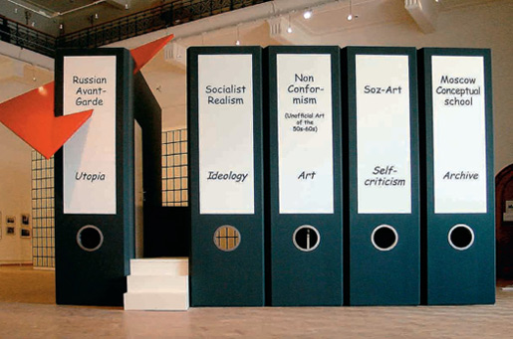
Vadim Zakharov, History of Russian Art from the Russian Avant-Garde to Moscow Conceptualism, installation, 2004³⁵
Moscow Romantic Conceptualism, which on the whole has been regarded as a concluding movement in late 20th century Soviet and Russian art (see Figure above), has often been described as emerging at the junction of art and literature. There have been proposed numerous ways of categorizing and arranging the conceptualists according to a period or dominant idea. Earlier, in the eighties, Moscow conceptualists had used the acronym “MANI” (the Moscow Archive of New Art, see above) to denote their circle. “NOMA,” (Pavel Pepperstein’s term) came to stand for a circle of people who describe themselves by means of a jointly developed set of linguistic practices, and it was used, especially in the early nineties, to refer to the central figures and the main texts of Moscow conceptualists.³⁶ Throughout the nineties the artists belonging to this circle referred to themselves as the “Moscow noma” (moskovskaia noma) or the “circle noma” (krug noma). “Estonia” was another term introduced in the early nineties to designate other re-groupings of younger conceptualists,³⁷ and in the nineties Monastyrsky introduced the term “Moksha,” to refer to the third phase of evolution of Moscow Conceptualism.³⁸ In the late eighties and early nineties the term “Psychedelic Conceptualism” was introduced and used by the members of the Medical Hermeneutics group. “Psychedelic Conceptualism” is defined in the Dictionary as a new tendency that “came to replace the ‘romantic conceptualism’ of the seventies and eighties, representing a critical and aesthetic manipulation of (collective or individual) psychedelic material.”³⁹ Monastyrsky’s novel Kashirskoe Road (Kashirskoe Shosse), published in 1998 as part of the first five volumes of the Journeys, where the author describes a psychotic episode from his life, was regarded by the Medical Hermeneutics artists as their initial point of departure. Thus, from the perspective of some artists of the last generation, Moscow Conceptualism can be divided into “romantic” (Kabakov, KD) and “psychedelic” (Medical Hermeneutics).
Other ways have been proposed of arranging the Moscow conceptualists. Some have suggested a tripartite order of dominant media, where Kabakov represents (from 1986 on) the art of installation, Vadim Zakharov printing, and KD performances and actions.⁴⁰ Others have argued that the “Moscow school” needs to be divided into three branches: “romantic conceptualism” (the circle of Kabakov), the “analytical conceptualism” practiced by Vitaly Komar and Alexander Melamid, and “inductive conceptualism,” the method favored by KD.⁴¹ A binary arrangement has also been put forward: one group assembles all those who earned their daily living by illustrating humanistic literature (especially children books) and another would incorporate all those who worked as illustrators for technical and scientific publications.⁴²
In 1991 Ekaterina Dyogot proposed a quadrilateral method of charting the Moscow noma, taking as her point of departure the concept of “privacy” (privatnosti).⁴³ Dyogot uses this concept (discussed above as “private art” [privatnoe isskustvo] with regard to the term “group”)⁴⁴ in order to emphasize once again the overall individual or personal character of this tradition, and in order to suggest that the conceptualists differed from their predecessors – both the historical avant-garde and the post-bellum modernists – in that they were not predominantly concerned with social or collective issues but rather with matters of personal freedom and individual expression. The series of oppositions that Dyogot proposes are centered on the concept of “privacy” and on various modes of defining individual psychological space.
In this version of the map of “private” Moscow Conceptualism the artists are arranged according to a series of psychological dichotomies: introverts versus extroverts and “existential” versus “character (role-playing)” (See Figure below).⁴⁵ The “existential” and “character” types are further elucidated by more colloquial versions of psychological typologies: those conceptualists who are believed to be sebe na ume (literally “in one’s mind”) and those who are ne v svoem ume (“out of one’s mind”). The Russian expression sebe na ume (“in one’s mind”) is often used to describe those regarded as reserved, self-absorbed or contemplative, to those who are believed to be inward-looking and seem concerned principally with personal affairs. The opposite type ne v svoem ume denotes (like its English equivalent) either someone who is believed to be “crazy,” someone who is predominantly concerned with external things, or someone who acts out his or her emotions and beliefs. These two poles can be also understood in terms of the psychological and psychoanalytic types “neurotic” and “psychotic,” as is suggested by Dyogot’s further addition of the opposition “sub-depressive” versus “para-maniacal.”
In her elaborations of this quadrilateral map of Moscow Conceptualism Dyogot also makes a series of references to Hermann Hesse’s novel Das Glasperlenspiel (The Glass Bead Game, 1943), a book that has had a great impact on the Moscow conceptualists. Drawing on this novel she constructs two other sets, setting an opposition between those artists who “play beads” – that is, the “introverts” who favor intellectual activities and dedicate their lives to the cultivation of the mind – and those who “cast beads,” meaning those extrovert artists who favor more manual, “worldly” or materially-oriented artistic activities. According to this map Monastyrsky and the members of Medical Hermeneutics fall in the category of existential introverts devoted to the “bead game,” for their artistic activities unfolded predominantly “in their mind,” that is, their work was largely conceptual and language-based. The more material-oriented extrovert artists such as Zvezdochetov and Gutov are categorized as “casting beads” because their work materializes above all “out of their mind,” that is in concrete artistic objects, or as Dyogot writes “on their fingers” (na palizakh).⁴⁶

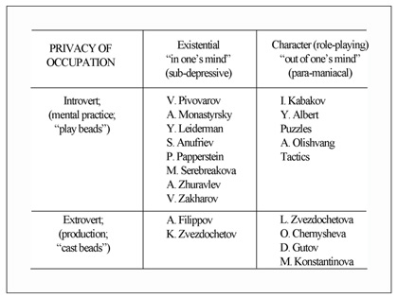
E. Dyogot Classification of Moscow Conceptualism 1991⁴⁷
The conceptualist quadrilateral can also be read according to the category of “emptiness” which is central for this tradition. Those grouped in the introvert columns are the artists who prefer more mental or conceptual practices; to use the terminology of Western conceptualism, these are the artists who are dedicated to the dematerialization of art and for whom language is their primary material (especially in the ‘Introvert/Existential” column). Those categorized in the extrovert tables tend toward “fullness,” or toward materialization and the production of tangible artworks. By the end of the nineties, and especially into the next century, those placed in the latter category, especially the “out-of their minds” or role-playing extroverts, had been largely left out of the “golden” circle of Moscow Conceptualism.⁴⁸ This tendency speaks again toward a certain propensity of those who formed the nucleus or the canon of Moscow Conceptualism to exclude the bead-casters, the manually or materially oriented artists, from their conceptualist circle, as if suggesting that this tradition were reserved for the introverts – for those who played mental games and who recognized the notion of “emptiness” as their sacrament.

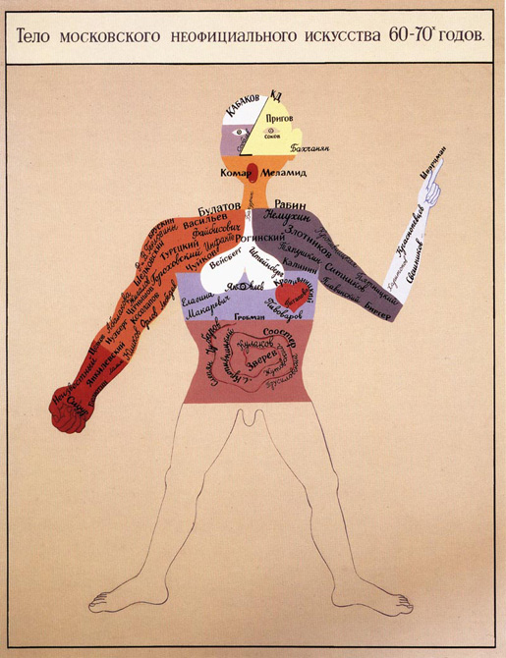
Viktor Pivovarov The Body of Unofficial Moscow Art – 1960-70s⁴⁹
Among all these attempts to comprehend the discursive field of Moscow Conceptualism, there have been also those who have gone so far as to dismiss the entire tradition. Nikita Alexeev, one of KD’s members, states: “Moscow Conceptualism never existed… Conceptual art for me is a limited number of British, American and a few German, Italian and French artists.”⁵⁰ Some critics outside of the Moscow circle have implied that Moscow Conceptualism was a matter less of beads than of Chinese Whispers, for in the Soviet period many of the Western cultural influences that made it over the Iron Curtain and reached Moscow were often altered or denatured within the local cultural context.
In the West, as a rule, conceptualism presupposes the triumph of intellect, of theory over spontaneous emotion. That is, theory is not a servant to art but is the art itself. The term “conceptualism” in Moscow, during the first half of the 1980s and later, played a collective function, as the term “futurism” did in the 1910s.”⁵¹
Indeed the history of the emergence of the designation “conceptualism” in Moscow shares many similarities with the Eastern careers of other Western art historical epithets. In the early twentieth century, for example, Velimir Khlebnikov declared that the term “futurism” in Russia was a pure accident, and instead coining and promoting the neologism Budetlyanin (man of the future). Filippo Tommaso Marinetti, on the other hand, was very critical of how the Russians used his term “futurism.” When presented with examples of zaum poetry during his 1914 tour to Moscow and St. Petersburg, he reacted by calling it too “abstract,” a “pseudo-futurism,” more “plusquamperfectum than futurum,” proposing instead that the Russians collect their experiments under the designation “savagism.”⁵² Breton voiced a similar concern in 1935, writing that “…the greatest danger threatening Surrealism today is the fact that because of its spread throughout the world, which was very sudden and rapid, the word [“surrealism”] found favor much faster than the idea, and all sorts of more or less questionable creations tend to pin the Surrealist label on themselves: thus works tending to be ‘abstractivist,’ in Holland, in Switzerland, and according to very recent reports in England, manage to enjoy ambiguous neighborly relations with Surrealist works…”⁵³
Despite arguments both pro and contra, however, and frequent questioning as to whether the term “conceptualism” appropriately described the art of certain Moscow artists and poets, “Moscow Conceptualism” remained to collect under its umbrella other words and concepts which accumulated and proliferated over the years. “Romantic,” “Emptiness,” “Psychedelic,” “Inductive,” “Analytical,” “Communal,” “MANI,” “Apt-art,” “Tot-art,” “NOMA,” “Estonia,” “KLAVA” (Club of the Avantgardists – the first officially registered Moscow artist association), “Moksha” and many others are not merely names, but have been used in order to express new directions, tendencies and attributes, shared aesthetic views, alliances, and the emergence of new groups during the more than thirty year history of Moscow Conceptualism.⁵⁴
MUSEOLOGICAL UNCONSCIOUS [Muzeologiceskoe bessoznatel’noe] – that thanks to which takes place the transfer of the survival instinct from the physical body of the individual to the result of his activities, achievements and accomplishments – achievements in the field of culture, science, etc. Accordingly the museological function follows the formula “I am legacy”. (V. Tupitsyn. Muzeologicheskoe bessoznatel’noe. Parachut, 1998).

H
CIRCUMCISION [Narezanie] – refers to the principle of working with text used in the artistic practice of Medgerminevtika, according to which a discourse, on one or another topic, is assembled from citations extracted from books drawn erratically from a dresser and opened at random. (See P. Pepperstein. “The Metaphorical body of the Ulianovs,” 1988).
THE FAILURE TO CARRY THE JAR [Nedonos banki] – method of terminating a process at its very climax. The termination of the form-shaping (formoobrazovanie) process at the time of its inception. (V. Zakharov, Fama & Fortune Bulletin, 1991 (7) Wien).
…A typical postmodern “Failure to Carry the Jar”! The story line ends not because the author does not know what to do next, but because he is not sure whether doing something next is necessary at all. It seems as if the characters begin to unfold, it is almost as if the character starts to emerge leading to a certain climax – but… the jar has not been carried to the destination. A revision of the creative attitude takes place…⁵⁵
FAILURE TO STICK [Nezalipanie] – equivocal attitude to your own “I”, to your place in this world, to your occupation, which is best described as a kind of “flickering” (mertsanie): you end up alternating between the state of being sometimes inside all of this [“I”, your place, your occupation], and sometimes outside. This “flickering” takes place continuously, following the same rhythm – sometimes you preserve your “identity”, and sometimes you lose it; sometimes you merge with your profession or occupation and sometimes at one instant you lose all of this. (See I. Kabakov, NOMA, Kunsthalle Hamburg, 1993).
UNNOTICED–NESS [Nezametnosti] – is one of the CATEGORIES OF KD. There is inscribed in the meaning of the category Unnoticed-ness an aesthetic device which presupposes the existence, in the common time-space zone, of an event in the general eventfulness of the action (often the most important one), of a certain “here and now” which is located beyond the boundaries of the spectators’ interest and attention. In the meaning of “Expositional Unnoticed-ness”, for instance, lies a working element of the creative and representative mechanism which is also hidden from the author at the early stages of the work, but which nevertheless influences the construction of the work (for example the case with the box under the chandelier which served A. M. [Andrei Monastyrsky] to produce the work “Cannon” (1975), a work constructed upon the relations between lighting and audio impressions). In its initial meaning, the term Unnoticed-ness was developed in collaboration with N. Panitkov. (See Journeys Outside the City p. 408, as well as A. Monastyrsky's text TSI-TSI, 1985 [published in the Journeys]).

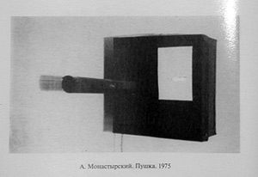
A. Monastyrsky, Canon. 1975
THE UNKNOWN [Neizvestnoe] – central category in medical-hermeneutical discourse [the work of Medgerminevtika]. The term refers to “that what lies beyond the surface (of painting, etc.), and what is impossible to identify in terms of the available or of the impossible, and whose agencies are the act of assuming or the slip of the tongue – which as a matter of fact are variants of one and the same thing” – S. Anufriev and S. Volkov, 1989. The formula of the unknown: “We know for sure what we do not know; do we know the unknown or don’t we.” (P. Pepperstein, Ideologia Neiszvestnogo, 1988).
NEO-PSEUDO-ART [Neolzheiskusstvo] – refers to an agreement to call all contemporary art Pseudo-art: an agreement formed in the days of youth, when such a definition of contemporary art was popularized by the mainstream Soviet literature of the 1960s and 1970s. The addition of the combining form “neo-” suggests that the author believes himself also to be working in the tradition of pseudo-art: “My entire life I dreamed to make only Real art, but somwhow every time I end up making only contemporary art.” (Y. Albert, Cycle of works of Elite-Democratic Art [Elitarno-demokraticheskoe iskusstvo] 1987).

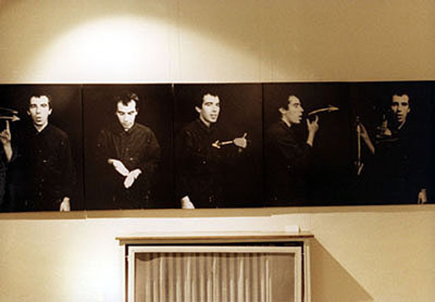
Y. Albert, From the series Elite-Democratic Art (for the Speech and Hearing Impaired), 1987⁵⁶
NEITHER TO THE MIND NOR TO THE HEART [Ni umu ni serdzu] – Term by S. Anufriev. The author did not present a definition for his term. (This was the title of one phase in the first exhibition organized by KLAVA, 1987).
THE NEW SINCERETY [Novaia iskrennosti] – within the boundaries of the totally established conventionality of languages, the art of primarily resorting to traditionally instituted lyrico-confessional discourses: this is what may be called The New Sincerity. (D.A. Prigov, From the preface to the text “Novaia iskrennosti,” 1884).
GK [Genady Katsov]: You mention the times before Gorbachev. I remember some time in 1987 I was told that Prigov was arrested. This was already during Perestroika?
DP [Dmitry Prigov]: The strangest thing is that this was in 1987, not even in 1985, during the endless struggles between the Communist Party, Gorbachev and all the others. At that time I was working in the direction of what I called “The New Sincerity” – something that I started to do back in 1982. I was writing on scraps of paper this kind of statement: “Citizens! If you destroyed a bird’s nest and trampled the grass – how dare you after all of this to look into the eyes of your mothers! Dmitry Aleksanych.” This was the sort of ecological statement that I was sticking all around the city. My old memory was telling me that this was dangerous but somehow I did not want to believe it (I was ignoring it)...⁵⁷
…Once tired of the frantic twirl of meanings, of pretentious weaving of words, of flickering simularcra and the whole kaleidoscope of distorted mirror reflections, art goes into searching for “wipers” in order to clean its windshield of postmodern layers. Art finds its life-saving pill in the “new sincerity” (or the “new sentimentality”) which emerged at the end of the twentieth century as a reaction to the crisis in art. Ironically, the concept of the “new sincerity” was introduced during the first half of the 1980s by none other than Dmitry Prigov – the classic of Moscow conceptualism and the brightest representative of Russian postmodernism.⁵⁸
NOMA – term introduced by Pavel Pepperstein in order to refer to the circle of Moscow conceptualism (the term replaced the term ‘circle MANI’ at the end of the 1980s). NOMA refers to “a group of people who describe the boundaries of the self [opisyvaiut svoi kraia] by means of a set of language practices that they have developed together.” The term was formed from the word ‘nome’ which was used in Ancient Egypt to refer to the divided parts of Osiris. The noma was also a territorial unit in Ancient Egypt. According to legend, in each Noma was buried one part of Osiris. (See P. Pepperstein, The Idealization of the Unknown, lecture delivered at the MGU (Moscow State University) seminar “New Languages in Art,” January 1988).
NOMA was one among many other terms invented by Moscow conceptualists in order to describe their hermetical circles and practices. Earlier, in the eighties, Moscow conceptualists had used the acronym “MANI” (the Moscow Archive of New Art, see above) to denote their circle. “NOMA,” (Pavel Pepperstein’s term) which stands for a circle of people who describe themselves by means of a jointly developed set of linguistic practices, and it was used, especially in the early nineties, to refer to the central figures and the main texts of Moscow conceptualists. Throughout the nineties the artists belonging to this circle referred to themselves as the “Moscow noma” (moskovskaia noma) or the “circle noma” (krug noma). “Estonia” was another term introduced in the early nineties to designate other re-groupings of younger conceptualists, and in the nineties Monastyrsky introduced the term MOKSHA, to refer to the third phase of evolution of Moscow Conceptualism.⁵⁹
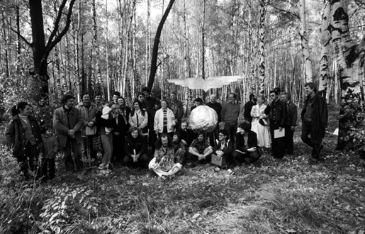
Photograph of the Moscow conceptualist NOMA, Kievogorskoe Field, 1983⁶⁰

O
OBSOSIUM [Obsosium] – phenomenon in epistemological package. Andrei Monastyrsky’s version of this term is “Obsosy”. The term was used by Vladimir Sorokin in discussions and in some of his texts of the 1980s.
Apparently the etymological origin of the term “Obsosium” is the Russian word sosat’ – to suck. The word was used extensively by the Russian contemporary writer Vladimir Sorokin, who was also actively involved in the work of the Moscow conceptualists, and in particular in the actions organized by KD. The fragment below is from one of Sorokin’s plays, entitled “The Dugout” (Zemleanka). The play depicts the daily life of five low-ranking Soviet army officers who share a dugout during the Second World War. The term OBSOSIUM appears in this fragment when the character Pukhov reads the newspaper. Please notice that many of the words in this fragment (placed in italics) do not exist in the Russian language, having been introduced with only the rhyme, for example, in mind. The word OBSOSIUM, which for certain reasons become very popular among the readers, also belongs to this group of invented words.
...VOLOBUEV. I'll go take a leak, and at the same point I'll check with my eagles [solders].
SOKOLOV. Listen, Vitea [Viktor] tell your first sergeant to provide my soldiers with a few more baskets. He promised.
VOLBUEV. O.K. (leaves).
DENISOV. I will also go! (Leaves after Volobuev).
PUKHOV. Yes…sweat is to our advantage (unfolds a newspaper and begins to read, chewing on a piece of bread).
Our great nation vliparo repeats again and again Lenin's name. Like the dearest word urparo the name lives with us like a flame. The great Soviet power barbido and the triumphs of our kolkhozes. This is Lenin's genius and glory carbido his eternal and sacred cause. We will never be tired of great work morkosy! And there is no country more powerful than ours. When our dear Party's warm-breathed sbrosy [waste]. Warms our people' heroic deeds like golden stars. I'll read you some poems, I'll tell you my children godo. About how our Lenin met once a little girl bodo. So that our red star will be with us forever meto. In those days we fought with our enemies beto. Lenin was very busy back then, but he took along the little child grother. He warmed and fed her and then he took a little book, oh brother. Amid all great and busy work she could have seen the koka. Lenin could love his people then, but he could also loath them voka. He hated masters and the tsar, the generals he loathed with brittle. He loved instead the simple folk and little children, little, little. And now the children are growing up like orchards in the spring of vupo. So let's grow up but try and be like our Lenin upo, upo. His portrait – OBSOSIUM, govnero, his portrait is OBSOSIUM aia. His portrait with the will of gorera, united OBSOSIUM oia. His portrait, which our krupsy like to decorate with flowers. This portrait of he who in the depth of obsupsy will bring us newer and newer powers.
RUBENSEIN. Nicely done.
SOKOLOV. I think that when one uses flowers to decorate coffins then for some reasons these flowers smell very strong.
PUKHOV. Well this depends on the flowers.
RUBINSTEIN. True, there are all sorts of flowers...⁶¹
WINDOWS [Okna] – constructions imitating real windows but which are in fact hybrids of windows and pictures that pretend to reveal the essence of painting. “Painting is the window on the world” Alberti. (Ivan Chuikov, Works starting with the painting Window # 1, 1967).

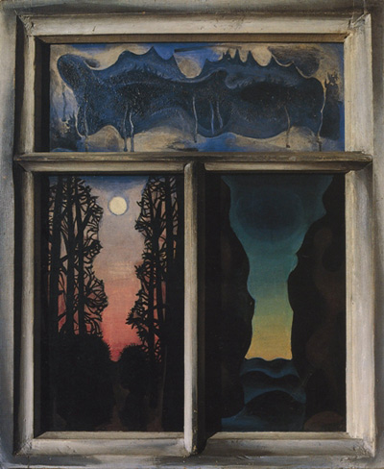
Ivan Chiukov Window # 1, 1967⁶²
OMS [Omy] – refers to transmutational monads of a certain metallicity that are capable of being verbalized, textualized and embodied in images. Oms are easily woven within various semantic ornaments, such as texts, pictures and photographs. The Oms belonging to certain individuals can often form relations or “bundles” with the Oms of other persons, animals or things, leading to the formation of double, triple or multiple (collective) Oms. One example of such a collective Oms is the NOMA. (V. Pivovarov, Metampsikhoz, 1993).
ORTHODOX HUT [Ortodoxal'naya izbushka] – the (honorary) title conferred upon the EMPTY CANON of MG [Medgerminevtika]. (P. Pepperstein. Letter to S. Anufiev from Prague, February 18, 1988).
OPEN PAINTING [Otkrytaia kartina] – if a classical painting, which on the whole has preserved its particularities throughout the modernist epoch, represents a closed space, a self-sufficient immanent “world in itself,” then the open conceptual painting is loose and unfastened. It is unfastened first of all in the direction of the spectator. This open conceptual painting seems eternally unfinished, perpetually in the process of its making, and it acquires meaning only during the contact and the dialogue with the spectator. Secondly, this painting is open in the direction of other paintings or artistic objects, that is it is absolutely contextual and may be “read” or interpreted only in relation to other paintings-texts. (V. Pivovarov. Razbitoe zerkalo, 1977).
ONANIUM [Onanium] – aesthetic auto-eroticism. (V. Sorokin. The object “Onanium,” 1988).

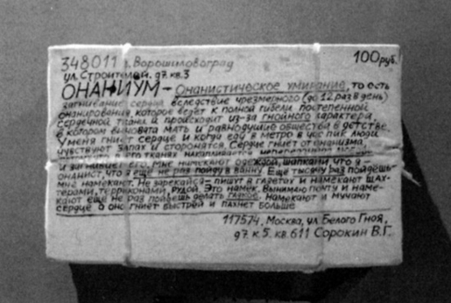
V. Sorokin Onanium, Stedelijk Museum, Amsterdam, 1990
THE DISCOVERY OF AMERICA OR FROM DUCHAMP TO DUCHAMP [Otkrytie Ameriki ili ot Dushana k Dushanu] – refers to the method of a second discovery of America, or to the discovery of something that has already been Known. This method presupposes nothing new or innovative, nothing original. (V. Zakharov. Poslednyaya progulka pe Eliseiskim poleam. Collogne Kunstverein, Cantz Ost-fildern, 1995).

П
PANORAMAS [Panoramy] – objects formed by reversing conventional panoramas in such a way that the internal becomes external and vice versa. In this case the observer is not inside the panorama but outside it, thus bringing the separation between the subject and the object to the absurd. (See I. Chuikov's Panoramas I, II, III, IV, V 1976, and the 1993 installation Panorama in Santiago-de-Compostela).
JOURNEYS OUTSIDE THE CITY (JOC) [Poezdki za gorod (PZG)] – is a genre of action (and the title of KD’s books) in which an emphasis is placed on the aesthetic significance of different phases of journeying to the place where the event [action] takes place, as well as on various forms of reporting and describing the event. It is also the general plot of all of KD’s JOC (including the sixth volume made by A. Monastyrsky and S. Hänsgen independently of KD.) The term was introduced by Monastyrsky and Kabakov in 1979. (A. Monastyrsky, Preface to the 3rd volume of the Journeys, 1985. A. Monastyrsky, KD and “Journeys Outside the City”, 1992. See also general comments in Monastyrsky, Poezdki Za Gorod: Kollektivnye Deistvia. Moskva; Ad Marginem, 1998).

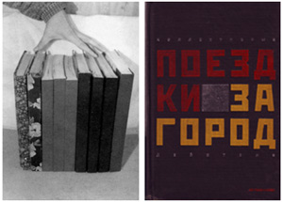
Left: The samizdat version of the Journeys Outside the City.
Right: The book version of A. Monastyrsky,Poezdki za gorod: kollektivnye deistvia (Moskva; Ad Marginem, 1999).
During three decades “Collective Actions” group or KD have been investigating the nature of art, developing their own methodology and tools, experimenting with different aesthetic and artistic approaches and strategies, and finally recording and collecting their findings, processes, conclusions, and interpretations into what today constitutes the ten-volume publication Journeys Outside the City (hereafter referred to as Journeys). This publication, which includes documents, photographs, schemas, diagrams, maps, reports, and commentaries about KD’s actions, started in 1980 in the format of samizdat. In 1998 this material was published (with the support of the Soros Center for Contemporary Art Moscow) in the five-volume publication of the same name by Ad Marginem. The first five volumes of the Journeys comprise the activity of the group during the Soviet period (1976-89), often described by the artists themselves as the “classical KD.” After a period of transition, which lasted six years (1989-1995) the group reunited and began to assemble material for the next five volumes of the Journeys (1991-2008) which is today available only on-line.⁶³
The material in the first volume of the Journeys is arranged in the following order: Acknowledgment, Foreword, Descriptive Texts, Participant Reports, and Commentaries. With some exceptions, this is the order that has been kept in all the subsequent volumes of KD’s Journeys. In the short “Acknowledgement,” (Ot avtorov) the artists thank all those who helped them organize and photograph their actions, and also list those who joined the group during some phase or another. Next is the “Foreword” (Predislovie), which is the main theoretical text of each volume. Here, Monastyrsky summarizes the general direction of the group during each phase, pointing to the main changes, their general direction and to the new terms and concepts developed in the course of a given phase. The next section, called “Descriptive Texts” (Opisatelinye texty), includes the descriptions of all the actions that were organized during each phase. Each description contains the plot of the action, the location where the action took place, the names of the authors (ordered according to their contribution to the action), and the documentation that accompanied it. The following section, called “Participants’ Reports” (Rasskazy uchastnikov), presents the reader with the spectator-participants’ writings after their participation in one of the group’s actions. Finally, each volume concludes with a section called “Commentaries” (Kommentarii), where the critical interpretations of the artists’ actions and the spectators’ reactions are compiled.
Monastyrsky has insisted that the “journeys outside the city” must also be regarded as an artistic genre. He writes that “the super-task of all the actions of the third volume was to activate the genre [of “journeys outside the city”] and to maintain a kind of aesthetic activity by negation.”⁶⁴ But a new genre also needs a theory and an aesthetics of its own. Monastyrsky’s text “Stages and Stops” (Peregony i sotianki), which appears as a statement after the description of all the actions of the third volume, may be regarded as an attempt to provide such a theoretical framework for the new genre of art called “journey outside the city.” The definition that the annex to the Dictionary of Moscow Conceptualism gives for the entry “Stages and Stops” is the following: “an aesthetics, in which are woven together elements of transportation and a religious aesthetics.”⁶⁵ Like many other definitions in the Dictionary this one is not very clear. The text itself describes the world that opens up when one travels from one place to another.⁶⁶ Train stations, airports, subways, buses, trains, whistles, instructions on how to comport yourself in each kind of transportation, all kind of posters telling of arrival and departure, the uniforms of the transportation personnel (each having its own emblem with golden and silver wings, wheels or hammers and sickles) and so forth – all these Monastyrsky calls the realm of the “transportation aesthetic”(235). From describing the extensive transportation system in Russia, which accommodates the immense expanse of its territory, the author crosses to the notion of “spiritual journeying,” bringing in various spiritual and religious practices where the notion of “journey,” “path,” “ascent,” “advancement,” “attainment” has played a central part. “It is possible” he writes “that the Russian people, who are scattered over the immense territory of their country and who are often forced to cover very long distances when they travel, are very sensitive to the ‘un-home-like’ atmosphere of life, to their ‘guest status’ on earth, which is often expressed in all kind of parties and binges.”⁶⁷
ON THE EDGE [Po kraiu] – refers to the inner sense of self as leaving or escaping one’s own “center,” as if living on the edge of life, on the margin of culture, on the verge of every kind of professional activity. The conviction that everything that is important in life takes place on the “edges,” in marginal zones, on the borders of everyday life and culture. (I. Kabakov, NOMA, Hamburger Kunsthalle; Cantz, 1993).
THE GESTURE OF PRESUMPTION, THE GESTURE OF DEFENSE, THE FAREWELL GESTURE [Polagaiuschii jest, jest zaschity, proschal’nyi jest] – are “art historical” categories. The Gesture of Presumption is the act of “creation,” that is the gesture by which the author (as part of his “God-imitating” posture) creates new “worlds.” The Gesture of Defense is the gesture that helps the “creator” [author] to distance himself from the created “worlds” in that moment when these “worlds” begin to threaten his existence. The Farewell Gesture is the gesture addressed to those “worlds” that begin to lose their actuality. (See P. Pepperstein, “The Idealization of the Unknown,” lecture delivered during the MGU [Moscow State University] seminar “New Languages in Art,” January 1988).
POLITICAL TALE [Politicheskaia skazka] – refers to imagery that incorporates both traditional [Russian] folkloric iconography and the visual arsenal of Soviet mythology. (M. Tupitsyn, “And Who Are You?” in Leonid Sokov. Zeus/Trabia, New York, 1986).

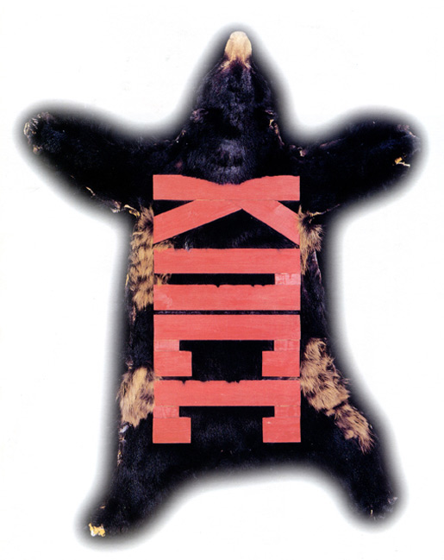
Leonid Sokov, Bearskin with CPSS, 1987.⁶⁸
In Leonid Sokov’s sculptural compositions, which are made in the style of the ‘political tale’ (term by M. Tupitsyn), the protagonists – imported from various socialist realist myths – turn into carnival characters; they become market fair toys or heroes of lubok bestiality.⁶⁹
ZONE OF IMPERCEPTIBILITY [Polosa nerazlichenia] – part of the DEMONSTRATIVE SEMIOTIC FIELD (often bordering the EXPOSITION SEMIOTIC FIELD) where certain aural and visual objects of the action cannot be recognized by the spectator as belonging to the action. (See A. Monastyrsky’s short explanation of KD’s action “Place of Action” and Appendix No. 4 to the same action, 1979. On the meaning of ZONE OF IMPERCIBILITY see also A. Monastyrsky, O structure akzii ‘Obsuzhdenie 2 in the Journeys).

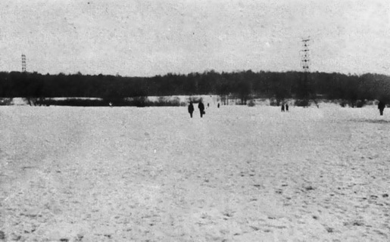
KD, Zone of Imperceptibility
“Indeed, if we regard our actions… then we may discover that they are not at all constructed in that undetermined place between life and art, and they do not point at this indeterminacy [gap] as their object of representation. The macrometaphor of KD’s actions is not ‘indeterminacy’ (heopredelennosti) but ‘aloofness’ (obosoblennosti). Initially this aloofness is easier to determine negatively: the event of the action takes place neither in the sphere of life nor in that of art, nor in the diffuse and undetermined zone that exists between them. The only way to determine it positively is in the dynamics of the work: the event of the action takes place within the common efforts of the authors and spectators, directed at the movement of the subject of perception from the demonstrative field (art) through the ‘zone of imperceptibility’ into the zone of the absent-minded, everyday contemplation of life.”⁷⁰
PANTAGRUEL OF PERIPHERAL VISION [Pontogruel’ bokovogo zrenia] – refers to the frontier zone located in between the Known and the Unknown; a “zone of incrimination” that constantly makes greater claims (based on “bluffing” [pont], or on “showing off” [vzeat' na pont]). (S. Anufriev Pontogruel’ bokovogo zrenia, 1989).
PORNO-ANGELISM [Pornoangelizm] – the insecurities of the recently urbanized collective bodies when they are faced with the developed practices of cultural consumption of the American or European types; the inevitable process of deformation of these practices of consumption when they reach the new contexts, up to that point when these cultures became in some instances practically unrecognizable. (M. Ryklin, “Metamorfozy rechegogo zrenia,” in Terrorologia, pp. 83-96).
PORNOLOGY, also Pornological Shift, Pornological Border, Pornological Funnel (PORNOLOGIA, pornologicheskii shift, pornologicheskaia granitsa, pornologicheskaia voronka) – pornology is the “orgiastic” state of speech (in the orthodox tradition this is sometimes called “prodigal cursing” [“bludnye brani”]. Pornological Shift is the gradual “slippage” of speech (text) into the state of “cursing”. The Pornological Border is that invisible border within the text after which all the norms of what constitutes “permitted” or “literary” language are abolished (one can encounter the Pornological Border in NOMA’s texts, and especially in the prose of V. Sorokin). The Pornological Funnel is the final “breakdown” of text that is often accompanied by the total collapse of speech, which may be regarded in itself as a certain aesthetic trick. (P. Pepperstein, Pornologia prodoljenii, 1993.)
This early story by Vladimir Sorokin, “In Transit” (Proezdom), is a perfect example of PORNOLOGY and the PORNOLOGICAL BORDER in particular.
V. Sorokin “In Transit” (Proezdom).
– Well, on the whole, comrades, your district performed well during this year – Georgii Ivanovich smiled, leaning slightly backward – this is what I was instructed to tell you. – Those sitting at the long desk smiled in response, exchanging glances among themselves. Georgii Ivanovich wagged his head and threw up his hands:
– When everything is well, comrades, then it is indeed well, and when it’s bad, then why take offense. Last year you were too late with the sowing campaign, your factory did not complete the plan, and the sports complex, remember, all the hassles? Eh? Remember?
Ivanov who sat on the left nodded:
– Yes, Georgii Ivanovich, of course we sinned, we are guilty.
– You yourself are the executive body, and you thought that the construction workers would be capable of managing without you and keeping with the deadline. But they are executors, why would they hurry. Your factory, however, is known in the entire Soviet Union, and we need the plastic very much, but last year 78%... What is this? This can’t be serious? Panteleev came to me… 78%, so what is this? Really, well, thank you comrade Panteleev for your organization of the industry in the district, eh?
– The assembled raikom employees smiled. Georgii Ivanovich sipped at his glass of cold tea, licking his lips.
– But this year it is a real pleasure. Your new secretary, pity he is not here today, came to me already last year; Panteleev, he visited us in the fall, and Gorohov – in spring. He came and reported to us in a business-like fashion about all the causes, about everything, responsibly indeed, reported about everything, you understand? The builders had to carry cement from another district. But that’s no good at all. For six years Panteleev could not get into the Kirovskii district. It is nearby, only 160 kilometers, and they have a drywall factory, and next to it there is a cement plant. That’s no good at all, comrades.
– We, Georgii Ivanovich, actually went there – Vorobiev leaned forward – but we were refused straight away. Back then they were connected with the Burkovski plant, with the construction site, but now they have finished with that – they were free, therefore that time it worked.
– If they hadn’t been pressured from above we wouldn’t have gotten our cement yet – Deveatov interrupted him – everybody needs cement these days.
– Georgii Ivanovich, of course, Panteleev was guilty, but if someone had pressed hard on them, we might have gotten some. They must have had some reserves.
– Of course there was a reserve, it is impossible that there wasn’t, there was, there definitely was – Georgii Ivanovich sipped his tea. On the whole, comrades, let’s not guess, and in the future let’s be more professional. You couldn’t figure this out by yourselves – shake down the vices and the deputies, consult the managers, the workers. And let’s maintain our reputation in the future, like this year; you started well so keep steady! Is it agreed?
– Agreed.
– Of course we agree.
– We agree Georgii Ivanovich.
– We’ll strive.
– We will do our best.
– This is wonderful comrades – Georgii Ivanovich stood up. – As far as your secretary is concerned, I will see him. Don’t let him be upset that I did not notify him about my visit, I was in transit. Let him get well. For what is this – an attack of quinsy in August, this couldn’t be serious.
– The assembled also stood up.
– He is strong, Georgii Ivanovich, he’ll get well fast. This must have been accidental, for he rarely gets sick. It’s a pity that it happened just when you decided to visit us.
Georgii Ivanovich looked at them smiling.
– Never mind, never mind, from now on I will show up unannounced. Take Panteleev for instance, when he appears suddenly at the door of my office, then everything is clear: he has come to repent and confess his sins.
Everybody laughed, and Georgii Ivanovich continued:
– Today I was in transit, decided to take a look – everything is fine. This what a new secretary means. Alright comrades. – He looked at his watch. – Three o’clock, it’s late… Look comrades, now all of you please go back to your places, and I will take a half an hour walk, I’d like to take a look around.
– Georgii Ivanovich, perhaps you would like to join us for lunch? – asked Iakushev approaching him. – It is here nearby, it has been arranged already…
– No, no, I don’t want to, thank you, I don’t want to, but you all go and have lunch, go to your working places, in short, mind your own business. And please do not follow me. I will do my own walking on all the floors. In short, everybody minds his own business, comrades.
Smiling he stepped through the waiting room into the corridor. The functionaries of the district committee followed him in the corridor then began to disperse, glancing back. Iakushev nearly began to follow but Georgii Ivanovich shook his finger at him and he smilingly dropped back.
Georgii Ivanovich set out along the corridor. The corridor was hollow and cold. The floor was composed of light-colored stone slabs, the walls were painted in a docile and pale blue. Square lamps were shining from the ceiling. Georgii Ivanovich walked to the end then climbed the wide staircase to the third floor. Here he ran into two functionaries, who greeted him loudly and affably. He greeted them in response.
On the third floor the walls were painted in a pale green. Georgii Ivanovich spent some time in front of the information stand. He lifted from the floor a fallen thumbtack and carefully fixed a protruding corner of a loose leaflet. A woman showed up in the next door.
– Good afternoon Georgii Ivanovich.
– Good afternoon.
– The woman walked along the corridor. Georgii Ivanovich looked at the door. A metallic plaque hung on the light-brown upholstered surface of the door: “Fomin V. I., Head of the Propaganda Department.”
Georgii Ivanovich cracked open the door:
– May I?
– Fomin at his desk raised his head, and jumped up:
– Please, please, Georgii Ivanovich, come in.
– Georgii Ivanovich stepped in and then took a look around. Over the desk hung a portrait of Lenin, in the corner there were two massive safes.
– Here I am sitting, Georgii Ivanovich – said Fomin approaching with a large smile on his face – too many things piled up over the summer.
– Well winter is for hibernation – smiled Georgii Ivanovich. – You’ve got a good office, it’s very cozy.
– Do you like it?
– Yes, its small but cozy. What’s your name?
– Vladimir Ivanovich.
– Well here we are, two Ivanovichs.
– Yes – laughed Fomin tugging at his blazer – and two heads of departments. Georgii Ivanovich moved towards the desk smiling.
– Vladimir Ivanovich is it true that there is so much work?
– Oh, yes – Fomin made a serious face – there is plenty, now the conference of printing press workers is coming soon. And the journalists are somewhat sluggish, there are problems with the factory’s anniversary album. Haven’t decided yet… All sorts of complications… And the secretary is sick.
– What is this about? What kind of album?
– The anniversary one. This year our factory is fifty years old.
– That’s quite a figure, of course. I didn’t know.
– Well, so we decided to make a special anniversary album. It is actually already made. I’ll show it to you now – Fomin dragged the drawer of the desk, pulled out a dummy copy of the album and passed it to Georgii Ivanovich.
– This is the dummy. It was made by two lads from Caluga, very good artists. On the front cover is the factory, and on the back cover is our lake and the forest.
Georgii Ivanovich was paging through the dummy:
– Aha… yes… very beautiful. So what?
– Well the problem is that the first vice doesn’t like it. He says it’s boring.
– What did he find boring about this beauty? A marvelous view.
– That’s also what I told him, but he wouldn’t agree under any circumstances.
– Are you talking about Stepanov?
– Yes. And the secretary is sick. For two weeks we cannot approve it. We’re delaying the artists, the printers.
– Well let me then sign it.
– I, Georgii Ivanovich, would be so grateful to you. This would take a load off my shoulders.
Georgii Ivanovich took his pen and wrote on the back cover: “I approve of the view of the lake,” swiftly signing underneath.
– Thank you, thank you so much, – Fomin took the booklet out of his hands, looked at the signature and hid it in the drawer – now with this booklet I will show them. I’ll tell them that the lake was accepted by the deputy head of the obkom. Enough dallying.
– Yes, tell them this – smiled Georgii Ivanovich and screwing up his eyes looked at some papers that laid next to the blotter. And what is this, it looks so neatly done?
– This is the June directive of the obkom.
– Ah, ah, is it the one about the harvesting campaign?
– Yes. You must know it better than we do.
Georgii Ivanovich smiled.
– Oh yes, I have spent plenty of time with it. Your secretary came twice and we racked our brains over it.
Fomin nodded seriously.
– I see.
– Well, Georgii Ivanovich sighed – Vladimir Ivanovich, we can only dream about the rest. We’ll settle down only when we kick the bucket.
Fomin bobbed his head in sympathy and smiled. Georgii Ivanovich took the directive, looked at the neat type-written text, paged through, slightly shifting and disheveling the pages.
– So what do you think about it, Vladimir Ivanovich.
– About the directive?
– Yes.
– In my opinion it is very practical. It is accurate and clear. I read it with much interest.
– This means that we didn’t spend our time in vain.
– It is a very useful document, no doubt. It is not a mere clerkly paper, but a serious document written with a genuine party approach.
– I’m glad that you like it. Usually these directives are collecting dust in safes. Listen Vladimir Ivanovich… take this directive and put it on the safe.
– On the top?
– Yes.
Fomin took from him the bundle of papers and put it very carefully on the safe. Georgii Ivanovich in the meanwhile came up to the desk, pulled the drawer out and took the album dummy.
– It’s good that I remembered – he began to page through the album – you know, Vladimir Ivanovich, what we are about to do… well… perhaps… that is. You know so there wouldn’t be any… really.
He placed the open album on the desk, quickly took off his blazer and threw it on the armchair. Then he slowly climbed on the desk, stood up and straightened himself. Smiling in astonishment Fomin looked at him. Georgii Ivanovich unbuttoned his pants, lowered them, then pulled down his underpants and glancing back, squatted over the album. He gripped his lean arms with his hands in front of him. Fomin looked at him with his mouth wide open. Georgii Ivanovich glanced back once more, moving his bent legs back and forth, then stood still and, groaning, stared past Fomin in the distance. Fomin paled as he suddenly began his retreat towards the door but Georgii Ivanovich said in a low voice: “See… yourself… stomach…” Fomin cautiously came to the desk and raised his arms in confusion:
– Georgii Ivanovich how is that… why… I don’t understand…
Georgii Ivanovich groaned loudly, stretching his bloodless lips he opened his eyes wide. Fomin went around the desk avoiding his knees. The flat buttocks of Georgii Ivanovich hovered over the opened album dummy. Fomin stretched his hands towards the neat little book but Georgii Ivanovich turned an angry face towards him: “Do not touch it, I said don’t touch it smart aleck.” Fomin backed up towards the wall. Georgii Ivanovich farted. His hairless buttocks swung. The brown spot that appeared in between his lean buttocks grew bigger and with each moment longer. Fomin, swallowing convulsively, leaned forward from the wall, stretching his arms and placing his hands above the album in order to protect it from the brown sausage. The sausage broke away and fell in his hands. Another one, thinner and lighter, followed. Fomin also accepted this one. Georgii Ivanovich’s short white penis swung, releasing a thick and intermittent yellow jet over the surface of the desk. Georgii Ivanovich farted again and, groaning, released the third portion. Fomin caught it too. His urine began to drip from the desk onto the floor. Georgii Ivanovich stretched his arms, took from a box on the desk a few sheets of note paper, wiped his anus, threw them on the floor, and began to get up, holding with his hands his lowered pants. Fomin stood in the back holding in his own hands the warm excrements. Georgii Ivanovich put on his pants and absent-mindedly looked at Fomin.
– Well… that’s it… now what’s up with you…
He tucked in his shirt, clumsily jumped off the desk, took his blazer and, holding it under his armpits, picked up the receiver of the telephone, slightly splashed by his urine.
Listen, how could I call your vice deputy, what’s his name…
– Iakushev?
– Yes.
– 327.
– Georgii Ivanovich dialed.
– Its me. Well, comrade Iakushev, I must leave. Perhaps. Yes, yes. No no, I am with Vladimir Ivanovich. Yes, with him. Yes, it would be better in two, yes, immediately, right now, I’m on my way. Okay, yes, yes.
He put down the receiver, put on his blazer, looked once again at Fomin and left, closing the door behind him. Yellow drops rapidly dripped from the edge of the desk into the puddle of urine which motionlessly sparkled on the polished wooden floor. The yellow puddle surrounded a notepad, a cigarette-holder, and one edge of the dummy. The door opened, revealing in the crack the head of Konikova:
– Volodea, it was you whom he just visited? Why didn’t you call me, you ass?
– Fomin quickly turned his back to her, hiding the excrements in his hands.
– I am busy, you cannot enter now, you cannot…
– Wait a minute. Tell me what you both discussed? It’s stuffy in here, and there is this strange smell…
– You can’t come in, I am busy, I’m very busy – shouted Fomin with a red face, shrugging his shoulders.
– Alright, alright, I’ll go, only please don’t shout.
– Konikova vanished. Fomin looked at the closing door, then quickly bent and was about to put his hands under the desk, when he heard a loud automobile horn coming from outside. Fomin stood up and ran to the window. Next to the main entrance of the raikom building was parked a black “Chaika” limousine, and two black “Volgas.” Georgii Ivanovich was descending towards them on broad granite stairs surrounded by a group of raikom employees. Iakushev was telling him something, making lively gestures with his hands. Georgii Ivanovich nodded, smiling. The “Chaika” turned around, taxied smoothly and stopped in front of the stairs. Fomin watched, pressing his forehead hard to the cold window glass. His hands, which were still holding the excrement, slightly dispersed, and one of the brown sausages flopped and plopped on the toe of his shoe.
Translated by Octavian Esanu
OBJECT-FRAME [Predmet-rama] – plastic (“artistic,” stylistic) material of the event, “within” which the event is constituted as “EMPTY ACTION”: often as a “washing up of objectified transcedentality.” One of CATEGORIES OF KD. See A. Monastyrsky, Foreword to the Third Volume of the Journeys Outside the City, 1985, pp. 420-425. See also his text “Tzi-Tzi” in the Journeys).

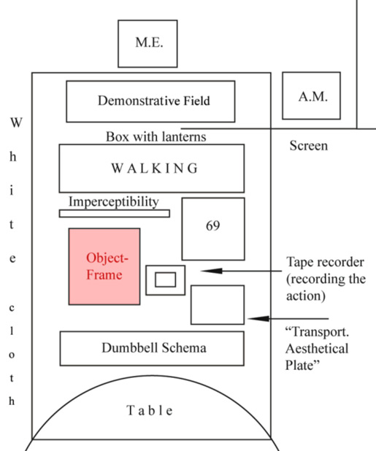
A. Monastyrsky Object Frame, [reconstructed diagram]
Under ‘Imperceptibility’ was placed the ‘Object-Frame’ – a pile of numbered black cardboard pieces, which had been used, as part of the interior object-frame, during the action ‘Translation.’⁷¹
GIVEN ART [Predostavitel’noe iskusstvo] – refers to a kind of fine art in which the spectator – by means of a complex figurative plot embedded in the structure of the work — is Given the opportunity to individually interpret the work of art. Term by S. Anufriev introduced in the early 1980s. (Definition developed by I. Chuikov).
PROGRAM OF WORKS [Programma rabot] – the AUTHOR [Lev Rubenstein] announced the beginning of the implementation of the Program of Works in 1975. It was assumed that all the subsequent artistic gestures of the AUTHOR would be included and drawn into the announced Program of Works. This is what obviously happened, despite the fact that later the AUTHOR stopped using this term. In fact, the term “Program of Works” meant at that time [1975] what later became designated by the widely used term “project”. The deliberately impersonal “anti-poetical” pathos of this term [PROGRAM OF WORKS] corresponded to the tendency, prevalent in those days, to formalize (up to the level of bureaucratization) the entire so-called “creative process.” (L. Rubinstein, Raboty. 1975).
…In the writing of Lev Rubinstein, the reading process uncovers its own active substratum, its nature as vital effort. The effort of reading is disclosed to be a principle of textual structure. The text is that which is performed in the reading of it: you turn the pages, you move your eyes, and you “imagine.” While the romantic imagination occupies its rightful place at this point, in the pose of the person reading, it then begins once again to beckon in the endless distance of the reading effort that registers the text.
As the reading is, so is the writing. In the “Program of Works” (1975), no descriptions are offered, yet at the same time no instructions are issued on what to do. The “program” sketches out the emptiness occupied by pure spontaneity, that is, by romantic subjectivity as such. And in this text we read: “In the event that the realization of this or that point in the Program should be factually impossible, the verbal expression of these points is to be regarded as a special case of realization or as a fact of literary creation.”⁷²
SPACE OF JUBILIATION [Prostranstvo likovania] – subway, recreation parks, palaces of culture, specially decorated halls, where various rites of jubiliation and rejoicing take place, striking and thrilling many travelers (for instance André Gide in 1936). Behind the ecstatic optimism, which is obligatory for this kind of space, is hidden a profound depression; in fact these are disguised funeral rites, whose object at that time cannot yet be named. (M. Ryklin, “Back to Moscow, sans the USSR” in Jacques Derrida v Moskve. Dekonstrukzia puteshestvia (M., RIK Kul'tura, 1993, 108-27).

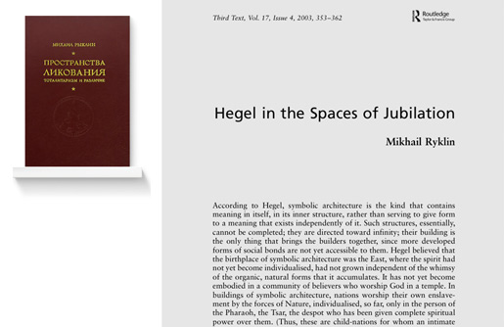
Mikhail Ryklin's book Spaces of Jubiliation: Totalitarianism and Difference (Moskva, Logos, 2001).⁷³
PSYCHEDELIC (COUNTER) REVOLUTION – [Psichodelicheskaia kontr-revoluzia] – programmatic orientation toward the preventional occultation (domestication) of psychodelic space. The term also denotes a concrete historical period (“in-between-putsches,” that is, the period that lasted between the putsch of 1991 and that of 1993), when the political (counter-)revolution was superimposed on the psychedelic (counter-)revolution. (Term by P. Pepperstein. See Medgerminevtika, Ideotechnika i rekreazia, 1989).

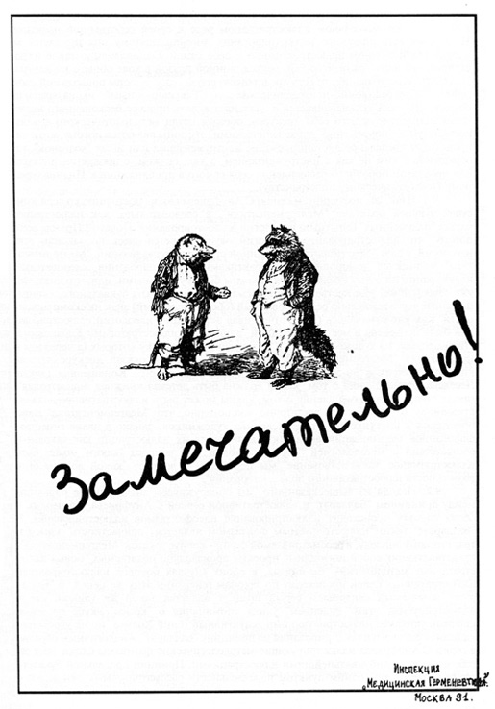
Medgerminevtika, Wonderful! 1991
…The circle ESTONIA emerged during the period of PSYCHEDELIC (COUNTER-)REVOLUTION in Moscow. It makes sense to say a few elucidating words about the term 'psychedelic (counter-)revolution'…
How did this circle (ESTONIA) emerge? This question has already been partially answered: the psychedelic experience (related to the consumption of such hallucinogenic substances as LSD, PCP, ketamine, DMT, psylocibin mushrooms, and others) coincided, for some culturally-engaged people, with a break between two systems, with a gap between two economical and ideological worlds. This experience, and this temporal overlapping, created a new type of intertext in art, suddenly bringing together people whose interests did not previously cross. For some this experience was limited to a series of psychic excesses, for others it opened the way for an intimate contact with the so-called 'new Russian reality,' and the specifics of this new 'reality' (the quotation may not be needed here) is that it is easier to approach it through hallucinogens rather than without them.
This, in fact, is the 'psychodelic (counter-)revolution'…⁷⁴
PSYCHEDELIC HETEROGENESIS [Psychodelicheskii geterogenez] – refers to the production of the other by means of borrowing from the text (literary, artistic, musical, etc.) its plasticity, its “physical” resources. (V. Tupitsyn, Drugoe iskusstvo. Moskva; Ad Marginem, 1997).
PSYCHO-TROPE [Psiho-trop] – figure of inner speech, which regulates the relations between various “psychema” [psihema], that is between forms filled with psychic content. (P. Pepperstein, Iz laboratornykh zapisei, 1992).

Vasnetsov’s Gaps⁷⁵
EMPTY [Pustoe] – primordial belief in the ambivalence and reversibility of the concept “Empty,” which denotes both absolute “nothingness” and absolute “fullness.” “Empty” is not a temporal or a spatial gap (pause) but an infinite field of intensities that potentially contains all the richness of various meanings and significances. (I. Kabakov, NOMA, Kunsthalle Hamburg, 1993).
The Moscow conceptualists distinguish in their Dictionary between the terms EMPTY and EMPTINESS. Both terms, which emerged in the early works of Ilya Kabakov, are central for the conceptualist tradition, whose aesthetics (if one must define them) would certainly be called an “Aesthetics of Emptiness.” The Dictionary defines the term EMPTY in terms of an “infinite field” whereas EMTINESS is described as a “negative space” (see EMPTINESS). Of these two terms EMPTINESS (pustota) has been used more often. Since EMPTY and EMPTINESS play such an important part in this tradition, and since no consistent distinction has been made between these two terms, I have decided to place the extensive material in Moscow Conceptualism on “emptiness” under the terms EMPTY, EMPTINESS, and EMPTY ACTION, treating the terms somewhat synonymously. Under the entry EMPTY I would like to bring into discussion the relation between “emptiness” and “nothingness,” a relation that Kabakov often discusses in his texts and memoirs.
The “emptiness” of Moscow Conceptualism must be also distinguished from other forms of negation developed by previous generations of Russian/Soviet artists. Zen and Ch’an Buddhism – the spiritual traditions which were very important for KD group – differentiate between nothingness and emptiness, nothingness being regarded as an extension of emptiness. Nothingness is the condition of total negation, “the no-concept of no-concept… Whereas emptiness is relative, nothingness is absolute, a notion that cannot be conceived and does not have a conceivable counterpart.”⁷⁶ To the notion of emptiness one can juxtapose the concept of fullness, whereas nothingness can only be contrasted with an abstract and ungraspable notion of everything, or of the infinite. “Nothingness,” to turn to the words of Sartre, “haunts being” – that is, in order to be able to discuss the notion of nothingness, being itself must be set as its ground.⁷⁷ Without being one cannot speak of nothingness.
An implicit distinction between emptiness and nothingness becomes evident when one compares how various forms of artistic negation have been used by Soviet/Russian artists of different generations. I would like to illustrate this difference using two artworks that have been considered paradigmatic for the two generations of Russian/Soviet artists: Malevich’s Black Square (ca. 1923), regarded as a symbol of the historical avant-garde, and one page from Kabakov’s album series, a cycle of works that had a great impact on the Moscow conceptualists.

Ilya Kabakov, In the Closet (1973) and Kasimir Malevich, Black Square (ca. 1923) [reconstructed]
It is not accidental that Malevich’s Black Square has collected such epithets as: “nothing,” “void,” “abyss,” “zero degree of form,” “infinity.”⁷⁸ With this work the artist makes an objective claim not only as to the condition of painting in the early twentieth century, but also as to the state of art in general. Malevich’s contemporaries regarded the Black Square as an abrupt end to the institution of art, as it had evolved until then in the bourgeois society, as a descent into absolute nothingness, which is the ultimate ground for a new radical act of creation.⁷⁹ Malevich’s unconditional nothingness is also suggested on the pictorial level. There are no other elements on the surface that would make this particular form of negation relative to anything. The negation applies to the entire surface of painting, to the whole surface of the canvas, suggesting a total cancellation, or a pulling down of the blinds on the “window into the world,” as this genre of fine arts was known in Western culture since Leon Battista Alberti.
In contrast, Kabakov’s picture, selected from the first cycle of the album entitled Sitting-in-the-Closet-Primakov (1974), would be more appropriately described as empty. The fact that this work convey emptiness rather than nothingness is suggested by a black surface which is not absolute but relative with regard to other pictorial elements that appear on the surface of paper, in this case the phrase “In the closet” (v shkafu), and the artist’s signature. As in Ch’an painting, in which the emptiness of the white page or canvas is emphasized by the presence of a few brushstrokes, this picture is empty due to the presence of a few textual elements. Unlike Malevich’s claim to universality, which is consistent with what has been described as “the utopian program of the historical avant-garde,” Kabakov’s statement is particular and subjective, as the very notion of “album” suggests. The album (the personal photographic account of one’s life) perfectly epitomizes the key principles of Moscow Conceptualism, expressing their primary aesthetic concerns with individual freedom. Kabakov’s picture is an illustration – a genre of art at the crossroads of painting and literature – from the subjective viewpoint of one who sits in the darkness of the closet; it is a glimpse into one of his characters’ frightened souls. And what his character Primakov sees from his dark closet is, in fact, a horrifying glimpse of “the famous square of Malevich – that symbol of the liberation of art from narrativity and ordinariness.”⁸⁰
It is through Kabakov’s particular version of EMPTINESS that one can trace some of the later generations of Moscow conceptualists’ main tools and devices. For instance, KD’s notion of EMPTY ACTION (see below), which refers to a set of apparently futile actions and gestures that are investigated for their marginal aesthetic value, is one of them. Kabakov’s metaphor of leafing through the family album of an unknown is a perfect example of an empty action. KD would later specify that one does not recognize it as such at the time it is performed; it can only be detected later by looking at the documentation material (records, photographs, texts, and so forth.) KD employed the term “empty photographs” from their second phase on (1980-83). The term “empty photographs” (pustye fotografii), part of the so-called “factographical discourse,” designates photographs in which nothing (or almost nothing) is shown – a “deliberate emptiness.”
The term “empty action” is best understood as a special kind of gesture, operation or move which has a very limited degree of representation; it is an “action where the representation is reduced practically to zero and it almost merges with the background – on the one hand the external background of the countryside, on the other the background of the internal psychological state of our spectators.”⁸¹ For instance, the act of appearance (of the artist on the field as in the action “Appearance,”) and that of disappearance or departure (of the artists from the field) are employed by the artists in order to catch the attention of their spectators-participants and keep it for as long as possible in the “empty state” of their waiting or looking in order to understand. The best way to express the effect of the empty action is by describing it in terms of a meditation practice, where the subject is focused for a long period of time on a certain object, idea, or psychological state. KD introduces empty actions within the demonstrative field of the action in order to draw the spectators’ attention to the action, or “…to create conditions for meditation on the level of perception.”⁸²
In 1999, at a symposium in Vienna, Monastyrsky explained this problematic to a larger audience:
“A group of spectators gather during a sunny April day on an empty snowy field. Suddenly a bell begins to ring from somewhere under the snow. Nothing else takes place. The spectators leave the field, but the bell is still ringing. Has the action ended, or not yet? The spectators don’t know yet and they will find out only later when they familiarize themselves with the description of the action and with the commentaries on it. These elements of ‘nothing-taking-place’ we call ‘empty actions.’ These are like pauses in John Cage’s ‘4.33.’ Similar cases of ‘empty waiting’ are in Kabakov’s ‘empty’ works.”⁸³
EMPTY ACTION [Pustoe deistvie] – refers to the outside-of-the-demonstration (vnedemonstratzionnyi) element of the text. (Often in KD’s actions this outside-of-the-demonstration – for the spectators – time of the event [action] constitutes the dramatic center of the action). (See A. Monastyrsky, Commentaries 10.07.1978. See also A. Monastyrsky, Foreword to the 1st volume of the Journeys Outside the City, 1980).
Here are a few more definitions of the term EMPTY ACTION, which are slightly different:
“A principle that manifests differently in each action and must be understood as a segment of time during the action when the spectator remains in a state of a ‘tense lack of understanding,’ (or has a ‘wrong understanding’) of what is going on [in the action]… The action-means (or event-means) by which the ‘empty action’ is achieved are [such moves from the side of the performers as] appearance, disappearance, moving away, etc, which also create conditions for mediation on the level of perception…” (Journeys, 20-21)
“Empty actions are aesthetic analogies of the Buddhist (or childish) consciousness, a state of consciousness that constitutes the aim of Buddhist and Christian spiritual practices.”⁸⁴
EMPTINESS [Pustota] – an extraordinarily active “negative” space entirely directed towards everyday reality which it constantly seeks to “swallow,” sucking and feeding on its energy. (Ilya Kabakov: Das Leben Der Fliegen = Ilia Kabakov: Zhizn’ Mukh. The Life of Flies, [Cologne; Edition Cantz, 1993]).
If “Moscow Romantic Conceptualism” answers to the “who,” then “EMPTINESS” is its “how,” its modus operandi, its main aesthetic and artistic tool. Emptiness is the magic formula, or at least the artistic device that many of these artists and poets have deployed in the construction of their work.
The function of this tool is comparable, in many respects, to those used by other generations of Russian and Soviet artists. During the early twentieth century, for instance, the Russian Cubo-futurists painters and poets often spoke of sdvig (shift, break, displacement), one of their most favored artistic techniques, which contributed to the emergence of such radical forms of artistic experiences as zaum poetry and Suprematist painting.⁸⁵ Pustota and sdvig are both priemy (devices, methods, techniques) – to use the language of the Russian formalists⁸⁶ – and as such they both have been used in order to revitalize a calcified or automatized artistic experience, in order to breathe new life into tired artistic forms. As concepts, both pustota and sdvig gathered around them constellations of other concepts, terms, ideas and formulas; they were the axes around which the discursive fields of these traditions evolved. Each words in turn shoulders the overall program of these two generations of artists and poets. Whereas “sdvig” expresses the avant-gardist radical break into modernity, “emptiness” conveys the attempt to sublate (to both posit and negate) the modernists’ achievements, which it does in a post-modernist fashion by re-instating and celebrating some of its principles and by canceling and nullifying others.
The relevance of the term “emptiness” for the Moscow Conceptualism is readily apparent in a series of subordinate concepts that use the word “empty,” or refer to such a state. The Dictionary lists such concepts as: “empty” (pustoe), “emptiness” (pustota), “empty action” (pustoe deistvie), “empty canon” (pustotnyi kanon), “empty photographs” (pustye fotografii), “hidden emptiness” (spreatannaia pustota), “empty eternity” (pustaia vechnosti), “empty villa” (pustaia dacha), “the unknown” (neizvestnoe), “the unseen” (nezametnoe), “the unrecorded” (nezapisanosti), “named emptiness” (poimenovannaia pustota), and the Sanskrit variant of shunyata (or sunyata) used in reference to Buddhist formulations of emptiness. The term “empty canon” refers to the writings produced by the members of the Medical Hermeneutics group, as well as to the major canonical texts of Moscow Conceptualism. Looking through the main texts of Moscow Conceptualism (through their “empty canon”), one cannot fail to notice that the concept of “emptiness” has received special attention and treatment.
For Kabakov, who has been one of its main practitioners and theoreticians, “emptiness” is part of the triad “white, Empty, and light (‘beloe, ‘Pustoe’ i ‘svet’).”⁸⁷ The theme of “emptiness” was present in some of the Kabakov’s early white paintings and especially the album series Ten Characters (1972-75).⁸⁸ “Each album narrates the story of one lonely human being who dies in the end; Kabakov registers this act of death by means of several white pages, which complete each portfolio.”⁸⁹ But it is not only in the whiteness of the page that Kabakov registers death or suggests emptiness. He explains that the notion of “emptiness” is more tightly related to his album series than one may think, and that it is the very medium (or genre) of the album that is somehow suggestive of “emptiness.” He provides the following example:
“Now, let’s remember a familiar situation, when you come into somebody’s house and the hostess, not knowing how to keep you entertained, starts to show you a very thick family album. ‘This is the aunt, this is the door, these are my sister’s acquaintances from school, etc.’ You know neither these acquaintances nor the hostess’ sister. The album is paged through and through until the moment when aunts, uncles, children, grannies, grandpas, children, military men, cousins, all mix up into one giant muddy stain. You are horrified and despairing when you think of the immense boredom that awaits you in the next fifty pages that you will have to look through, and not too fast, for you don’t want to offend the hostess who has been carried away by memories.”⁹⁰
That “muddy stain” made up of unknown aunts, uncles, grannies and cousins, is Kabakov’s notion of emptiness and its relation to the genre of album. In an earlier text written in the seventies Kabakov states that “the essence of the album consists in the turning over of its pages.”⁹¹ It is not what is printed or shown on the surface of those pages, but the very repetitive gesture of paging through: page after page, page after page – it is then that the emptiness of the “muddy stain” and of the album will emerge. The paging through is thus not an everyday (bytovoe) action, as it may seem at first glance, but an artistic (khudojestvennoe) gesture.
There is another significant source of inspiration for the category of “emptiness,” a source that came from abroad, though it followed a twisted and convoluted route: the influence of Eastern spiritual practices – in particular that of Buddhism. This significant supplement to the Muscovites’ emptiness did not arrive, as one would expect, from the East, but from the West. It emerged as a theme that dealt with Western post-World War Two contemporary culture and its infatuation with Zen Buddhism. The members of the KD group in particular, who brought into their aesthetics and artistic practice some Buddhist postulates and principles, have contributed to this aspect of conceptualist emptiness.⁹²
EMPTY CANON [Pustotnyi kanon] – term used by MG [Medgerminevtika group] to describe the entire body of texts written by the group, also including the most important texts of NOMA [i.e. of Moscow Conceptualism]. Later, EMPTY CANON, and namely Medgerminevtika’s part of the CANON was called: Empty Canon “Orthodox Hut” (Pustotnyi Kanon “Ortodoksalinaia izbushka”). (P. Pepperstein, Letter to S. Anufiev from Prague, February 18, 1988).
The term EMPTY CANON refers to the writings produced by the members of the Medical Hermeneutics group [Medgerminevtika], as well as to the major canonical texts of Moscow Conceptualism. To the Empty Canon belong such texts as: Boris Groys “Moscow Romantic Conceptualism,” in A-Ya, no. 1 (1979): 3-12; ——— “Existentzialnye predposylki kontzeptualinogo iskusstva” in Moskovskii konzeptualism, ed. Ekaterina Dyogot and Vadim Zakharov, World Art Muzei no. 15-16 (Moskva: Izdatelistvo WAM, 2008); Yury Leiderman, “Nikolai Fiodorov i Venera Stockman,” in Moskovskii konzeptualism; Andrei Monastyrsky “Peregony i stoianki” in Poezdki Za Gorod: Kollektivnye Deistvia (Moskva; Ad Marginem, 1998), 234-9; ——— “Kashirskoe Shosse” [Kashirskoe Road] in Poezdki Za Gorod: Kollektivnye Deistvia; ——— “Batiskaf Kontseptualizma.” In Die Totale Aufklärung: Moskauer Konzeptkunst 1960-1990 = Total Enlightenment: Conceptual Art in Moscow 1960-1990, edited by Boris Groys, Max Hollein and Manuel Fontán del Junco. Ostfildern: Hatje Cantz, 2008; Ilya Kabakov “On Emptiness” in David A. Ross, ed., Between Spring and Summer: Soviet Conceptual Art in the Era of Late Communism, 1st MIT Press ed. (Cambridge: The MIT Press, 1990). P. Pepperstein, Ideologizatsia neizvestnogo, 1998.⁹³
THE PATH OF CONCENTRATION OF INATTENTION [Put’ konzentrazii nevnimania] – the psychic capacity to maintain independence in conditions when you become aware of the multitude of conflicting doctrines. (S. Gundlakh, Pro okul’tistov i dekadentov, 1991).

P
RELYARS, Editorial Lyarvs [Relyary, Redakzionnye lyarvy] – characters who “curate” one or another periodical publication, for instance Punch in the magazine Punch, Crocodile in Crocodile [Krokodil], Murzilka in the magazine Murzilka, etc. (P. Pepperstein. Tri zhurnala, 1989).
SPEECH (PAN-SPEECH) CULTURE (SPEECH SIGHT) [Rechevaia (panrechevaia) kul'tura (rechevoe zrenie)] – refers to a culture in which the relation between expression and content is fundamentally broken because speech practices tend to overlap completely with possible actions or deeds. The bodies of a Speech Culture are irresponsable (nevmeneaemy) on the level of action (in the plane of content) not because of their perversity, but because the speech originally constitutes the living environment of the action. (The concept of Speech Culture was developed in 1984 by M. Ryklin in his analysis of texts by M. Bakhtin and other Russian authors. This theory is presented in such articles as “Consciousness in Speech Culture” [Soznanie v rechevoi kul'ture] 1988).
RPP [RPP] – Recreational-Psychedelic-Practice of Medgerminevtika (also known as Recreational-Psychedelic-Pause) [rekreazionno-psichodelicheskaia pauza]. (Medgerminevtika. Ideotechnika i rekreazia, 1989).
RUSSIA – region in which a series of unconscious, destructive aspects of Western civilization are revealed (see also WEST). The term is derived from the title of Boris Groys’ text “Russia as the Unconscious of the West” (Rossia kak podsoznanie Zapada). See B. Groys, Utopia i obmen (Moscow, Znak 1993) translated in English as The Total Art of Stalinism: Avant-Garde, Aesthetic Dictatorship, and Beyond (Princeton: Princeton University Press, 1992).
The dichotomous concepts “Russia” and the “West” (zapad) entered the Dictionary of Moscow conceptualists in the first half of the nineties. These two terms appeared after the translation and publication in 1993 of Groys’ article “Russia as the Unconscious of the West” (Rossia kak podsoznanie Zapada).⁹⁴ After the collapse of the USSR the theme of Russia’s identity and its place in the world returned to the center of the country’s intellectual life.⁹⁵ In his article Groys defined “Russia” as the place where a number of the destructive processes of Western civilization are summoned and conserved. The instinctual “Russia” is the dark, self-destructive unconscious composed of repressed and forbidden impulses, which resists the rationality of the always conscious and lucid “West.” In the late 1970s Groys used the same opposition to distinguish between the Moscow Conceptualism, which was a “romantic” and instinctual movement and the Western rationalistic conceptualism. If Groys’ late seventies constructions were drawn according to the cultural opposites “romantic” versus “rationalist,” or “spiritual” versus “positivist” and “pragmatic” then in the nineties the new dichotomy is framed within the discipline of psychoanalysis. The “West” takes towards “Russia” the critical and moralizing function of the superego. Groys even finds similarities between Freudian psychoanalysis and the Russian Slavophiles’ “Russian Idea,”⁹⁶ suggesting that the two theories emerged in order to help the Central European Jews and the Russians to resist the growing pressure of Western cultural imperialism.⁹⁷
It was not accidental that the “Russia” versus “West” dichotomy entered the vocabulary of Moscow conceptualists in the first half of the 1990s, when many of these artists were living a nomadic lifestyle, split in between Moscow and any one of a number of Western cities, and others had moved and settled permanently abroad. The dichotomy “Russia/West” appeared in order to signal a new turn in the relation between Russian intellectuals and the West. In Soviet times, the artists had certainly kept their eyes fixed on the West, and the tradition of Moscow Conceptualism emerged in part as an imaginary dialogue with Western art. But in the before-period, the West was far less real. Groys writes: “…that West with which Russian culture wanted to identify itself is not by any means the real West but a Russian phantasm that does not exist outside Russia.”⁹⁸ This was particularly the case in the Soviet period, for though the artists knew that the “West” existed somewhere, they had never experienced it in reality but as imaginary, either through the tinny Voice of America interrupted by the static of the short-wave radio, or in the glossy pages of art magazines and large coffee-table art books brought into the country by visitors or the personnel of the foreign embassies in exchange for nonconformist Soviet art.
The appearance of the “Russia/West” terms in the vocabulary of Moscow Conceptualism marked the beginning of a new stage in the relation of these artists to the previous phantasm West. By the mid-1990s the West began to lose interest in Russian art, and many artists began to change their attitudes towards what they now perceived, rightly or wrongly, as the “real West.” The 1994 exhibition Interpol, also called the “art show that divided East and West,” was remembered for the scandalous accidents involving the Israeli-Russian poet and artist Alexander Brener and the Russian-Ukrainian artist Oleg Kulik. In this international contemporary art exhibition organized in Stockholm, Brener destroyed the installation of the Chinese-American Wenda Gu; whereas Kulik took the role of the artist-dog and violently attacked and bit a spectator who had transgressed upon the territory Kulik had marked as his own, ignoring his sign “Danger!”⁹⁹ These accidents led to a collective protest against Brener and Kulik by the Western participants in Interpol and by the Swedish public, as well as to a new phase in the relations between Russian and Western art.
This incident is suggestive of certain other aspects of the cultural dialogue between the West and the rest of world. Groys, for instance, argues that during the most critical phases in the history of Western art its practitioners turned for insight and inspiration to the culture of the “other,” to the non-Western or the “primitive” at the peripheries, hoping to find new solutions.¹⁰⁰ The European historical avant-garde provides a good example of how artists in the West turned to the African mask and to the Japanese gravure in order to find ways out of the cultural impasse in which Western Europe found itself at the turn of the nineteenth century. The end of the eighties, argues Groys, was similar in many respects to the situation at the beginning of the twentieth century: many had hoped to find in the unofficial art and culture of the USSR new opportunities to revive Western art.
“The West was looking for a new form. The West expected from Russian artists just such a new form because they had naively assumed that the Russians followed their own alternative way of development. It was these expectations that provided a big impulse to the reception of Russian art in the West. But they did not receive from Russian artists the desired new form but only a new content in which the West was never particularly interested.”¹⁰¹

C
SACRALIZERS [Sakralizatory] – special protective devices used to safeguard the “inside” from the “outside.” Sacralizers may be the most ordinary household objects. Wearing a Sacralizers – for instance, by hanging a pan on the nose and shoe brushes on the ears – it is possible to appear in the most “polluted” public and spiritual spaces, remaining protected from hazardous and invisible [spiritual] contamination. (Term by V. Pivovarov. See the album Sakralizatory, 1979).

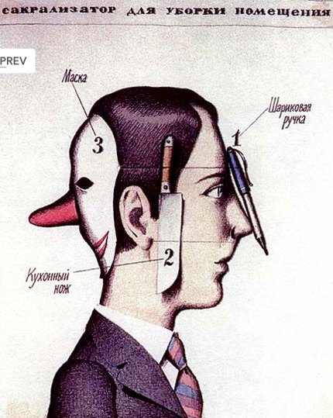
Viktor Pivovarov, Page from the Album Sakralizatory, 1979.¹⁰²
SEMANTIA, (SEMANTIC CHEESE) [Semantia, (Semanticheskii syr)] – torrent of significances that contains gaps and cavities. (Term by S. Anufriev, 1989. The definition was provided by P. Pepperstein).
DICTIONARITY [Slovarnosti] – results from a semantic shift that takes place in relation to the concept of “orality” [slovesnost']. (Term by P. Pepperstein. Medgerminevtika, Slovarnost', 1988).

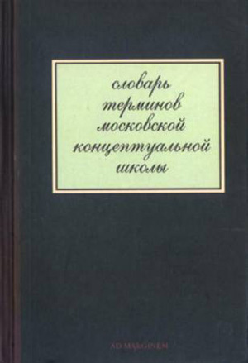
Cover of the Dictionary of Moscow Concetpualism
SYSTEM OF FALSE SARCOPHAGI [Sistema lozhnykh sarkofagov] – method of production of textual, installational, ideological, and other traps, leading the spectator away from the meaning embedded at the foundation of the work. (Term by V. Zakharov. Fama & Fortune Bulletin, Berlin (7), Wien).
SLIDING WITHOUT CHEATING [Skol'zhenie bez obmana] – Term by S. Anufriev. The author refuse to provide a definition for this term.
GLORY [Slava] – total clarification and (at the same time spontaneous) absolute orderliness. (Term by MG [Medgerminevtika]. See text “Slava” in Latex, 1988).
COAUTHORSHIP [Soavtorstvo] – refers to the method of expanding the author's territory through the exploration of foreign in-between-authors-zones by means of joint efforts. This eventually leads to the total extinction of the author's territory. The method of Coauthorship was first explored in between 1980 and 1982 by Skersis and Zakharov, who engaged in collabortations with such Moscow artists as the Mukhomor group [Toadstools], the KD group, Zhigalov & Abalakova, Alexeev, and others. In 1983 Coauthorship as a method was adopted by Zakharov together with N. Stolpovskaia. Together they established three types of Coauthorship: parallel, consecutive and assumptive. Zakharov's Coauthorship activities, which lasted from 1977 till 1998, have been related to the following names: I. Lutz, V. Skersis, N. Stolpovskaia, S. Anufriev, MG, Y. Albert, I. Chuikov, A. Gonopolisky, I. Sokolov. (V. Zakharov. See his works in the MANI Archive, nos. 3 and 4).
CONTEMPORARY ARTIST [Sovremeny khdozhnik] – curator of somebody else’s bad art. The term was derived from Boris Groys’ article Khudozhnik kak kurator chujogo plokhogo iskusstva (Artist as Curator of Somebody Else’s Bad Art) in Utopia i obmen, M., Znak 1993.
After 1989 Moscow Conceptualism found itself part of a new structure called “contemporary art,” and to have left its previous “unofficial” status behind. For most of the decade this fact went unnoticed, and only relatively recently have some artists and critics begun to express disappointment, trying to distance themselves from the new cultural paradigm.
The misfortune of Moscow Conceptualism was that it was inscribed in the orbit of the phenomenon known as ‘contemporary art,’ to which it is deeply antagonistic. As a typical Moscow conceptualist I never could stand contemporary art. I never attended exhibitions… Contemporary art in the form in which it exists today represents one aspect of the colonial structures that are being imposed on all colonized territories together with McDonald’s and other things… The plein air painter who is daubing his birches somewhere in the woods is today the real revolutionary and the anti-globalist.¹⁰³
The point must be made, however, that such a dire dissatisfaction with “contemporary art” is also a relatively recent phenomenon. Moscow conceptualists have contributed to, and have even been actively involved in, the creation of the first foreign and domestic institutions to promote their work under the mainstream appellation “contemporary art.”¹⁰⁴ In the late nineties the foreword of the Dictionary of Moscow Conceptualism stated that “for the last quarter of the century the notions Moscow Conceptualism and Russian Contemporary Art have been synonymous.”¹⁰⁵
More recently Kabakov has expressed his disappointment with the bourgeois hypocrisy of the contemporary art industry that puts economic concerns over artistic ones.¹⁰⁶ Monastyrsky’s messages are somewhat more puzzling, for he declares that the “discourse of contemporary art, as a single ideologeme, had already ended in the mid-nineties,”¹⁰⁷ despite the fact that in the next century numerous new contemporary art centers, galleries, biennials, were launched, and that it was then that the Russian state began to award contemporary art prizes every year. Groys is more theoretical but not more optimistic. In his recent analysis he presents “contemporary art” as a separate entity, detaching it from both “postmodernism” and “modernism” and presenting it as a cultural paradigm obsessed with the presentation of the present.¹⁰⁸ He ponders over the new type of artist who has replaced the former producers, insisting that “the contemporary artist is rather a consumer, analyst, and critic of images and texts produced by contemporary culture and I doubt that this role of the contemporary artist could change in the coming future.”¹⁰⁹
SOTS-ART – form of postmodernism which resorts to various Soviet ideologemes: political, social, etc. The term was introduced by V. Komar & A. Melamid in 1972. Sots-Art as a movement was theorized and instituted by M. Tupitsyn in her articles “Sots art: russkii psevdogeroicheskii stil” (“Sots-Art: the Russian Pseud-Heroic Style,” 1984) and “Sots-art: russkoe dekonstruktivnoe usilie” (“Sots-Art: the Russian Deconstructivist Effort;” The New Museum of Contemporary Art, 1986).
SOCIALIST REALISM – late avant-garde trend in Russian art of the 1930-40s that combined the method of appropriation from various artistic traditions of the past with twentieth century avant-garde strategies, based on the constant astonishment of the spectator. Its biggest representative was Josef Stalin. See Boris Groys, Gesamtkunstwerk Stalin: die gespaltene Kultur in der Sowjetunion (München: C. Hanser, 1988).
Most of the unofficial Soviet artists from the fifties on were faced with the question of how to relate to the revolutionary zeal of the avant-garde artists of the twenties. Groys’ Gesamtkunstwerk Stalin (1988), which assimilated some of the concerns voiced by many unofficial artists with regard to their historical predecessors,¹¹⁰ believed that the doctrine and the language of Socialist Realism, which was the major working material for many conceptualists, were the logical outcome of the historical Russian avant-garde’s work and their radical program of transforming reality. To many artists of the post-1945 generations, Stalin was the perfect embodiment of the avant-garde artist of the twenties – the artist-ideologue, who shouldered the demiurgic task of transforming and reshaping inert human material. In this and in other books, Groys suggests that the main political and aesthetic task of the Moscow conceptualists was to disrupt the Soviet project, to deconstruct that language and ideology to which the Russian avant-garde artists had indirectly contributed.¹¹¹ Other critics have referred to the program of the Moscow conceptualists in terms of a counter-revolution and an anti-Utopian trend directed against their historical predecessors.¹¹²
SOTSMODERNISM [Sotsmodernism] – socialist modernism of the 1920s and 1930s, which co-existed concomitantly with SOCIALIST REALISM, but unlike the latter was capable of generating a style. Examples of Sotsmodernism are: the architecture of the first line of the Moscow subway, book and magazine design, photography and photomontage, the decoration of exhibition pavilions and workers' clubs, etc. What makes Sotsmodernism different from the traditional avant-garde is its canceling or removal (sneatie) of the negation. Therefore Sotsmodernism can be considered an affirmative avant-garde. (V. Tupitsyn, Drugoe Iskusstvo. Moskva; Ad. Marginem, 1997).

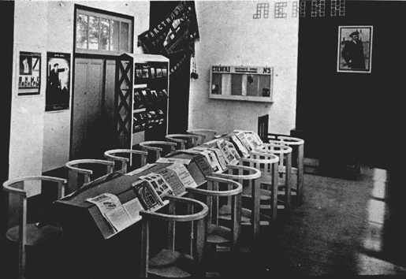
Alexandre Rodchenko, Design for Workers Club (1925)
TRANQUIL COUNTING OF NON-EXISTENT OBJECTS (TCNO) [Spokoinyi podscet nesuschestvuischikh predmetov (SPNP)] – non-functional practice that continues the apophatic direction of KD despite the engaged socail reality of the late 1990s, despite the BAKSTEIN FUNCTION, and all the other functions. (Yuri Leiderman. Dima Bulychev, 1996. Yuri Leiderman. Spokoinyi podscet nesuschestvuischikh predmetov, 1998).
STALIN – leading Soviet avant-garde artist of the 1930s and 1940s, who was a convinced suprematist in the fields of both art and politics. During his time he also appeared as a star of mass culture (geroi massovoi kul'tury). Stalin anticipated many strategies of postmodernsim – see for instance SOCIALIST REALISM. (See Boris Groys, Gesamtkunstwerk Stalin: die gespaltene Kultur in der Sowjetunion, München: C. Hanser, 1988).

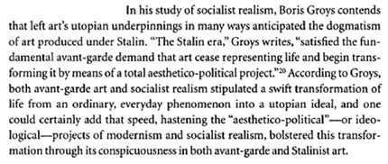
Google Books Crop from Tim Harte, Fast Forward p. 236¹¹³
SOUVENIR [Suvenir] – type of object, which preserves in itself the memory of a certain event (objectified memory). (Medgerminevtika. Trofei, Suvenir, Atribut, 1994).

T
TEDDY SYNDROME – Syndrome of immediate (phantasmal) understanding. The term was proposed by Monastyrsky in the mid-1980s and widely used in the texts of the Medgerminevtika group. The syndrome was derived from the story “Teddy,” by the American writer J.D. Salinger. (Medgerminevtika Dialogue, “Teddy,” 1988).
Some books have had a great impact on the vocabulary and artistic strategies of the Moscow conceptualists. During the late 1970s such a book was Eastern Culture in the Contemporary Western World (1977), by Evgenia Zavadskaia, which quickly became very popular among the younger generation of unofficial artists, poets and writers.¹¹⁴ Eastern Culture was based on an earlier publication by the same author, entitled East in the West (1970),¹¹⁵ an aesthetical investigation into the impact of Buddhism on Western culture. It examined in particular the philosophical and aesthetical influence of Ch’an, rather than that of Zen – the branch of Mahayana Buddhism that had become the most popular in the West.116 The emphasis on the Chinese rather than on the Japanese tradition may have been conditioned by the fact that China, unlike Japan, was also a communist country, and for a short period of time an ally of the USSR.

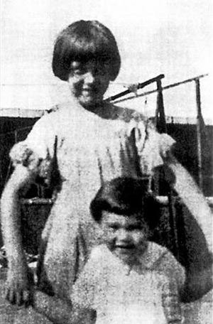
Salinger with his sister Doris in August 1920. (Wikipedia)
This book’s importance for the conceptualists is revealed in a series of words that would later re-surface in the vocabulary of KD. For example, the concept “Teddy Syndrome” was used extensively in the terminology of KD and Medgerminevtika to refer to the various ways in which the spectator reacts to the group’s actions. The Dictionary defines it as a “syndrome of immediate or instant understanding” meaning that someone participating in KD’s activities is capable of “understanding,” or of providing an instant interpretation of one of their actions. The syndrome is derived from J.D. Salinger’s short story “Teddy,” which Zavadskaia discusses at length, presenting it as a perfect example of the influence of Zen and Ch’an Buddhism on many Western writers. Salinger’s character Teddy is the extraordinary American boy who shares a perception of the world similar to that advocated by Ch’an Buddhists. The rejection of a strictly rational view of the world, as well as the refusal to divide the world according to a hierarchy of values, is reflected in Teddy’s innocent, childlike and yet serious conduct. Monastyrsky’s “immediate or instant understanding” is set in contrast to SYNDROME GUGUTA (Guguta Sindrom), which the Dictionary defines as “complete lack of understanding”; the term also alludes, by the way, to some national stereotypes existing in the USSR. Within the spiritual and aesthetic contexts the two syndromes may be also reagarded as allusions to the two main schools of Ch’an Buddhism (the Southern and the Northern), a split that occurred due to certain divergences regarding the path to enlightenment – the method of “instant enlightenment” advocated by the Southerners versus the “gradual enlightenment” promoted by the Northerners.¹¹⁷
TEXTURBATION (SPEECHOLOGY) [Texturbatsya (Recelozhstvo)] – the ecstasy of speaking; the distinct role that various speech acts play in Russian culture. V. Tupitsyn in a series of 1990s discussions with Kabakov. (V. Tupitsyn, Razgovor s I. Kabakovym, 1990. Arts, 1991).
BODY OF TERROR [Telo terrora] – simultaneous victims and agents of a certain type of Terror that destroys bodies in order to preserve the eidetic fullness of orthodox speech, which perceives this destruction as something completely positive. (See M. Ryklin. “Bodies of Terror,” 1990).
As Ryklin argues in his “Bodies of Terror,” Bakhtin’s ostensibly joyous book on Rabelaisian carnival is the product of a complex trauma. In writing about Rabelais during the Stalinist 1930s, Bakhtin was composing a requiem for the individual body. Your body, my body, became incidental, synthetic, disposable, mute-and in its place the collective body of the people was granted all the reproductive and rhetorical rights. It could not die, so others were set free to kill the individual you. But what is this “body of the people” in Bakhtin, and during the Stalinist epoch? In fact you cannot see or hear it: it is too brilliant, threatening, primeval, and depersonalized, it “strikes blind anyone who dares to glance at it.” This anaesthetizing monumentality is nowhere as richly condensed as in the Moscow subway. As Ryklin suggests, the resultant invisibility of real bodies and the blind--literally blind--faith in utopia that followed were essential for the “ecstasy of terror” to work.¹¹⁸
CORPORAL OPTICS [Telesnaya optika] – carnal, belittling vision, as well as the ability to look at the world (and at oneself within it) with the “eyes” of the communal body. When equipped with Corporal Optics, the individual acquires the skills of group vision. (V. Tupitsyn, Drugoe Iskusstvo. Moskva; Ad Marginem, 1997).
NAMELESS-BODY [Telo-bez-imeni] – refers to an alternative artistic environment that has refused to name or define its socio-cultural identity in order to survive. (V. Tupitsyn, Drugoe Iskusstvo. Moskva; Ad Marginem, 1997).
COMMODITY PANEL OF SIGNS [Tovarnaia panel’ znakov] – level of visual representation, a kind of firing ground for signs, where one can establish their psycho-economic value. (P. Pepperstein. Belaia koshka, 1988).
THEORY OF REFLECTION [Teoria otrazhenia] – the phrase, which seems to draw parodically on the Marxist-Leninist theory of art, actually suggests the relativity and the conventionality of all means of representation. (See I. Chuikov's works “Theory of reflection I, II, IV” starting with 1992).

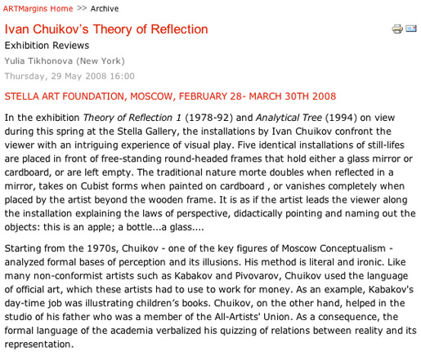
Ivan Chuikov’s “Theory of Reflection”¹¹⁹
TOTAL INSTALLATION – is constructed in such a way as to include the spectator within it; it is so designed as to take into account the spectator’s reaction inside a closed “windowless” space that often consists of several rooms. Of the most decisive importance for the Total Installation is the atmosphere, the aura, which is attained through painting the walls, lighting, the configuration of rooms, etc. In the meantime the “usual” components of the installation – objects, drawings, paintings, texts – become ordinary components of the whole. (See I. Kabakov, On the “Total” Installation. Ostfildern, Germany: Cantz, 1995, 243-260).
…If in the Soviet Union Kabakov’s work took the form of albums and fragmentary collections of Soviet found objects, in exile Kabakov embraced the genre of the “total installation.” Paradoxically, with the end of the Soviet Union, Ilya Kabakov’s work has become more unified and total. In it Kabakov documents many endangered species - from the household fly to the ordinary survivor, homo-sovieticus, from lost civilizations to modern utopias. What is the artist nostalgic for? How can one make a home through art at a time when the role of art in society dwindles dramatically? Is his work about a particular ethnography of memory or about global longing? What gives makes an installation “total” is not a unified interpretation, but the totality is the environment. The total installation turns into a refuge from exile. Kabakov describes being overcome by a feeling of utter fear during his first residence “in the West” when he realized that his work, taken out of the context, could become completely unreadable and meaningless, could disintegrate into chaos, or dissolve in the sheer overabundance of art objects. While acknowledging the connection to Western conceptual art, Kabakov insists on the existence of fundamental differences in the perception of artistic space in Russia and the West. In the West, conceptual art originated with a ready-made. What mattered was an individual artistic object sanctioned by the space of the Museum of Modern Art. In the absence of such an institution in the “East,” objects alone had no significance, whether they were drab or unique. It was the environment, the atmosphere, and the context that imbued them with meaning…
Kabakov’s total installations have several features that concern the issues of authorship, narrative dramatization, space and time. In the total installation Kabakov is at once artist and curator, criminal litterer and trash collector, author and multivoiced ventriloquist, the “leader” of the ceremony and his “little people.” For a few years following the break up of the Soviet Union, Kabakov, who was already living abroad, persisted in calling himself a Soviet artist. This was an ironic self-definition. The end of the Soviet Union has put an end to the myth of the Soviet dissident artist. Sovietness, in this case, does not refer to politics, but to common culture. Kabakov embraces the idea of collective art. His installations offer an interactive narrative which could not exist without the viewer. Moreover, he turns himself into a kind of ideal communist collective, made up of his own embarrassed alter-egos - the characters from whose points of view he tells his many stories and to whom he ascribes their authorship. Among them are untalented artists, amateur collectors, and the “little men” of nineteenth-century Russian literature, Gogolian characters with a Kafkaesque shadow. Recently, Kabakov has discreetly dropped the adjective “Soviet” and now considers himself an artist, with two white space around the word.¹²⁰

TOT-ART – total art in a total situation. The term was introduced by Natalya Abalakova and Anatoly Zhigalov in 1983 (to replace the name of the group “Total Artistic Action”). Tot-Art is the realization of Abalakova and Zhigalov’s project “Investigating the essence of art in relation to life and art,” which was based on the method of criticizing art by means of art itself.
TOTART
Natalya Abalakova and Anatoly Zhigalov
the performances by Ekaterina Bobrinsky
If one attempts to briefly define the basic issues that Abalakova and Zhigalov touch upon in their TOTART performances they can be summarized as follows: firstly, an investigation of the unconscious mechanisms and the ways in which art functions; secondly, an exposure of the basic hidden structures and perceptions that are inherent in the system of cultural communication. Unlike the majority of Moscow artists, TOTART often employs symbolic elements to which specific cultural meanings adhere (for example, the use of black, white, red and gold which refer to their symbolic role within the conventions of icon painting). The action of the performance opens up the layers of cultural stereotypes to reveal their unconventional core. The performance leads each participant and the audience to reconstruct the primal mechanisms of the stereotype freed from the overlay of contemporary meanings. In other words, in TOTART performances situations are created in which the traditional cultural signs and symbols are deprived of the specificity of fixed and frozen meanings and thus are in a state of permanent fluctuation between culture and nature. By constructing the action in this way, an emphasis on play and parody has become an important element of their work.
In June 1985 the artists put up a notice for voluntary Sunday work in the “Kvant” Housing and Maintenance Office, where Zhigalov worked as a supervisor; it was signed TOTART. On the day the event took place, fences, benches and litter bins around the building were painted gold. The performance was called Golden Voluntary Sunday.¹²¹ This and other performance events were parodies of particular aspects of Soviet social life. The avant-garde strategy unexpectedly reveals itself in every-day situations, as emphasizing the awareness of its own absurdity. The introduction of such a symbolic color as gold into this paradoxical situation deprived it of the conventional, conceptual baggage which it had acquired over the ages. The action represented the color not as a cultural sign but as a natural element. This desire to reveal the deeper archetypes of the subconscious determines not only the deliberate manner of execution, but also the plastic expressiveness of TOTART works. They appeal to unconscious and purely emotional levels of perception. Several performances are directed towards the plastic transformation of various objects during the course of the event. The central theme of the performances is the study of boundaries between two forms of space, the chaotic and that which is structurally organized, how they are created and how they are overcome. The construction of the cube that encapsulated an idea of spatial perfection played a major part in several works. In the White Cube performance (1980) the frame of a cube was created from wooden beams in a space of a room. The participants then bandaged up the cube and the resulting object divided them into two groups. It was possible to re-unite the participants only after the cube had been destroyed ( by severing the bandaged surface). The physical actions of the performance were quite straight forward. However, by displacing the meaning of the actions from their usual context they were deprived of any practical aim. The message could not be rationally expressed in language and was therefore stressed on the level of unconscious feelings and emotions. The imperative of making manifest the immediate primeval aspect by highlighting the conventional cultural framework likens this and other TOTART events to religious rituals.
In the performance “Sixteen Positions for Self-Identification” (1985) this effect was achieved literally by physical entry into the space of art work. Having found oneself inside, one was deprived of one’s usual estrangement from the art object. In being excluded from familiar living space the participant is unable to find the reassuring support of familiar patterns of behavior and as a result is obliged, perhaps for the first time, to “grope” his way in the new environment. We can say that this performance represents the picture-making process from within the space of a picture itself. In an enclosed room the artists moved round the wall painting each other’s silhouettes with red and gold paint. At the end of the action, having returned to the original point of departure, they painted each other. Thus their painted bodies, as it were, dissolved and merged with the surrounding space. In the course of the action the room imperceptibly turned from being the object into the subject, and thereby gained an independent power of action. The performance was sufficiently expressive to be comprehensible to all participants. By such an immersion “inside” art, as well as a breaking away from the conventional framework and the awakening of the deeper archetypes of the consciousness, the action eradicated the significance of everything conditioned by social and cultural norms. All that remained was that which is common to all mankind, the “generic.”
Major themes determining many of the artists’ works are: the collective and the individual, its boundaries, its interrelationships and the limits of their constructive and destructive possibilities. The action of an entire series of TOTART performances is based, as the artists themselves defined it, on the principle of perpetuum mobile. This method was first used in the performance “Work” (1983). Its action was laconic in the extreme and involved taking pieces of dry clay from one pile to another. Abalakova took the clay from the first pile to the second and Zhigalov took it from the second pile back to the first. The performance was constructed, theoretically, as an endless and closed process. At the same time, this deliberately simple and ordered activity, by repetition of the same event ad infinitum, at a certain moment begins to be perceived as something that is deprived of structure and is therefore chaotic. Because of its theoretically infinite nature, i. e. the absence of a point of reference for its beginning and end, “Work” did not allow an individual human being to find a stable system of coordinates and thereby discover a definite and personal position to the whole.
“TOTART expresses itself in the language of masses and addresses the masses”- this is the definition given by the artists in explaining the peculiarity of their position. Their actions construct situations which blur the boundaries between the rational and irrational, between “self” and “other” and between personal and impersonal. From behind the facade of mundane and familiar actions an unknown dimension suddenly emerges which cannot be calculated logically.
It is precisely such borderline and unstable situations which determine and expose the mechanisms of contemporary art that TOTART examines in its performances.¹²²
CRACKED MATRYOSHKA [Tresnutaya matreshka] – demonstration principle (in a discourse) in which a number of internal objects belonging to a particular discourse are demonstrated without exteriorization, by means of a specially prepared demonstration section (“fissure” or “crack”). (See P. Pepperstein, Belaia koshka, 1988).
TROPHY [Trofei] – object brought from the depth of hallucinosis. (P. Pepperstein, Fontan-gora. 1993).

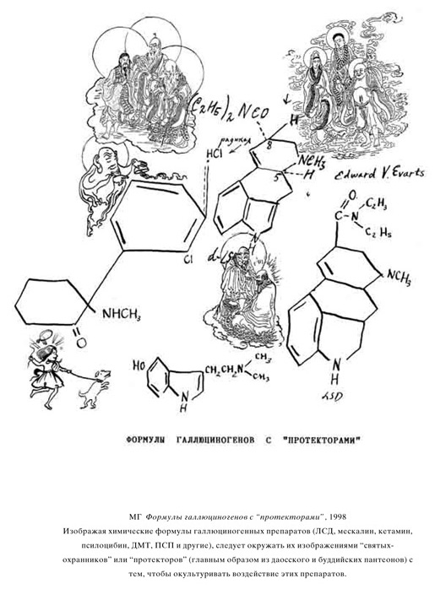
Medgerminevtika, Formulas of Hallucinogens with ‘Projects,’ 1998.¹²³
DEADLOCK AS GENRE [Tupik kak zhanr] – the term was examined for the first time by S. Anufriev and V. Zakharov in 1997 when the two worked on a book and exhibition project entitled “The Deadlock of Our Time. Deadlock as Genre” [Tupik nashego vremeni. Tupik kak zhanr]. (See S. Anufriev, V. Zakharov, Tupik nashego vremeni, Pastor Zond Edition, Cologne-Moskva, 1997).

У
RETENTION IN UNBRINGING [Uderzhanie v nedonose] – the constant interruption of the process of constructing the fields of inferiority, powerlessness, apathy, unattainability, incompleteness. (V. Zakharov. Fama & Fortune Bulletin (7) Wien).
RETENTION OF THE WORK IN THE PRESENT (THE COMPLEMENT METHOD) [Uderzhanie raboty v nastoeaschem (Metod dopolnenia)] – the preservation of the original meaning of an arbitrarily selected work, despite changes that take place in its context due to the extension in time of its commentary, which may be expressed in the open form of text, object, drawing, photography, etc; this does not exclude the occasional remaking of the work itself. (V. Zakharov, Catalogue Kunstverein Freiburg, 1989).
UM – UM (УМ – УМ) – term which is opposed to the term “zaum.” It refers to texts (mostly poetic) of the Moscow conceptual school. (Hirt Wonders. Together with texts about texts next to the texts. A revision of the theory of culture of Moscow Conceptualism, 1991).
The English equivalent of the Russian word um is “mind” or “intellect.” The term is opposed to “zaum” – one of the most important contributions of the historical Russian poetic avant-garde. Zaum, which was coined by the futurist poet Alexei Kruchenykh in 1913, has been described as the most prominent, unique and provocative feature of Russian Futurism. It has been translated in English as: “trans-mental,” “transrational,” “trans-sense,” “metalogical,” “nonsense” “beyonsense.” The poet Kruchenykh wrote his first self-conscious zaum poem “Dyr Bul Shchyl,” in 1913. Although scholars of the Russian literary avant-garde have repeatedly drawn attention to the impossibility of translating many works of this period, this may not be the case with Kruchenykh’s “Dyr Bul Shchyl,” for the simple reason that it does not contain one single Russian word.¹²⁴
dyr bul shchyl
ubeshshchur
skum
vy so bu
r l èz.
U-TOPOS (UTOPOS) – place which does not have its own place – a place without place. Term by S. Anufriev, 1989. (The definition was offered by P. Pepperstein).

Ф
FAKES (Imitatsii [imitations]) – used to name a series of works [by I. Chuikov], the term equates painting, as a form of high art, with craft [alfreinymi rabotami], suggesting that the application of signs on the surface of canvas is the essence of the practice of painting. (See I. Chuikov's series “Fakes” (Imitatsia), 1989).

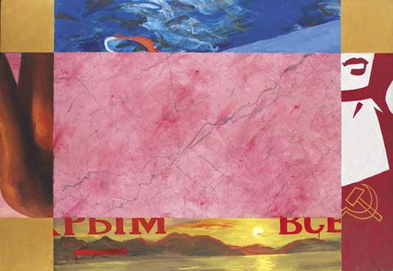
Ivan Chuikov A Fake, 1989¹²⁵
FACTOGRAPHICAL DISCOURSE [Faktographicheskii diskurs] – system of documentation used to construct various meta-levels of the artistic event in terms of resultative contexts of the aesthetic action. (A. Monastyrsky, Foreword to the second volume of Journeys Outside the City, 1983).
The main change or innovation that took place in the second phase of KD or volume of the Journeys (1980-1983) was the introduction of the so-called “factographical discourse.” The Dictionary defines it in terms of a “system of documentation, which helps to establish multiple levels within an action.”¹²⁶ The factographical discourse can be regarded as the unfolding of the action on the level of documents, texts, photographs, and other additional or secondary material that supports an action or any other type of artwork. The introduction of the factographical discourse was like the discovery of another layer of reality, which from the second phase on ran parallel to other layers in the demonstrative field of the actions.
In the foreword to the second phase Monastyrsky compares the action “Ten Appearances” (second volume) to the action “Appearance” (first volume) maintaining that the latter took place in the so-called “eventful space,” or within the real or empirical space of the forest and the field, whereas the former action unfolded both in the “eventful space” and in the space of the “factographical discourse,” that is in the photographs and documents of the action. He also announces that it was precisely this action that opened this new discourse for KD.
…the action ‘Ten Appearances’ has activated the space of the factographical discourse and announced it as a new artistic context, as a new element of the ‘demonstrative field.’ Now to those components that constitute the ‘demonstrative field’ may be also added the existence of the factographical discourse, defined as the layer of language whose text-forming material may be perceived as aesthetically self-sufficient.¹²⁷
Thus the demonstrative field, which stands for all those elements included by the artists in the construction of the action, acquired during the second phase a third factographical layer, which belongs to the realm of representation. The factographical discourse came forward and became, from this phase on, more important than the other discourses or components of the demonstrative field.
To the psychic (subjective) and the empirical (objective) dimensions of the demonstrative field, KD added a third dimension, which operated on a level constructed by various forms of mechanical reproductions (text, photo, sound, etc.). Emptiness, the main theme of KD, spread now into all these three layers. If in the action “Appearance” of 1976 it was the snowy field that was empty and this emptiness merged with the empty states of the spectators who were waiting to see what would happen, now in 1981 the emptiness also extended, by means of photography, into the third zone or layer of the factographical discourse. After the participants returned to the middle of the field they were handed out labeled “empty photographs” which depicted a gray sky and a black strip of the forest that stretched in the distance over the large white Kievogorskoe Field and a very tiny figure of somebody far in the distance emerging from the trees. It soon became a tradition of KD to give to their spectators, at the end of each action, “souvenirs” – a photograph or another token, an artifact of the factographical discourse.
With the introduction of the factographical discourse a series of new concepts enter the lexicon of the group. Such terms as “empty photographs” (pustye fotografii), “imperceptibility” (nevidimosti), “the zone of imperceptibility” (polosa nerazlichenia), and “the out-of-the-photography-space” (vnefotograficeskoe prostranstvo)¹²⁸ registered the emergence of the new layer and the shift towards representation. The term “out-of-the-photography-space,” for instance, suggests the space where the photographer is positioned during the shooting (behind the viewfinder of the camera). If in the first phase the artists expressed their interest in terms of liminal psychological states that emerged during the action within the “emotional space” (ES) of the spectator, then from the second phase on it appears that the artists were more interested in the liminal position of the photographer who documented their actions. By raising this position into a concept it also emphasizes the new direction and priorities of KD. It is a general tendency to move the action from what earlier was called “out-of-town-ness,” (that is, the natural countryside surroundings in which the actions once took place) into that of “out-of-the-photography-space” which defines the place of the artist or of the assistant in charge of taking pictures. The artists appear to have become more interested in the new space offered by the photographs, phonograms and other forms of technical recordings, and all these seems to have diverted KD’s attention from their initial interest in the pure unmediated perception of their spectators and the psychology of perception that dominated the first phase’s methodology of investigating the nature of art. Moreover, the new style of conducting the action and KD’s reliance on certain mediatory tools (directions, instructions, signals) also introduced a certain degree of tension into the relation between the artists and their spectators.
But the turn towards the factographical discourse, or to representation, also meant a certain degree of distancing and estrangement from direct experience, prompting Monastyrsky to use the metaphor of the space suit in order to describe this shift. The factographical discourse became like the transparent visor of the space or the diving helmet (skafandry faktografii) that separated the artists from their previous rough and unmediated experience.
In the actions “Ten Appearances” (Deseati poeavlenii) and “Recording” (Vosproizvedenia) the events took place on the real field. But after these two actions the events turned into photographs of the out-of-town fields, as if we had been separated from reality by a factographical film. It was as if we had been suddenly put into the space suits of the factographical discourse, and kept those suits in our subsequent actions. But the place itself had also been covered by a thin layer of film that belonged to the factographical discourse… The removal of the factographical space helmet during the action did not guarantee a return to reality, to a real sky, field, and so forth, because this reality was already of the second order and it was also covered by a layer of film, or a helmet. And although the space helmet could be removed because it was within reach, on our heads, then to remove the factographical layer of film that had covered the woods, the field, and the sky was impossible. It was out of reach. The Kievogorskoe Field was irreversibly transformed into a space shuttle (a mechanism) which flew from action to action in the cosmos of logos. In fact, the field research of the first volume has ended and we have turned to the usual frame of art and literature.¹²⁹
FACTOGRAPHY–AS–AFFIRMATION [Faktografia-kak-affirmatsia] – a positive and uncritical recording of events, as for example in the work of “factists” [faktoviki] (N. Chiuzhak and others, “October”, “ROPF” and other associations and groups active during the 1920s and 1930s). Factography–as–resistance [or negation] consists in documenting those facts that diverge from the official version, leading to the destabilization of affirmative culture. (V. Tupitsyn Kommunalinyi (post)modernism. Moskva; Ad Marginem, 1998).
PHILOSOPHICAL PRACTICE [Filosofskaia praktika] – the ritual part of philosophy. A type of occupation or quasi-ritual that confers upon philosophy a practical component. The term helped the circle MANI to identify itself, and it is considered this circle's greatest discovery. (S. Gundlakh, from texts of the late 1970s).
PHOTOCREATION [Fotokreatsia] – the creation of light, including also the “lightening of meaning.” (S. Anufriev, Fotokreatsia, 1996).
FRAGMENTS (Fragmenty) – isolated and enlarged pieces or conglomerations of pieces containing various representations with no hierarchy among them. Fragmentation in this context refers to the selection and the comparision of the most diverse stylistic components in order to demonstrate the conventionality of representation. (I. Chuikov. 1982).
FUNCTIONING IN CULTURE (Funktsionirovanie v kul'ture) – activity influencing the already established cultural-semantic space in all of its points by such means as: probing (zondirovanie), amplification, simulation, substitution, overtaking (operezhenie), deterrence, stagnation, etc. The term emerged in 1979 in the co-authored works of Zakharov and Lutz. It was developed by the SZ group in 1980-84 (in the reenactment of KD's action “Liblich” during the exhibition “Apt-art in Nature” and others). It was also occasionally employed by V. Zakharov and S. Anufriev in 1986 in the process of considering the methods of “tossing” [podbrasyvanie] ideas and total repetitions. (V. Zakharov, MANI 1, 1981).

X
HACK-WORK (THE ART OF ELITE BOTCHERS) [Khaltura, Iskusstvo elitarnykh khalturschikov] – term which is applied to the art produced in the Furmanov and Chistye [Prudy] streets from 1986 to 1990. (S. Anufriev, V. Zakharov, Tupik nashego vremeni, in Pastor Zond Edition, Collogne–Moscow, 1997).
ARTISTIC INSANITY [Khudozhestvennoe nevmeniaemosti'] –behavior of artists who do not reflect upon a specific cultural-historical context, and neither upon the succession of dominant cultural-aesthetic mainstreams, to the point that [these mainstreams] affirm themselves within a particular culture, turning into artistic genres [promysly]. (D. Prigov, Foreword to a collection of texts from the early 1980s).
ARTIST-CHARACTER [Khudozhnik personaj] – intermediary figure between artist and spectator. The term was introduced by Sven Gundlakh (see his text “Character Author” [Personazhnyi avtor] in the literature issue of A-Ya, 1985). The concept of artist-character was further developed by Kabakov (see “Artist Character” [Khudojhnik personaj], 1985). In addition the expansion of the discursive score [partitura] of the “character” had two more phases: in 1988, in a dialogue between Kabakov and Monastyrsky entitled “Spectator-character” [Zritel’-personaj], (See MANI # 4, “Materialy dlea publikazii”) Kabakov introduced the term “Spectator-character” [Zritel’-personaj], and in 1989 in a dialogue between Backstein and Monastyrsky for the journal “Iskusstvo” Monastraysky introduced the terms “critic-character” (kritik-personaj) and “ideologue–character” (ideolog-karakter).
HOMO COMMUNALIS – person who went through the communal school of life (for instance, lived in a communal apartment) or was educated in the spirit of the communal tradition. (V. Tupitsyn, Kommunalinyi (post)modernism. Moskva; Ad Marginem, 1998).
HOMO LIGNUM – rigidity, stiffness of the consciousness. (I. Makarevich, Series of works from 1996-1999).

Ш
SHAGREEN EFFECT – method of maintaining a cultural paradigm in its most minimal condition by minimal means and a minimal quantity of people. (V. Zakharov, Pastor, n.2, 1992).
SCHIZOANALYSIS – Deleuze and Guattari’s term from Anti-Oedipus: Capitalism and Schizophrenia… where they criticize psychoanalysis as a repressive, family-oriented and neurosis-generating practice. […] This as well as other terms from Anti-Oedipus (“desiring machines,” “bodies without organs”) have been reconsidered and recontextualized by the Moscow conceptualists. The term was introduced in the circle of Moscow Conceptualism by M. Ryklin, who in 1987 made an abridged translation of Anti Oedipus (Moscow: INION, 1990).
After 1989 the lexicon of Moscow Conceptualism is populated by a series of new words. Some of these words, beginning with the prefix “schizo-“, emerged in the late eighties when the philosopher Mikhail Ryklin translated and published an abridged version of Gilles Deleuze and Felix Guattari’s Anti-Oedipus: Capitalism and Schizophrenia (the only available version of this work in Russian to date).130 The conceptualists were inspired by this work’s central concept of “schizoanalysis,” often applying it to describe or express their own practice, as well to form their own terminology such as: “schizo-illustration,” “SCHIZO-CHINA,” or “schizo-analytical places of Moscow and the Moscow Region”. However, unlike many terms from the before-period, including “EMPTY ACTIONS,” or “DEMONSTRATIVE” and “EXPOSITION FIELDS” (regularly deployed to describe and analyze actions), the schizo-concepts are treated inconsistently. References to the schizo-terms appear here and there throughout the seventh and the eighth volumes of the Journeys, but nowhere are they clearly explained nor is it even demonstrated how to handle them, which is not unusual given the propensity of the conceptualists to leave many terms undefined.¹³¹
SCHIZO-ILLUSTRATION [Shizoillustrirovanie] – one of the main artistic principles of Medgerminevtika: the division between “direct illustration” and “illustration of the illustration.” (Medgerminevtika, Ideotekhnika i rekreazia. Moskva; Obskuri Viri, 1994).
SCHIZO-CHINA (or the Schizophrenic China) – refers to an acoustical effect of a “centuries-long tradition” employed by the NOMA members, who used the schizophrenic “extension of consciousness” – an aptitude that the members of this circle possess. (P. Pepperstein, Letter to S. Anufiev from Prague, February 18, 1988).
LOCK-BUILDING [Shliuzovanie from Russian шлюз – lock] – a) method of unconscious creation within the expositional space of exit mechanisms which have not been anticipated by the author; b) method of control of parallel processes by means of pulling them from one into another (in my case this refers to my involvment in archiving, publishing, artistic and collecting activities. (V. Zakharov, from the series of works from the early 1990s).

Э
EXPOSITION SEMIOTIC FIELD [Ekspozitzionnoe znakovoe pole] – system of elements from the time-space continuum which are not deliberately included by the authors in the construction of a concrete text [work], but which are nevertheless influencing it by means of their hidden motivational contexts. In the aesthetic practice of KD the “exposition semiotic field” may be activated as part of a correlated pair with the DEMONSTRATIVE SEMIOTIC FIELD by means of the discourse of EMPTY ACTION (See also INCITERS). A. Monastyrsky, Zemlianye raboty, 1987.
In addition to the term “demonstrative field,” KD also lists in the Dictionary the term [Exposition Semiotic Field] (expozitionnoe znakovoe pole) (henceforth “exposition field”). The exposition field is constituted of all those elements that “were not deliberately included by the authors in the construction of a certain work, but which are nevertheless influencing the work…”¹³² The “exposition field” comprises those subjective and objective elements which are neither pre-planned nor foreseen, and simply emerge as unanticipated side effects. For instance, the plot of the action “Appearance” has it that the group of spectator-participants will stand at the edge of the field and wait. If for some unexpected reason one of the guests refuses to wait there or suddenly starts to walk towards the tiny dots in the distance, interfering with the plan of action, then such an unannounced act would be part of the exposition field. Later KD artists would use the notion of the “exposition field” to refer to the urban or the natural context in which, or in the proximity of which, a certain action took place and which in turn influenced the action. All that is part of this field emerges spontaneously and, although the artists cannot control what happens, it remains an important part of the action.¹³³
EXPONEMA [Exponema] – unit of the EXPOSITION SEMIOTIC FIELD correlated with the corresponding element in the paradigmatic series (that is, in the system of units of a certain discourse). (A. Monastyrsky, Eksponemy konzeptualizma, 1989).
AESTHETICS OF REAL ACTION [Estetika real’nogo deistvia] – term proposed to serve as a methodological foundation for non-mimetic action art; it contrasts with the traditional dramatic arts and most of the happenings. (S. Romashko, Estetika real’nogo deistvia, 1980 in the Journeys, p. 109).
ESTONIA – name of a circle which replaced to some extent NOMA [Moscow Conceptualism]… The circle ESTONIA consisted of such groups as MG, [Medgerminevtika], MG Inspection Board, The Sky Commission, Fenzo, SSV, The Fourth Height, Russia, Tartu, Piarnu, KZS, Disco, etc. The circle was formed after the second putsch of 1993. [See also PSYCHEDELIC (COUNTER) REVOLUTION]. (P. Pepperstein, Krug Tartu i krug Estonia, 1998)
See also PSYCHEDELIC (COUNTER) REVOLUTION
ELEMENTARY POETRY [Elementarnaya pezia] – term used to name a series of texts and objects produced by A. Monastrysky (1975-1983) and which is related to the development of KD's aesthetic discourse.

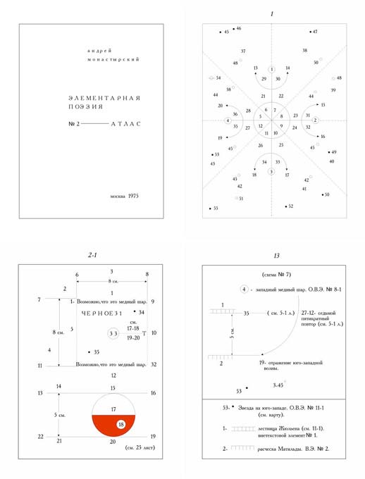
Cover and pages 1, 2-1, and 13 from A. Monastyrsky, Elementarnaya poezia # 2, Atlas, 1975¹³⁴
ES [ES -emozionalinoe prostranstvo] – emotional space (the spectator’s consciousness). In the DEMONSTRATIVE FIELD of KD’s actions the temporary vector of the emotional perception of the action (divided into the pre-eventful, eventful, and post-eventful [dosobytiinoe, sobytiinoe, i poslesobytiinoe]). The degree of emotional involvement of the spectator in the action. (N. Panitkov, O tipakh vosprieatia, vozmozhnykh na demonstrazionnom pole akzii KD, 1985).
For KD the action itself, or its scenario, is a decoy and that the mythical or symbolical content (which is sometimes called the “eventful part”135) is not important to the organizers. “We have no intention of ‘showing’ anything to the spectator; our task is to preserve the experience of waiting as an important, valuable event.”¹³⁶ The eventful part of the action serves as mere preparation for opening up and activating a series of empty or undefined psychic processes. During their first phase, for example, KD attempted to target the [ES] of the participating spectators. “ES” is the “emotional space [or the degree of] emotional involvement of the spectator in the action.”¹³⁷ The plot of the action only helps trigger a series of states and makes the spectator live and experience these states.¹³⁸
“ETHICAL” CONCEPTUALISM (“Eticheskii” konzeptualism) – in conceptual art practice the tactical emphasis on “relationship of preservation,” [otnosheniea sokhranosti], on “technicisms” [tekhnitsizmy] and the preference to work with the opposition “man versus reality” instead of the “man versus culture” opposition employed by the new aesthetic nomads. (In this case under the “ethical” (English “etic”) must be understood the “non emic” (English “emic”) in the meaning of the “structural units of language”; i.e. that which does not have semiological relevance [in linguistics – that which relates to the physical properties of linguistic material]). A. Monastyrsky, I. Backstein, TSO ili chiornye dyry kontzeptualizma – 1986, in MANI # 1, “Ding an Sich”, 1986. See also A. Monastyrsky, Zamechianie of eticheskikh granizakh khudozhestvennogo proizvedenia, 1988.

Я
CLARITY AND PEACE [Iasnost' i pokoi] – Term by S. Anufriev. The author did not present a definition for this term.

Notes, Textual References and Image Sources
1. Yulia Tikhonova, “Ivan Chuikov’s Theory of Refletion” ArtMargins (29 May, 2008) http://www.artmargins.com/index.php/archive/94-ivan-chuikovs-theory-of-reflection (Accessed October 5, 2010).
2. Text from Romilly Eveleigh The Moscow Times, February 4, 2005.
“A Chair:” Image Source http://conceptualism.letov.ru/TOTART/APTART.htm. The first Aptart exhibition at the New Museum of Contemporary Art. Image source: M. Tupitsyn. Margins of Soviet Art: socialist realism to the present. Milan; Politi, 1989.
3. From Esanu, Transition in post-Soviet Art
4. Arthur Conan Doyle The Boscombe Valley Mystery http://classiclit.about.com/library/bl-etexts/acdoyle/bl-acdoyle-bos.htm (Accessed October 14, 2010).
5. Translated from Russian by Octavian Esanu. Text and image from: http://www.kandinsky-prize.ru/hronika/uchastniki-vistavok/2009/vadim-zaharov (Accessed 19 October 2010).
6. Text and images from http://conceptualism.letov.ru/KD-ACTIONS-47.htm. Text slightly modified (Accessed August 5, 2010).
7. Image from the journal Pastor at: http://www.conceptualism-moscow.org/files/Pastor%207%20all%20pages.pdf (Accessed August 5, 2010).
8. Image Source: http://www.radioromaniacultural.ro/emisiuni/comment-ca-va/editii-lunare/2009/200906.html (Accessed October 10, 2010).
9. Text and image from Margarita Tupitsyn, “Photography as a Remedy for Stammering,” in Boris Mikhailov, Unfinished Dissertation (Zurich/New York: Scalo, 1998) [unpaginated].
10. Monastyrsky, Poezdki za gorod: kollektivnye deistvia 1-5 vols, 22-23.
11. From Esanu, Transition in post-Soviet Art.
12. Komar & Melamid. From the series Nostalgic Socialist Realism, 1981-82. Image source: http://www.komarandmelamid.org/chronology/1981_1983/index.htm (Accessed August 14, 2010).
13. Monastyrsky, Poezdki za gorod: kollektivnye deistvia 1-5 vols, 673.
14. From Esanu, Transition in post-Soviet Art.
15. Monastyrsky, Poezdki za gorod: kollektivnye deistvia 1-5 vols, 728.
16. [sobytiinaia chasti] Ibid., 107.
17. Ibid., 22.
18. From Esanu, Transition in post-Soviet Art, 76.
19. Description of the action “Translation,” Moscow 1985. (Image and text from http://conceptualism.letov.ru/KD-ACTIONS-36.htm (Accessed October 22, 2010).
20. From Esanu, Transition in post-Soviet Art. For the original Russian version see Monastyrsky, Poezdki za gorod: kollektivnye deistvia 1-5 vols, 384-87.
21. Text (slightly modified) and image from http://www.rustoys.com/Kolobok.htm (Accessed June 15, 2010).
22. Tupitsyn, Kommunalinyi (post)modernizm. See also Monastyrsky, Slovari terminov moskovskoi kontzeptualinoi shkoly, 60.
23. From Esanu, Transition in post-Soviet Art.
24. Image source: http://englishrussia.com/index.php/2010/09/09/the-early-ussr-in-pictures/ [Accessed November 8, 2010]
25. Monastyrsky, Poezdki za gorod: kollektivnye deistvia 1-5 vols., 25.
26. Backstein, Josef , and Bart de Baere. Angels of History: Moscow Conceptualism and Its Influence. (Brussels: Mercatorfonds, 2005) 24.
27. From Esanu, Transition in post-Soviet art.
28. Fragment translated by Octavian Esanu from M. Ryklin, Luchshii v mire http://topos.ru/article/4123 (Accessed June 24, 2010).
29. Email message to the translator from A. Monastyrsky explaining the meaning of the term MOKSHA
30. From Esanu, Transition in post-Soviet Art.
31. The concept of “parallel polis” was introduced by the Czechoslovakian Charter 77 dissident writer Václav Benda in 1978 to describe unofficial economic, political and cultural manifestations in the countries of the Soviet block. The Moscow unofficial art scene had all the attributes of a “parallel polis:” an economic black market where artists sold their works, parallel information networks where critics published unofficial criticism in the format of samizdat (self-published) or tamizdat (published abroad). See Vaclav Benda, “The Parallel ‘Polis’,” in Civic Freedom in Central Europe: Voices from Czechoslovakia, ed. H. Gordon Skilling and Paul Wilson (New York: St. Martin’s Press, 1991).
32. For the entry “Moscow Conceptualism” the Dictionary provides Groys’ text from A-Ya as the first reference source. See Monastyrsky, Slovari terminov moskovskoi kontzeptualinoi shkoly. 61
33. Today the statement that American and English conceptual art was inspired by the language of scientific experiment (Groys 1979, p. 4) is frequently doubted. In 1969 Sol LeWitt wrote that “conceptual artists are mystics rather than rationalists; they leap to conclusions that logic cannot reach.” See Sol LeWitt, “Sentences on Conceptual Art,” in Theories and Documents of Contemporary Art: A Sourcebook of Artists’ Writings, ed. Kristine Stiles (Berkeley: University of California Press, 1966). 826-7.
34. The reference to the Russian spirit was then picked up by other critics who wrote about this phenomenon. See Bobrinskaia, Konzeptualism, [unpaginated]. For the quasi-religious atmosphere of criticism see Dyogot and Zakharov, Moskovskii konzeptualism, 332-42.
35. Image Source: Dyogot, Ekaterina, and Vadim Zakharov. Moskovskii Konzeptualism, World Art Muzei No. 15-16. Moskva: Izdatelistvo WAM, 2005.
36. Monastyrsky, Slovari terminov moskovskoi kontzeptualinoi shkoly, 65.
37. Estonia – the name of a circle, which to some extent came to replace NOMA. The circle Estonia consisted of the groups MH (Medical Hermeneutics), SSV, The Fourth Height, Fenzo, Russia, Tartu, Piarnu, etc. The group was formed in the period after the second putsch of 1993. Ibid., 98-9.
38. Moksha – Moscow Conceptual School. The third phase of development of Moscow Conceptualism after MANI and NOMA. Ibid., 60.
39. The term was introduced by Pavel Pepperstein in 1997. Ibid., 180.
40. Monastyrsky, “Poezdki za gorod: kollektivnye deistvia 6-10 vols.” [unpublished manuscript]
41. For the division into “romantic,” “analytic,” and “inductive” see Donskoy, Roshal, and Skersis, Gnezdo (The Nest) (Moscow: National Center for Contemporary Art, 2008), 17.
42. The suggestion to classify the conceptualists according to their official employment by “humanistic” versus “scientific” publishers belongs to Yuri Leiderman. Interview with the author, Moscow, Russia July 24th 2004.
43. Ekaterina Dyogot, “Prieatnye zaneatia,” Tvorchestvo, no. 11 (1991). 18.
44. On “private art” (privatnoe isskustvo) see also Eimermacher and Margulis, Ot edinstva k mnogoobraziiu: razyskaniia v oblasti “drugogo” iskusstva 1950-kh –1980-kh godov. 53.
45. Dyogot, “Prieatnye zaneatia,” 18.
46. Ibid.
47. Image reconstructed and translated from Dyogot, “Prieatnye zaneatia,” Tvorchestvo, no. 11 (1991). p. 18.
48. See for instance the “golden book” of Moscow Conceptualism, which does not include any of the “extrovert” artists in the circle of Moscow Conceptualism. Dyogot and Zakharov, Moskovskii konzeptualism. Such artists as D. Gutov did indeed moved towards a more constructivist or activist art.
49. Image Source: http://kak.ru/columns/illumination/a2849/ (Accessed July 12, 2010).
50. Nikita Alexeev denies the existence of Moscow Conceptualism in Donskoy, Roshal, and Skersis, Gnezdo (The Nest), 21.
51. Rakitin, “Russkaia volna, kajhetsea, poshla na spad.” 26.
52. See Vladimir Markov, The Longer Poems of Velimir Khlebnikov, University of California publications in modern philology (Berkeley: University of California Press, 1962). 3. ———, Russian Futurism; a history (London: Macgibbon & Kee, 1969). 157.
53. See “Surrealist Situation of the Object” in André Breton, Manifestoes of Surrealism (Ann Arbor,: University of Michigan Press, 1969). 257.
54. From Esanu, Transition in post-Soviet Art
55. Translated from Anastasia Rozanova Kromeshnaia Puteaga – Rezenzia WA on http://www.world-art.ru/animation/animation_review.php?id=3625 (Accessed June 28, 2010).
56. Image source: http://www.artinfo.ru/artbank/scripts/russian/title_base.idc?author_id=1154&title_id=5247 (Accessed August 2, 2010).
57. Fragment from Genady Katsov, Interview with Dmitry Prigov in New York, August 2000. http://www.gkatsov.com/articles/articles_prigov_interview.html (Accessed July, 07, 2010).
58. Fragment from “Novaia Iskrennosti” in Be-In at http://www.be-in.ru/people/455-novaya_iskrennost (Accessed July 01, 2010).
59. From Esanu, Transition in post-Soviet Art
60. Image source: http://conceptualism.letov.ru/KD-actions-29.html (Accessed July 8, 2010).
61. Vladimir Sorokin’s play Zemleanka http://lib.babr.ru/index.php?book=393 (Accessed August 1, 2010). Translated by Octavian Esanu.
62. Courtesy Bar-Gera collection. Image source http://www.artchronika.ru/item.asp?id=1673 (Accessed July 21, 2010).
63. Andrei Monastyrsky, Poezdki za gorod: kollektivnye deistvia 1-5 vols. ———, “Poezdki za gorod: kollektivnye deistvia 6-10 vols.” The material for the actions organized after 1989, which constitute five post-Soviet volumes of the Journeys, are available only online at http://conceptualism.letov.ru/KD-actions-91.html.
64. ———, Poezdki za gorod: kollektivnye deistvia 1-5 vols, 221-22.
65. ———, Slovari terminov moskovskoi kontzeptualinoi shkoly, 152.
66. ———, Poezdki za gorod: kollektivnye deistvia 1-5 vols, 234-9.
67. From Esanu, Transition in post-Soviet Art.
68. Image source: Leonid Sokov; sculptures, paintings, objects, installations, documents, articles. (The State Russian Museum, 2000).
69. Tupitsyn, Kommunalinyi (Post)Modernizm, 72.
70. Monastyrsky, Poezdki za gorod: kollektivnye deistvia 1-5 vols, 449-50. Quoted from Esanu, Transition in post-Soviet Art.
71. Textual excerpt from the description of KD’s action “Discussion” [Obsujdenie] 1985. Fragment from the diagram The Position of the Objects, the Spectators and the Organizers during the Action “Discussion,” 1985, (translated and reconstructed). For a full description of this action and diagram see Esanu, Transition in post-Soviet Art.
72. Boris Groys, “Moscow Romantic Conceptualism.” A-Ya, no. 1 (1979): 3-12.
73. See also Mikhail Ryklin, Hegel in the Spaces of Jubilation, Third Text, vol. 17 #4, December 2003.
74. Translated excerpt from Pavel Pepperstein, Khudozhestvenye gruppy vkhodeaschie v krug Medgermenevtika, 1999. http://www.aerofeev.ru/content/view/99/68/ (Accessed July 8, 2010). Image source: Inspection Medical Hermeneutics Ideotechnique and Recreation, vol. 1 (Moscow: Obskuri Viri, 1994).
75. Image source: Inspection Medical Hermeneutics Ideotechnique and Recreation.
76. Ray Grigg, The Tao of Zen, 1st ed. (Boston: C.E. Tuttle Co., 1994). 241.
77. On the concept of nothingness see chapter “The Problem of Nothingness” in Jean-Paul Sartre, Being and Nothingness, trans. Hazel E. Barnes (New York: Washington Square Press, Inc., 1966).
78. For example of words used to describe this work see for instance Henderson, The Fourth Dimension and non-Euclidean Geometry in Modern Art. 288.
79. In a lecture delivered in Berlin in 1922, El Lissitzky spoke about the importance of this painting in following terms:
[…] Malevich exhibited a black square painted on a white canvas. Here a form was displayed which was opposed to everything that was understood by ‘pictures’ or ‘painting’ or ‘art.’ Its creator wanted to reduce all forms, all painting, to zero. For us, however, this zero was the turning point. When we have a series of numbers coming from infinity …6, 5, 4, 3, 2, 1, 0…it comes right down to the 0, then, begins the ascending line 0, 1, 2, 3, 4, 5, 6…
These lines are ascending, but already from the other side of the picture. It has been said that the centuries have brought painting right up to the square, so that here they can find their way down. We are saying that if on the one side the stone of the square has blocked the narrowing canal of painting, then on the other side it becomes the foundation-stone for the new spatial construction of reality.” Quoted in W. Sherwin Simmons, Kasimir Malevich’s Black Square and the Genesis of Suprematism 1907-1915 (New York: Garland Pub., 1981). 3.
80. Groys, “The Artist as Narrator.” ix.
81. Monastyrsky, Poezdki za gorod: kollektivnye deistvia 1-5 vols, 306.
82. Ibid. See Monastyrsky, p. 21 or Kizevalter, p. 108.
83. Andrei Monastyrsky, “Rybak,” in TransArt: Simposium 10 und 11 Mai 1999, Akademie der Bildenden Kunste (Vienna: 1999), [unpaginated]. Extract from Esanu, Transition in post-Soviet Art.
84. Monastyrsky, Ob akzii ‘625-520,’ Meshok,’ i ‘pustom deistvii’ (Volume Eight) in Monastyrsky, Poezdki za gorod: kollektivnye deistvia 1-5 vols.
85. The most complete elaboration of the notion of sdvig and sdvigology was made by the poet Alexei Kruchenykh in A. Kruchenykh, Kukish proshliakam: faktura slova, sdvigologiia russkogo stikha, apokalipsis v russkoi literature (Moskva: Gileia, 1992). See also Markov, Russian Futurism; A History, Kazimir Severinovich Malevich and Dmitri i Vladimirovich Sarabianov, Sobranie sochinenii v piati tomakh (Moskva: Gileia, 1995). On the relation between “sdvig,” zaum poetry and Malevich’s Suprematism see Octavian Esanu, Malevich’s “passage” to Suprematism: (a painterly sdvigology or a poetic passageology) 2005. [unpublished].
86. See Shklovskii, Viktor Borisovich, and Benjamin Sher. Theory of Prose. Elmwood Park, IL,: Dalkey Archive Press, 1990.
87. Kabakov, 60-e – 70-e: zapiski o neofitialinoi zhizni v Moskve, 96.
88. “Kabakov has created a total of 50 albums, the first ten of which can be considered the most significant, and which were produced by the artist in the early 70s under the collective title Ten Characters.” Boris Groys, “The Artist as Narrator,” in Ilya Kabakov Viisi Albumia, Fem Albumer, Five Albums, Piat’ Al’bomov, ed. Ilya Kabakov (Helsinki: The Museum of Contemporary Art, 1994). viii.
89. Tupitsyn, Margins of Soviet Art: Socialist Realism to the Present, 40.
90. Kabakov, 60-e – 70-e: zapiski o neofitialinoi zhizni v Moskve, 104.
91. Dyogot and Zakharov, Moskovskii konzeptualism, 357-59.
92. From Esanu, Transition in post-Soviet Art.
93. Ibid.
94. Groys, Utopia i obmen.
95. Once again, like before the October revolution, the intellectual life of Russia’s two capitals was divided between the Slavophiles and the Westernizers. This becomes particularly clear at the turn of the century, when the artistic scene became polarized and fragmented into various anti-Western cultural and political fractions (e.g. the Eurasian nationalists, the National Bolsheviks).
96. The “Russian Idea” refers to Nicholas Berdyaev’s theorization of freedom. In contrast to liberal individual freedom, or personalism, the Russian Idea regards freedom as part of Christian community, which is often understood through the concept of sobornost’.
97. Groys, Utopia i obmen, 245-58.
98. See Kabakov, Groys, and Petrovskaia, Dialogi: 1990-1994, 79.
99. See “An Open Letter to the Art World” in Eda Cufer and Viktor Misiano, eds., Interpol: The Art Show which divided East and West (Ljubljana: IRWIN, Moscow Art Magazine, 2000).
100. Kabakov, Groys, and Petrovskaia, Dialogi: 1990-1994, 81.
101. From Esanu, Transition in post-Soviet Art.
102. Image source: http://artgals.info/art/notes/art-runok-kalashnikova/ (Accessed July 18, 2010).
103. Pavel Pepperstein, “Soziologia moskovskogo konzeptualizma,” Khudozhestvenyi zhurnal, no. 69 [Noeabr’ 2008]. http://xz.gif.ru/numbers/69/soc-conc-msk/ (Accessed January 23, 2009).
104. The magazine A-Ya was launched in order to “inform the reader about the artistic creativity and developments in contemporary Russian art…” “A-Ya,” (Elancourt, France: Boris Karmashov, 1979). The “Contemporary Russian Art Center of America” that opened in New York with support from the Cremona Foundation was also dedicated to Russian contemporary art. In Moscow the first institutions of contemporary art were opened during the nineties by those who were part of Moscow conceptualist circles. The Institute of Contemporary Art launched in 1991 in Kabakov’s studio and the New Strategies in Contemporary Art, a postdoctoral program financed by the Soros Foundation Moscow in 1995, were initiated by Josef Backstein. In addition many Moscow Conceptualists have benefited or participated in numerous activities of the Soros Centers for Contemporary Art Network and the Soros Foundation.
105. Josef Backstein in Monastyrsky, Slovari terminov moskovskoi kontzeptualinoi shkoly, 15.
106. See dialogue between Kabakov, V. Tupitsyn and M. Tupitsyn in Viktor Tupitsyn and Ilia Iosifovich Kabakov, Glaznoe iabloko razdora: besedy s Il’ei Kabakovym, 106-117.
107. Monastyrsky Ob akzii ‘625-520’, ‘Meshok’, i ‘pustom deistvii’ (Volume Eight) Monastyrsky, Poezdki za gorod: kollektivnye deistvia 6-9 vols.
108. “Today the term ‘contemporary art’ does not simply mean art made in our time. The contemporary art of today is a method by which contemporaneity presents its essence – the very act of presenting the present (akt prezentazii nastoiaschego). In this regard contemporary art is different both from modern art, which was oriented to the future, as well as from postmodern art, which was a historical reflection on the subject of the modernist project. Contemporary art gives preference to the present in regard to the future and the past. Thus in order correctly to characterize contemporary art, it is necessary to follow its relation to the modernist project and its evaluation of postmodernism. Boris Groys, “Topologia sovremennogo iskusstva,” Khudozhestvenyi zhurnal 61-62 (2006).
109. Groys, “Moskovskii konzeptualizm: 25 let spustea,” in Moskovskii konzeptualism, ed. Ekaterina Dyogot and Vadim Zakharov, World Art Muzei no. 15-16 (Moskva: Izdatelistvo WAM, 2005), 24. The material under the term “contemporary artist” is from Esanu, Transition in post-Soviet Art.
110. Groys, Utopia i obmen.
111. One wing of the historical Russian avant-garde to which the conceptualists and other Soviet unofficials showed full loyalty and claimed direct linkage, was the OBERIU group. But the latter did not share a passion for revolutionary art with the Cubo-futurists, the Constructivists or the Suprematists, and therefore they have been less known abroad. For an overview of the OBERIU movement see Graham Roberts, The Last Soviet Avant-garde: OBERIU–Fact, Fiction, Metafiction, (Cambridge, New York: Cambridge University Press, 1997); A. Kobrinskii, Poetika “OBERIU” v kontekste russkogo literaturnogo avangarda, Izd. vtoroe, ispr. i dop. ed., 2 vols. (Moskva: Izd-vo Moskovskogo kulturologicheskogo lytsieia, 2000).
112. See Backstein and Baere, Angels of History: Moscow Conceptualism and its Influence. 16-20. Material under the term “Socialist Realism” from Esanu, Transition in post-Soviet Art.
113. Quote from Tim Harte, Fast Forward; the Aesthetics and Ideology of Speed in Russian Avant-garde Culture, 1910-1930 (Madison: University of Wisconsin Press, 2009), 236.
114. E.V. Zavadskaia, Kulitura Vostoka v sovremennom zapadnom mire (Moskva: Nauka, 1977). Artists mention the significance of this book and its impact on KD in Solomon, The Irony Tower: Soviet Artists in a Time of Glasnost. 85-86.
115. Vostok na Zapade (Moskva, 1970).
116. Ch’an is the Chinese and Zen is the Japanese transcription of the Sanskrit term dhyana meaning meditation or concentration. In a footnote the author explains that the two are not identical. Zavadskaia, Kulitura Vostoka v sovremennom zapadnom mire. n 1.
117. From Esanu, Transition in post-Soviet Art.
118. Emerson, Caryl. “Preface to Mikhail K. Ryklin, ‘Bodies of Terror.’” New Literary History, Vol. 24, no. 1 (1993): 45-49.
119. Text fragment from http://www.artmargins.com/index.php/archive/94-ivan-chuikovs-theory-of-reflection (Accessed July 28, 2010).
120. From Svetlana Boym “Ilya Kabakov: the Soviet Toilet and the Palace of Utopia” in Artmargins, Dec. 3, 1999 http://www.artmargins.com/index.php/archive/435-ilya-kabakov-the-soviet-toilet-and-the-palace-of-utopias (Accessed July 23, 2010).
121. “Voluntary Sundays” and “Saturdays” were important Soviet institutions. On appointed days the masses were encouraged to fulfill their civic duty by doing necessary tasks (painting, tidying up, fixing things etc.) at their place of work and where they lived. Red was the color of the day.
122. Text source: http://conceptualism.letov.ru/BOBRINSKAYA-TOTART.htm (Accessed July 20, 2010).
123. Page 62 from Vadim Zakharov’s journal Pastor.
124. From Octavian Esanu, Malevich’s “Passage” to Suprematism: a painterly sdvigology or a poetic passageology (unpublished paper).
125. Image and caption from: http://www.phillipsdepury.com/auctions/lot-detail.aspx?sn=UK010408&search=&p=&order=&lotnum=328 (Accessed August 2, 2010).
126. Monastyrsky, Slovari terminov moskovskoi kontzeptualinoi shkoly, 90.
127. ———, Poezdki za gorod: kollektivnye deistvia 1-5 vols, 118.
128. “Empty photographs [pustye fotografii] – ‘central’ works of photography in the actions of KD, where nothing (or almost nothing) is shown, other than ‘deliberate emptiness.’” “Imperceptibility [nevidimosti] – demonstrative relation in the aesthetics of KD (part of ‘KD categories’)…” [introduced in 1980] ———, Slovari terminov moskovskoi kontzeptualinoi shkoly, 148.
“Zone of imperceptibility” [polosa nerazlichenia] – zone of the “demonstrative field” (often bordering the “exposition field”) where certain audio and visual objects cannot be recognized by the spectator as belonging to the action, [first mentioned in 1979]. Ibid., 71.
“Out-of-photography-space” [vnefotograficeskoe prostranstvo] – the space where the photographer is positioned during the shooting… [introduced in 1980]. Ibid., 141.
129. From Esanu, Transition in post-Soviet Art.
130. Gilles Deleuze and Felix Guattari, Kapitalism i shizophrenia: Anti-Oedipus, trans. M. K. Ryklin (Moskva: INION, 1990).
131. From Esanu, Transition in post-Soviet Art.
132. Monastyrsky, Slovari terminov moskovskoi kontzeptualinoi shkoly, 97.
133. From Esanu, Transition in post-Soviet Art.
134. For the complete version see http://conceptualism.letov.ru/1/slides/AM-ATLAS-29.html (Accessed August 1, 2010).
135. [sobytiinaia chasti] Monastyrsky, Poezdki za gorod: kollektivnye deistvia 1-5 vols., 107.
136. Ibid., 22.
137. Monastyrsky, Slovari terminov moskovskoi kontzeptualinoi shkoly, 98.
138. From Esanu, Transition in post-Soviet Art.

