PRESS RELEASE (January 22, 2007)
------------------------------------------------------------------------------

Personal Rapid Transit (PRT) network shown to cut car use and eliminate the need for local bus services in Daventry study.

Daventry
Daventry has a population of 23,000, which is due to rise to 40,000 under the Government’s Sustainable Communities Plan. In the UK’s first comprehensive study of the possible role of an urban PRT network, Colin Buchanan defined the town’s transport problems as:
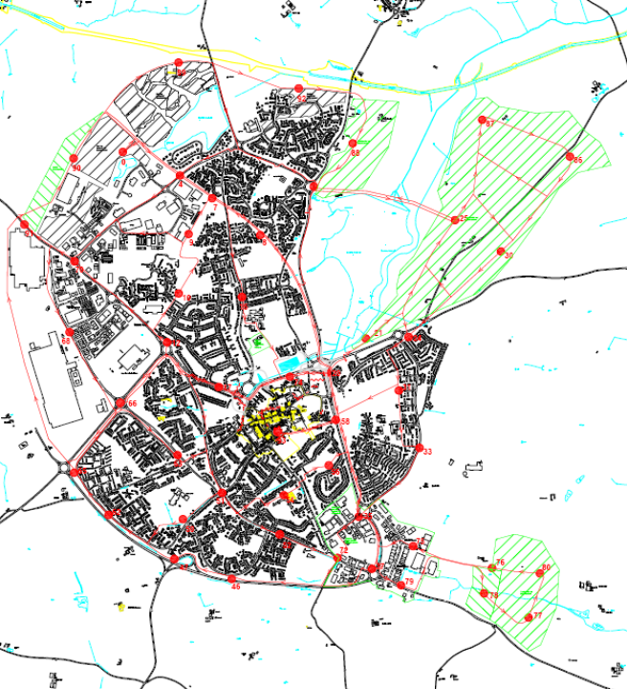
- An under-used and expensive bus network
- A massive planned expansion of the town
- A need to accommodate the growth
- …and the resulting traffic and parking
- …while supporting the town centre plan
- A need to attract jobs of the right type
- … and hence to put Daventry on the “map”
- A need for a good public transport system, capable of providing a genuine alternative to the car

Fig 1: The proposed network and stations

The proposed network and market share
A PRT network comprising 50km of one way track and with 50 stations (Fig 1) was designed and compared with two alternative upgrades of the existing bus services, supported by bus priority measures. These alternative networks were then tested using the County Council’s multi-modal model to estimate mode switching between car, bus and PRT. This showed that depending on the fares charged and the modal penalties assumed for PRT, the latter would reduce internal car trips by between 22% and 33%, whereas even the best bus network would increase its share of the mechanised trip market from the current 4% to only 10%.
A second, simulation model was then used to check that the network would not overload and to estimate the number of driverless cabs that would be required to carry the passengers with minimal waiting times averaging less than one minute.
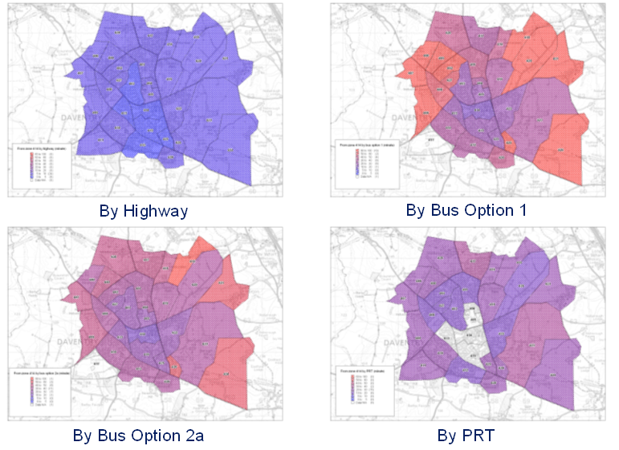
Fig 2: Travel time by different modes from central zone

Financial and cost/benefit performance
Capital and operating costs were then estimated, taking advice on PRT costs from Arup, who are currently designing the Heathrow PRT system. The complete PRT network, including depot, track, safety fencing and 300-500 cabs was estimated to have a capital cost of £80-85m, the difference being related to the number of cabs required. Annual operating costs ranged for the same reasons from £4m to £6m at 2006 prices. Summed and discounted over the government’s required timescale of 60 years, the PRT network was capable of earning substantial operating profits provided its fares were raised well above the current average bus fare of 80p. With a fare of £1.60 the demand was still substantial and the operating surpluses were estimated to be almost sufficient to fund the full capital costs, a remarkable prediction when compared with the finances of trams and guided buses. It was judged that with such a network the town bus services would be withdrawn.

The reasons for the apparent financial success of the PRT network when compared with even the best bus alternative relate to its much greater competitiveness with the car. Daventry is a town largely laid out for the car and with many housing estates designed to semi-Radburn principles. There is little congestion and it is possible to get almost anywhere in the town by car in a drive of 10 minutes or less. The bus is very much slower with services and connections that mean some journeys can take over an hour. PRT is not as fast as a car but it is very much quicker and more convenient than a bus. This bodes well for the success of PRT when introduced in more conventional towns where traffic congestion is far more widespread and severe. In such situations it is easy to see that the Swedish prediction (for Gothenburg) that PRT could cut car use by 50% may prove realistic. Even without such speculation it is clear that PRT is likely to achieve greater reductions in urban traffic than any policy alternatives yet tried. This potential was reflected in a healthy benefit/cost ratio of 3.7.

The pilot network
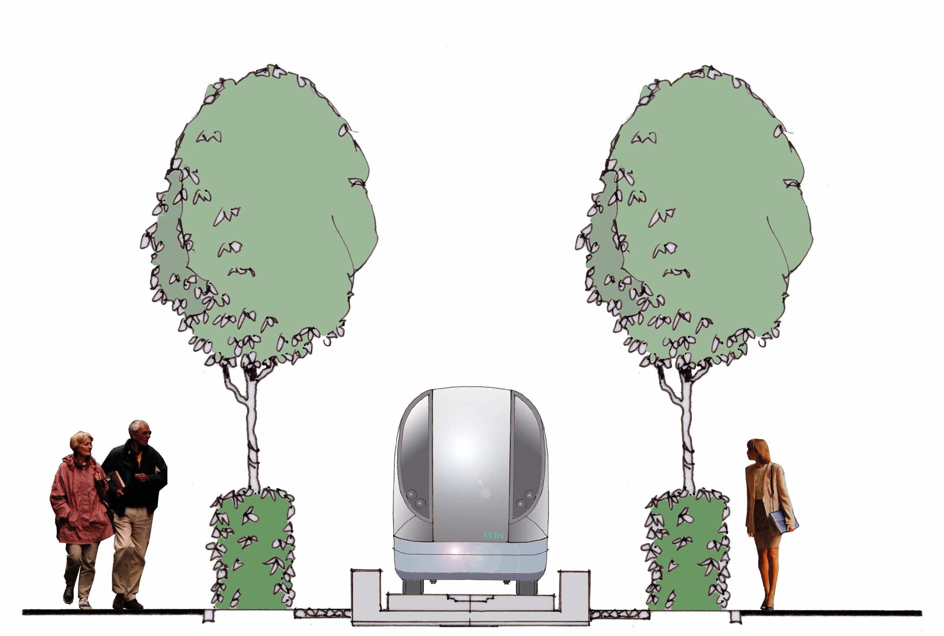
Daventry is now set to move swiftly on with the procurement of the first part of its PRT network as a pilot for the exploration of issues such as the suitability of the system for the journey to school, the likelihood of cab sharing, the modal penalty, the control system, the actual costs and construction problems and the dangers of vandalism. On the assumption that these problems prove not to be insuperable, PRT will then be confirmed as a form of urban public transport capable of providing a genuine and commercial alternative to the car in areas largely laid out for the car, and thus able to deliver on a commercial basis substantial reductions in carbon emissions.
Fig 4: At grade PRT tracks
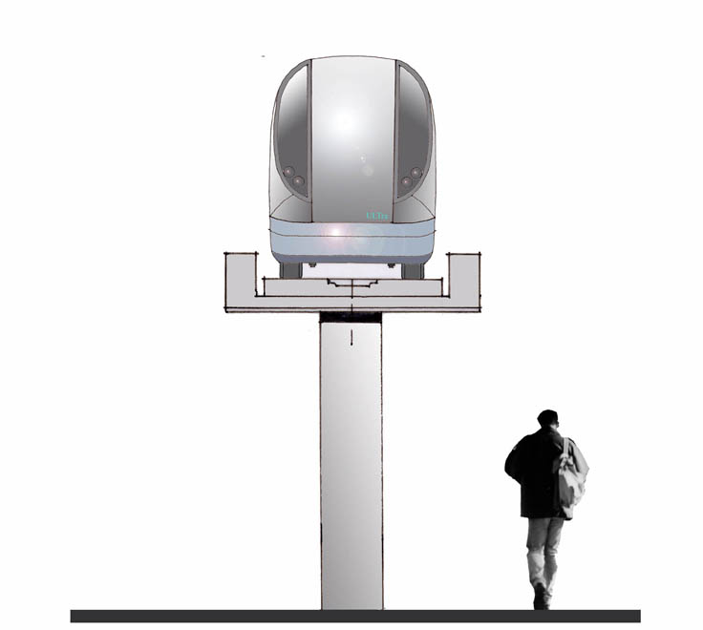
Fig 3: Elevated PRT tracks

Malcolm Buchanan
Colin Buchanan
0207 309 7001

