J.A. Gross, Wendy A. Cohen, F.A. Mann
Problem: Assessing risk of neurological injury without inducing loss of current or future neurological function regardless of individual’s level of consciousness (GCS); that is, the protective recognition of individuals whose vertebral columns have not or will not protect their contents. We will call this loss of protective capability, “clinical instability.”
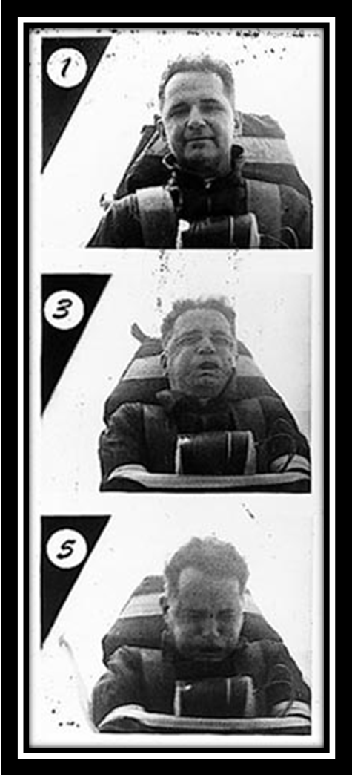
Clinical Instability: “…is the loss of the ability of the spine under physiologic loads to maintain its pattern of displacement so that there is no initial or additional neurological deficit, no major deformity, and no incapacitating pain.” [White AA, Panjabi MM. Clinical Biomechanics of the Spine, 2nd edition. J.B. Lippincott Co.; 1990: 278]
In the efficient management of injury-related risk to neurological integrity, imaging is commonly used to detect injuries to the vertebral column and its contents, and then to characterize injury patterns as an adjunct to clinically assessing likelihood of permanent loss of neurological function, whether current neurological status is static (normal or fixed or recoverable deficits) or at risk for future loss of function (instable). Assessing risk of clinical instability based on what anatomic structures are disrupted assumes predictive models of structural stability. Conceptual models abound (vida infra), and are based on a few fundamental properties of physical materials.
General definitions:
Stability - 1 : the quality, state, or degree of being stable as a : the strength to stand or endure; b : the property of a body that causes it when disturbed from a condition of equilibrium or steady motion to develop forces or moments that restore the original condition [Merriam-Webster Online 8/28/07, http://www.m-w.com/dictionary/stability].
Etymology: Middle English, from Anglo-French estable, stable, from Latin stabulum, from stare to stand [Merriam-Webster Online 8/28/07, http://www.m-w.com/dictionary/stable].
Figure 1 Physiologic? Major Stapp decelaration at 42.6 G [http://en.wikipedia.org/wiki/Image:StappSled.jpg#filelinks]
Deformation [Wikipedia 8/28/07, http://en.wikipedia.org/wiki/Deformation]:
Biomechanically, deformation is shape change due to applied force. Deformations can be due to tension (pulling), compression, shear, bending or torsion (twisting). Deformation may be quantified as strain.
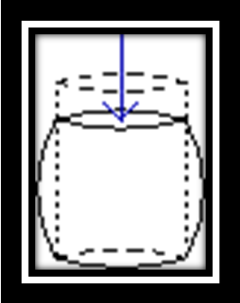
In figure 2, the compressive loading (indicated by the arrow) has deformed the cylinder such that the original shape (dashed lines) is deformed into a squat cylinder with bulging sides.
Bulging occurs because the material is strong enough not to fail, but is not sufficiently strong to resist the load without shape change that results in material being forced out laterally. Deformation may be temporary, similar to a rubber band or a spring that returns to its original length when tension is removed, or deformation may be permanent such as when an object is irreversibly bent or broken. The physical composition and structure of objects determine their ability to resist deformation by compressive, tensile, shear, bending or torsion forces. Regardless of the type of stress, materials will respond to a single application of an isolated force in one of three ways: elastic (temporary) or plastic (remains deformed but otherwise intact) deformation, or fracture (failure). Of course, if the magnitude of the force is small relative to the structure, the concept of a rigid body is appropriate when the deformation is trivial or non-existent.
Figure 2 Compression deformation

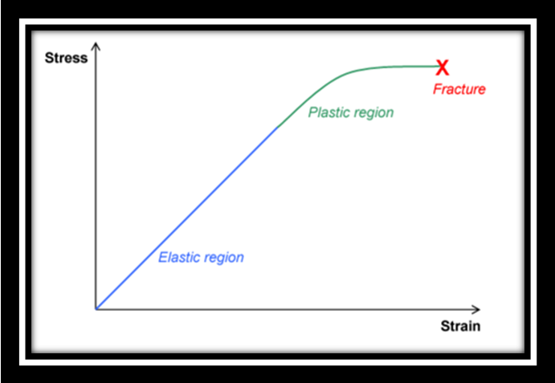
Elastic deformation is reversible. Once the forces are relieved, the object returns to its original shape.

Plastic deformation is not reversible. Note that plastic deformity requires more force than elastic deformation. Thus, an object in the plastic deformation range will have passed through a load range that would have resulted in elastic deformity (return to its original shape) if the force had been relieved.
Figure 3 Diagram of a Stress-strain curve, showing the relationship between stress (force applied) and strain

Fracture is not reversible. Breaks occur after the material has transited force levels that would have resulted in elastic, and then plastic deformation ranges. At some point, sufficient force accumulates and causes a fracture. All materials eventually fracture, if sufficient force is applied

Relevance to clinical medicine: The elasticity of an intact and normal vertebral axis affords extraordinarily complex motions for movement while attempting to protect central canal and foramina contents [Figures 4-7].
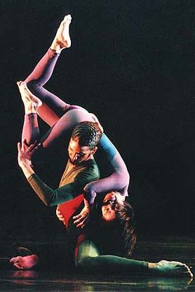

Figure 5. Modern dance (above) http://www.soafi.org/UserFiles/Image/Dance-postcard.jpg

Figure 4. Asian-influenced dance (above left) http://www.ichinohedance.org/files/images/BambooCouple_0.jpg


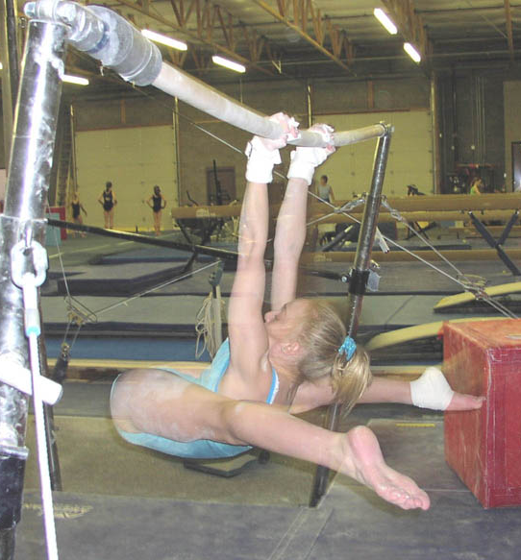
Figure 6. Gymnastic twists http://www.cartersgymnastics.org/Julie2.JPG

Figure 7. Rugger chokes… http://www.sportsphotography.net/portfolio/rugby.jpg

However, the vertebral column constituents (bone, ligaments, muscles, spinal cord and nerve roots/ganglia) have unique and different deformation characteristics that change dramatically with age. For example, SCIWORA and deceleration renal arterial occlusions (e.g., SCIWORA wherein cord rupture occurs because the tensile elasticity of the cord is less than that of investing anterior longitudinal and posterior longitudinal vertebral ligaments in chronologically juvenile individuals(Pang 2004); and renovascular occlusions in blunt abdominal deceleration trauma where the arterial adventitia has much greater tensile elasticity than its intima, thus leading to circumferential intimal tears when vessels are “stretched”(Beyer and Daily 2004)). Similarly, bones plastically deform at much lower compressive forces than their attached ligaments (e.g., 2- or 3-column burst fractures). Variations seen in blunt force injury arise from inherent material stability and inter-tissue differences in deformability relative to the applied stress types and magnitudes. Finally, the thecal sac does not float in the spinal canal, but is maintained in a relatively constant relationship to its bony borders by the meningovertebral ligaments that form longitudinal raphes within the epidural space, and epidural processes (such hemorrhage) can create extrinsic compressions depicted on cross-sectional imaging as unusual-appearing triangular or polygonal stenosis (Geers, Lecouvet et al. 2003).
Clinical Instability Applied
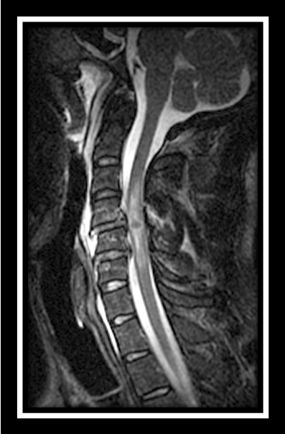
Acute neurological deficit: myelopathy or radiculopathy directly indicates failure of the vertebral column to protect its neural contents. At MR, hemorrhage extending beyond one functional spinal unit (FSU) is a reliable predictor of fixed deficit(Andreoli, Colaiacomo et al. 2005) [Figure 4].
Primary and Secondary neurological injuries: Spinal cord injuries (SCI) may be considered either primary or secondary. Primary SCIs are due to mechanical disruption or distraction of neural elements, and usually occurs at the time of fracture and/or dislocation of the spine. Primary SCIs can occur in the absence of spinal fracture or dislocation (e.g., spinal epidural hematomas or abscesses). Secondary SCIs are caused by systemic (hypoperfusion due to shock), regional or local vascular injury to the spinal cord caused by arterial disruption, arterial thrombosis, etc. Needless to say, anoxic or hypoxic effects exacerbate the extent and severity of SCI [Schreiber D. Spinal cord injuries. 8/28/07; http://www.emedicine.com/emerg/topic553.htm].
Figure 4 Cord hemorrhage

Inability of patient anatomy to protect neural elements from future injury (a.k.a. biomechanical stability.
As noted above, predictive conceptual models for spine stability abound, and attract regular controversies. Nonetheless, we present modified versions of the two-column model of the cervical spine, and the three-column model of the thoracic and thorcolumbar spines.
Cervical spine:
Craniocervical junction (C0-C2):
Occipital condyle fractures (OCF) have been increasingly recognized with the widespread use of CT to survey the potentially injured cervical spine(Bub, Blackmore et al. 2005; Goradia, Blackmore et al. 2005). Cranial nerve deficits occur in approximately 30% of the patients with OCFs, and deficits present delayed in over one-third. Truly asymptomatic OCF will be found by CT in approximately 1%. CT scans are warranted in the following circumstances: presence of lower cranial nerve deficits, associated head injury or basal cranial fracture, or persistent severe neck pain despite normal radiographic results. Since these fractures may be associated with craniocervical instability, classification systems for the management and treatment of OCF should be based on the stability of the C0-C1-C2 joint complex reflected by the presence of displacement of the condyle at CT or MR evidence for related ligamentous injury(Tuli, Tator et al. 1997).
Disruptions of alar ligaments, the transverse atlantoaxial ligament, or the posterior longitudinal ligament (and associated ligament complexes) results in biomechanical instability. In particular, disruption of the tectorial membrane suggests potentially life threatening instability(Sun, Poffenbarger et al. 2000). Thus, patients with isolated ligamentous instabilities, Type III hangman's fractures and Type II odontoid fractures with dislocation more than 5 mm usually receive surgical fusion as their primary treatment.C2 fracture morphology dominates decision making in combined C1/C2 fractures(Vieweg, Meyer et al. 2000). Regarding C2 traumatic sponylolysis, Type II spondylolisthesis injuries should be assumed to be biomechanically unstable, and harbor great potential for neurological deterioration and significant complications associated with non-operative treatment(Muller, Wick et al. 2000).
Subaxial cervical spine (C3-T1): Popularized by Allen and Ferguson, the two-columns, where all vertebral elements (bony and soft-tissue) anterior to the PLL are anterior column and everything posterior to the PLL is the posterior column. Presumptive biomechanical stability may be diagnosed when any part of the remaining column is injured when the primary injured column is completely disrupted.
As the cephalic extension of the supraspinous ligament in the thoracic and lumbar spines, the nuchal ligament should reasonably be considered as part of the posterior ligamentous complex of the posterior column. In experimental models, flexion range increases by 30% after removal of the nuchal ligament. Following resections of the interspinoud soft-tissues and the ligamentum flava, the flexion range increases 50% relative to the intact spine(Takeshita, Peterson et al. 2004).
In order to determine extent of soft-tissue disruptions necessary to create isolated dislocations, a variety of experimental animal and cadaveric models have been evaluated. Empiric observations (vida infra) have validated many of these findings. Recognition of the effective equivalence between a demonstrated dislocation and one that has the same extent of soft-tissue disruptions is important in recognition of otherwise occult instabilities. For example, unilateral facet dislocations require disruption of the ipsilateral articular capsule, ligamentum flavum, and more than half of the anulus fibrosus. Although not necessary for dislocation, disruption of the ligamentum nuchae and interspinous soft-tissues facilitates (i.e., lessens the force required) unilateral facet dislocation. Importantly, disruption of the anterior and posterior longitudinal ligaments is not necessary to create a unilateral facet dislocation [Sim E, Vaccaro AR, Berzlanovich A, Schwarz N, Sim B. In vitro genesis of subaxial cervical unilateral facet dislocations through sequential soft tissue ablation. Spine 2001;26:1317-23]. Interestingly, in the absence of associated fractures, the cervical spine is biomechanically stable while isolated articular masses are locked unilaterally. However, the functional motion segment usually manifests overt instability after the facet dislocation is reduced [Crawford NR, Duggal N, Chamberlain RH, Park SC, Sonntag VK, Dickman CA. Unilateral cervical facet dislocation: injury mechanism and biomechanical consequences. Spine 2002;27:1858-64].
A quantitative system using an analog score of 0 to 5 points based on fracture displacement and severity of ligamentous injury to each of four spinal elements (anterior, posterior, and each lateral mass). The total possible score ranges from 0 to 20 points. Almost all patients with a score ≥7 points require surgery and the majority sustained neurologic deficit versus non-surgical management and infrequent neurological deficit when scores are < 7. It appears that quantifying stability on the basis of fracture morphology allows better characterization of cervical vertebral column injuries [Anderson PA, Moore TA, Davis KW, Molinari RW, Resnick DK, Vaccaro AR, et al. Cervical spine injury severity score. Assessment of reliability. J Bone Joint Surg Am. 2007;89:1057-65].
The risk of cord impingement varies with developmental characteristics of the spinal canal, superimposed degenerative changes and the position/alignment of the spine at the time of impact (Ando, Yanagi et al. 1992). Advancing age appears to be a reasonable surrogate for altered biomechanical properties in the cervical spine. Among patients aged 65-years and older, 65% have upper cervical spine injuries, and up to 40% of these will involve more than one vertebral level. Circumstances of injury seem to be age-related, too: motor vehicle crashes in "young elderly" (65-75 years old; 60%) and falls from standing or seated height in "old elderly" (>75 years old; 40%). “Unstable” fracture patterns (i.e., increased risk for neurologic deterioration) are common (>50%), even in the absence of acute myelopathy or radiculopathy. Predictors of upper cervical spine injury include individuals older than 75 years (independent of causative mechanism), and patients injured in fall from standing height (independent of age). Thus, cervical spine injuries in elderly patients show a predisposition to involve more than one level with consistent clinical instability, and commonly affect the atlantoaxial complex. Patients older than 75 years and patients who fall from standing height more often sustain injuries to the upper cervical spine [Lomoschitz FM, Blackmore CC, Mirza SK, Mann FA. Cervical spine injuries in patients 65 years old and older: epidemiologic analysis regarding the effects of age and injury mechanism on distribution, type, and stability of injuries. AJR Am J Roentgenol 2002;179:1346].
Thoracic and thoracolumbar spines: Originally proposed by Denis, the three columns consist of anterior, middle and posterior columns. Compared to the 2-column concept of Allen and Ferguson, the anterior column of the 2-column model is divided into anterior and middle columns arbitrarily near the posterior cortex of the vertebral body, and includes the adjacent disc and PLL [Panjabi MM, Oxland TR, Kifune M, Arand M, Wen L, Chen A. Validity of the three-column theory of thoracolumbar fractures. A biomechanic investigation. Spine. 1995 May 15;20(10):1122-7]. The soft-tissue elements of the posterior column, the posterior ligamentous complex (PLC), contributes significantly to the stability of thoracolumbar spine. The PLC consists of supraspinous ligament (SSL), interspinous ligament (ISL), ligamentum flavum (LF), and the facet joint capsules [Vaccaro AR, Lee JY, Schweitzer KM Jr, Lim MR, Baron EM, Oner FC, et al. Assessment of injury to the posterior ligamentous complex in thoracolumbar spine trauma. Spine J 2006;6:524-8].
In the upper thoracic spine (T2-T6), a fourth-column model has been proposed and incorporates the sternal-rib complex. [Shen FH, Samartzis D. Successful nonoperative treatment of a three-column thoracic fracture in a patient with ankylosing spondylitis: existence and clinical significance of the fourth column of the spine. Spine. 2007;32:E423-7]. An intact rib cage increases stability of the thoracic spine by 40% in flexion/extension, 35% in lateral bending, and 30% in axial rotation. Sternal fractures caused by indirect flexion-compression reduce stability of the thoracic spine by 40% in sagittal plane flexion-extension, 20% in lateral bending, and 15% in axial rotation [Watkins R 4th, Watkins R 3rd, Williams L, Ahlbrand S, Garcia R, Karamanian A, et al. Stability provided by the sternum and rib cage in the thoracic spine. Spine 2005;30:1283-6].
Regarding burst fractures of the thoracolumbar spine, integrity of the posterior column, not the middle column, is a better indicator of burst fracture biomechanical stability [James KS, Wenger KH, Schlegel JD, Dunn HK. Biomechanical evaluation of the stability of thoracolumbar burst fractures. Spine 1994;19:1731-40]. However, neither the stenotic ratio of spinal canal nor the severity of its kyphotic deformity is reliably associated with the severity of neurological deficit. Neither does the stenotic ratio of spinal canal or kyphosis angle correlate with initial and final ASIA score or recovery rate. Simply, the neurologic recovery from thoracolumbar burst fractures is not predicted by the amount of canal encroachment and kyphotic deformity shown at initial imaging. Treatment for patients with thoracolumbar burst fractures, requires consideration of both neurologic function and spinal stability [Dai LY, Wang XY, Jiang LS. Neurologic recovery from thoracolumbar burst fractures: is it predicted by the amount of initial canal encroachment and kyphotic deformity? Surg Neurol 2007;67:232-7].
Regarding multidirectional instabilities (tensile and rotational, in addition to load-bearing), the load-sharing score of a fracture increases with the magnitude of impact energy. Significant positive correlations between the load-sharing score and the motion parameters predict stability. Fractures with mild comminution (≤6 points) showed more stability than those with more comminution (≥7 points) [Wang XY, Dai LY, Xu HZ, Chi YL. The load-sharing classification of thoracolumbar fractures: an in vitro biomechanical validation. Spine 2007;32:1214-9].
The Thoracolumbar Injury Classification and Severity Score is based on three injury characteristics: 1) radiographic morphology of injury, 2) integrity of the posterior ligamentous complex, and 3) neurologic status of the patient. A composite injury severity score was calculated from these three characteristics, which allowed stratification of patients into surgical and nonsurgical treatment groups. And, a guideline developed to select the optimum operative approach for surgical injury patterns [Vaccaro AR, Lehman RA Jr, Hurlbert RJ, Anderson PA, Harris M, Hedlund R A new classification of thoracolumbar injuries: the importance of injury morphology, the integrity of the posterior ligamentous complex, and neurologic status. Spine 2005;30:2325-33].
Intuitively, a combination of fracture deformity and mechanism should improve the predictive capabilities of the 3-column model. The average spinal canal cross-sectional area compromise due to translation or bony fracture incursion exceeds 55% in neurologically impaired and is less than 15% among neurologically intact individuals. The frequency of neurological impairment increases monotonically as the number of columns disrupted by tensile element failure increases from none to three columns: all columns intact 15%; one column disrupted 40%; two columns disrupted 65%; and, three-columns disrupted 85%. The association between neurological impairment and failure of load-bearing elements (the anterior and middle columns of Denis) as seen in burst and wedge fractures is less convincing: 49% of individuals with neurological impairment and 48% of intact individuals. However, load-bearing failure may warrant spinal reconstructive surgery to control late deformity and pain [Tsou PM, Wang J, Khoo L, Shamie AN, Holly L. A thoracic and lumbar spine injury severity classification based on neurologic function grade, spinal canal deformity, and spinal biomechanical stability. Spine J 2006;6:636-47].
Not surprisingly, the TLISS (ThoracoLumbar Injury Severity Score) better predicts treatment than the TLICS (ThoracoLumbar Injury Classification and Severity Score), which underscores the importance of trauma mechanism relative to fracture morphology in the classification and treatment planning for thoracolumbar injuries. Nonetheless, both mechanism and fracture extent are interrelated and critical to the preservation of spinal stability, and both dimensions must be considered to optimize patient assessment and management [Whang PG, Vaccaro AR, Poelstra KA, Patel AA, Anderson DG, Albert TJ, et al. The influence of fracture mechanism and morphology on the reliability and validity of two novel thoracolumbar injury classification systems. Spine 2007;32:791-5].

Lumbar and lumbosacral spines:
The conus medullaris typically terminates at the L1 level, and vertebral column injuries caudal to the conus may cause the cauda equine syndrome.
Lumbosacral dislocations are rare high-energy injuries most often reported as isolated cases. Improved outcomes from major trauma suggests that these cases will likely become more common. Surgical decompression, reduction, and internal fixation with posterior pedicle screw instrumentation results in a stable lumbosacral junction, and recovery of nerve root injuries. Pre-existing spondylolysis or spondylolithesis may predispose to the injury [Robertson PA, Sherwood MJ, Hadlow AT. Lumbosacral dislocation injuries: management and outcomes. J Spinal Disord Tech 2005;18:232-7].
Image interpretation:
Cervical spine: MRI use is commonplace among SCI patients [Saifuddin A. MRI of acute spinal trauma Skeletal Radiol 2001;30:237-46, Takhtani D, Melhem ER. MR imaging in cervical spine trauma. Clin Sports Med 2002;21:49-75]. MR allows direct assessment of spinal cord structural continuity (e.g., evidence for complete or partial transaction), morphology (e.g., focal swelling or mass effect due to edema and/or hematoma), and signal characteristics (e.g., edema, petechial hemorrhage or hematoma). For example, injuries showing spinal cord edema extending over more than one vertebral level (typically > 60 mm), or hematoma ≥ 4mm (typically > 10 mm) in length predicts a very poor prognosis for meaningful improvements in clinical neurologic deficits; and hemorrhage and edema less extensive is associated with a good prognosis for neurologic improvement (Andreoli, Colaiacomo et al. 2005; Boldin, Raith et al. 2006). The prognostic value of cord edema and hemorrhage shown by in MR is the same for individuals sustaining central cord injury syndromes (Dai 2001). Static images may not depict position specific encroachments, especially in patients with spondylosis (Morimoto, Ohtsuka et al. 1998).
Not all sagittal sequences are equally sensitive in depiction of normal longitudinally oriented ligaments. Relative toT2-weighted FSE sequences, T1-weighted sequences demonstrate ALL (which are particularly misleading in presence of degenerative change) and PLL at ~75%, ligamentum flavum at ~65% and apical ligaments in ~60% as often (Saifuddin, Green et al. 2003).
Craniocervicojunction (Occiput-C2):
Purely ligamentous or osseoligamentous injuries at the craniocervical junction are both common and commonly overlooked. The upper cervical spine warrants particular attention not just for clinical reasons, but radiologists are up to twice as likely to miss lesions in this region compared to the lower cervical spine (Goradia, Blackmore et al. 2005). The combination of improved in-field resuscitation and transport, acute trauma care and advances in imaging diagnoses has led to a better understanding of the broad spectrum of craniocervical junction injuries (Deliganis, Baxter et al. 2000). Assessment of craniocervical biomechanical stability has traditionally been inferential (e.g., type 3 occipital condyle fracture with ≥3 mm diastasis).
More recently, thin-section CT has been shown to confirm atlanto-occipital dislocation, and depict precisely pathological relationships and the magnitude of displacements. OCFs may be classified into the following types: Type 1 (stable), undisplaced fracture; Type 2A (stable), ≥3mm displaced fracture with no ligamentous instability (neither C0-C1 subluxation nor abnormal signal intensity at MR); and Type 2B (unstable), ≥3 displaced fracture with ligamentous instability (C0-C1 subluxation or abnormal signal intensity at MR) [Tuli S, Tator CH, Fehlings MG, Mackay M. Occipital condyle fractures. Neurosurgery 1997;41:368-76; Noble ER, Smoker WR. The forgotten condyle: the appearance, morphology, and classification of occipital condyle fractures. AJNR Am J Neuroradiol 1996;17:507-13].
Targeted MRI has been reported to directly show ligament disruptions as a combination of their absence, abnormal relationships and signal characteristics [Hamai S, Harimaya K, Maeda T, Hosokawa A, Shida J, Iwamoto Y. Traumatic atlanto-occipital dislocation with atlantoaxial subluxation. Spine 2006;31:E421-4](Sun, Poffenbarger et al. 2000). MR depicted injury to the tentorial membrane predicts instability, regardless of the pattern of alar ligament injuries; and, an index of the interspinous distances C1-C2/C2-C3 ≥ 2.5 predicted tectorial membrane involvement with a sensitivity of ~85% and a specificity of 100% (Sun, Poffenbarger et al. 2000). Recognition of subtle instabilities are important as surgical treatment increases the likelihood that individuals will regain function and even return to work (Volle and Montazem 2001).
As for the ALL and PLL, the alar ligaments are more reliably shown at higher field strengths (eg., 1.5T >> 0.5T) and more reliably on coronal PD sequences (Roy, Hol et al. 2004). Alar ligaments, however, show great inter-individual variation in their orientations and courses between the occipital condyles and their insertions into the tip of the dens, and radiologists should be cautious not to infer clinical abnormality based on subtle differences in shape or signal characteristics (Roy, Hol et al. 2004; Bitterling, Stabler et al. 2007). Further underscoring this limitation, left and right alar ligaments were depicted in only ~85% and 75% of normal young adults (mean 30-years) using T1- and T2- weight FSE and T2* GRE sequences at 1.5T (Pfirrmann, Binkert et al. 2001). Normal C0-C1 and C1-C2 joints also commonly (~60%) show small amounts of asymmetry in their apparent joint heights, and small amounts of fluid (C0-C1 ~10%, C1-C2 ~60%) (Pfirrmann, Binkert et al. 2001). Similar caution is warranted with dynamic, quantitative rotational studies of C0-C1 and C1-C2 (especially in the assessment of whiplash injuries), because of the substantial differences in side-to-side magnitude of rotations (up to 10⁰ and 15⁰, respectively) (Pfirrmann, Binkert et al. 2000).
Some authors believe that MR is not necessary to accurately assess stability of C2 traumatic spondylolyses. In particular, Type II spondylolyses may be considered “unstable,” because many of these are associated with neurologic injury or late deformity (Muller, Wick et al. 2000). Any additional role for MR is not well studied.
Atlantoaxial injuries with atlas assimilation are often unstable and difficult to reduce, and commonly show progressive deformity (instability). Combined static and dynamic MR targeted to the craniocervical junction show both the injury patterns and the often associated developmental neural abnormalities (hydromyelia, Chiari, etc.) [Chirossel JP, Passagia JG, Gay E, Palombi O. Management of craniocervical junction dislocation. Childs Nerv Syst 2000;16:697-701].
Remembering that injuries to important neural and vascular structures are more common than previously appreciated, careful search for associated injuries is especially productive when the upper cervical spine is injured. MRI may be used to simultaneously evaluate the extracranial vertebral circulation by MRI angiography, with particular attention to the position of the dens and adjacent subarachnoid space at the end positions of active or passive rotational and tilting maneuvers. Such techniques can show both direct evidence of ligament injury and functional instability (paradoxical motion at C1-C2 and subluxation at C1-C1). Presence of instability with either complete or partial tear warrants surgical evaluation. Functional MRI with lateral tilting and rotation appears to be a useful tool for investigating craniocervical instability [Volle E, Montazem A. MRI video diagnosis and surgical therapy of soft tissue trauma to the craniocervical junction. Ear Nose Throat J 2001;80:41-4, 46-8].
Subdaxial cervical spine (C3-T1):
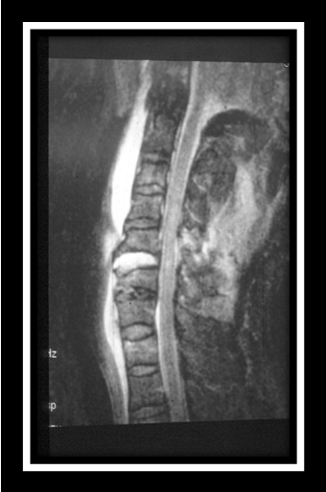
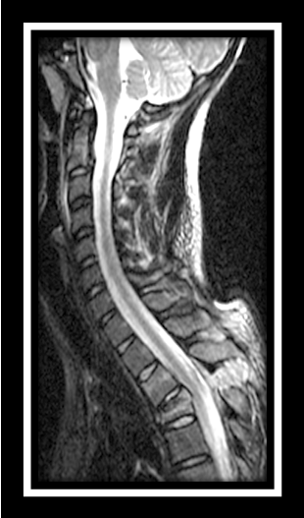
Early demonstration by MR that, in the absence of fracture, the conventional radiographic finding of abnormal pre-cervical soft-tissue swelling predicted ALL disruption in >50% of cases stimulated clinical interest in MR’s role in determining biomechanical stability (Silberstein, Tress et al. 1992). MR’s ability to accurately depict soft-tissue injuries found in fracture-dislocations has been well demonstrated. Among patients with flexion-distraction injuries, stage 3 ( bilateral facet dislocation), disruption to the posterior musculature, interspinous soft-tissues, supraspinous ligament, facet capsule, ligamentum flavum, and posterior and anterior longitudinal ligaments is reliably shown. Among patients with flexion-distraction injuries, stage 2 (unilateral facet dislocation), most of these structures can be shown to be disrupted except for the posterior longitudinal ligament, which is inconsistently ruptured. Comparing unilateral and bilateral facet dislocations, using multivariate analysis, disruption to the anterior longitudinal ligament is associated more consistently with bilateral facet dislocation. Disc disruption is predictably associated with both injury types, but is more common in bilateral facet dislocation. [Vaccaro AR, Madigan L, Schweitzer ME, Flanders AE, Hilibrand AS, Albert TJ. Magnetic resonance imaging analysis of soft tissue disruption after flexion-distraction injuries of the subaxial cervical spine. Spine 2001;26:1866-72] [Figure 8]
Figure 8. Disrupted ligamentum flavum
Hyperextension injuries are not uncommonly either overlooked or understaged by conventional radiography – especially when the disc space is not widened (Harris and Yeakley 1992). On MR, disruption of the ALL (although assessment may be unreliable when large osteophytes are present), characteristic separation of disc from adjacent vertebral body (~70%), anterior annular tears of the disc, avulsion fractures of the endplates and PLL avulsions from the subjacent vertebra may be associated with acute disc herniation into the spinal canal (~50%), and typically occur at multiple levels – unless substantial spondylosis exists (≥ 3 contiguous levels) (Davis, Teresi et al. 1991; Harris and Yeakley 1992).
Figure 9. Acute ALL and disc disruption
Enthusiasm for use of MR to detect otherwise occult ligamentous injuries in the cervical spine varies greatly, especially across time. For example, in a small case-series almost 1/3 of surgically-treated instabilities were “missed” by T1-weighted sequences performed on a low field strength MR (Weisskopf, Bail et al. 1999). Compare that with a report that among a cohort of patients with normal conventional radiographs, but suspected on clinical or historical grounds to have occult SCI, 8% were found to have MR-detected ligamentous injury, one-quarter of whom required surgery. The authors concluded that, “MRI studies of patients with negative standard radiographs but with suspected occult cervical injury are excellent and safe studies for the evaluation of cervical spinal stability because of their ability to detect ligamentous injuries that are not evident on plain radiographs” [Geck MJ, Yoo S, Wang JC. Assessment of cervical ligamentous injury in trauma patients using MRI. J Spinal Disord 2001;14:371-7]. [Figure 9] Approximately 40% of adult individuals with acute post-traumatic neurologic cervical cord deficits and ‘negative’ conventional and CT imaging will show either developmental or acquired (degenerative) spinal stenosis and NO associated soft-tissue injuries (i.e., cord injury without demonstrable ligament or muscle injuries) (Bhatoe 2001). Children aged 9-years and less, especially infants,that sustain acute myelopathies have higher frequency of truly normal conventional radiographs and CT. Eighty-five to 90% of these will show MR abnormalities of the ligaments, muscles and bone marrow. The 10-15% that are MR normal, even those with abnormal somatosensory evoked potentials, will generally regain normal neurologic status, even without bracing (Pang 2004).
However, few direct clinical pathological-radiological correlations are available to estimate the sensitivity of MR to detect injuries to specific ligaments (Katzberg, Benedetti et al. 1999; Goradia, Linnau et al. 2007). Moreover, field strength seems to matter (1.5T(Goradia, Linnau et al. 2007) vs. 0.3T(Katzberg, Benedetti et al. 1999)) : ALL ~70% vs. ~45%, disc and PLL both ~90% vs. ~45%, ligamentum flavum ~65% vs. ~35%, and interspinous soft-tissues >95% vs. ~55% (Goradia, Linnau et al. 2007). On the other hand, both clinical and experimental observations suggest that the specificity is excellent.
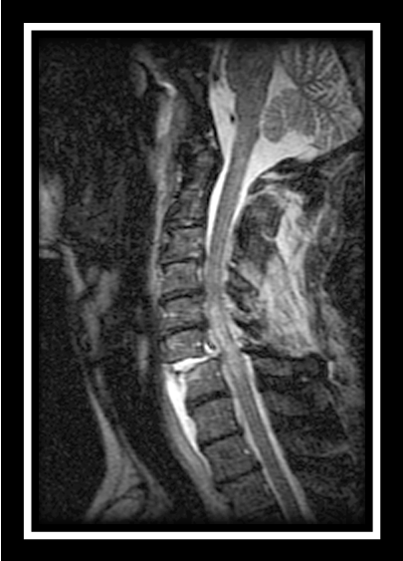
Witness, limited (sagittal T1- and T2-weighted) MR imaging performed to assess soft-tissue abnormalities in obtunded patients based on the mechanism of injury within 48 hours of injury allowed either treatment of MR-detected instability or spine clearance and discontinuation of spinal precautions. Up to 25% of such patients can be expected to show injury to the paravertebral ligamentous structures, the disc interspace, or the bony cervical spine previously undetected by conventional radiography. Patients without abnormal findings on MR are effectively shown not to have sustained a soft-tissue injury [Figure 10]. However, only 20% of patients with abnormal MR studies require surgery, suggesting the study is very sensitive but not very specific for grading the severity of potential biomechanical instability [D'Alise MD, Benzel EC, Hart BL. Magnetic resonance imaging evaluation of the cervical spine in the comatose or obtunded trauma patient. J Neurosurg 1999;91(1 Suppl):54-9]. Other authors have been less sanguine. Detection of isolated cervical ligament injuries is uncommon: 0.9% and 22.7% of all cervical spine injuries when diagnosed with dynamic fluoroscopy and MRI, respectively. Continued immobilization was required for 100% and 80% of isolated ligament injuries diagnosed by dynamic fluoroscopy and MR, respectively. Dynamic fluoroscopy appears to better predict the need for surgery as 60% and 5% of isolated ligament injuries required surgery when diagnosed by dynamic fluoroscopy and MR, respectively. On the other hand, 2.5% of obtunded patients assessed with MR imaging and 0.5% of obtunded patients evaluated with dynamic fluoroscopy required surgery [Sliker CW, Mirvis SE, Shanmuganathan K. Assessing cervical spine stability in obtunded blunt trauma patients: review of medical literature. Radiology 2005;234:733-9]. Abnormal soft-tissue (prevertebral or paraspinal) findings on MR imaging are common in high-energy blunt trauma victims. Compared to CT and conventional and dynamic radiography potentially injured investing or intrinsic ligament or disc tissues may be present in up to 25%, none of whom would be expected to have clinical instability – if their CTs and conventional radiographs are normal. Thus, it appears that MR is very sensitive to soft-tissue injuries of the cervical spine, but not reliable in assessing the severity of detected injuries (Goradia, Linnau et al. 2007). As a caveat, when CT survey of the cervical spine detects neither fractures nor signs of instability, MR imaging may lead to unnecessary testing [Horn EM, Lekovic GP, Feiz-Erfan I, Sonntag VK, Theodore N. Cervical magnetic resonance imaging abnormalities not predictive of cervical spine instability in traumatically injured patients. Invited submission from the Joint Section Meeting on Disorders of the Spine and Peripheral Nerves, March 2004. J Neurosurg Spine. 2004 Jul;1(1):39-42].
Figure 5 ALL, disc and PLL disruptions
Thoracic and thoracolumbar spine (T2-L1): As with the cervical spine, imaging has been liberally applied to assessments of stability of the thoracic and lumbar spine injuries [Oner FC, van Gils AP, Dhert WJ, Verbout AJ. MRI findings of thoracolumbar spine fractures: a categorisation based on MRI examinations of 100 fractures. Skeletal Radiol 1999;28:433-43; Saifuddin A, Noordeen H, Taylor BA, Bayley I. The role of imaging in the diagnosis and management of thoracolumbar burst fractures: current concepts and a review of the literature. Skeletal Radiol 1996;25:603-13].
Radiographic predictors of instability in lumbar and thoracolumbar fracture-dislocations without concomitant posterior vertebral body compression (e.g., wedge, flexion-dsitraction, etc.) include: (1) kyphosis of the lumbar motion segment ≥12⁰(impending instability) or ≥19 degrees (total instability) on lateral radiographs; (2) Relative increase in interspinous distance ≥20 mm (impending instability), ≥33 mm (total instability) on anteroposterior radiographs [Neumann P, Nordwall A, Osvalder AL. Traumatic instability of the lumbar spine. A dynamic in vitro study of flexion-distraction injury. Spine 1995;20:1111-21].
When evaluating burst fractures, conventional radiographic and CT signs of instability include widening of the interspinous and interlaminar distance, translation of more than 2mm, kyphosis of more than 20 degrees, dislocation, height loss of more than 50%, and articular process fractures. Not uncommonly, flexion-distraction forces contribute to vertebral column failure. Specific search for otherwise unrecognized supraspinous ligament disruption is best evaluated by MR examination [Petersilge CA, Emery SE. Thoracolumbar burst fracture: evaluating stability. Semin Ultrasound CT MR. 1996;17:105-13]. Curiously, a poor correlation has been found between MR findings of ligament disruption and pattern of AO classification of thoracic and lumbar spine fractures (Oner, van Gils et al. 1999).
Two conventional radiographic findings are commonly considered most predictive of PLC disruption: "pathological” vertebral body translation shown on conventional lateral radiographs, and interspinous distance of 7 mm greater than that of level above or below on anteroposterior conventional radiographs. In general, most spine surgeons rely on conventional radiographic signs to a greater extent than findings at computed tomography or magnetic resonance imaging in assessing the likelihood of injury-related biomechanical instability. Despite its often cited indication for imaging, history of the mechanism of injury is generally of little predictive value [Vaccaro AR, Lee JY, Schweitzer KM Jr, Lim MR, Baron EM, Oner FC, et al. Assessment of injury to the posterior ligamentous complex in thoracolumbar spine trauma. Spine J 2006;6:524-8]. At least in burst fractures, however, only 1/3 of individuals sustaining burst fractures with MR demonstration of disrupted supraspinous ligaments were predicted by conventional radiographic or CT findings (Petersilge, Pathria et al. 1995).
MDCT shows sensitivity and interobserver agreement for detection of unstable fractures of 97.2% and 0.951, respectively, which compares favorably to 33.3% and 0.368 for conventional radiography [Wintermark M, Mouhsine E, Theumann N, Mordasini P, van Melle G, Leyvraz PF, et al. Thoracolumbar spine fractures in patients who have sustained severe trauma: depiction with multi-detector row CT. Radiology 2003;227:681-9].
In the thoracic and lumbar spines, confusion exists when conventional radiography shows injury to the anterior spinal column without significant kyphosis or widening of the posterior interspinous space. Absence of PLC components (i.e., interspinous ligament, supraspinous ligament, ligamentum flavum) on T1 sagittal MRI are commonly considered the findings most predictive of disruption of PLC. Diastasis of the facet joints, especially on parasagittal MR or CT reformations is also a good indicator of destabilizing soft-tissue injury [Lee JY, Vaccaro AR, Schweitzer KM Jr, Lim MR, Baron EM, Rampersaud R, et al. Assessment of injury to the thoracolumbar posterior ligamentous complex in the setting of normal-appearing plain radiography. Spine J. 2007;7:422-7]. Others report that addition of T2-weighted FSE fat-suppressed sequences increases accuracy of showing surgically demonstrable disruptions of the PLC could be shown in all fracture-dislocations, in almost all flexion-distraction injuries, in ~40% of burst fractures, and ~25% of presumed anterior compression fractures (Terk, Hume-Neal et al. 1997).
Recently, the concept of SCIWORA (spinal cord injury without radiographic abnormality) has been extended to the thoracic spine, particularly in children aged 9-years and younger sustaining injuries as pedestrians struck by motor vehicles at street speeds or above, slow crushing injuries (driven over in parking lots or driveways) and as a result of lap belt mechanisms in high-velocity deceleration injuries (Pang 2004).
MR also provides additional clinically important information in individuals with ankylosing spondylitis that sustain fractures. Disruption of all ligaments is generally expected with vertebral fractures or subluxations that occur at an ankylosed level. With MR imaging, however, up to 12% of ALLs may be intact, and post-gadolinium T1-weighted fat-suppressed FSE sequences may show epidural adhesions as triangular enhancing regions deforming the thecal sac (Shih, Chen et al. 2001; Wang, Teng et al. 2005).
Progressive deformity
Almost all unstable spinal injuries are diagnosed promptly and managed appropriately. On occasion, initial treatments may not have afforded adequate immobilization. The combination of inadequate fixation/immobilization and continued exposure to physiologic stresses may result progressive post-traumatic deformity and further degradation of neurological or biomechanical function. Post-traumatic kyphotic deformities may occur in the cervical, thoracic, thoracolumbar, or lumbar spine. Appropriate imaging studies aid treatment planning. Surgical intervention may be appropriate if the kyphotic deformity is progressive over time or there is new onset or progression of a neurologic deficit. Surgical treatments can be very challenging technically. Procedures may include either isolated posterior or anterior only approaches or combined anterior and posterior procedures. Typically, use of posterior-only fusion will not achieve optimal realignment and stabilization. Most patients developing post-traumatic deformity are initially managed non-operatively. However, progressive post-operative deformities occur and may be associated with nonunion, implant failure, neuropathic spine, and technical error. Operative complications include neurological injury, because neural elements may sustain tensile forces when draped over the anterior vertebral elements, which may be exacerbated by scarring with cord tethering due to the original injury. Close follow-up and early intervention minimize risks associated with progressive but gradual biomechanical failure of the spine [Vaccaro AR, Silber JS. Post-traumatic spinal deformity. Spine 2001;26(24 Suppl):S111-8] .
Techniques to classify patients at risk for progressive deformity based on initial imaging have been disappointing. Initial instability, defined as progression of the kyphotic deformity (by at least 5⁰ using the Cobb technique) was used as the basis of comparison of the predictive values of the Sagittal Index (SI), McRae Index (McRI) and Knight Index (KI) for development of delayed deformity. Progressive deformity was correctly predicted in 75% by SI, in 55% by McRI, and in 43% by KI. The predictive value was higher for SI (75%), reflecting greater reliability of this method of measurement in classifying the initial injury morphology at risk for potential delayed instability. However, the probability of a classification error is still 25% [Ramieri A, Villani C, Nocente M, Belli P, Costanzo G. Vertebral instability in non-neurologic thoracolumbar fractures: the predictive value of methods of measurement. Chir Organi Mov 2000;85:121-7].

Selected Bibliography.
Ando, T., T. Yanagi, et al. (1992). "["Dynamic" MR imaging of the cervical cord in patients with cervical spondylosis and ossification of the posterior longitudinal ligament--significance of dynamic cord compression]." Rinsho Shinkeigaku 32(1): 30-6.
Andreoli, C., M. C. Colaiacomo, et al. (2005). "MRI in the acute phase of spinal cord traumatic lesions: Relationship between MRI findings and neurological outcome." Radiol Med (Torino) 110(5-6): 636-45.
Beyer, R. W. and P. O. Daily (2004). "Renal artery dissection associated with Gz acceleration." Aviat Space Environ Med 75(3): 284-7.
Bhatoe, H. S. (2001). "Spinal cord injury." J Neurosurg 94(2 Suppl): 339-40.
Bitterling, H., A. Stabler, et al. (2007). "[Mystery of Alar Ligament Rupture: Value of MRI in Whiplash Injuries - Biomechanical, Anatomical and Clinical Studies.]." Rofo 179(11): 1127-1136.
Boldin, C., J. Raith, et al. (2006). "Predicting neurologic recovery in cervical spinal cord injury with postoperative MR imaging." Spine 31(5): 554-9.
Bub, L. D., C. C. Blackmore, et al. (2005). "Cervical spine fractures in patients 65 years and older: a clinical prediction rule for blunt trauma." Radiology 234(1): 143-9.
Dai, L. (2001). "Magnetic resonance imaging of acute central cord syndrome: correlation with prognosis." Chin Med Sci J 16(2): 107-10.
Davis, S. J., L. M. Teresi, et al. (1991). "Cervical spine hyperextension injuries: MR findings." Radiology 180(1): 245-51.
Deliganis, A. V., A. B. Baxter, et al. (2000). "Radiologic spectrum of craniocervical distraction injuries." Radiographics 20 Spec No: S237-50.
Geers, C., F. E. Lecouvet, et al. (2003). "Polygonal deformation of the dural sac in lumbar epidural lipomatosis: anatomic explanation by the presence of meningovertebral ligaments." AJNR Am J Neuroradiol 24(7): 1276-82.
Goradia, D., C. C. Blackmore, et al. (2005). "Predicting radiology resident errors in diagnosis of cervical spine fractures." Acad Radiol 12(7): 888-93.
Goradia, D., K. F. Linnau, et al. (2007). "Correlation of MR imaging findings with intraoperative findings after cervical spine trauma." AJNR Am J Neuroradiol 28(2): 209-15.
Harris, J. H. and J. W. Yeakley (1992). "Hyperextension-dislocation of the cervical spine. Ligament injuries demonstrated by magnetic resonance imaging." J Bone Joint Surg Br 74(4): 567-70.
Katzberg, R. W., P. F. Benedetti, et al. (1999). "Acute cervical spine injuries: prospective MR imaging assessment at a level 1 trauma center." Radiology 213(1): 203-12.
Morimoto, T., H. Ohtsuka, et al. (1998). "Postlaminectomy cervical spinal cord compression demonstrated by dynamic magnetic resonance imaging. Case report." J Neurosurg 88(1): 155-7.
Muller, E. J., M. Wick, et al. (2000). "Traumatic spondylolisthesis of the axis: treatment rationale based on the stability of the different fracture types." Eur Spine J 9(2): 123-8.
Oner, F. C., A. P. van Gils, et al. (1999). "MRI findings of thoracolumbar spine fractures: a categorisation based on MRI examinations of 100 fractures." Skeletal Radiol 28(8): 433-43.
Pang, D. (2004). "Spinal cord injury without radiographic abnormality in children, 2 decades later." Neurosurgery 55(6): 1325-42; discussion 1342-3.
Petersilge, C. A., M. N. Pathria, et al. (1995). "Thoracolumbar burst fractures: evaluation with MR imaging." Radiology 194(1): 49-54.
Pfirrmann, C. W., C. A. Binkert, et al. (2000). "Functional MR imaging of the craniocervical junction. Correlation with alar ligaments and occipito-atlantoaxial joint morphology: a study in 50 asymptomatic subjects." Schweiz Med Wochenschr 130(18): 645-51.
Pfirrmann, C. W., C. A. Binkert, et al. (2001). "MR morphology of alar ligaments and occipitoatlantoaxial joints: study in 50 asymptomatic subjects." Radiology 218(1): 133-7.
Roy, S., P. K. Hol, et al. (2004). "Pitfalls of magnetic resonance imaging of alar ligament." Neuroradiology 46(5): 392-8.
Saifuddin, A., R. Green, et al. (2003). "Magnetic resonance imaging of the cervical ligaments in the absence of trauma." Spine 28(15): 1686-91; discussion 1691-2.
Shih, T. T., P. Q. Chen, et al. (2001). "Spinal fractures and pseudoarthrosis complicating ankylosing spondylitis: MRI manifestation and clinical significance." J Comput Assist Tomogr 25(2): 164-70.
Silberstein, M., B. M. Tress, et al. (1992). "Prevertebral swelling in cervical spine injury: identification of ligament injury with magnetic resonance imaging." Clin Radiol 46(5): 318-23.
Sun, P. P., G. J. Poffenbarger, et al. (2000). "Spectrum of occipitoatlantoaxial injury in young children." J Neurosurg 93(1 Suppl): 28-39.
Takeshita, K., E. T. Peterson, et al. (2004). "The nuchal ligament restrains cervical spine flexion." Spine 29(18): E388-93.
Terk, M. R., M. Hume-Neal, et al. (1997). "Injury of the posterior ligament complex in patients with acute spinal trauma: evaluation by MR imaging." AJR Am J Roentgenol 168(6): 1481-6.
Tuli, S., C. H. Tator, et al. (1997). "Occipital condyle fractures." Neurosurgery 41(2): 368-76; discussion 376-7.
Vieweg, U., B. Meyer, et al. (2000). "Differential treatment in acute upper cervical spine injuries: a critical review of a single-institution series." Surg Neurol 54(3): 203-10; discussion 210-1.
Volle, E. and A. Montazem (2001). "MRI video diagnosis and surgical therapy of soft tissue trauma to the craniocervical junction." Ear Nose Throat J 80(1): 41-4, 46-8.
Wang, Y. F., M. M. Teng, et al. (2005). "Imaging manifestations of spinal fractures in ankylosing spondylitis." AJNR Am J Neuroradiol 26(8): 2067-76.
Weisskopf, M., H. Bail, et al. (1999). "[Value of MRI in traumatic disco-ligament instability of the lower cervical spine]." Unfallchirurg 102(12): 942-8.

