COURSE NOTES

Business Economics 420 and 520

Financial Markets

Michael G. Foster School of Business

University of Washington

© Professor Alan C. Hess 2008

BE 420 and 520 Financial Markets
Tues. and Thurs. 8:30 AM-10:20 PM in Balmer 213
Office hours: Tuesday afternoons and anytime on Wednesday. Mackenzie 214.
206-543-4579, hess@u.washington.edu

Catalog Description
Analysis of the structure and functions of financial markets and institutions; the behavior of interest rates through time; the cross-sectional structure of interest rates; and the roles of the Federal Reserve and Treasury in financial markets. The MBA core and the MBA Bridge finance class are prerequisites for BE520. Business Economics 301 is a prerequisite for BE 420.

What you will learn
A person taking this class has the opportunity to learn:
- How financial markets add value to borrowers, savers, and investors in financial institutions.
- The factors that affect the level and variability of interest rates in the context of the loanable funds model of interest rates.
- The factors that affect the cross-sectional structure of interest rates.

This class is designed to be valuable to:
- People who anticipate working in a corporate finance department who will be charged with issuing corporate bonds and negotiating bank loans.
- People who anticipate buying or advising others on buying fixed income securities, including corporate, treasury and municipal securities, for investment purposes, whether for their own portfolios, institutionally-managed portfolios including mutual funds, pension funds and insurance companies’ assets, or as a financial advisor.
- People who anticipate making markets in debt instruments including people who plan to be bankers or other debt lenders and want to understand the features and pricing of bank loans.
- Policy makers who want to devise policies that maximize the value added by financial markets.
Attendance requirements:
I trust my teaching to be sufficiently informative and entertaining that you will want to attend. I do not require attendance.

Grading policy:
I compute a numerical grade for each student as an average of the student’s score on each assignment relative to the highest score on the assignment.

The textbook is Financial Markets and Institutions (6th edition) by Frederic S. Mishkin and Stanley G. Eakins, Pearson Prentice-Hall 2009. There is also a packet of Course Notes at the University Book Store.

Assignments

Date Assignment

Sep 25 Th Course Overview
Course Notes pages 7-23.
Text chapter 3, pages 41 – 55.

topic 1. Why do Interest Rates Change and What can we do about it?

Sep 30 T The behavior of interest rates through time
Text chapters 1 & 2. Course Notes 26-40

Oct 2 Th Yields and returns
Text chapter 3 pages 55 - 67. Course Notes page 41-46

Oct 7 T Consumption and saving
Text chapter 4. Course Notes 48-53

Oct 9 Th Investment
Text chapter 4. Course Notes pages 54-66

Oct 14 T The loanable funds theory of the natural interest rate
Text chapter 4. Course Notes pages 67-70.

Oct 16 Th Effects of fiscal policy on interest rates
Read Course Notes pages 71-77
Optional reading Alan Shapiro, “Why the budget deficit doesn’t matter,” Journal of Applied Corporate Finance. On reserve at Foster library.

Oct 21 T Effects of monetary policy on interest rates
Text chapters 7 & 8. Course Notes, pages 78-84.

Optional reading, Milton Friedman “Factors affecting the level of interest rates” On reserve at the Foster library.

Optional reading Marquis 2002-30, October 11, Setting the Interest Rate
(PDF - 72KB).

Optional readings from the Federal Reserve.
U.S. Monetary Policy: An Introduction
Part 1: How is the Fed structured and what are its policy tools?
U.S. Monetary Policy: An Introduction
Part 2: What are the goals of U.S. monetary policy?
2004-02, January 23 (PDF - 49KB)
U.S. Monetary Policy: An Introduction
Part 3: How does monetary policy affect the U.S. economy?
2004-03, January 30 (PDF - 48KB)
U.S. Monetary Policy: An Introduction
Part 4: How does the Fed decide the appropriate setting for the policy instrument?
2004-04, February 6 (PDF - 46KB)

Oct 23 Th Empirical evidence about the behavior of interest rates.
Text chapter 6. Course Notes page 85.

Read Balduzzi, et al, “Economic News and Bond Prices: Evidence from the U.S. Treasury Market,” JFQA, Dec 2001. On reserve at Foster library, and available at http://www.lib.washington.edu/subject/BankingFinance/dr/eljnl.html then go to Journal of Financial and Quantitative Analysis December 2001. The results reported in this research are important to your understanding of how the loanable funds model actually works.

Oct 28 T Test 1. Use the theory of interest rates to explain the results reported in Table 2 of the Balduzzi et al. paper. You may either hand in a typed paper by the end of class or write out your answer in class.

Topic 2. Factors that affect the structure of interest rates

Oct 30 Th Risk aversion and risk premiums
Total utility, expected utility, the efficient frontier and the capital market line.
See the power point slides in the Course Notes, pages 86-89

Nov 4 T The term structure of interest rates
Read text chapter 5. Read Course Notes, pgs. 91-95

Read “What makes the yield curve move?” FRBSF Economic Letter, June 6, 2003. In Course Notes.

Nov 6 Th An integrated view of the loanable funds theory and the liquidity premium theory.
Course Notes pages 102-103

Nov 11 T No class, UW holiday

Nov 13 Th Can the government reduce the variance of interest rates?
Read Principles of Reducing Interest Rate Risk, Course Notes 104-106
Read “The Taylor Rule” in Course Notes pages 107-108.

Nov 18 T Test 2 See the questions on page 109 of these Lecture Notes.

topic 3. How do Financial Markets Benefit Savers and Investors?

Nov 20 Th Effects of trading costs on value added
Text, chapter 15.
Read “Effects of Trading Costs on a Financial Market” Course Notes pgs. 110-123

Nov 25 T Continue value added
Read “A Model of Market Makers” Course Notes pgs. 124-129

Nov 30 Th Thanksgiving holiday, no class

Dec 2 T A modern approach to understanding financial intermediaries
Text, chapter 16.

Read “Notes on Campbell and Kracaw’s theory of financial intermediation,” in Course Notes, pgs. 130-137.
Our goal is for you to understand how financial intermediaries add value by reducing the bid/ask spread via low cost production of information.

Dec 4 Th Review

Dec 9 T 10:30 a.m.-12:20 p.m. Final paper

Economic Decisions that Interest Rates Affect
- Capital spending decisions
  - The discounted cash flow approach to making capital investments
    - Present value approach: Invest if the net present value is non-negative
    - Rate of return approach: Invest if the rate of return equals or exceeds the cost of capital
  - How do changes in interest rates affect capital investment decisions?
    - The net present value of a stream of cash flows: 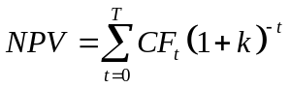
    - A CAPM cost of capital formula:
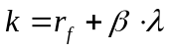
    - Graphs of the present value equation for different yields and different maturities of an annual cash flow of $1000.
      - At low yields, present values of cash flows of different maturities are quite different. At high yields the present values of the cash flows are closer together.
      - The longer the maturity of the cash flow, the greater the response of the present value of the cash flow to a change in its yield.
      - Ergo, when rates are low and capital goods have long lives, their values are most sensitive to changes in interest rates.

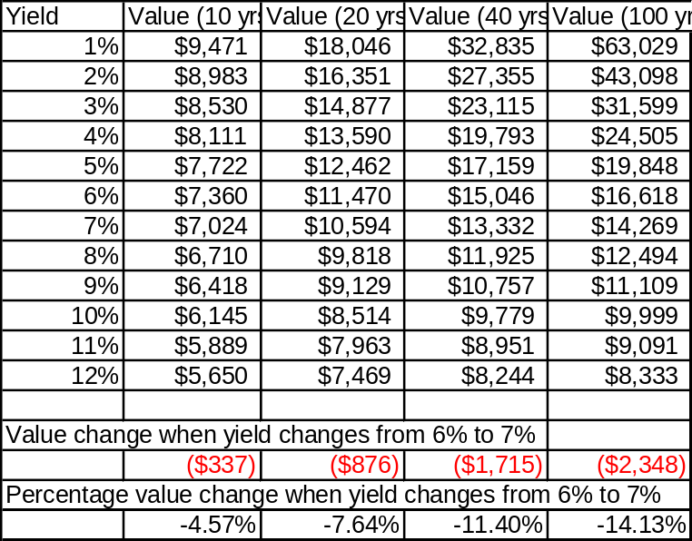
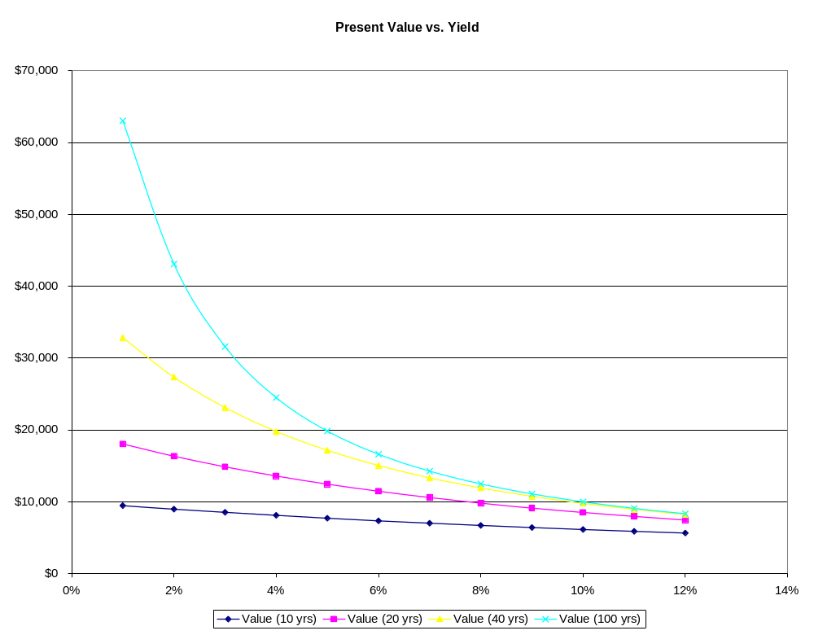
- Saving and consumption decisions
  - Saving = Asset accumulation
    - The more risk you take on your saving, the greater your average rate of return. The following chart uses annual data from 1926 – 2005.

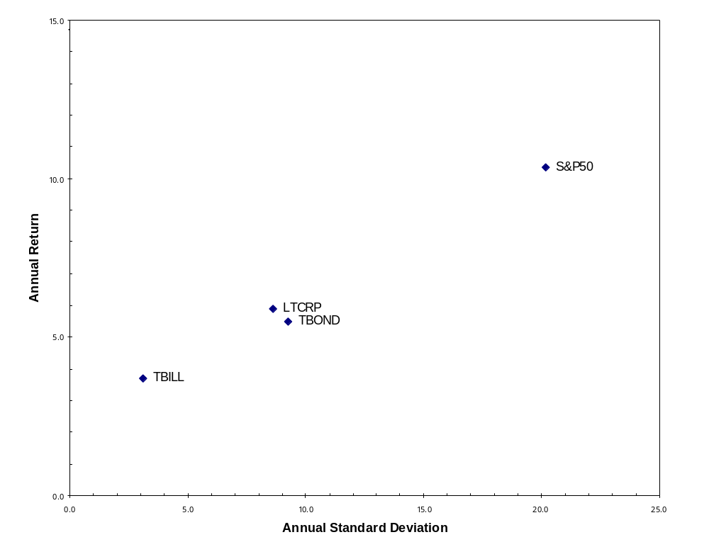

    - The longer you save the greater the accumulated benefit of compounding. (The miracle of compound interest) For each yield, compare the ratio of accumulated saving after 40 years to accumulated saving after 10 years. This shows the benefit to risk taking if it is properly priced. (Spreadsheet assumes the person saves $1000 per year)
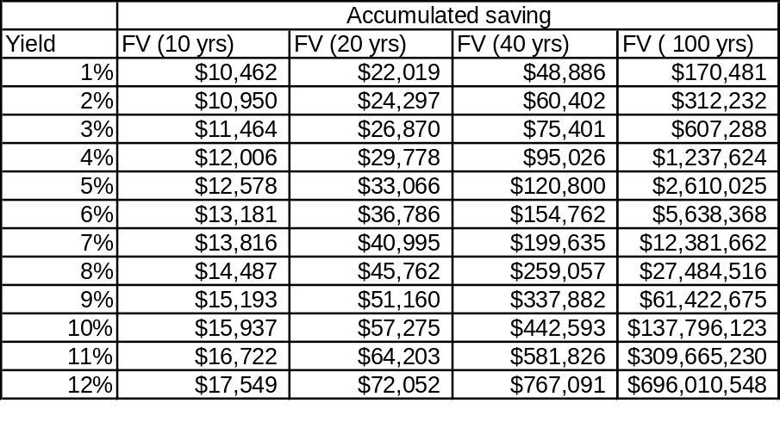

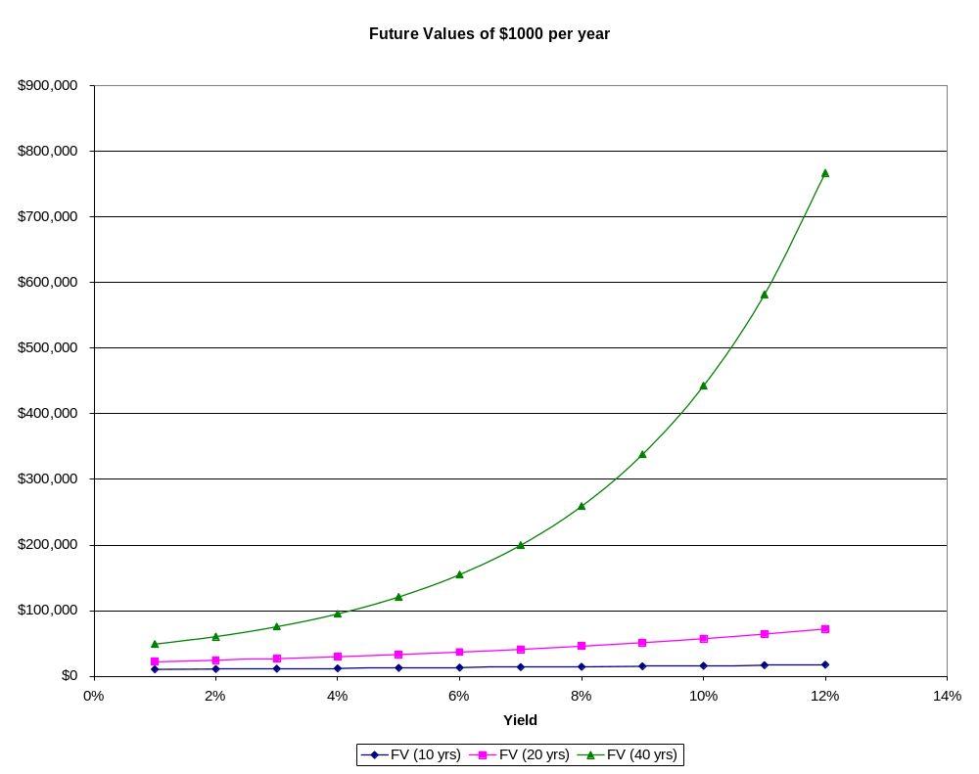

  - Dissaving = Asset withdrawal
    - Assumes the person saved $1000 per month at 6% for 40 years and accumulated $1,857,144 per the prior spreadsheet. Annual retirement income for 34 years of retirement is $131,496 per the following from www.dinkytown.net .



Retirement Income

Your retirement savings provides $9,585 per month after taxes and inflation.
According to your inputs, at age 66 your savings will provide $10,958 per month for 34 years. This is before taxes. After taxes you will have $9,883 per month. In today's dollars, this is equivalent to $9,585 with 3.10% annual inflation.
Savings can provide
Income of before taxes | $10,958 per month
Income of after taxes | $9,883 per month
Value of income today ( with 3.10% annual inflation) | $9,585

Retirement Income Results
Starting balance | $1,857,144
Annual contribution | $0
Current age | 65
Age of retirement | 66
Years of retirement | 34
Rate of return before retirement | 6.00%
Rate of return during retirement | 6.00%
Current tax rate | 25.00%
Retirement tax rate | 15.00%
Expected rate of inflation | 3.10%
Is this savings tax deferred? | no
Increase annual deposit with inflation? | yes
Total contributions | $0
Savings total before taxes | $1,940,715
Savings total after taxes | $1,940,715
Value of savings today | $1,882,362

Income Taxes
We estimate that you will owe 15.00% income tax on $1,075 of your monthly retirement income. This assumes that all of your investments were made after tax, and that you paid income taxes on any interest as it was earned. Any interest earned on your balance at retirement will also be subject to income taxes in the year the interest is earned.
Balances by year

Age | Investments | Interest | Taxes | Savings  Balance
65 | $0 | $111,429 | $27,857 | $1,940,715

© 1998-2008 KJE Computer Solutions, LLC
Financial Calculators at http://www.dinkytown.net
(612) 331-2291
1730 New Brighton Blvd. PMB #111
Minneapolis, MN 55413
KJE Computer Solutions, LLC's information and interactive calculators are made available to you as self-help tools for your independent use and are not intended to provide investment advice. We can not and do not guarantee their applicability or accuracy in regards to your individual circumstances. All examples are hypothetical and are for illustrative purposes. We encourage you to seek personalized advice from qualified professionals regarding all personal finance issues. More Information.

    - Now assume the interest rate the person earns during retirement decreases from 6% to 5%. Annual income decreases to $118,872. This is a 9.6% decrease in annual income.

Retirement Income

Your retirement savings provides $8,167 per month after taxes and inflation.
According to your inputs, at age 66 your savings will provide $9,906 per month for 34 years. This is before taxes. After taxes you will have $8,420 per month. In today's dollars, this is equivalent to $8,167 with 3.10% annual inflation.
Savings can provide
Income of before taxes | $9,906 per month
Income of after taxes | $8,420 per month
Value of income today ( with 3.10% annual inflation) | $8,167

Retirement Income Results
Starting balance | $1,857,144
Annual contribution | $0
Current age | 65
Age of retirement | 66
Years of retirement | 34
Rate of return before retirement | 6.00%
Rate of return during retirement | 5.00%
Current tax rate | 25.00%
Retirement tax rate | 15.00%
Expected rate of inflation | 3.10%
Is this savings tax deferred? | yes
Increase annual deposit with inflation? | yes
Total contributions | $0
Savings total before taxes | $1,968,573
Savings total after taxes | $1,673,287
Value of savings today | $1,622,975

Income Taxes
We estimate that you will owe 15.00% income tax on $9,906 of your monthly retirement income. This assumes that all of your investments were before taxes, and that you will pay income taxes on those investments as well as any interest when withdrawals are made. The remaining balance will still earn tax deferred interest. Please note, if your savings are in a Roth IRA, none of your withdrawals will be subject to income taxes.
Balances by year

Age | Investments | Interest | Taxes | Savings  Balance
65 | $0 | $111,429 | $0 | $1,968,573

© 1998-2008 KJE Computer Solutions, LLC
Financial Calculators at http://www.dinkytown.net
(612) 331-2291
1730 New Brighton Blvd. PMB #111
Minneapolis, MN 55413
KJE Computer Solutions, LLC's information and interactive calculators are made available to you as self-help tools for your independent use and are not intended to provide investment advice. We can not and do not guarantee their applicability or accuracy in regards to your individual circumstances. All examples are hypothetical and are for illustrative purposes. We encourage you to seek personalized advice from qualified professionals regarding all personal finance issues. More Information.

Overview of the Course
Interest Rate
Theory
Bid-Ask Spread
Theory
Yield Curve
Theory
Consequences
for Intermediaries
and Investors
Models of Financial Markets
The loanable funds market determines the risk-free, one-period rate.
The CAPM determines the equity risk premium.
The term structure determines the term premium for multi-period interest rate risk.
Information and transaction costs determine the bid/ask spread.
Interest Rate Theory

Risk Free Rate
Risk Premium
Real
Inflation
- Average GDP
Growth Rate
- Output Gap
- Variance of
Output Gap
Quantity Theory
- Average Money
Growth Rate
- Average GDP
Growth Rate
- Variance of
Inflation
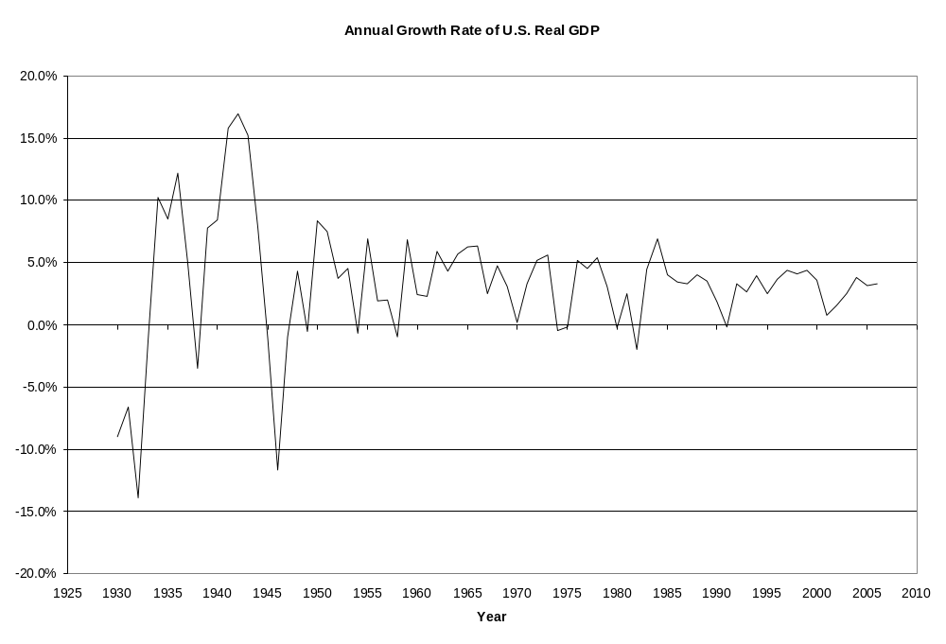
U.S. Real GDP Growth is Trendless
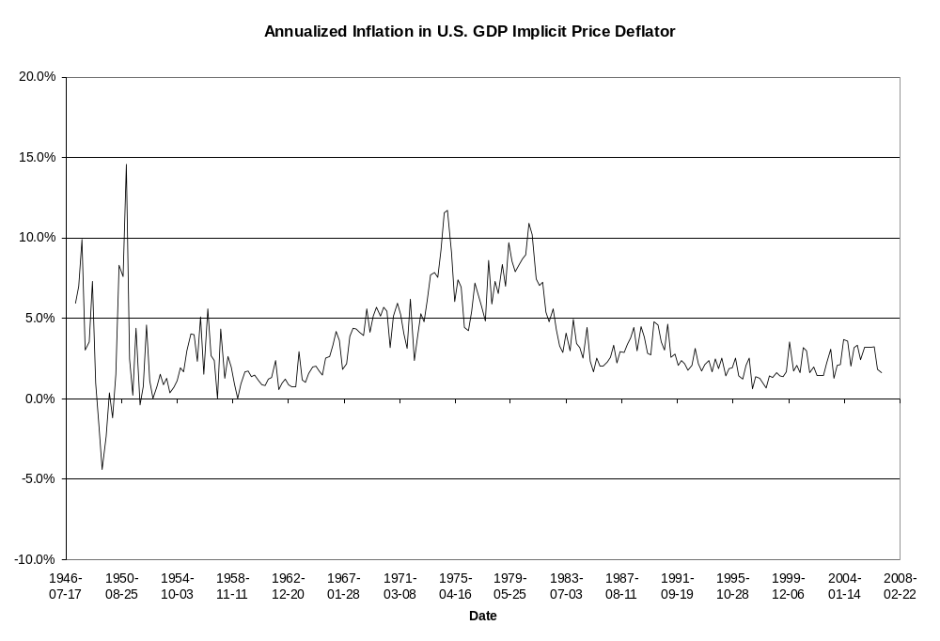
U.S. Inflation is Trendless
Yield Curve Theory
- Long term rate is average of expected future short term rates plus a term premium.
- Futures rates are unbiased forecasts
of future spot rates.
- Forward rates are biased forecasts of future spot rates.
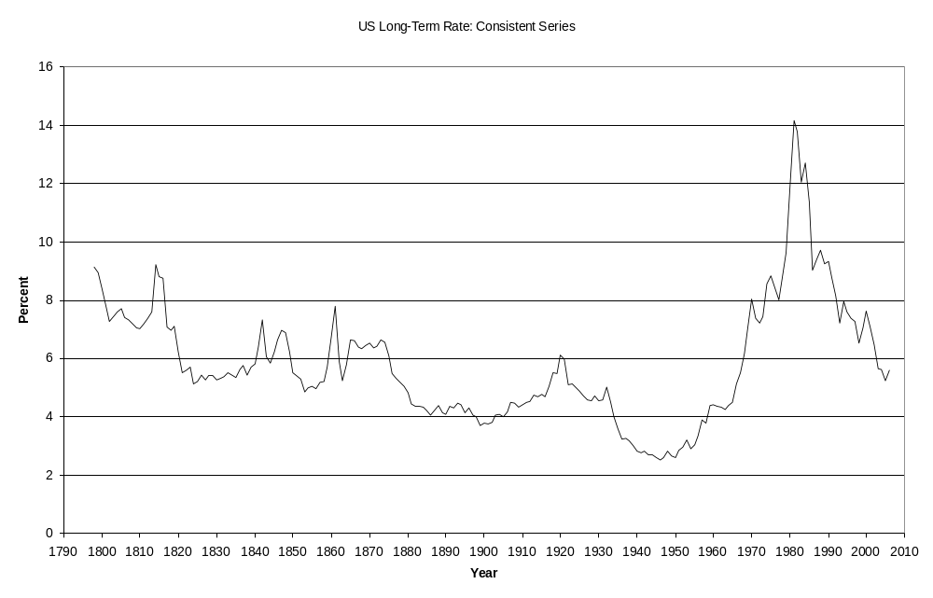
A long-term interest rate
Bid-Ask Spread Theory
- Spread is the average cost of
providing the ten financial services.
- Banks with the lowest efficiency ratio set the spread.
- Banks do not need to speculate on
the yield curve to be profitable.
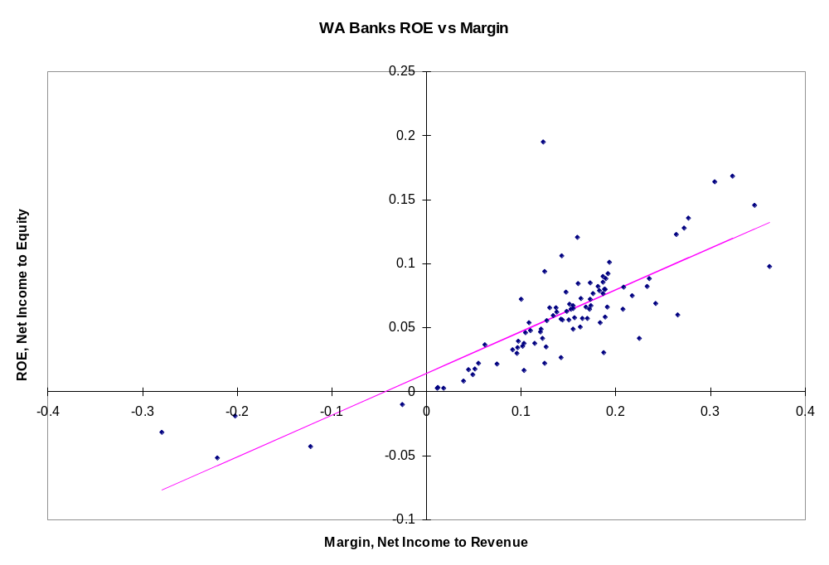
Margin drives ROE
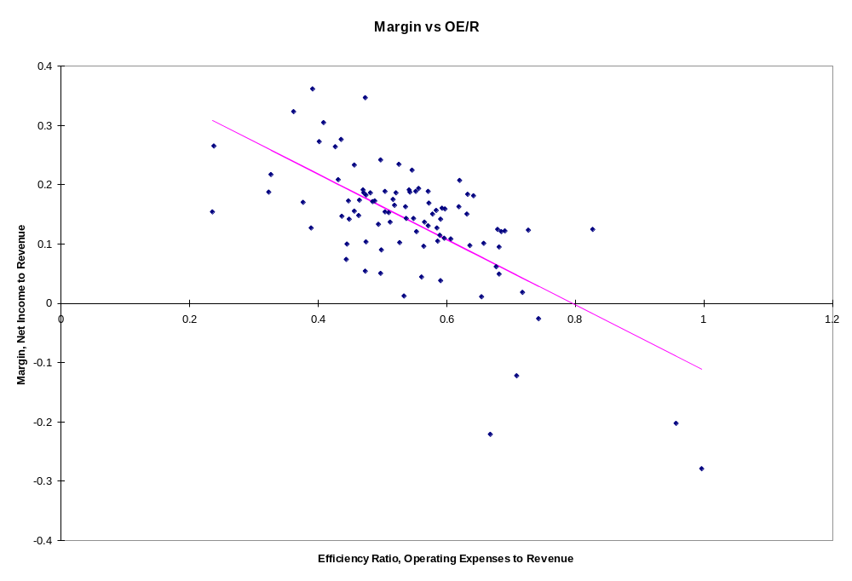
Efficiency Ratio Drives
Margin
Topic 1. Causes and Consequences of Changes in Interest Rates

U.S. businesses issue debt to fund 89 percent of their external financing.
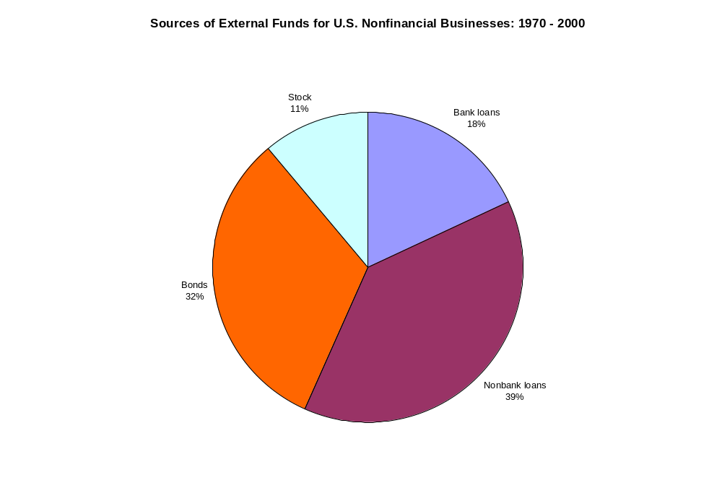
Source: Andreas Hackethal and Reinhard H. Schmidt, Financing Patterns:
Measurement Concepts and Empirical Results, No. 125, January 2004

The interest rate is the price of debt. In this course we study:
- Why interest rates vary through time and across securities, and
- Financial markets where interest rates are set by supply and demand.
Companies pay the yield to maturity when they issue debt. Yields vary considerably through time.

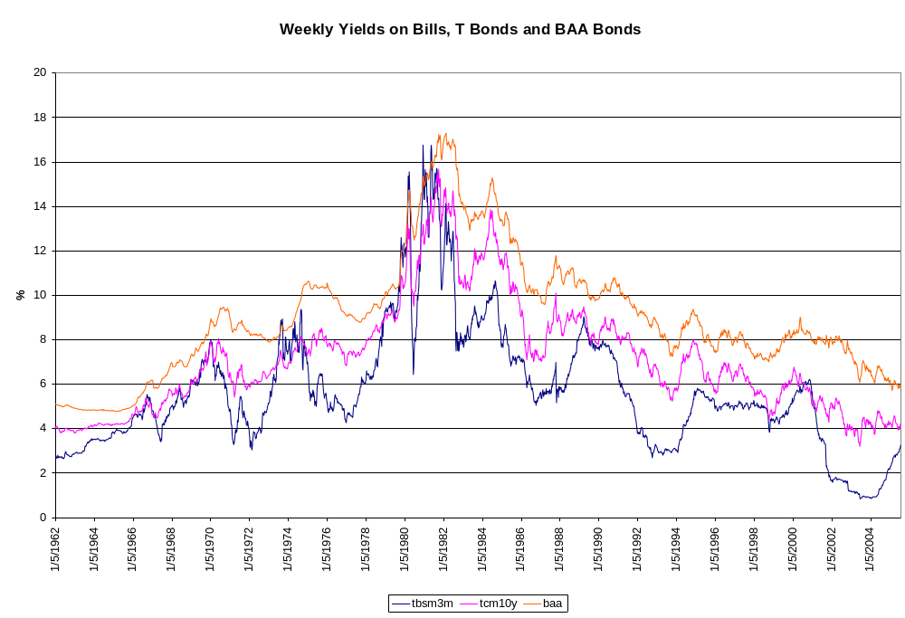
Source: Federal Reserve Statistical Release H.15

Yield to maturity is the internal rate of return on a cash flow stream. It is found from various versions of the formula: 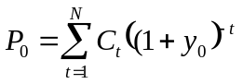. In the formula, P₀ is the price of the bond at date 0, which is now, C_{t} is the cash flow the bond pays at date t, which includes the coupon payments and the principal, y₀ is the bond’s yield to maturity, and N is the maturity of the bond, which means the number of periods between now and when the bond makes its last payment. If we know the bond’s maturity, coupon payments, and principal, all of which are specified in the bond contract, and if we know the current price of the bond, which we may be able to observe in the bond market, we can use the formula to determine the bond’s yield to maturity.
As we proceed we will learn to distinguish between real and nominal yields. The next graph shows the weekly yields on nominal and inflation-indexed (i.e. real) interest rates. Why do they differ? What does the upward trend suggest? Will the trend continue or reverse or just wither away? Why is the real rate so low? These are some of the types of questions we address in this course. During the course you will learn how to answer these questions.
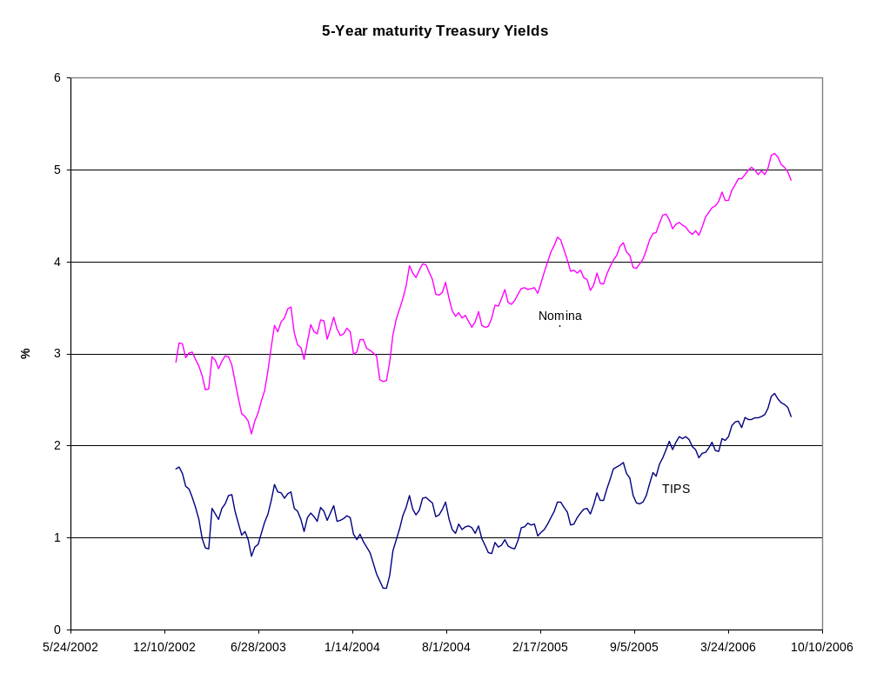
Here are real and nominal yields for Canada. Why the downward trend? Is it going to continue or cease? Why do the two rates differ? Why is the difference between the two rates not constant? How should the Canadian rates compare to the U.S. rates?
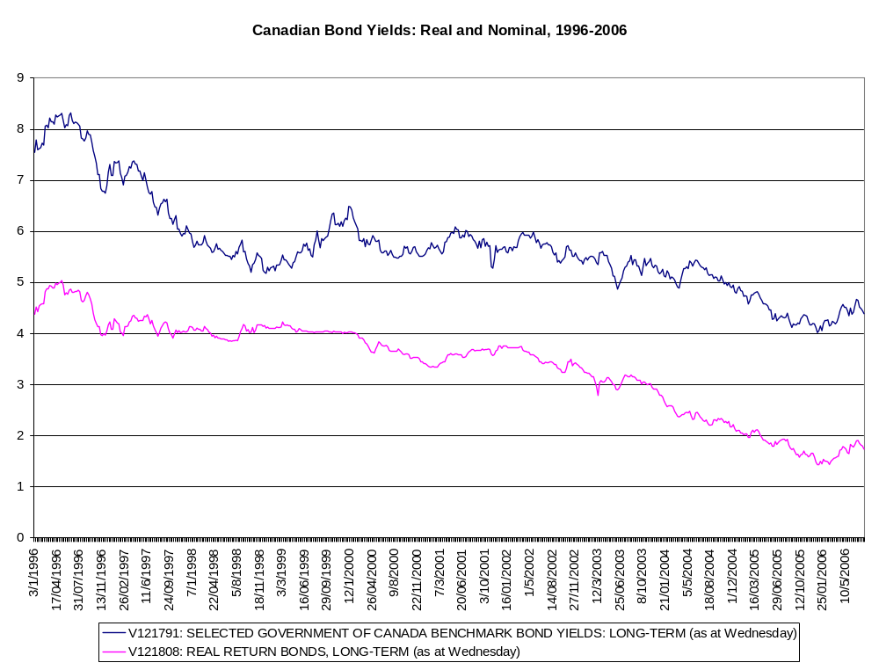

Because yields vary, borrowers may want to time when they issue debt. Are yields predictable from week to week? Here is one way to study the possibility that yields are predictable. The column labeled AC shows that the Bill yield in one week is almost equal to its yield in the previous week. You may think of the AC entries as one-variable regressions of this week’s Bill yield on last week’s yield, this week’s yield on the yield two weeks ago, this week’s yield on the yield three weeks ago, and so on. The column labeled PAC reports the regression coefficients of this week’s yield on last week’s yield, followed by this week’s yield on last week’s yield and the yield two weeks ago, and so on. Notice that once we have allowed for the effect of last week’s yield on this week’s yield, and the effect of two-weeks ago yield, the previous weeks’ yields do not affect this week’s yield.

Date: 08/17/06 Time: 11:01 TBSM3M (bill rate)
Sample: 1/05/1962 7/22/2005
Included observations: 2273
Autocorrelation | Partial Correlation |  | AC | PAC | Q-Stat | Prob
|******** | |******** | 1 | 0.997 | 0.997 | 2260.5 | 0.000
|******** | **| | | 2 | 0.992 | -0.239 | 4499.2 | 0.000
|******** | | | | 3 | 0.986 | -0.008 | 6714.4 | 0.000
|******** | | | | 4 | 0.980 | -0.044 | 8904.5 | 0.000
|*******| | *| | | 5 | 0.974 | -0.067 | 11067. | 0.000
|*******| | | | | 6 | 0.967 | -0.021 | 13201. | 0.000
|*******| | | | | 7 | 0.961 | 0.025 | 15306. | 0.000
|*******| | |* | | 8 | 0.954 | 0.075 | 17385. | 0.000
|*******| | | | | 9 | 0.948 | -0.001 | 19440. | 0.000
|*******| | | | | 10 | 0.943 | 0.015 | 21469. | 0.000
|*******| | | | | 11 | 0.937 | 0.011 | 23476. | 0.000
|*******| | | | | 12 | 0.932 | 0.014 | 25461. | 0.000
|*******| | | | | 13 | 0.926 | -0.037 | 27423. | 0.000
|*******| | | | | 14 | 0.921 | -0.014 | 29363. | 0.000
|*******| | |* | | 15 | 0.916 | 0.088 | 31283. | 0.000
|*******| | | | | 16 | 0.911 | -0.049 | 33182. | 0.000

The next table shows that weekly values of the three-month nominal Treasury bill rate are trend less and behave as a random walk. I will explain this in class. If you are not a PhD student you do not have to get excited about knowing the details as I use this table to set up the next set of tables, which you should understand.

Null Hypothesis: TBSM3M has a unit root
Exogenous: Constant, Linear Trend
Lag Length: 1 (Automatic based on SIC, MAXLAG=26)
 |  |  | t-Statistic | Prob.*
Augmented Dickey-Fuller test statistic |  |  | -2.628415 | 0.2675
Test critical values: | 1% level |  | -3.962087
 | 5% level |  | -3.411787
 | 10% level |  | -3.127780
*MacKinnon (1996) one-sided p-values.
Augmented Dickey-Fuller Test Equation
Dependent Variable: D(TBSM3M)
Method: Least Squares
Date: 08/17/06 Time: 10:33
Sample (adjusted): 1/19/1962 7/22/2005
Included observations: 2271 after adjustments
Variable | Coefficient | Std. Error | t-Statistic | Prob.
TBSM3M(-1) | -0.004167 | 0.001585 | -2.628415 | 0.0086
D(TBSM3M(-1)) | 0.271858 | 0.020205 | 13.45499 | 0.0000
C | 0.032655 | 0.013533 | 2.412999 | 0.0159
@TREND(1/05/1962) | -7.62E-06 | 6.70E-06 | -1.137459 | 0.2555
R-squared | 0.076058 | Mean dependent var |  | 0.000207
Adjusted R-squared | 0.074835 | S.D. dependent var |  | 0.214277
S.E. of regression | 0.206104 | Akaike info criterion |  | -0.319114
Sum squared resid | 96.29933 | Schwarz criterion |  | -0.309026
Log likelihood | 366.3545 | F-statistic |  | 62.20580
Durbin-Watson stat | 1.997676 | Prob(F-statistic) |  | 0.000000

The next three tables give estimates of the changes in yields from week-to-week. The formula is 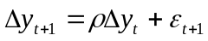 where ρ is the AR(1) coefficient in the tables. Note the intercepts do not differ from zero. Notice that the R² are rather low meaning that a lot of the changes in yields are not predictable. Notice the differences in the values of the standard deviations of the dependent variables. Weekly changes in Bill yields are most volatile, and weekly changes in BAA yields are less volatile.
Dependent Variable: D(TBSM3M) Weekly change in 3-month T-bill yield
Sample(adjusted): 1/19/1962 7/22/2005
Included observations: 2271 after adjusting endpoints
Variable | Coefficient | Std. Error | t-Statistic | Prob.
C | 0.000213 | 0.005934 | 0.035977 | 0.9713
AR(1) | 0.270285 | 0.020213 | 13.37201 | 0.0000
R-squared | 0.073049 | Mean dependent var |  | 0.000207
Adjusted R-squared | 0.072641 | S.D. dependent var |  | 0.214277
S.E. of regression | 0.206348 | Akaike info criterion |  | -0.317625
Sum squared resid | 96.61293 | Schwarz criterion |  | -0.312580
Log likelihood | 362.6627 | F-statistic |  | 178.8107
Durbin-Watson stat | 1.996386 | Prob(F-statistic) |  | 0.000000

Dependent Variable: D(TCM10Y) Weekly change in 10-year T-note yield
Sample(adjusted): 1/19/1962 7/22/2005
Included observations: 2271 after adjusting endpoints
Variable | Coefficient | Std. Error | t-Statistic | Prob.
C | 7.57E-05 | 0.003830 | 0.019771 | 0.9842
AR(1) | 0.285208 | 0.020122 | 14.17382 | 0.0000
R-squared | 0.081338 | Mean dependent var |  | 7.05E-05
Adjusted R-squared | 0.080933 | S.D. dependent var |  | 0.136089
S.E. of regression | 0.130466 | Akaike info criterion |  | -1.234534
Sum squared resid | 38.62126 | Schwarz criterion |  | -1.229490
Log likelihood | 1403.814 | F-statistic |  | 200.8971
Durbin-Watson stat | 1.977006 | Prob(F-statistic) |  | 0.000000

Dependent Variable: D(BAA) Weekly change in BAA yield
Sample(adjusted): 1/19/1962 7/22/2005
Included observations: 2271 after adjusting endpoints
Variable | Coefficient | Std. Error | t-Statistic | Prob.
C | 0.000417 | 0.002740 | 0.152011 | 0.8792
AR(1) | 0.433490 | 0.018919 | 22.91266 | 0.0000
R-squared | 0.187900 | Mean dependent var |  | 0.000396
Adjusted R-squared | 0.187542 | S.D. dependent var |  | 0.082068
S.E. of regression | 0.073973 | Akaike info criterion |  | -2.369345
Sum squared resid | 12.41607 | Schwarz criterion |  | -2.364301
Log likelihood | 2692.392 | F-statistic |  | 524.9901
Durbin-Watson stat | 2.007750 | Prob(F-statistic) |  | 0.000000
Let us say that despite the above evidence you were convinced that you could find a detectable pattern in interest rates that would allow you to time your sale of securities to get the lowest possible yield. You must choose a period of time over which to estimate your model of interest rates. I recommend that you use as much data as possible. But, let us say that you are only going to use data since October 1982 because you learned that the Federal Reserve changed monetary policy then. Let us settle on the sample period from the end of December 1982 through July 2005. Here is the regression. Note the low R². This means that changes in the Bill rate have little or no detectable pattern. Not much hope here for an accurate prediction.

Dependent Variable: D(TBSM3M)
Method: Least Squares
Date: 08/17/06 Time: 11:15
Sample: 12/31/1982 7/22/2005
Included observations: 1178
Variable | Coefficient | Std. Error | t-Statistic | Prob.
C | -0.003189 | 0.003125 | -1.020323 | 0.3078
D(TBSM3M(-1)) | 0.194295 | 0.028603 | 6.792901 | 0.0000
R-squared | 0.037756 | Mean dependent var |  | -0.003956
Adjusted R-squared | 0.036938 | S.D. dependent var |  | 0.109236
S.E. of regression | 0.107200 | Akaike info criterion |  | -1.626553
Sum squared resid | 13.51430 | Schwarz criterion |  | -1.617942
Log likelihood | 960.0395 | F-statistic |  | 46.14351
Durbin-Watson stat | 1.978132 | Prob(F-statistic) |  | 0.000000

Summary. Based on the empirical evidence presented above, interest rates are trend less over long periods of time, and they change randomly from day to day, week to week, and month to month. An acceptable theory of interest rates must imply these two features of interest rates: trend less with random changes.
The term premium is the difference between the yields on risk-free, zero-coupon, long-term securities minus the yield on a short-term security. Here is an empirical approximation to the term premium using the 10-year Treasury yield, which pays a semi-annual coupon, minus the three-month Treasury bill yield, which does not pay a coupon.

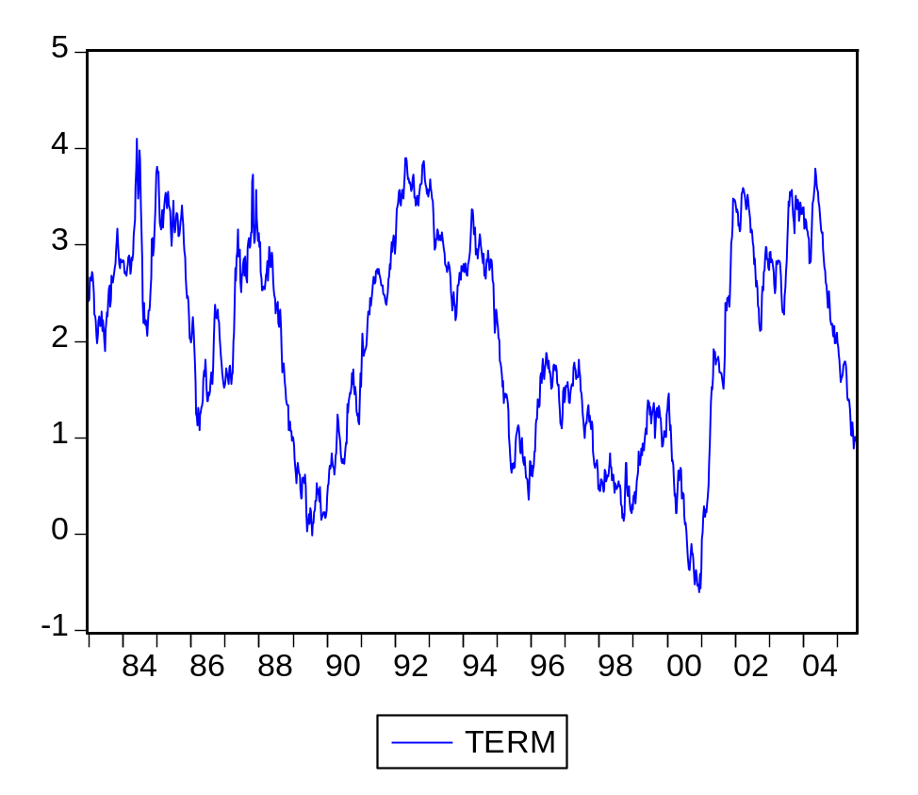
The term premium has a mean value of 2 percent and a standard deviation of 1.1 percent. Does the term premium look predictable to you? Here is the result of a unit root test.

We cannot reject the hypothesis that the term premium has a unit root. This means that its value today equals its value last week plus an autoregressive term plus a random error, which is large as the R² is small.

Null Hypothesis: TERM has a unit root
Exogenous: Constant
Lag Length: 1 (Automatic based on SIC, MAXLAG=22)
 |  |  | t-Statistic | Prob.*
Augmented Dickey-Fuller test statistic |  |  | -2.339773 | 0.1597
Test critical values: | 1% level |  | -3.435687
 | 5% level |  | -2.863784
 | 10% level |  | -2.568015
*MacKinnon (1996) one-sided p-values.
Augmented Dickey-Fuller Test Equation
Dependent Variable: D(TERM)
Method: Least Squares
Date: 08/24/06 Time: 11:50
Sample: 12/31/1982 7/22/2005
Included observations: 1178
Variable | Coefficient | Std. Error | t-Statistic | Prob.
TERM(-1) | -0.007354 | 0.003143 | -2.339773 | 0.0195
D(TERM(-1)) | 0.231892 | 0.028374 | 8.172587 | 0.0000
C | 0.013647 | 0.007153 | 1.907882 | 0.0567
R-squared | 0.056469 | Mean dependent var |  | -0.001426
Adjusted R-squared | 0.054863 | S.D. dependent var |  | 0.119756
S.E. of regression | 0.116425 | Akaike info criterion |  | -1.460599
Sum squared resid | 15.92681 | Schwarz criterion |  | -1.447683
Log likelihood | 863.2929 | F-statistic |  | 35.16102
Durbin-Watson stat | 1.978573 | Prob(F-statistic) |  | 0.000000

Here is an empirical regularity to be explained. When the bill rate increases from one week to the next, the term premium decreases. We will learn the loanable funds model of interest rates, which says that interest rates are set in competitive markets by the demands and supplies of many different savers and investors, both individuals and institutions such as mutual funds. The next regression shows that when investors decrease their demands for bills, which causes the bill rate to increase, they simultaneously increase their demands for longer-term Treasury securities, which causes the long-term Treasury yield to decrease. This causes the term premium to decrease. Why might investors behave this way?

Dependent Variable: D(TERM)
Method: Least Squares
Date: 08/24/06 Time: 14:00
Sample: 12/31/1982 7/22/2005
Included observations: 1178
Convergence achieved after 3 iterations
Variable | Coefficient | Std. Error | t-Statistic | Prob.
C | -0.003176 | 0.004115 | -0.771650 | 0.4405
D(TBSM3M) | -0.446867 | 0.028908 | -15.45813 | 0.0000
AR(1) | 0.246490 | 0.028277 | 8.716933 | 0.0000
R-squared | 0.212062 | Mean dependent var |  | -0.001426
Adjusted R-squared | 0.210721 | S.D. dependent var |  | 0.119756
S.E. of regression | 0.106393 | Akaike info criterion |  | -1.640809
Sum squared resid | 13.30040 | Schwarz criterion |  | -1.627893
Log likelihood | 969.4363 | F-statistic |  | 158.1168
Durbin-Watson stat | 1.981355 | Prob(F-statistic) |  | 0.000000
Inverted AR Roots | .25

An empirical approximation to the default premium is the spread between BAA corporate bond yield and the 10-year Treasury yield. Here is its graph. Its mean is 2.1 percent, it appears to be trend less and its standard deviation is 0.5 percent.

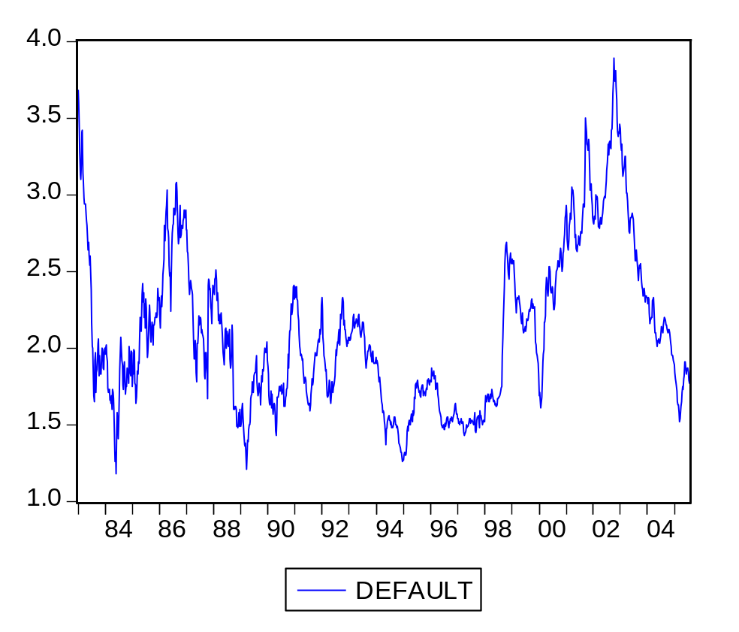
The default risk premium does not have a unit root.

Null Hypothesis: DEFAULT has a unit root
Exogenous: Constant
Lag Length: 1 (Automatic based on SIC, MAXLAG=22)
 |  |  | t-Statistic | Prob.*
Augmented Dickey-Fuller test statistic |  |  | -3.582761 | 0.0063
Test critical values: | 1% level |  | -3.435687
 | 5% level |  | -2.863784
 | 10% level |  | -2.568015
*MacKinnon (1996) one-sided p-values.
Augmented Dickey-Fuller Test Equation
Dependent Variable: D(DEFAULT)
Method: Least Squares
Date: 08/24/06 Time: 13:12
Sample: 12/31/1982 7/22/2005
Included observations: 1178
Variable | Coefficient | Std. Error | t-Statistic | Prob.
DEFAULT(-1) | -0.014609 | 0.004078 | -3.582761 | 0.0004
D(DEFAULT(-1)) | 0.149423 | 0.028738 | 5.199546 | 0.0000
C | 0.029382 | 0.008840 | 3.323927 | 0.0009
R-squared | 0.031474 | Mean dependent var |  | -0.001587
Adjusted R-squared | 0.029826 | S.D. dependent var |  | 0.073743
S.E. of regression | 0.072635 | Akaike info criterion |  | -2.404202
Sum squared resid | 6.199079 | Schwarz criterion |  | -2.391286
Log likelihood | 1419.075 | F-statistic |  | 19.09205
Durbin-Watson stat | 1.990724 | Prob(F-statistic) |  | 0.000000

Week to week changes in the default risk premium are negatively related to week-to-week changes in the bill rate and the term premium. Later in the quarter I might ask you to use the material presented in this class to explain this negative relationship. For now you should understand that when investors increase their demands for bills they

Dependent Variable: D(DEFAULT)
Method: Least Squares
Date: 08/24/06 Time: 13:51
Sample: 12/31/1982 7/22/2005
Included observations: 1178
Convergence achieved after 9 iterations
Variable | Coefficient | Std. Error | t-Statistic | Prob.
C | -0.004255 | 0.001886 | -2.256707 | 0.0242
D(TBSM3M) | -0.519776 | 0.013884 | -37.43671 | 0.0000
D(TERM) | -0.418410 | 0.012773 | -32.75850 | 0.0000
AR(1) | 0.279785 | 0.028051 | 9.974180 | 0.0000
R-squared | 0.601922 | Mean dependent var |  | -0.001587
Adjusted R-squared | 0.600905 | S.D. dependent var |  | 0.073743
S.E. of regression | 0.046586 | Akaike info criterion |  | -3.291632
Sum squared resid | 2.547908 | Schwarz criterion |  | -3.274411
Log likelihood | 1942.772 | F-statistic |  | 591.7246
Durbin-Watson stat | 1.982184 | Prob(F-statistic) |  | 0.000000
Inverted AR Roots | .28

While debt issuers may be interested in the yields they have to pay, debt buyers may be interested in the returns they earn. This is a key point. Make sure you understand it. Investors are unlikely to earn the yield. Instead, they receive a return that differs from the yield. Here are some returns.
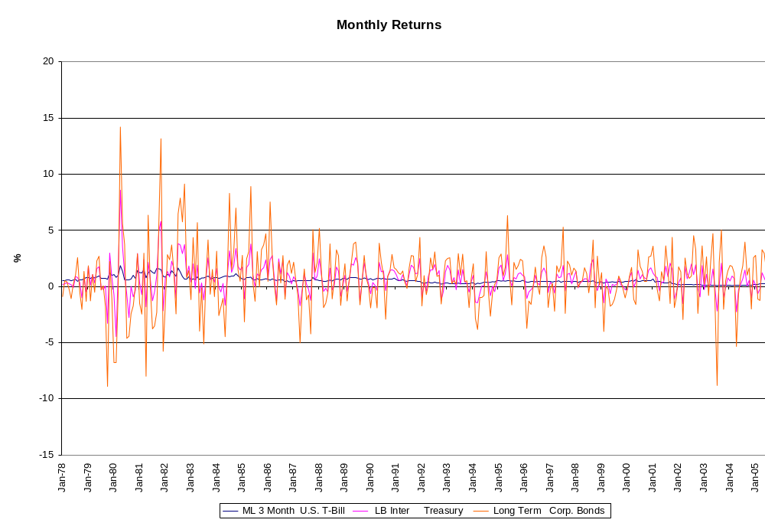
The holding period rate of return for a period of time is the sum of the coupon plus the price change all divided by the beginning price. 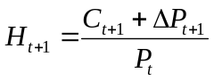.
If the yield to maturity increases, the price of a debt instrument decreases, and the holding period rate of return decreases. The holding period rate of return can be negative if the price decrease is greater than the coupon. Thus, while nominal yields are never negative, returns can be negative.
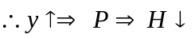

Here is why yields and returns are inversely related.

(1) Start with the formula for the price as it relates to the yield, cash flow and maturity.
- The return depends on the change in price.
- From the present value equation (1), as the yield increases the present value, which equals the price of an asset, decreases. From the return equation (2), as the price decreases, the return decreases. Thus, as the yield increases the return decreases.

Here is formal demonstration of the above conclusion.
- Differentiate the price with respect to the yield, holding maturity and cash flow constant.
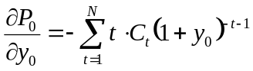
- To make this expression simpler, convert it to an elasticity. To do so, multiply both sides by 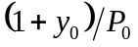. This gives the duration formula, where duration is the negative of the interest elasticity of price.
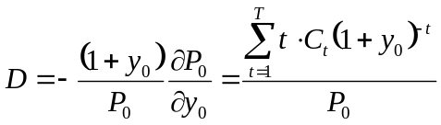
- We now rearrange the duration formula to give a discrete approximation to the percentage price change:
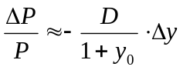
- Substitute (6) into (2). This shows that as the yield increases, the holding period return decreases.
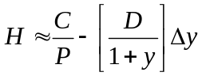
Are monthly holding period rates of return predictable? Here is some evidence. Note the low R²s.
1. The monthly return on a 3-month T bill equals last month’s return.
ADF Test Statistic | -1.726800 | 1% Critical Value* |  | -3.4523
 |  | 5% Critical Value |  | -2.8706
 |  | 10% Critical Value |  | -2.5716
*MacKinnon critical values for rejection of hypothesis of a unit root.
Augmented Dickey-Fuller Test Equation
Dependent Variable: D(TBILL) Monthly change in 3-month bill return (DFA)
Sample(adjusted): 1978:06 2005:07
Included observations: 326 after adjusting endpoints
Variable | Coefficient | Std. Error | t-Statistic | Prob.
TBILL(-1) | -0.045013 | 0.026067 | -1.726800 | 0.0852
D(TBILL(-1)) | -0.368659 | 0.057110 | -6.455273 | 0.0000
D(TBILL(-2)) | -0.360147 | 0.059345 | -6.068704 | 0.0000
D(TBILL(-3)) | -0.177574 | 0.058301 | -3.045837 | 0.0025
D(TBILL(-4)) | -0.240994 | 0.054336 | -4.435254 | 0.0000
C | 0.022604 | 0.016071 | 1.406508 | 0.1605
R-squared | 0.214855 | Mean dependent var |  | -0.000828
Adjusted R-squared | 0.202587 | S.D. dependent var |  | 0.149862
S.E. of regression | 0.133824 | Akaike info criterion |  | -1.166350
Sum squared resid | 5.730832 | Schwarz criterion |  | -1.096652
Log likelihood | 196.1150 | F-statistic |  | 17.51362
Durbin-Watson stat | 1.950075 | Prob(F-statistic) |  | 0.000000

2. The monthly return on a T note is 68 basis points plus it depends on its returns in the two prior months.
Dependent Variable: TNOTE Monthly return on T Note (DFA)
Sample(adjusted): 1978:04 2005:07
Included observations: 328 after adjusting endpoints
Variable | Coefficient | Std. Error | t-Statistic | Prob.
C | 0.677323 | 0.076507 | 8.853052 | 0.0000
AR(1) | 0.198379 | 0.055665 | 3.563810 | 0.0004
AR(2) | -0.102835 | 0.056456 | -1.821524 | 0.0694
AR(3) | -0.017576 | 0.055653 | -0.315810 | 0.7523
R-squared | 0.043827 | Mean dependent var |  | 0.677713
Adjusted R-squared | 0.034974 | S.D. dependent var |  | 1.300506
S.E. of regression | 1.277562 | Akaike info criterion |  | 3.339904
Sum squared resid | 528.8212 | Schwarz criterion |  | 3.386160
Log likelihood | -543.7443 | F-statistic |  | 4.950277
Durbin-Watson stat | 1.996847 | Prob(F-statistic) |  | 0.002252

3. The monthly return on BAA corporate bonds is 81 basis points plus it depends on last month’s return.
Dependent Variable: BAA
Sample(adjusted): 1978:04 2005:07
Included observations: 328 after adjusting endpoints
Variable | Coefficient | Std. Error | t-Statistic | Prob.
C | 0.811436 | 0.154707 | 5.244988 | 0.0000
AR(1) | 0.135311 | 0.055593 | 2.433948 | 0.0155
AR(2) | -0.086953 | 0.055910 | -1.555238 | 0.1209
AR(3) | -0.049250 | 0.055612 | -0.885596 | 0.3765
R-squared | 0.027230 | Mean dependent var |  | 0.812378
Adjusted R-squared | 0.018223 | S.D. dependent var |  | 2.830241
S.E. of regression | 2.804335 | Akaike info criterion |  | 4.912330
Sum squared resid | 2548.031 | Schwarz criterion |  | 4.958586
Log likelihood | -801.6221 | F-statistic |  | 3.023175
Durbin-Watson stat | 1.997884 | Prob(F-statistic) |  | 0.029846

Investors are interested in the return they can receive from owning an asset relative to the risk they bear in owning it. Here is a chart of realized annual returns versus the annual standard deviation or returns. Even Treasury bills and notes are not risk free. They both have interest rate risk. Bills have reinvestment risk and notes have price risk.
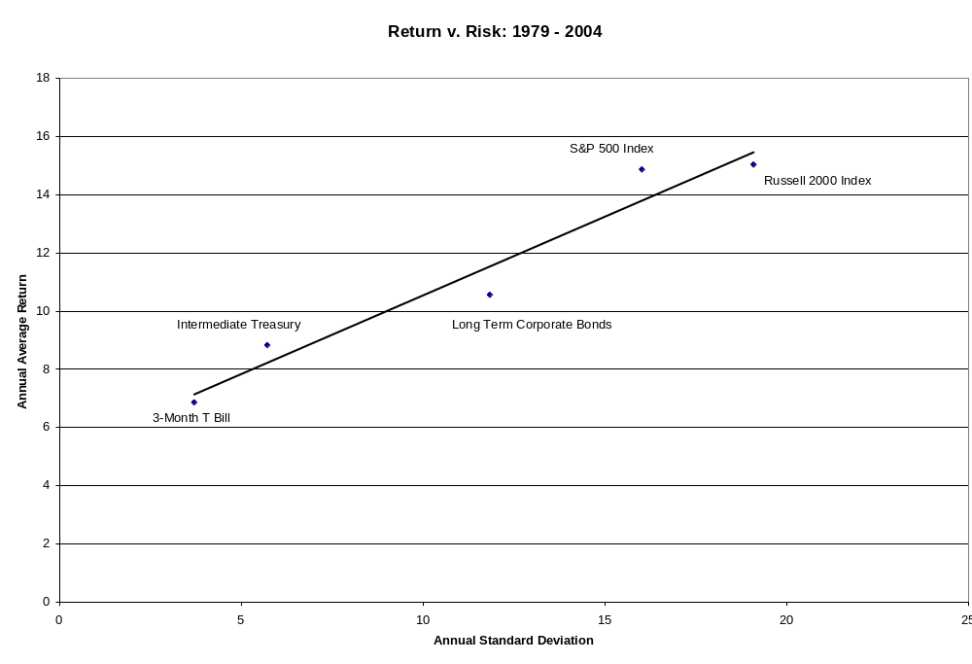
A focus of this course is to understand the causes, consequences, and management of interest rate risk.
Note that for the T-bill the annual return is more predictable than the weekly yield, but for the T-note and BAA bond the returns are less predictable than the yields. This is because of the differences in their durations. The duration of a 3-month T-bill is 0.25 years. The duration of a 10-year T-note that yields 6 % is about 3.8 years. Thus, the T-note’s duration is about 16 times that of the T-bill. This larger duration makes the T-note a riskier asset than the T-bill. The corporate bond has default risk in addition to interest rate risk. If the default risk premium changes the corporate bond’s yield changes as does its return.
Here is a final point to note. The risk of a default-free security depends on the risk of changes in interest rates. This is shown from the holding period rate of return equation, which is
. We can measure the interest rate risk of the holding period rate of return by
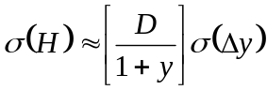. Longer duration assets have greater interest rate risk.
Course Overview in One Set of 3 Graphs

The preceding material introduces you to the volatility of yields and returns. The graphs on the following page summarize what you will learn in this class that will assist you to understand why yields and returns are volatile.

- The loanable funds model of the interest rate.
  - The effects of investment financing, government deficits and changes in the demand for money on the demand for credit and the interest rate.
  - The effects of saving and changes in the money supply on the supply of credit and the interest rate.
  - Various interest rates
    - The natural interest rate
    - The money interest rate
    - The nominal interest rate
- The bid-to-asked spread
  - Value added by financial markets
  - Information costs
  - Transaction costs
- Risk premiums
  - The amount of risk
  - The unit price of risk
- Term structure of interest rates
  - Expectations theory
  - Risk premiums

Loanable Funds Market
Borrowing and Lending
CPM
Risk
Term Structure
Maturity
%
%
%
B
L
CML
Yield curve
Spread
Risk free rate
Term premium
Equity premium
Borrowing and Lending
%
%
%
B
L
Alan Hess
June 1995
Models of Financial Markets
The loanable funds market determines the risk-free, one-period rate.
Information and transaction costs determine the bid/ask spread.
The CAPM determines the equity premium for one-period systematic risk.
The term structure determines the term premium for multi-period interest rate risk.
Loanable Funds Market
CAPM
Risk
Term Structure
Maturity
CML
Yield curve
Spread
Risk free rate
Term premium
Equity premium

A Loanable Funds Model of the Natural Interest Rate
©Alan C. Hess, 2005

      - Based on the empirical evidence, an acceptable theory of interest rates must imply that interest rates are trend less over long periods of time and change randomly. Fortunately, the loanable funds/rational expectations model of interest rates that I present in these notes has these two implications. Over long periods of time the demand and supply of credit grow at about the same rate, and as a result, interest rates are trendless. Over short periods of time the demand and supply of credit change randomly, and this causes interest rates to change randomly.
      - In the loanable funds model, the real interest rate, which is the interest rate that exists if expected inflation is zero, is determined by equality between the demand for and supply of loanable funds, also called borrowing, B, and Lending, L.
B = L
        - The demand for loanable funds is the sum of external financing for investment, I, plus government borrowing, which is government spending, G, minus taxes, T, plus increases in the demand for money, which Keynes called liquidity preference, Lp.
B = I + (G – T) + ΔLp
        - The supply of loanable funds is the sum of saving, S, plus increases in the real money supply, ΔM^{s}/P.
L = S + ΔM^{s}/P.
        - The loanable funds model says that the interest rate will adjust until investment borrowing plus deficit financing plus additions to money balances equal saving plus changes in the real money supply. The credit market clearing relationship is:
I + (G – T) + ΔLp = S + ΔM^{s}/P.

      - To proceed in an understandable manner, we analyze each component of borrowing and lending and then integrate them into the loanable funds model. We start with saving, which is the difference between current income, X₀, and current consumption, C₀.
S = X₀ – C₀.
        - Current income is determined outside the financial market and is considered to be a given amount that the saver cannot change by his or her current saving and consumption choices.
        - The challenge is to understand how households determine how much to consume each year and in total present value over their lifetimes. We now take a timeout from the constraints of this summary to explain the modern theory of consumption and saving.
The Modern Theory of Consumption and Saving
©Alan C. Hess, 2005
The modern theory of consumption is a revival of the classical theory of saving that Fisher (1930) developed. Fisher was overshadowed by Keynes’ (1936) theory, which captured the forefront when he presented it and drove the classical theory into temporary recess. Franco Modigliani (1954) who wrote the Life Cycle Hypothesis, and Milton Friedman (1957) who wrote the Permanent Income Hypothesis, each won Nobel prizes for reviving and extending Fisher’s classical theory.
The two main features of the modern theory of consumption are (1) people save now to consume later and thus plan ahead, and (2) if people can borrow and lend, the present value of their lifetime consumption is constrained to be less than or equal to their beginning financial and real wealth plus the present value of their future labor earnings.
The following graph displays these two features for a household that plans for the current period and one future period and leads us to several conclusions about the economic variables that affect consumption and therefore saving.
Here is the setup of Fisher’s model:
- Each household starts with an endowment consisting of current income and future income. Young households have endowments with small current income and large future income. Old households have endowments with high current income and low future income.
- If the household can borrow and lend in a perfect financial market, we can draw a two-period, intertemporal budget constraint through the endowment. The slope of the budget constraint is –(1+r) where r is the real interest rate. Moving up the constraint from the endowment means reducing consumption below current income, which is saving. Moving down the constraint below the endowment means consuming more than current income, which is borrowing.
- Each household has preferences for current and future consumption, which are shown by a set of indifference curves (only one is shown on the graph). Each household determines its optimal consumption by finding the combination of current and future consumption that gets it to the indifference curve that is tangent to the budget constraint. The tangency point is determined by the household’s rate of time preference, which is its willingness to trade-off current and future consumption. Households with a high rate of time preference is a preference for current consumption have a tangency down to the right on the budget constraint. Households with a low rate of time preference have a tangency up to the left on the budget constraint. Many households are about in the middle of their budget constraint because they borrow and lend to smooth consumption.
- Each household determines its saving as the residual between its endowed current income and its optimal current consumption.

Here are some key implications of Fisher’s model:
- Consumption depends on the intercept and slope of the budget constraint and the curvature of the indifference curve. Thus, consumption depends on wealth, which is the intercept, the interest rate, which is the slope, and the rate of time preference, which is the curvature of the indifference curve.
- Changes in the endowment that do not change wealth do not change consumption. To see this, move the endowment up the budget constraint past the consumption plan. Note that the tangency point does not change. Thus, consumption does not change. All that changes is the household that was formerly a saver is now a borrower. Thus, consumption does not depend directly on current income as in Keynes’ model. Because consumption does not change if wealth does not change, holding the interest rate and preferences constant, saving must change. Thus, changes in the endowment that do not change wealth change saving on a one-to-one basis.
- Permanent income is the amount that could be consumed forever. It is the annuity equivalent of wealth. This is Friedman’s idea.
- Actual income, X, is permanent income, X_{P}, plus a transitory deviation, X_{T}, of actual income from permanent income. X = X_{P} + X_{T}. Also Friedman’s idea.
- Consumption is approximately proportional to permanent income. C = αX_{P}.
- Transitory income does not affect wealth and hence does not affect consumption. It affects saving on a one-to-one basis. S = (1-α)X_{P} + X_{T}.
- Saving grows through time with permanent income, and it fluctuates randomly because of transitory income.

Indifference curve between current and future consumption

Future consumption
Saving times one plus the interest rate
Optimal consumption plan

Future income
Endowment
Saving
Two date budget constraint

Current income
Consumption
Wealth

Ph.D. students might find the following paper interesting: http://papers.ssrn.com/sol3/papers.cfm?abstract_id=1086365#PaperDownload

End of the subset on the modern theory of consumption.
We now discuss the external financing of investment, which is based on the NPV rule.

The Rate of Return, Cost of Capital, and Growth Opportunities
©Alan C. Hess 2005

The Standard Analysis

Irving Fisher's (1930) theory of investment opportunities provides a framework for analyzing how much a business enterprise should invest in productive assets. A productive asset is an asset that is used in the production of other goods and services. Bonbright (1937) credits Fisher with developing the concept that the value of any asset is the present value of the expected future cash flows that the asset generates or has a claim to. Figure 1 illustrates this concept. An enterprise has both current and future cash flows from its existing assets. The distance B0 on the horizontal, or present value, axis represents the current cash flow from assets-in-place. The distance B1 on the vertical, or future value, axis represents the expected future cash flow from assets-in-place. To determine the present value of the assets-in-place, project a straight line with slope equal to -(1+k), where k is the cost of capital for the assets-in-place, through the combination of current and future cash flow at point B0,B1. The horizontal intercept of this line is point C. The distance from the origin to C is the present value of the assets-in-place. The value of assets-in-place is the value of the realized current cash flow, B0, plus the present value of the future cash flow, 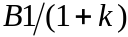. Thus, 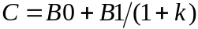.
Next, assume that the enterprise has investment opportunities shown by the concave line labeled IOS, which stands for investment opportunity set. The IOS shows the additional future cash flow from each additional unit of current investment. The slope of this line at any point is -(1+r) where r is the rate of return on the investment. The future cash flow from investment increases at a decreasing rate as prescribed by the law of diminishing marginal returns. This is why the IOS is concave.
The enterprise starts with the cash flow from its assets-in-place at point B0,B1 and must decide how much of its current cash flow to invest to increase its future cash flow. At point B0,B1, the IOS is steeper than the cost of capital line. That is, the rate of return from investing in new plant and equipment is greater than the cost of capital, r>k. Thus, the firm invests. The value-maximizing firm continues to invest by moving up the IOS. As investment increases, the rate of return decreases. Eventually, the firm reaches the point r=k, where the cost of capital line is tangent to the IOS. At this point it stops investing since additional investments have r<k. The firm invests the amount B0-A0 and receives an increase in its expected future cash flow from B1 to A1. This investment increases the value of the firm from C to D. The cum investment value of the firm, D, has two components. One component is A0 the remaining current cash flow after investment. The other component is the present value of the future cash flow. It is the horizontal distance D-A0. Equivalently, the value of the firm after investment is the value of assets-in-place C before investment plus the net present value of the investment D-C.
Notice that even though r=k for the last unit of investment, the investment increases the value of the firm from C to D. Thus, it is incorrect to say that if r=k for an investment, the investment does not increase value. Analysts must distinguish the last or marginal unit of investment, the one for which r=k, from the inframarginal units of investment, the ones for which r>k. Investment in the inframarginal units increases wealth. But, all discrete sized investments are inframarginal investments. Thus, even though r=k, investment increases wealth. Stated differently, if the firm continues to increase the size of the investment until its marginal rate of return equals the cost of capital, the investment will increase the value of the firm's assets.
An implication of this analysis is that the cost based approach to valuation understates the discounted cash flow value of the enterprise. The original value of the assets-in-place was C. The discounted cash flow value of the assets after investment is D. However, the original cost value of assets after investment is E. The cost of the newly constructed assets is B0-A0. By construction, the distance from C to E is the same as the distance from A0 to B0. An appraiser using the cost approach would value the firm at E. An appraiser using the discounted cash flow approach would value the firm at D. Since D exceeds E, the cost approach to value produces a valuation that is less than the value from the discounted cash flow approach.

Table 1 shows a sample calculation of the marginal rate of return to investment. The first column shows the investment, and the second column shows the output that the investment can produce. In accord with the law of diminishing marginal returns, output increases at a decreasing rate as more investment is undertaken. The third column shows the marginal rate of return on the investment. It is the incremental output divided by the incremental investment required to produce it. 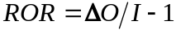 The marginal rate of return declines as investment increases. The fourth column is the net present value NPV of the investment assuming the utility's cost of capital is 15%. 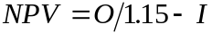. Net present value first increases as investment increases, it reaches a peak at 5 units of investment, and then decreases for investments past 5 units. The value maximizing utility invests in 5 additional units of plant and equipment. The net present value of this investment is $2.43. At 5 units of investment, the marginal rate of return is equal to the cost of capital, and the net present value of the investment is positive. This is because the marginal rate of return is greater than the cost of capital for all units of investment up to the 5th unit. This table demonstrates the point of this paper that investment adds value even though the rate of return on the investment equals the cost of capital.

Summary

The statement that if the rate of return to an investment equals the cost of capital then the investment does not increase the value of the firm is not universally correct. If the law of diminishing marginal returns holds, the rate of return on the last unit of investment equals the cost of capital, and the rates of return on all the previous units of investment exceed the cost of capital. It is through these inframarginal units that investments increase the value of the firm.
References

Bonbright, James C. The Valuation of Property, vol. I. New York: McGraw-Hill, Inc., 1937.

Fisher, Irving. The Theory of Interest. New York: Augustus M. Kelley, 1965.

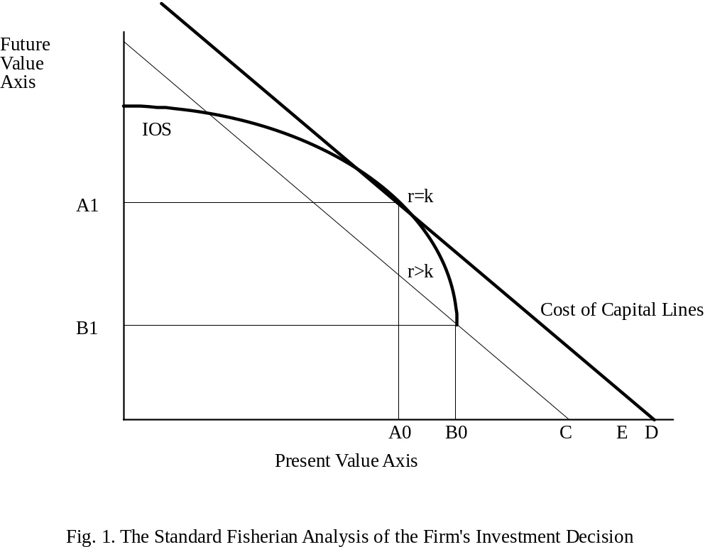

B0 is the cash flow this period from assets-in-place.
B1 is the cash flow next period from assets in place.
C is the present value of assets-in-place.
IOS is the investment opportunity set showing the future returns from investment.
B0 to A0 is the investment that maximizes value.
D-C is the net present value of the investment.
A0 is the marginal investment for which r=k.
B0 up to A0 are inframarginal investments for which r>k.
D is the value of the firm after investment. The sum of the values of asset-in-place plus the net present value of the investment.

Table 1. Calculation of the Rate of Return to Investment

Investment | Output | ROR | NPV@15%
1 | 3.00 | 3.00 | 1.61
2 | 4.71 | 0.71 | 2.09
3 | 6.13 | 0.42 | 2.33
4 | 7.39 | 0.26 | 2.42
5 | 8.54 | 0.15 | 2.43
6 | 9.61 | 0.07 | 2.36
7 | 10.63 | 0.01 | 2.24
8 | 11.59 | -0.04 | 2.08
9 | 12.51 | -0.08 | 1.88
10 | 13.40 | -0.11 | 1.65

Output is calculated as 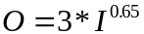. The rate of return is the change in output divided by the change in investment minus 1, . The net present value is the present value of output at 15% minus the investment necessary to produce the output,

Next we extend the analysis to incorporate risk.
Certainty Equivalent Investment

©Alan C. Hess, November 8, 1995

We can estimate the net present value of an investment in two ways. We can either discount the expected cash flows at the risk-adjusted cost of capital, or we can discount the certainty-equivalent expected cash flows at the risk-free cost of capital. The two procedures properly applied yield the same result. This note shows the equivalence of the two approaches using the CAPM to represent the cost of capital.

Using standard notation, the expected rate of return on the jth project is
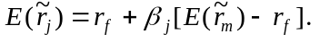 (1)
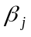, the systematic risk of the asset or project, is the slope of the regression of the project’s rate of return on the market’s rate of return.
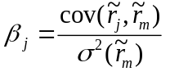. (2)

We measure the one-period rate of return as the cash payoff, 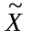, minus the amount invested, I, divided by the amount invested.
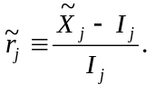 (3)

As an interim step, substitute the definition for the rate of return, equation (3) into equation (1) to obtain
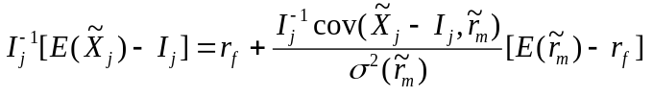. (4)
Since the investor knows the current investment, I_{j}, its covariance with any random variable, such as the return on the market, is zero. Multiply both sides of (4) by I_{j} to obtain
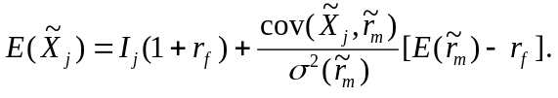 (5)
Subtract the risk premium from both sides of (5) to obtain
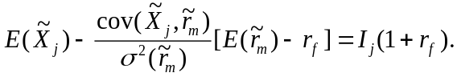 (6)
The left-hand-side of equation (6) is the risk-adjusted, expected cash flow. It is the certainty-equivalent cash flow. It is the expected cash flow minus the cost of its risk. The cost of its risk is its beta times the equity premium. Equation (6) shows that an investor with an amount of money I_{j} is indifferent between lending it at the risk free rate or investing it in the risky project.

The present value of the risky project is the present value of the certainty equivalent cash flow discounted at the risk free interest rate.
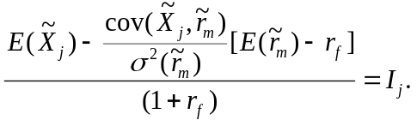 (7)
We can either discount the certainty-equivalent cash flow at the risk free rate, or the expected cash flow at the risk-adjusted rate.

End of the subset on investment.

I use the certainty-equivalent cash flow in the loanable funds model to determine the natural interest rate. If the risk of the project or the market price of risk increases, the certainty equivalent cash flow decreases. We show this in the loanable funds diagram by shifting the certainty-equivalent investment schedule to the left. We also shift the certainty-equivalent saving schedule to the left since it is the savers who are bearing the risk. This leads to a decrease in savers’ and investors’ surpluses and a decrease in the value added by financial markets.
We now return to the loanable funds model that we left above.
      - I develop the loanable funds model in stages. In this first stage I am assuming there is no government. Thus, there is no money, and no monetary or fiscal policies. The interest rate in this simple world is called the natural rate of interest. It is set by market equilibrium between saving and investment. Using the saving and investment functions we developed,
S = I
S = (1-α)X_{P} + X_{T}.
Therefore, (1-α)X_{P} + X_{T} = 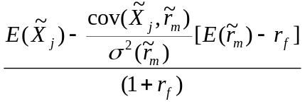
      - Both saving and investment depend on the interest rate and exogenous variables, which are transitory income, permanent income, expected future income, risk and the risk premium, λ. Equating saving to investment gives a formula for the interest rate in terms of the exogenous variables.
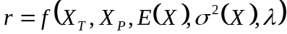
        - An increase in transitory income increases saving by an equal amount, which causes the interest rate to decrease.
        - An increase in permanent income increases saving by a small amount, which causes the interest rate to decrease by a small amount.
        - An increase in expected future income increases investment, which causes the interest rate to increase. This may also affect permanent income, which can cause consumption to increase and saving to decrease. This causes an additional increase in the interest rate.
        - The loanable funds model treats investment as risk-less so for now we will ignore the amount of risk and the risk premium.
        - If income is at full employment, the resulting interest rate is called the natural interest rate.
      - This version of the loanable funds model predicts the effects of changes in income, which we can equate to real GDP, on real interest rates.

        - We can approximate the realized real interest rate by subtracting the rate of inflation from the yield on Treasury bills. As the following chart shows, the rate is volatile but trend-less. Rates do not go up and up, they go up and down. The realized rate can be negative even though we think the expected real rate is usually positive.
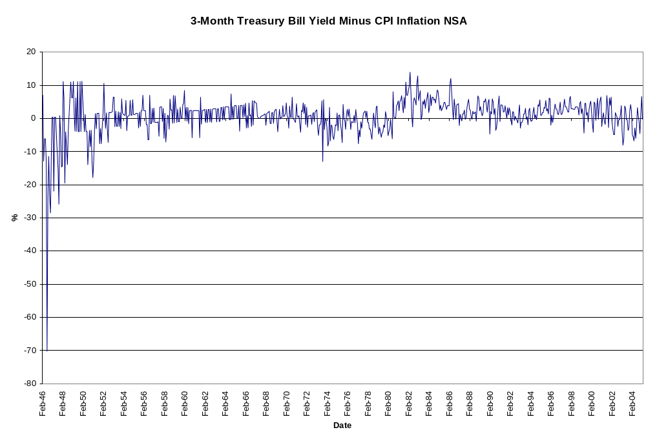
        - If the PIH-CAPM version of the loanable funds model is to explain the lack of trend in the realized real interest rate, it must explain why saving and investment grow at the same average rate. The following table summarizes the subsequent analysis.
Income Change | Saving Change | Investment Change | Interest Rate Change
Expected income | Negative | Positive | Positive
Realized income | Positive | No change | Negative

        - First, we consider a change in expected income.
          - Because wealth is the present value of current and expected future income, an increase in expected future income increases current wealth. When wealth increases, so does consumption. However, current income is unchanged. Thus, people increase their current consumption by reducing their saving. This causes the interest rate to increase.
          - The increase in expected future income may also increase the net present values of investment projects. If so, current investment increases, which causes the interest rate to increase.
          - If people are accurate forecasters, when they expect their future income to increase, in the future their actual incomes will be higher. Because they expected the income increase, when it occurs it does not change wealth or future expected income. Thus, it has no further effects on consumption or investment. Instead, people save the realized increase in their income. This causes the interest rate to decrease. So, first rates increase and then they decrease. Overall, over time they are trend-less.
        - Next we consider a change in unexpected income.
          - Realized income is the sum of expected income plus a random forecast error. Sometimes the error is positive and sometimes it is negative. Let us assume that the forecast error is purely random and has no information about the future.
          - In this case, when income is greater than expected, people do not revise their forecasts of their future income. Hence, their consumption and investment do not change. Only saving changes. It increases by the amount of the unexpected increase in income.
          - If the income forecast errors are purely random, over long periods of time positive errors and negative errors offset each other. Thus, saving increases and decreases randomly, and the ups and downs cancel each other eventually. As a result, the interest rate goes up and down but it does not stay up or stay down. It is trend-less.
        - Now we consider a more advanced case. What if an unexpected increase in income causes us to expect our future income will increase? This gives us two immediate effects.

If a forecast error is thought to be a one-time event, it does not change expected future income. However, it changes wealth by the forecast error. Since consumption in every period is a normal good, the change in wealth is spread over lifetime consumption. The effect on current consumption is small. At most it would be the product of the real interest rate times the forecast error in income times the marginal propensity to consume. Thus, most of the unexpected income goes to saving. If expected future income is unchanged, investment is unchanged. If income is larger than expected, saving increases, and the real interest rate falls. If income is less than expected, saving falls and the real interest rate increases. In short, unexpected changes in income have a positive effect on saving and a negative effect on the real interest rate.

Expected future income must be approximated. Some researchers model income as having a deterministic trend. If it has a deterministic trend, deviations of income from trend are self-reversing. Future income variations are limited to random fluctuations around the trend line. There may be a short-run cyclical pattern to these changes. but they do not require huge revisions in expected income. Consequently, a change in current income signals a small change in the ratio of current income to wealth and has little effect on the interest rate.

Other researchers view income as being a random walk with a drift. If income is a random walk, every change in current is permanent and future income starts from the new value of current income. Each change in current income requires a large revision in future incomes. Consequently, a change in current income signals a large change in the ratio of income to wealth and leads to a large change in the interest rate.

FRBSF ECONOMIC LETTER Number 2003-32, October 31, 2003

The Natural Rate of Interest
A key question for monetary policymakers, as well as participants in financial markets, is: “Where are interest rates headed?” In the long run, economists assume that nominal interest rates will tend toward some equilibrium, or “natural,” real rate of interest plus an adjustment for expected long-run inflation.

Unfortunately, the “natural” real rate of interest is not observable, so it must be estimated. Monetary policymakers are interested in estimating it because real rates above or below it would tend to depress or stimulate economic growth; financial market participants are interested because it would be helpful in forecasting short-term interest rates many years into the future in order to calculate the value and, therefore, the yields of long-term government and private bonds. This Economic Letter describes factors that influence the natural rate of interest and
discusses different ways economists try to measure it.

Defining the natural rate of interest
In thinking about the natural rate of interest, economists generally focus on real interest rates. They believe that movements in those rates, more so than in nominal rates, influence businesses’ decisions about investment spending and consumers’ decisions about purchases of durable goods, like refrigerators and cars, and new housing, and, therefore, economic growth.
Over 100 years ago, Wicksell defined the natural rate this way:
There is a certain rate of interest on loans which is neutral in respect to commodity prices, and tends neither to raise nor to lower them. (1936 translation from 1898 text, p. 102.)

Since then, various definitions of the natural rate of interest have appeared in the economics literature. In this Letter, the natural rate is defined to be the real fed funds rate consistent with real GDP equaling its potential level (potential GDP) in the absence of transitory shocks to demand. Potential GDP, in turn, is defined to be the level of output consistent with stable price inflation, absent transitory shocks to supply. Thus, the natural rate of interest is the real fed funds rate consistent with stable inflation absent shocks to demand and supply. (Note: Professor Hess prefers that you think of the natural rate as the rate on Treasury Inflation Indexed Securities.)

This definition of the natural rate takes a “long-run” perspective in that it refers to the level expected to prevail in, say, the next five to ten years, after
any existing business cycle “booms” and “busts” underway have played out. For example, the U.S. economy is still at a relatively early part of its recovery from the 2001 recession, so the natural rate refers not to the real funds rate expected over the next year or two, but rather to the rate that is expected to prevail once the recovery is complete and the economy is expanding at its potential growth rate.

Figure 1 shows what determines the natural rate in a stylized form. The downward-sloping line, called the IS (investment = saving) curve shows the negative relationship between spending and the real interest rate. The vertical line indicates the level of potential GDP, which is assumed to be unrelated to the real interest rate for this diagram. (In principle, potential GDP is also a function of the real rate, but this modification does not affect the basic point.) At the intersection of the IS curve and the potential GDP line, real GDP equals potential, and the real interest rate is the natural rate of interest.

Importantly, the natural rate of interest can change, because highly persistent changes in aggregate supply and demand can shift the lines. For example, in a recent paper, Laubach (2003) finds that increases in long-run projections of federal government budget deficits are related to increases in expected long-term real interest rates; in Figure 1, an increase in long-run projected budget deficits would be represented by a rightward shift in the IS curve and a higher natural rate. In addition, economic theory suggests that when the trend growth rate of potential GDP rises, so does the natural rate of interest (see Laubach and Williams (2003) for supporting evidence).

Measuring the natural rate of interest
Although it is relatively straightforward to define the natural rate of interest, it is less straightforward to measure it. If the natural rate were constant over time, one might estimate it simply by averaging the value of the real funds rate over a long period. For example, the average real fed funds rate over the past 40 years has been about 3%, so if history were a good guide, then one would expect real interest rates to return to 3% over the next five to ten years.

But predicting the natural rate using a long-term average is akin to using a baseball player’s lifetime batting average to predict his batting average over the next season. This makes sense only if the likelihood of getting a hit doesn’t change much over a career. In reality, the factors that affect a baseball player’s performance—experience, age, and the quality of opponent pitching—change from year to year. For example, Barry Bonds’s batting average over the past three seasons was well above his career average, suggesting an important change in the factors that determine whether Barry gets a hit. The leap in performance is even greater when looking at his home run hits: over the past three years, he has hit home runs at a rate over 50% higher than during the rest of his career. Indeed, Barry Bonds’s performance during the 2003 season was much closer to his record over the past three seasons than his career statistics would predict, showing that long-term averages can be misleading predictors.

The same logic of time variation in batting averages of baseball players applies to the natural rate of interest. The factors affecting supply and demand evolve over time, shifting the natural rate around. If these movements are sufficiently large, the long-term average could be a poor predictor of the natural rate of interest.

One way to allow for structural changes that may influence the natural rate of interest is to compute averages of past values of the real funds rate while putting less weight on older data. Figure 2 illustrates such a calculation, taking the average over the past five years. Other more sophisticated statistical approaches identify the natural rate by using weighted averages of past data, and they yield plots similar to those in the figure.

Although such averaging methods tend to work well at estimating the natural rate of interest when inflation and output growth are relatively stable, they do not work so well during periods of significant increases or declines in inflation when real interest rates may deviate from the natural rate for several years. For example, during the late 1960s and much of the 1970s, inflation trended steeply upward, which suggests that the real funds rate was below the natural rate on average. The averaging approach misses that point, however, and ascribes this pattern of low real rates to a low natural rate.

Estimating the natural rate of interest with an economic model
Since the averaging approach does not work well when interest rates deviate from the natural rate
for long periods, economists also use other economic variables to estimate the natural rate. For
example, Bomfim (1997) estimated the location and slope of the IS curve and potential output
shown in Figure 1 using the Federal Reserve Board’s large-scale model of the U.S. economy, and thereby derived estimates of the natural rate of interest. In terms of the baseball analogy, these methods try to estimate some aspect of a player’s abilities, taking into account the effects of relevant observable characteristics, say, the player’s age and the quality of the opposing pitcher.

Laubach and Williams (2003) use a simple macroeconomic model to infer the natural rate from
movements in GDP (after controlling for other variables, including importantly, the real fed funds
rate). In their model, if the real fed funds rate is above the natural rate, monetary policy is contractionary, pulling GDP down, and, if it is below the natural rate, monetary policy is stimulative, pushing GDP up.

An important component of their procedure is a statistical technique known as the Kalman filter; this method works on the principle that you partially adjust your estimate of the natural rate of interest based on how far off the model’s prediction of GDP is from actual GDP. If the prediction proves true, you do not change your estimate of the natural rate. If, however, actual GDP is higher than predicted, then monetary policy probably was more stimulative than you had thought, implying that the difference between the real fed funds rate and the natural rate of interest was more negative than you thought. The estimate of the natural rate goes up by an amount proportional to the GDP prediction error, or “surprise.” If GDP is lower than predicted, the estimate of the natural rate is lowered. This procedure is designed to allow for the possibility of a change in the natural rate and also to protect against overreacting to every short-term fluctuation in GDP.

The final estimate for the natural rate of interest that Laubach and Williams get for mid-2002 is
about 3%, coincidentally not far from the historical average of the real funds rate (Figure 2). But,
for other periods, the estimates range from a little over 1% in the early 1990s to over 5% in the late 1960s.The high estimates in the late 1960s reflect the fact that output was growing faster than expected, given the history of real interest rates and the prevailing estimates of the natural rate of interest. The natural rate estimates fell during the early 1990s owing to the slow recovery from the recession of 1990–1991 even with low real fed funds rates.

These results show that the procedure for estimating the natural rate using the Kalman filter was not “fooled” by the period of the late 1960s and 1970s, but instead recognized it as one of excessive growth and inflationary pressures resulting from real rates that lay well below the true natural rate of interest. Similarly, it was not fooled by the early 1980s into thinking that the natural rate had increased sharply because policy had tightened; instead, it recognized that real rates well above the natural rate had contributed to the slowing of economic activity and, in fact, had little longer-term implications for real interest rates.

Conclusion
Economists have made progress in estimating the natural rate of interest in recent years. But they have not yet hit a “home run.” For example, although the Kalman filter has proven its usefulness in this effort, it is important to note that the resulting estimates are not very precise; that is, from a statistical viewpoint, we cannot be confident that these estimates are correct. Furthermore, as Orphanides and Williams (2002) point out, these estimates are sensitive to the choice of statistical methods, which further obscures our ability to measure the natural rate of interest accurately.
John C.Williams

Senior Research Advisor
References
Bomfim,Antulio. 1997.“The Equilibrium Fed Funds Rate and the Indicator Properties of Term-Structure
Spreads.” Economic Inquiry 35(4), pp. 830–846.
Laubach,Thomas. 2003.“New Evidence on the Interest Rate Effects of Budget Deficits and Debt.” Board of
Governors of the Federal Reserve System,FEDS Working Paper 2003-12 (April). http://www. federalreserve.gov/pubs/feds/2003/200312/200312pap.pdf.
Laubach,Thomas, and John C.Williams. 2003.“Measuring the Natural Rate of Interest.” The Review of Economics and Statistics 85(4) (November).
Orphanides, Athanasios, and John C.Williams. 2002. “Robust Monetary Policy Rules with Unknown
Natural Rates.” Brookings Papers on Economic Activity, 2, pp. 63–145.
Wicksell, Knut. 1936. Interest and Prices (tr. of 1898 edition by R.F. Kahn). London: Macmillan.

This publication is edited by Judith Goff, with the assistance of Anita Todd. Permission to reprint portions of articles or whole articles must be obtained in writing. Permission to photocopy is unrestricted. Please send editorial comments and requests for subscriptions, back copies, address changes, and reprint permission to: Public Information Department, Federal Reserve Bank of San Francisco, P.O. Box 7702, San Francisco,CA 94120, phone (415) 974-2163, fax (415) 974-3341, e-mail sf.pubs@sf.frb.org
Fiscal Policy Components, Alan Hess

Government spending
Consumption goods
Investment goods
Private investment goods
Public investment goods
National defense
Environment
Legal system
Optimal level of spending

-Taxes
Lump sum
Income taxes
Optimal tax rate, Laffer curve
Optimal changes in the tax rate, incentive effects
Multiple taxation of corporate revenue
Sales taxes

Deficit
Determining factors
Expensing capital outlays
Consolidating state and local budgets
Business cycle effect
Full employment deficit and growing out of the deficit
Inflation effect
Interest expense as a pass through
Financing
Monetizing
Issuing government debt
Effects on interest rates
Crowding out
Ricardo effect
Effects on exchange rates
Debt=Accumulated Deficit
A brief summary of the effects of fiscal policy on interest rates

If the federal government runs a deficit, what affect if any will it have on saving, investment, and interest rates?
- A common sense benchmark answer.
Do you know about LIBOR? Do you know that much of the U.S. debt is held in other nations? Are you willing to assume that interest rates are set in international financial markets? Some of these markets are in London, Singapore, Tokyo, and New York City. In 2004, net debt securities issued worldwide totaled $1.6 trillion dollars. http://www.bis.org/publ/qtrpdf/r_qt0503c.pdf. The United States government’s deficit in 2004 was 1.6 billion. http://research.stlouisfed.org/fred2/data/TGDEF.txt. U.S. government’s deficit to total debt issued worldwide was 0.1% in 2004. If someone posits that the U.S. deficit can affect U.S. interest rates, he or she either must be thinking that U.S. debt is not sold worldwide, or has not looked up these data. Based on these data, I am dubious that the U.S. deficit affects interest rates.

- A more complicated answer called Ricardian equivalence. (Check out the references on www.dogpile.com )
  - If the U.S. government increases its spending it gets the money to buy the new goods and services either by raising taxes, borrowing, or printing money. Let us skip the money printing possibility for now.
  - If the government raises taxes, peoples’ after tax incomes decrease by the amount of the tax increase.
  - If the government takes the money raised by taxes and distributes it to people, their after tax incomes increase by the amount of government spending.
  - The tax increase and the government spending increase offset each other leaving no change in their after tax incomes. Thus, wealth and consumption do not change. Neither does saving or the interest rate.
            - Effects of Change in Balanced Budget Government Spending
on the Real Interest Rate: The Case of Private Goods
©Alan C. Hess, 2005

1. ΔT>0→ΔS<0
Lending Schedule

Market Rate
Natural Rate

2 ΔG>0→ΔS>0
Borrowing Schedule

Assume the government increases taxes.
- The increase in taxes reduces households’ disposable incomes from X to X - T. Because saving equals disposable income minus consumption, the tax increase reduces households’ disposable income and saving. The saving schedule shifts to the left by the amount of the tax increase, and the market interest increase above the natural rate. ΔT>0→ΔS<0→Δr>0
- The government buys and distributes goods to people who would have bought the goods for themselves. This is equivalent to an increase in households’ disposable incomes from X – T to X – T + G = X, the beginning disposable income before the fiscal policy action. The saving schedule shifts back to where it was. The market rate returns to the natural rate.
ΔG>→ ΔS>0→Δr<0

Effects of Change in Balanced Budget Government Spending
on the Real Interest Rate: The Case of Public Goods
©Alan C. Hess, 2005

1. ΔT>0→ΔS<0

Lending Schedule

Market Rate

Natural Rate

MRR↑→B↑

Borrowing Schedule
2. PV(ΔT)→ΔW<0)→ΔC<0)→ΔS>0

Assume the government increases taxes and spends the revenue on public goods.
      - The tax increase reduces households’ disposable income from X to X – T. They decrease their saving. This shifts the saving schedule to the left, and the market interest rate rises above the natural interest rate.
      - The present value of the increased future taxes reduces households’ wealth and their consumption. The reduction in consumption causes an increase in saving by the marginal propensity to save out of wealth. If this is less than one, on net saving is lower than before the tax increase. Thus, the market rate is above the natural rate.
      - The government pays for the production and distribution of public goods that people would not produce privately. Public goods may increase the marginal productivity of private capital. If so, investment demand increases as the borrowing schedule shifts to the right. This causes the market rate to exceed the natural rate.

Effects of fiscal surprises on real interest rates: Summary
©Alan C. Hess, November 5, 1999

- A Keynesian textbook view. If the federal government spends (G) more than it taxes (T), it issues debt in the amount G-T. The debt issue increases total borrowing in the economy, which increases the interest rate.

- Ricardian equivalence says that if the government runs a deficit this period, it must increase future taxes by an amount whose present value equals the current deficit. The increased tax liability leads long-horizon households, this means those who care about their descendants, to increase their current saving. The households use this saving and the interest they earn on it to pay their increased future taxes. The present value of their future tax liability equals the current deficit. Thus, households increase their saving by the deficit. The increased saving causes the interest rate to decrease to the natural rate. On net, increased saving offsets the effect of deficit financing on interest rates leaving rates unchanged.

- The composition of government spending approach says that government spending on public goods increases interest rates but government spending on private goods does not affect the interest rate.

  - By Ricardian equivalence the deficit does not affect interest rates. Thus, we can start our analysis by assuming that the government increases spending and taxes by equal amounts. This means there is no deficit. In the Keynesian approach, no deficit means the increase in government spending has no effect on interest rates. In contrast, the Ricardian approach says that the increase in taxes reduces saving, which causes the interest rate to increase. This starting point is critical. You may be used to starting your analysis by assuming that an increase in government spending increases total borrowing relative to total saving. This is not the Ricardian approach. In the Ricardian approach, an increase in government spending reduces private saving. The question is whether households and business will take any subsequent action that offsets the effect of this tax-induced decrease in saving on interest rates.

  - If the government spends its increased tax revenues on private consumption, households reduce their private consumption and increase their private saving. This secondary increase in saving offsets the initial tax-induced decrease in saving. On net the interest rate is unchanged.

Why does it work this way? A household’s optimal private consumption depends on its private wealth. Nothing in the analysis has changed private wealth. Thus, optimal private consumption has not changed. Households view the government spending on consumption as an increase in their in-kind income. Since their wealth has not changed they save an amount of their private income that equals the increase in their in-kind income. Government spending on private consumption replaces private consumption thereby freeing up households to increase their saving.

  - If the government spends its increased tax revenues on private investment goods, companies reduce their investment and borrowing. The reduction in external financing by companies reduces the interest rate. The initial tax-induced decrease in saving is offset by the secondary reduction in private investment by businesses. This leaves the interest rate unchanged.

Why does it work this way? Government spending has not changed the economy’s set of investment projects. All that has happened is that the government is financing some of them through its tax revenues. This reduces the number of positive NPV private investment projects remaining in which businesses can invest. Increased government financing of investment implies decreased private financing of investment.

  - If the government spends its tax revenues on public goods, it affects neither private saving nor private investment. Thus, the tax-induced decrease in saving is not offset by either an increase in private saving or a decrease in private investment. As a result, the interest rate increases.

Why does it work this way? Public goods are non-exclusive and non-rival. Non-exclusive means that once public goods exist, they are freely available for all. Non-rival means that the consumption of a public good by one person does not reduce the consumption of another good. Public goods do not substitute for private goods.

Public goods do not substitute for private consumption. Hence, they do not affect saving.

Public goods do not substitute for private investment. Hence, they do not affect the external financing of investment by businesses.

Since public goods do not affect private saving or investment, they do not offset the tax-induced decrease in private saving. Thus, an increase in government spending on public goods increases the interest rate.
Effects of Unexpected Changes in the Growth Rate of the Money Supply on Interest Rates

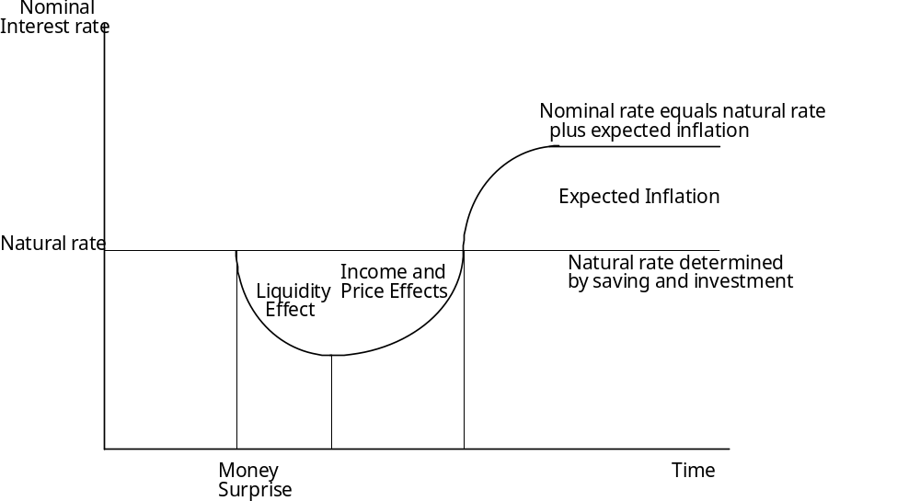
            - Initially inflation is zero, the economy is at full employment, and the nominal rate equals the money rate, which equals the natural rate.
            - Liquidity effect: The Federal Reserve increases the growth rate of the money supply. This increases the supply of loanable funds, which causes the money interest rate to decrease below the natural rate.
            - Income effect: The lower interest rate has two effects. (1) It causes more investment projects to have positive NPVs. Investment borrowing increases and the money interest rate increases. (2) It increases wealth (the PV of future income). This increases consumption and reduces saving, which further increases the money interest rate.
            - Price effect: Both investment demand and consumption demand for goods as increased, but the economy was at full employment so supply of goods cannot increase. As a result prices increase and the real stock of money decreases. This causes the money interest rate to increase back to the natural rate.
            - Expected inflation effect: If the growth rate of the money supply continues to exceed the growth rate of real GDP, prices continue to rise. Savers demand an inflation premium to compensate them for the loss of purchasing power when they save. This causes the nominal rate to increase above the natural rate by the rate of inflation.
Connections Among Nominal and Real Interest Rates and Inflation
Alan C. Hess

Money in hand now, M₀
Goods in hand now, I₀
Money in hand at end of period, M₁

Goods in hand at end of period, C₁

Current price level P_{k,0}
Real interest rate, r₀
Inflation rate, (P₁/P₀)-1

Nominal interest rate, R₀

Price level at end of period, P_{c,1}

There are two routes through which an individual or business can convert current money holdings into future consumption.

1. Use money now to invest in capital goods that produce output in one period.
The current rate of exchange between money and capital goods is the current price of capital goods. 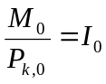
The real rate of return on the marginal unit of investment is the current real interest rate. Thus, the quantity of future goods produced is 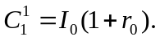
The relationship between money now and goods later is 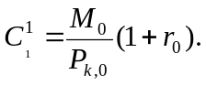

2. Use money now to buy a financial asset that earns the nominal interest rate. 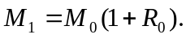
In one period use the principal and interest to buy goods at the then prevailing price. 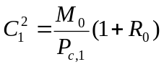

These two routes have to have the same payoff in equilibrium, 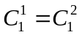. Therefore, 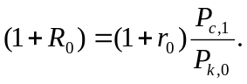 The nominal return equals the real return times one plus the expected rate of inflation.

The Term Structure of Real Rates and Expected Inflation
Andrew Ang and Geert Bekaert
September 2004
Abstract
Changes in nominal interest rates must be due to either movements in real interest rates or expected inflation, or both. We develop a term structure model with regime switches, time varying prices of risk and inflation to identify these components of the nominal yield curve. We find that the unconditional real rate curve is fairly flat at 1.44%, but slightly humped. In one regime, the real term structure is steeply downward sloping. Real rates (nominal rates) are pro-cyclical (counter-cyclical) and inflation is negatively correlated with real rates. An inflation risk premium that increases with the horizon fully accounts for the generally upward sloping nominal term structure. We find that expected inflation drives about 80% of the variation of nominal yields at both short and long maturities, but during normal times, all of the variation of nominal term spreads is due to expected inflation and inflation risk.

Quantity theory of money and inflation
Alan C. Hess

This teaching note explains the quantity theory of money and combines it with the loanable funds theory to demonstrate how monetary policy affects the volatility of interest rates.

1. The equation of exchange says that the nominal money supply, M, times the velocity of money, V, which is the number of times per period that a unit of money is spent, equals the quantity of goods sold, which is real GDP, times the price level, P.
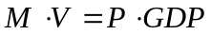
To convert this to a model of inflation, first take the natural logarithm of both sides.
Now take the derivative with respect to time.
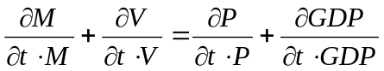.
Take a discrete time approximation to the above expression and put the percentage change in the price level, which is inflation, on the left-hand-side. This gives the dynamic version of the equation of exchange.
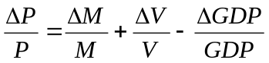
Inflation increases with the growth rate of the money supply and the growth rate of velocity, which affect the demand for goods, and it decreases with the growth rate of real GDP, which is the supply of goods.
- The Federal Reserve controls the growth rate of the money supply through its monetary policy and open market operations.
- Changes in velocity have a large random component with the expected change in velocity being zero.
- The long run growth rate of real GDP depends on productivity increases and increases in the supplies of labor and capital. According to the “Money is Neutral” doctrine, monetary policy does not affect productivity or the supplies of capital and labor.
- Thus, expected inflation is approximately the difference between expected money growth and expected real GDP growth.
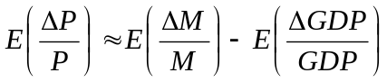

- In the loanable funds model, the nominal interest rate, R, equals the expected real interest rate plus the expected rate of inflation. This is often called the Fisher equation, after Irving Fisher.
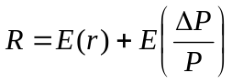
- If we insert the quantity theory formula for expected inflation into the Fisher equation we get the combined model of the nominal interest rate. The nominal interest rate equals the expected real interest, which is the rate that would prevail if inflation were zero, plus the difference between the expected growth rate of the money supply, which affects total spending in the economy, minus the expected growth rate of real GDP, which is the growth rate of the supply of goods.
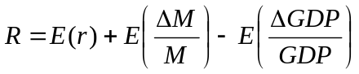
- The longer the time period, such as 10 years, the more accurately the quantity theory explains inflation. Over shorter periods inflation has volatility that is not related to money growth.
- Some empirical evidence

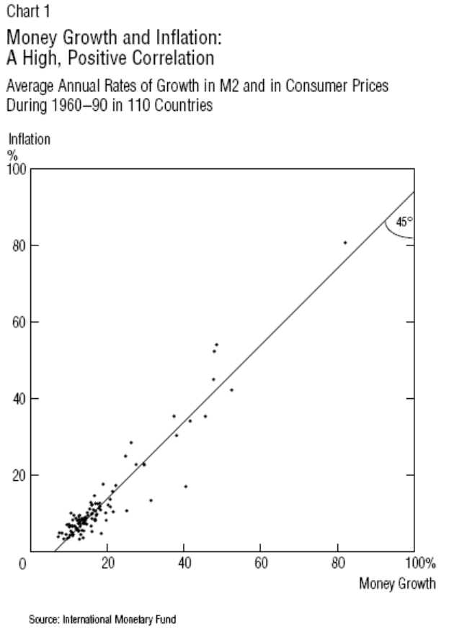

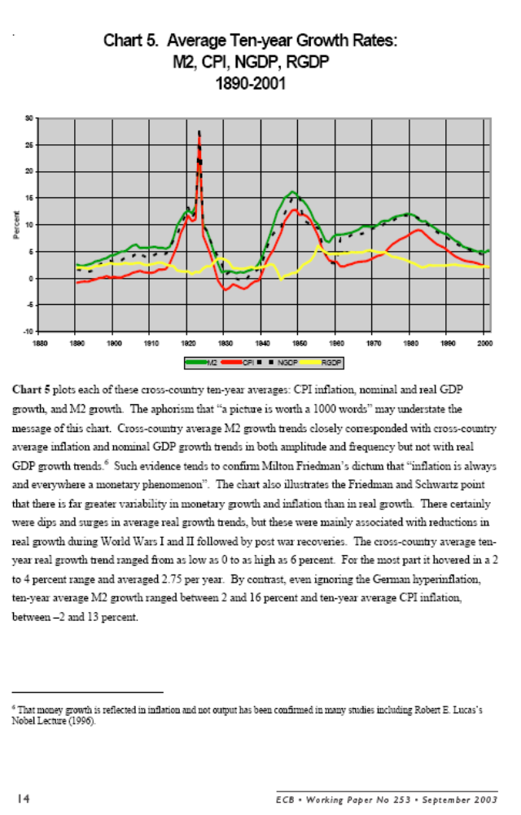
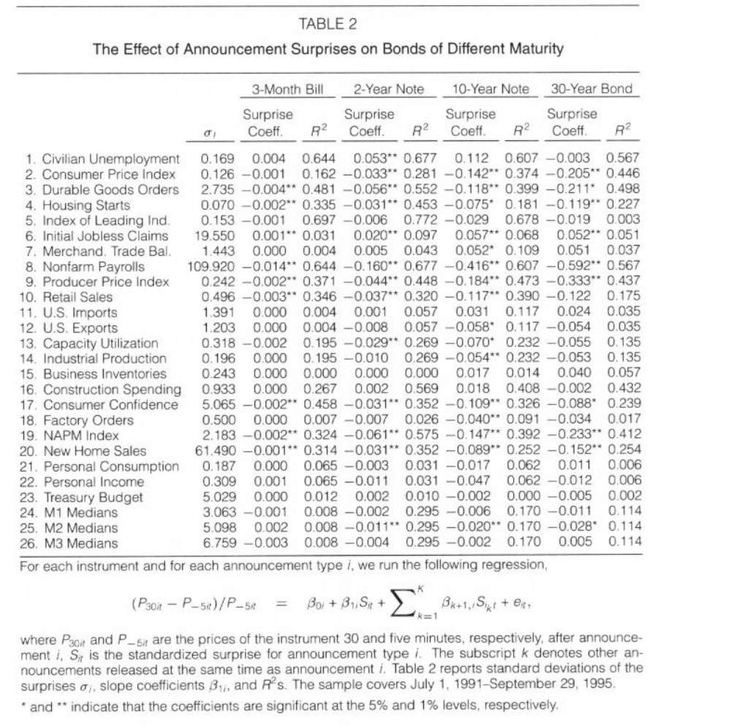

Topic 2. Factors that affect the structure of interest rates

The individual begins with expected terminal consumption of E(C) and a 50-50 chance that actual terminal consumption will either decrease to Bad or increase to Good. The individual’s expected utility is E[U(C)]. This expected utility is less than the utility of expected consumption which is U[E(C)]. The individual would rather have E(C) for sure than a 50-50 chance at B or G. Since E[U(C)] is less than U[E(C)], this individual is risk averse.
This individual’s certainty equivalent consumption is CE(C). This is the certain amount of consumption that has the same expected utility as the 50-50 chance at B or G. The difference between expected consumption and certainty equivalent consumption is the risk premium.
This individual is willing to pay up to the risk premium to transfer his or her risk to someone else.
If either the amount of risk as represented by the distance between Good and Bad, or the individual’s risk aversion, as represented by the curvature of the utility curve, increase, the risk premium increases.
The Expected Utility Model Narrative
Alan C. Hess
The Expected Utility Model Diagram
Alan C. Hess
Utility curve
Terminal Consumption
Good
E(C)
CE(C)
Bad
Risk premium
U(B)
E[U(C)]
U[E(C)]
U(G)
Utility

Theories of the Term Structure

We start with some notation to make precise what is meant by the term structure of interest rates. On any date t, such as right now, 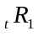 is the yield to maturity on a discount security with one period to maturity, 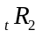 is the interest rate on a discount security with two periods to maturity, and the three year rate is 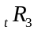. These interest rates constitute the term structure of interest rates. The yield curve, a plot of the actual values of these rates on the vertical axis and the maturities on the horizontal axis, is a graphical depiction of the term structure. Several theories of the term structure have been proposed over the 100 years or so academic economists have investigated it. I address three of them: the unbiased expectations theory, the preferred habitat theory, and the liquidity premium theory. As is usual in economics, each theory assumes that interest rates are set by equilibrium between the demand for the security by savers and the existing supply of the security. The supply of each security is given by the amount outstanding. We derive the market demand for each security by investigating saver's choices among the three maturities of securities.
I use the saver's holding period as the organizing framework to show the similarities and differences among the three theories. A holding period is the length of time between now, when a saver buys a security, and later, when he sells it or redeems it for money. Assume a saver wants to save money for two years. The saver can
- buy a one-year security today and reinvest the principal and interest at the end of the year, or
- buy a two-year security today and hold it until maturity, or
- buy a three-year security today and sell it after two years.
Let us write formulas for much money the saver will have after two years for each saving alternative. In these formulas, is the market interest rate at date t on a zero coupon security with one year to maturity, 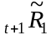 is the market interest rate that will prevail at date t+1 on a zero coupon security with one year to maturity. Since its value is unknown at date t, it has a tilde over it to indicate that it is a random variable. The saving alternatives relate the money available for consumption at year 2, 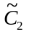, to current and future market interest rates. The superscript on is the number of the saving alternative.
- Buy a one-year security and reinvest principal and interest at the spot interest rate prevailing at date t+1. 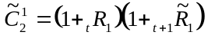
- Buy a two-year security and hold it until it matures at date 2. 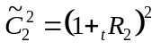
- Buy a three-year security and sell it at date 2 at a price that depends on the one-year rate 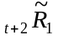 prevailing at date t+1. 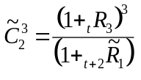
We will see how savers' choices among these three securities determines the term structure of interest rates. We assume that each saver buys the security that has the highest expected utility. Since future consumption is uncertain, expected utility depends on the saver's risk aversion. The three theories of the term structure differ in their assumptions about the risk aversion of savers.
The unbiased expectations theory assumes that savers are risk neutral. A saver’s expected utility depends only on the expected value of his or her consumption at date 2. These expected values at date t are:
- 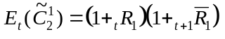
- 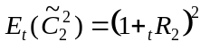
- 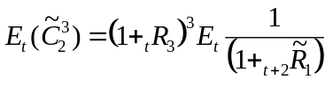
We will now show that this theory implies that savers buy and sell securities until the three spot interest rates are such that the expected values of consumption for each of the three securities are equal. We say that expected holding period returns are equal in the unbiased expectations theory.
I show the trades that rational savers make if the three securities do not have the same expected payoffs. I do it for alternatives 1 and 2. I hope that you will be able to do it for any two other alternatives, or for all three at once. Assume that the first saving alternative has a higher payoff than the second one. Every saver places orders to buy one-year securities and sell two-year securities. Prices of one-year securities rise and prices of two-year securities fall. You already know that yields on discount securities move inversely to their prices. Thus, the one-year rate falls and the two-year rate rises. When do the rates stop changing? The answer is, when they have adjusted to the point where the one-year and two-year securities have equal expected payoffs. Trading stops when the following relationship prevails among interest rates
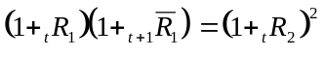 (1)
This says that the two-year rate depends on the current one-year rate and the one-year rate expected to prevail at date t+1. The observed pattern in spot rates, according to this theory, depends only on the current one-period spot rate and expectations of future one-period spot rates. An upward sloping yield curve signals expectations of rising interest rates, a downward sloping yield curve signals expectations of falling interest rates, and a horizontal yield curve signals expectations of constant interest rates.
If the unbiased expectations theory is an accurate description of the yield curve, we can deduce a forecast of future interest rates from current spot rates. To do so we calculate the forward rate of interest 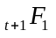on a one-year, zero coupon security starting at date t+1. The forward rate is defined by the formula
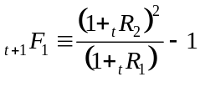. (2)
The forward rate is a break-even interest rate. If you bought a one-year security now and reinvested the principal and interest at the end of the first year at the forward interest rate, your total return at the end of year 2 would be the same as you would have earned had you purchased a two-year security now and held it for two years. Are you not sure of this? Rewrite equation (2) as 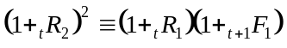. The left-hand-side is the total return after two years from buying a two year security now, at the currently prevailing two-year spot rate and holding it for two years. The right-hand-side is the total return after two years from buying a one-year security now at the currently prevailing one-year spot rate and reinvesting at the one-year forward rate one year from now.
Equation (2) defines the forward rate. Equation (1) interprets the forward rate in the context of the unbiased expectations theory. Equations (1) and (2) together show that if the unbiased expectations theory is true, then
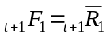. (3)
According to the unbiased expectations theory, the forward rate is the market's forecast of the expected future spot rate. This leads to an empirical test of the unbiased expectations theory. We can calculate the forecast error between the spot rate observed at date t+1 and its forward rate calculated at date t and test whether the average value of the error is zero over a large number of periods. Many researchers, see Hess and Kamara (1994), report that the forward rate is systematically larger than the subsequent spot rate. This evidence is inconsistent with the unbiased expectations theory.
The preferred habitat theory of the term structure of interest rates assumes that people are averse to both price risk and reinvestment risk. Savers evaluate securities on the basis of their expected rates of return and the risk that the expected rate of return will not be realized. Each saver is assumed to have a sequence of desired holding periods, called preferred habitats. Savers who buy zero-coupon securities with maturities shorter than their holding period face reinvestment risk. Savers who buy zero-coupon securities with maturities longer than their holding period face price risk. To avoid interest rate risk, risk-averse savers buy zero-coupon securities whose maturity matches their holding period, unless they receive a sufficiently high risk premium to induce them to accept the risk. According to this theory, spot interest rates on securities that differ only in their term to maturity adjust so that risk-adjusted, certainty-equivalent holding period rates of return are equal. Savers with two-period holding periods continue to adjust the maturities of their security holdings until the following relationship holds,
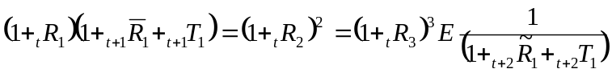. (4)
For two-period savers to be willing to hold one-period securities they must receive a term premium denoted 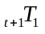that compensates them for the reinvestment risk that they will face at date t+1. For them to be willing to buy and hold three-period securities, they must receive a risk premium denoted 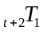 to compensate them for the price risk that they face at date t+2.
The observed spot rates, according to this theory, depend on the current one-period spot rate, expectations of future one-period spot rates, and term premiums. Because of the term premiums, the slope of the yield curve cannot be used to infer the market's expected future short-term interest rates. The yield curve is described by the formula
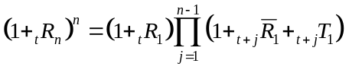. (5)

The long-term interest rate depends on the current one-period interest rate, expected future one-period interest rates, and the term premiums. The theory does not predict the pattern in the term premiums. Instead, it specifies the variables that affect the premiums.
According to the preferred habitat theory the one-period forward rate starting one period from now is
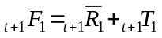. (6)
Because the theory does not specify the sign or size of the term premium and because the term premium is not expected to be constant through time, forward rates are imprecise forecasters of future spot rates.
The liquidity premium theory is a special case of the preferred habitat theory in which savers are assumed to have one-period holding periods. This assumption means that savers are affected more by price risk than by reinvestment risk. They have a bias toward owning short-term securities and hold longer term securities only if they are paid a premium, termed the liquidity premium, to do so. Equation (5) describes the yield curve with the additional prediction that the liquidity premiums are non-decreasing in maturity. This implies that forward rates on average are upwardly biased forecasts of future spot rates. This prediction is consistent with much empirical evidence presented prior to Hess and Kamara (1994).

What Makes the Yield Curve Move?
- Finding the common factors
- Microeconomic interpretations of why the yield curve moves
- Tentative conclusions
- References
Download and Print PDF Version (462KB)

One common misperception about monetary policy is that the Federal Reserve controls all interest rates. In fact, the Fed controls only a very short-term rate, the federal funds rate; this is the rate banks charge each other for overnight loans of reserves. Yet Fed policymakers—and central bankers generally—are vitally concerned with the behavior of interest rates of all maturities. In particular, policymakers would like to understand how a change in short-term rates will affect medium-term and long-term rates, because these latter rates determine the borrowing costs people and firms face, which, in turn, determine aggregate demand in the economy.
The yield curve, which plots a set of interest rates of bonds of different maturities, describes the relationship among short-term, medium-term, and long-term rates at a given point in time. It has been the subject of much research in the finance literature, because it is the natural starting point for pricing fixed-income securities and other financial assets. While this research has provided useful statistical explanations of movements in the yield curve, it has not focused on what causes the yield curve to move. This Economic Letter reviews some of the latest studies in both finance and macroeconomics that have explored the macroeconomic determinants of the yield curve.
Finding the common factors
Typically, the yield curve depicts a line that rises from lower interest rates on shorter-term bonds to higher interest rates on longer-term bonds. Researchers in finance have studied the yield curve statistically and have found that shifts or changes in the shape of the yield curve are attributable to a few unobservable factors (Dai and Singleton 2000). Specifically, empirical studies reveal that more than 99% of the movement of various Treasury bond yields are captured by three factors, which are often called "level," "slope," and "curvature" (Litterman and Scheinkman 1991). The names describe how the yield curve shifts or changes shape in response to a shock, as shown in Figure 1. Panel A of Figure 1 illustrates the influence of a shock to the "level" factor on the yield curve. The solid line is the original yield curve, and the dashed line is the yield curve after the shock. A "level" shock changes the interest rates of all maturities by almost identical amounts, inducing a parallel shift that changes the level of the whole yield curve. Panel B shows the influence of the "slope" factor on yield curve. The shock to the "slope" factor increases short-term interest rates by much larger amounts than the long-term interest rates, so that the yield curve becomes less steep and its slope decreases. Panel C shows the response of the yield curve to a shock to the "curvature" factor. The main effects of the shock focus on medium-term interest rates, and consequently the yield curve becomes more "hump-shaped" than before.
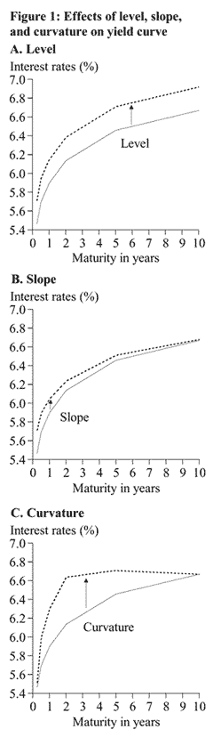
Various models have been developed and estimated to characterize the movement of these unobservable factors and thereby that of the yield curve by financial economists and bond traders in asset-pricing exercises. Few of these models, however, provide any insight about what these factors are, about the identification of the underlying forces that drive their movements, or about their responses to macroeconomic variables. Yet these issues are of most interest to central bankers and macroeconomists.
Macroeconomic interpretations of why the yield curve moves
Macroeconomists view the Federal Reserve as controlling the short end of the yield curve, that is, the federal funds rate, in response to fundamental macroeconomic shocks in order to achieve its policy goal of a low and stable inflation and maximum sustainable output. Therefore, macroeconomic variables, through defining the state of the economy and the Federal Reserve's policy stance, will be useful in explaining movements in the short end of the yield curve. Furthermore, expectations about future short-term interest rates, which determine a substantial part of the movement of long-term interest rates, also depend upon macroeconomic variables. For instance, when the Federal Reserve raises the federal funds rate in response to high inflation, expectations of future inflation, economic activity, and the path of the federal funds rate all contribute to the determination of the long-term interest rates. Therefore, one would expect macroeconomic variables and modeling exercises to be quite informative in explaining and forecasting the yield-curve movements. However, until very recently, standard macroeconomic models have not incorporated long-term interest rates or the yield curve. And even when they have, as in Fuhrer and Moore (1995), most of the attention is still on the correlation between the real economy and the shortest-term interest rate in the model rather than on the whole yield curve.
Several recent economics and finance papers have explored the macroeconomic determinants of the unobservable factors of the yield curve identified by empirical finance studies. Wu (2001) examines the relationship between the Federal Reserve's monetary policy "surprises" and the movement of the "slope" factor of the yield curve in the U.S. after 1982. His study identifies monetary policy "surprises" in several ways to make the analysis more robust; the results indicate a strong correlation between such monetary policy "surprises" and the movement of the "slope" factor over time. In particular, he finds that the Federal Reserve's monetary policy actions exert a strong but short-lived influence on the "slope" factor: they explain 80% to 90% of the movement of "slope" factor, but such influences usually dissipate in one to two months. At the same time, monetary policy "surprises" do not induce significant changes in the "level" factor, implying that during this period the Federal Reserve affects the yield curve primarily through changing its slope.
Ang and Piazzesi (2001) examine the influences of inflation and real economic activity on the yield curve in an asset-pricing framework. In their model, bond yields are determined not only by the three unobservable factors—level, slope, and curvature—but also by an inflation measure and a real activity measure. They find that incorporating inflation and real activity into the model is useful in forecasting the yield curve's movement. However, such effects are quite limited. Inflation and real activity help explain the movements of short-term bond yields and medium-term bond yields (up to a maturity of one year), but most movements of long-term bond yields are still accounted for by the unobservable factors. Therefore, they conclude that macroeconomic variables cannot substantially shift the level of the yield curve.
Evans and Marshall (2001) analyze the same problem using a different approach. They formulate several models with rich macroeconomic dynamics and look at how the "level", "slope," and "curvature" factors are affected by the structural shocks identified in those models. Their conclusion confirms Ang and Piazzesi's (2001) result that a substantial portion of short- and medium-term bond yields is driven by macroeconomic variables. However, they also find that in the long run macroeconomic variables do indeed explain much of the movement of the long-term bond yields, and the "level" factor responds strongly to macroeconomic variables. For instance, their identification results indicate that the changes in households' consumption preferences induce large, persistent, and significant shifts in the level of the yield curve.
Tentative conclusions
Recent literature generally agrees on the effects of macroeconomic variables, especially those of monetary policy, on the slope of the yield curve. A monetary policy tightening generates high nominal short-term interest rates initially, but, because of its anti-inflationary effects, these rates quickly fall back; since long-term rates embed expectations of this behavior of short-term rates, they rise by only a small amount. As a result, the slope of the yield curve declines when contractionary monetary policy shocks occur.
The conflicting results on the macroeconomy's effects on the movement of the level of the yield curve (Ang and Piazzesi 2001 and Evans and Marshall 2001) suggest a rich field for future research. After all, it is difficult to believe that the structure of the macroeconomy has little effect on long-term interest rates or on the level of the yield curve, since long-term nominal interest rates are the sum of expected long-run inflation and long-term real interest rates. Therefore, any structural macroeconomic movement contributing to the determinations of long-run expected inflation or long-term real interest rates will have a substantial influence on the "level" factor. For instance, in an inflation-targeting monetary regime, the inflation target is a natural anchor of expected long-run inflation, and therefore any changes in the market's perceptions of the inflation target will directly shift the level of the yield curve. Figure 2 plots the "level" factor and the five-year moving average of core consumer price inflation in the U.S. from 1962 to 2002. Clearly, the two series are quite similar. A simple regression shows that the movement of this inflation measure alone can explain 66% of the variability of the "level" factor in this period. Likewise, long-term changes in the structural economy, for example the technology innovations, will also influence the long-term real interest rates and therefore the level of yield curve.
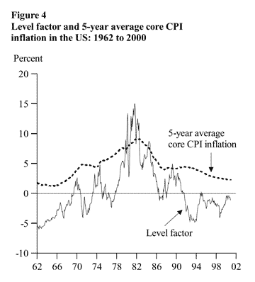
Tao Wu
Economist
References
[URLs accessed May 2003.]
Ang, A., and M. Piazzesi. 2001. "A No-Arbitrage Vector Autoregression of Term Structure Dynamics with Macroeconomic and Latent Variables." Working Paper. Columbia University. Forthcoming, Journal of Monetary Economics.
http://www-1.gsb.columbia.edu/faculty/aang/papers/bond.pdf
Dai, Q., and K. Singleton. 2000. "Specification Analysis of Affine Term Structure Models." Journal of Finance 55 (October) pp. 1,943-1,978.
Evans, C., and D. Marshall. 2001. "Economic Determinants of the Nominal Treasury Yield Curve." FRB ChicagoWorking Paper 01-16.
http://www.chicagofed.org/publications/workingpapers/papers/Wp2001-16.pdf
Fuhrer, J.C. and G.R. Moore, 1995. "Monetary Policy Trade-offs and the Correlation between Nominal Interest Rates and Real Output." American Economic Review 85 (March) pp. 219-239.
Litterman, R., and J. A. Scheinkman. 1991. "Common Factors Affecting Bond Returns." Journal of Fixed Income 1.
Wu, T., 2001. "Monetary Policy and the Slope Factor in Empirical Term Structure Estimations." FRB San Francisco Working Paper 2002-07. http://www.frbsf.org/publications/economics/papers/2002/wp02-07bk.pdf

Summary formulas for Financial Markets
©Alan C. Hess, December 11, 2002

- Gordon growth model relates the value of the firm to its cash flow from its assets, the growth rate of the cash flow, and the firm’s cost of capital.
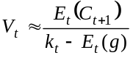
- The firm’s weighted average cost of capital based on its target capital structure
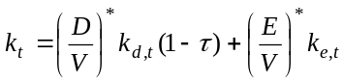
- Bond market equilibrium. The firm must pay the rate demanded by bond investors.
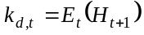
- Holding period rate of return
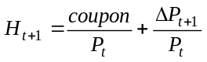
- Initial coupon is set so the bond sells at par when it is originated
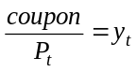
- Change in the price of an assets depends on its duration and convexity 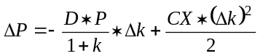
- Therefore, holding period rate of return is
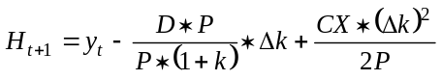
- Expected holding period rate of return equation based on random walk model of interest rate.
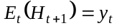
- Expectations theory of term structure determines yield to maturity at issue date based on expected future spot rates, term premia and the default risk premium.

- Term premium depends on volatility of holding period rate of return, which depends on volatility of short-term interest rate.
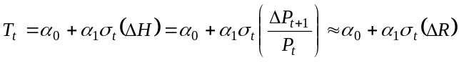
- Merton’s option pricing model relates the default premium to the risk of changes in the value of the firm’s assets.
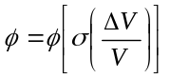
- Ignoring convexity, the volatility of the rate of change in the value of the firm’s assets is
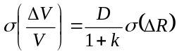
Note that both the term premium and the default risk premium depend on the volatility of the short-term interest rate.
- Following Friedman the volatility of interest rates can be decomposed into the volatility from private actions and the contribution to or reduction in volatility from government actions.
Optimal government policies determine the 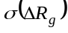, which is the contribution of government actions to the volatility of interest rates, that maximizes the value of a typical firm.
- The theory presented in the course explains the factors that affect the risk free rate and changes in it.
- Balduzzi et al and Fair provide empirical evidence on these factors.
- The theory and empirical evidence guide the design of monetary and fiscal policies that maximize the value of a firm.

Principles of Reducing Interest Rate Risk
Based on Milton Friedman, “Full Employment Policy and Economic Stability” in
Essays in Positive Economics

This teaching note shows conditions that government policies must meet if they are to reduce interest rate risk.

Let R be the interest rate quoted on a financial asset that is traded in an efficient financial market. This rate is usually called a nominal interest rate. It is a yield to maturity.
Let r_{n} be the interest rate that would prevail in a full-employment economy absent government policies. This is often called the natural interest rate.
Let Δ be the effect of government policies on the interest rate. Δ includes the effects of yesterday’s policy actions on today’s interest rate, today’s policy actions on today’s interest rate, and savers’ and borrowers’ anticipations of future government policies on today’s interest rate. Δ includes the effects of monetary and fiscal policies plus other government policies that might affect interest rates.

The observed interest rate is the sum of what it would be without policy interventions plus the effects of policy interventions.
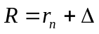 (1)

Interest rate risk may be measured as the variance of the observed interest rate. Using a formula from statistics that every finance student should know, the variance of the observed interest rate is the variance of the natural rate plus the variance of interest rates due to government policy plus a term that includes the combined effects of changes in the natural interest rate and policy actions.
(2)

If the government is to reduce interest rate risk, the variance of the nominal rate must be less than the variance of the natural rate.
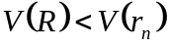 (3)

Comparing equations (2) and (3) and doing a bit of algebra, you should be able to show that policy actions that are designed to reduce interest rate risk will be successful only if the correlation between the natural rate and policy actions is negative and of the proper size.
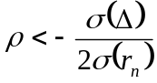 (4)

To determine the proper size of a policy action, differentiate the variance of the nominal rate, equation (2), with respect to the size of the policy action, which is 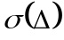, set the result equal to zero and solve for the optimal size of the policy action. This gives
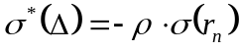. (5)
Note that because standard deviations are positive, equation (5) only holds for negative correlations, as equation (4) requires.

Let us assume that the government is sufficiently omniscient that it knows the values of both the correlation coefficient and the variance of the natural interest rate. It can then determine the optimal policy action from equation (5). To see what policy actions are stabilizing, substitute the optimal policy action from equation (5) into the interest rate risk equation (2), do a bit of algebra and arrive at
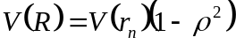. (6)

Equations (5) and (6) shows that an omniscient policy action that is negatively correlated with the natural rate can reduce interest rate risk.

If the government is not omniscient, policy can increase interest rate risk even if it is negatively correlated with the natural interest rate. I constructed the following Excel table using equation (2), and a value of 4 for the variance of the natural rate. Policy is stabilizing for the combinations of the size of the policy action and the correlation that give an entry in the table that is less than or equal to 4.

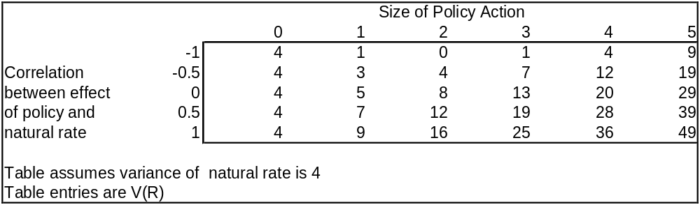
For a risk reduction example, assume that ρ = -1/2 and the size of the policy action is 1. The table shows that the variance of the nominal rate is 3, which is less than the variance of the natural rate.

The table shows that few policy actions reduce risk. Even if the correlation is minus 1, a policy of greater than 4 increase risk.

If the government does not know the correlation coefficient or the variance of the natural rate, its policies may increase interest rate risk.
The Taylor Rule http://research.stlouisfed.org/conferences/homer/rule.html
The following discussion is taken from the chapter "Monetary Policy Guidelines," which was written by John Taylor for the book Inflation, Unemployment, and Monetary Policy (MIT Press, 1998). In this portion, Professor Taylor describes some of the important features that a monetary policy "rule" should possess, including its advantages over a pure discretionary framework. The discussion then concludes with a brief outline of the mechanics of the Taylor Rule.
Modern research in macroeconomics provides many reasons why monetary policy should be evaluated and conducted as a policy rule - or contingency plan for policy - rather than as a one-time change in policy. First, the time-inconsistency literature shows that without commitment to a rule policymakers will be tempted to choose a suboptimal inflation policy—one that has a higher average inflation rate and no lower unemployment than a policy with a lower average inflation rate. Second, one needs to stipulate future as well as current policy actions in order to evaluate the effects of policy. (This is a positive statement of the Lucas critique of policy evaluation.) It is why virtually all policy evaluation research on monetary policy in recent years has focused on policy rules. Third, credibility about monetary policy appears to improve its performance; sticking to a policy rule will increase credibility about future policy action. Fourth, policy rules that give market participants a way to forecast future policy decisions would reduce uncertainty. Fifth, policy rules are a way to teach new policymakers, students, and the public in general about the operations of the central bank. Finally, policy rules increase accountability, potentially requiring policymakers to account for differences between their actions and policy rules.
In arguing in favor of policy rules I recognize that certain events may require that the rule be changed or departed from; that is, some discretion is required in operating the rule. But there is still a big difference between a policy approach that places emphasis on rules and one that does not. With a policy rule in mind the analysis of policy—including questions about whether a deviation from the rule is warranted—will tend to focus more on the rule rather than pure discretion. But to be more specific about rules versus discretion one needs to be more specific about the policy rule. What should the rule be?
A survey of simulations of econometric models with rational expectations suggests to me that monetary policy should respond in the following way. First, the policy should respond to changes in both real GDP and inflation. Second, the policy should not try to stabilize the exchange rate, an action which frequently interferes with the domestic goals of inflation and output stability. Third, the interest rate rather than the money supply should be the key instrument that is adjusted. Because of the nature of the trade-off between inflation stability and output stability, the weights on these two measures of stability appear to matter relatively little for these general conclusions.
In order to investigate the practical application of such a policy rule, several years ago I proposed a specific formula for policy that had these characteristics. According to this policy rule the federal funds rate is increased or decreased according to what is happening to both real GDP and inflation. In particular, if real GDP rises one percent above potential GDP the federal funds rate should be raised, relative to the current inflation rate, by .5 percent. And if inflation rises by one percent above its target of 2 percent, then the federal funds rate should be raised by .5 percent relative to the inflation rate. When real GDP is equal to potential GDP and inflation is equal to its target of 2 percent, then the federal funds rate should remain at about 4 percent, which would imply a real interest rate of 2 percent on average.
The policy rule was purposely chosen to be simple. Clearly, the equal weights on inflation and the GDP gap are an approximation reflecting the finding that neither variable should be given a negligible weight.
BE 420 and BE 520, Financial Markets, Test 2, Autumn 2005, Professor Hess

- According to expectations-based theories of the term structure of interest rates, how are long-term interest rates related to short-term interest rates? Why might expectations-based theories of the term structure have theoretical merit? How might an expectations-based theory of the yield curve explain the relationship between inflation and the level of the yield curve that is displayed on page 68 of the Lecture Notes?
- The level, slope and curvature of the yield curve change over time. What do the interest rate theories of Knut Wicksell and Irving Fisher tell us about how a change in the growth rate of the money supply will affect the level, slope and curvature of the yield curve? See the article by Tao Wu of the Lecture Notes for hints and some empirical evidence.
- What is the Taylor Rule? What institution in each nation is responsible for implementing a rule like the Taylor Rule? Explain whether the Taylor Rule is consistent with Friedman’s analysis of the effects of policy actions on interest rates.
- What is inflation targeting? Is inflation targeting consistent with the Taylor Rule? What do the findings of Ang and Bekaert reported in the Lecture Notes suggest will be the consequences for the yield curve if a nation uses inflation targeting? You should base your analysis on the summary equations reported on pages 82-83 of the Lecture Notes. You should observe that Ang and Bekaert report findings about the causes of interest rate risk.
- Specify monetary and fiscal policies that minimize interest rate uncertainty.
- The TIPS yield curve is approximately flat at 2%. The Strips yield curve is approximately flat at 4%. Use the loanable funds theory, the quantity theory, the Fisher effect, and the Taylor Rule to explain why this can be interpreted as representing an economy that is doing as well as it can do.

topic 3. How do Financial Markets Benefit Savers and Investors?
Summary of how financial markets add value

People voluntarily organize and participate in financial markets as savers, borrowers and intermediaries. Why do they? There are four reasons people participate in financial markets:
- Consumption smoothing. People are better off when they reduce the variability of their consumption from one period to the next by saving when their income is high and dissaving when their income is low.
- External financing of investment. Investment in positive net present value projects increases wealth, which increases consumption, which makes people better off. Many investments involve such large outlays that firms with investment projects can only finance them by selling equity and debt claims to savers.
- Risk diversification. Risk-averse savers require compensation for bearing risk. Issuers of financial claims must pay a risk premium to induce savers to bear risk. This risk premium increases the cost of investing and reduces the number of positive net present value projects. Diversification reduces risk, the risk premium, and the cost of capital to equity and debt issuers. This increases the number of positive net present value projects and the nation’s wealth.
- Risk sharing. If people differ in their risk-aversions, people with high degrees of risk aversion are willing to pay to transfer their risk to people with low degrees of risk aversion.
Effects of Information and Transaction Costs on a Financial Market
©Alan C. Hess, 2000

1.0 Introduction

Financial markets and intermediaries exist to reduce the information and transaction costs of transferring money from savers to borrowers and back to savers at future dates. These transfers have two main benefits: First, they provide for the external financing of investment, which if the investments have positive net present values, increases the nation's wealth. Second, they allow households to adjust the timing and risk exposure of their saving to maximize their expected utility of lifetime consumption. Investors' and savers' surpluses measure the benefits of external investment financing and saving. Intermediation costs increase the interest rate paid by borrowers, decrease the interest rate received by savers, and reduce investors' and savers' surpluses. An operationally efficient financial market or intermediary is one that minimizes information and transaction costs thereby maximizing investors' and savers' surpluses.

2.0 A Model of an Intermediated Financial Market

In a perfect financial market the interest rate paid by the borrower equals the interest rate received by the lender, the amounts borrowed and lent are as large as they simultaneously can be, and trading benefits are maximized. Intermediation costs cause the interest rate paid by the borrower to exceed the interest rate received by the lender by the unit cost of supplying intermediation services. If financial intermediaries can reduce the spread between the borrowing rate and the lending rate, they can increase the quantity of saving and investment and savers' and investors' surpluses.

2.1 A perfect financial market

In a perfect financial market: (1) transaction costs are zero. All participants have free and equal access to the market and can trade at zero marginal cost. (2) information costs are zero. Information about the risks and returns to financial assets are freely and widely available to all participants. No participant has control over prices. All participants are price takers. (3) No distorting taxes exist.

The bold line in Figure 1 labeled "I perfect market" represents external financing of investment in a perfect financial market. Its height for any quantity of investment is the marginal rate of return on the investment. As the amount of financing and investment increase, the marginal rate of return declines due to the law of diminishing marginal returns. The diminishing marginal rate of return is shown as the downward slope of the investment schedule.

The bold line labeled "S perfect market" represents lending by savers in a perfect financial market. The height of the saving schedule is the rate of time preference. This is the rate of return savers require to save instead of consume. As saving increases and consumption decreases, people require ever-higher rates of return to save more.

Equality between perfect market saving and investment sets the perfect market interest rate 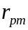, and the perfect market quantities of saving and investment 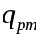. For investments less than , the marginal rate of return is greater than the market interest rate. These investments have positive net present values. For all investments greater than , the marginal rate of return is less than the market interest rate. These investments have negative net present values. The marginal investment, , for which the marginal rate of return equals the market interest rate has a zero net present value.

The area of the triangle that lies above the market interest rate and below the investment schedule 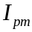 is the wealth created by external financing of positive net present value investments. This area is called investors' surplus. It represents the accumulated difference between what investors would pay to borrow, the marginal rates of return, and what they had to pay, the market interest rate.

The area of the triangle that lies above the saving schedule and below the market interest rate is called savers' surplus. It represents the aggregate gains to savers from lending. These gains are the differences between the interest rate they receive and the interest rates they required based on their rates of time preference.

The sum of these two triangles, the area above the saving schedule and below the investment schedule, is the total trading surplus from being able to trade in a competitive market. Investors gain because they can finance their projects at an interest rate that is less than their projects' marginal rates of return, and savers gain because the interest rate they receive more than compensates them for foregoing current consumption.

2.2 A financial market with trading costs but no intermediary.

Borrowers and lenders face two types of trading costs. Information costs include the costs of finding trading partners, estimating the payoffs to investments, estimating the risk-adjusted, expected rate of return for the investment, and monitoring the performance of borrowers to ensure that borrowers use the money in the ways they promised when they solicited the loan. Transaction costs are the costs of effecting a transaction once a decision to trade has been made. They include the costs of agreeing on a transaction size and maturity, writing contracts to document the transaction, transferring money from a lender to a borrower and back to the lender, and managing the risks of the saving portfolio.

In the presence of trading costs, the net marginal rate of return to the investor is the marginal rate of return in a perfect market less the marginal cost of trading. The downward sloping, dashed line labeled "I imperfect market, no banks" is the net marginal rate of return when there are trading costs but no intermediaries. The vertical distance, denoted 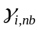, between this line and the perfect market investment schedule is the unit cost of borrowing without intermediaries. It is the cost of homemade, that is, non-specialized, intermediation.

In the presence of trading costs, the lender requires compensation for foregoing consumption and for incurring trading costs. The saving line labeled "S imperfect market, no banks" is the gross rate of return required by lenders when they trade with trading costs and without banks. It consists of the rate of time preference given by the perfect market saving schedule plus 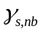 which is the unit cost of saving without banks.

In an imperfect, non-intermediated market, lending and borrowing are equal at the quantity 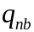. The rate of time preference at this quantity of saving is 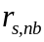. Savers must receive the interest rate after paying trading costs to be induced to save the amount . The marginal rate of return at the quantity of investment of is 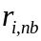. Savers lend the amount to borrowers. Borrowers pay the interest rate which covers the unit costs of trading + and the required return to savers of . The spread between the borrowing rate and the lending rate is the cost of trading.

- = + (1)

Trading costs divide the perfect market-trading surplus into four pieces. First, at the borrowing rate fewer investments have positive net present values. Investors' surplus is reduced to the area of the triangle that lies above the interest rate and below the perfect market investment schedule. The vertical distance is the cost of effecting the loan and is the cost of the borrowed money.

Second, at the lending rate the reward to saving is lower. Savers' surplus is the area above the perfect market saving schedule and below the interest rate .

Third, the area of the rectangle with height - and width is the total cost of trading.

Fourth, the area of the triangle that lies above the perfect market saving schedule and below the perfect market investment schedule and between and is the lost surplus due to trading costs. It is the sum of the projects that no longer have positive net present values, and the benefits that are lost to savers who have high rates of time preference.

2.3 A financial market with trading costs and banks.

If a bank or other financial intermediary can profitably reduce trading costs, it can pay a higher interest rate to savers and charge a lower interest rate to borrowers. These attract savers and investors and increase its value as it adds value.

If banks' incurs unit information costs of 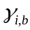 and unit transaction costs of 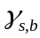, they can offer savers the interest rate 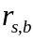 and charge borrowers the rate 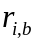. Savers decide how much to save by comparing the interest rate they receive net of all trading costs to their rate of time preference. The increase in the interest rate from to induces them to increase their saving up to the quantity . To loan the amount banks post a borrowing rate of . This rate consists of the banks' cost of money plus the banks' cost of trading which is +. Borrowers compare their borrowing rate to the marginal rates of return on their investments and borrow the amount . Thus, borrowing equals lending even though the borrowing rate is greater than the lending rate.

Investors' surplus is the area of the triangle above and below the marginal rate of return schedule. Savers' surplus is the area of the triangle below and above the rate of time preference schedule. If banks are low cost suppliers of trading services, both investors' and savers' surpluses increase as compared to the case with trading costs and no banks. The banks' spread is -. The product of this spread times the amount of trading is the total cost of trading services supplied by banks. The remaining lost trading surplus is the triangle above the rate of time preference schedule, below the marginal rate of return schedule, and between and . Efficient banks minimize this triangle.

From the investors' and savers' views, the two groups of people who are the demanders of financial services, the spread between the banks' lending and borrowing rates is the sum of unit information and transaction costs.

- = + . (2)

From the banks' views, the suppliers of financial services, the spread is unit operating costs which is the sum of unit labor and capital costs, plus expected loan losses per dollar of loans, plus any possible profit. Let be the wage rate paid by the bank, the number of bank employees, the bank's weighted average cost of capital, and 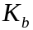 the amount of debt and equity capital used to finance the bank. The debt excludes deposits. LL stands for loan losses, and is profits. For the bank to continue to exist its net revenues must at least cover its costs. This requires
+ 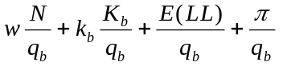. (3)
The bank's bid/ask spread of + must cover the sum of its average variable costs, 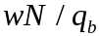, and average fixed costs, 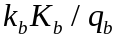, expected loan losses as a percent of loans, 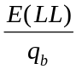, and unit profits 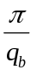.

Banks exist because they reduce trading costs through economies of scale, scope, and specialization. These economies work either by increasing the average product of labor, 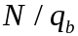, or the average product of capital, 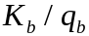, or by reducing expected loan losses. Economies of scale exist when banks can spread fixed costs over a large volume or value of transactions, or when they can reduce risks by pooling the risks of many different loans. Banks have made large investments in computing and communications equipment. Most U.S. banks are large enough that they have exhausted possible economies of scale. While banks may not differ from each other in their economies of scale, they have large economies of scale compared to individuals. Economies of scope exist when the joint production of two goods or services is less costly than separate production. Banks appear to have economies of scope in many of the financial services they provide that deal with information. They can reuse information gathered in providing one service to provide other services without having to search anew for the information. Economies of specialization are due to learning by doing, training and education. Often, a well-trained, experienced person can do a task much faster and more accurately than an inexperienced, untrained person. Even though the experienced person may earn more, he or she may be sufficiently more productive to be the lowest cost producer of the service.

3.0 Banks' Supply of Intermediation Services

There are two dimensions to the services that banks provide to savers and investors. One dimension distinguishes between the origination and portfolio management activities. The other distinguishes between information and transaction services (see Table 1). To understand these services we analyze the steps prudent investors and savers take before and during the process of transferring money from savers to borrowers and back to savers.

3.1 Information services. Information about the payoffs to investment projects, the skills and effort needed to implement the projects, costs of capital, and the identities of savers and investors is costly to produce and distribute. We first discuss the role of financial intermediaries in reducing information costs.

Search for counterparties. Borrowers do not know who or where the lenders are, and lenders do not know which enterprises seek financing. Banks can eliminate direct search between savers and investors by providing either the broker function - they conduct the search and bring the parties together but do not take a position in the transaction, or the dealer function - they bring borrower and lender together and take a position in the transaction. U.S. commercial banks provide the dealer function for reasons discussed below in connection with independent valuation, price discovery, and monitoring.

The cost to a bank of supplying dealer services is the sum of a broker's costs of finding borrowers and savers, plus the costs of originating and managing a portfolio of assets and liabilities. Brokerage costs include a fixed component for the physical facilities used as the central meeting place for conducting business, and a variable component for the costs of loan officers and deposit takers. Banks spread the fixed costs over large numbers of transactions. They reduce variable costs by becoming knowledgeable about who the savers and investors are. Gains in knowledge increase the marginal and average products of labor. This reduces average variable costs and spreads, increases volume and reduces average fixed costs.

Project valuation. Lenders recognize that borrowers have incentives to overstate their ability to repay and understate the risk of their investment. To overcome adverse selection, either the lender or a third party provides an independent valuation of the borrower's ability to repay. We use the net present value model to identify the elements of investment valuation. The components of the model are the investment, I, the expected future cash flows 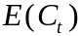 for each of the T periods in the life of the project, and the set of discount rates kt for each cash flow. The net present value equation is
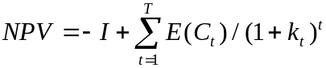. (4)

The valuator projects the future cash flows from the borrower's pro forma financial statements. At a minimum, a cash flow forecast depends on projected revenues, projected costs, and taxes. Projected revenues are the product of the total size of the output market times the enterprise's projected market share times the unit price of the product. Costs consist of variable costs, as recorded in cost of goods sold, and fixed costs, as recorded in overhead or administrative costs. There may be other allowable deductions from net revenues before the tax liability is computed. A simple cash flow statement includes the following items.

Projected market size
x Projected market share
x Price per unit
= Projected revenues
- Cost of goods sold
= Gross margin
- Overhead expenses
- Allowable non cash expenses
= Taxable income
- Taxes
+ Allowable non cash expenses
= Projected cash flow

The bank must either make these projections itself or buy them from an agent who has an incentive to provide accurate projections. Banks have an advantage in independent valuation if a borrower is more willing to give the bank confidential information that may affect its market share because the bank keeps the information private. The bank signals to savers that it views the projections as accurate by taking an at risk position in the investment. Taking this position is what makes the bank a dealer and not a broker. If the bank did not take this position, savers would have less confidence in the bank and be unwilling to deposit their savings with it. Banks have an economy of specialization in project valuation as they gain information on market sizes, potential market shares, and project's costs of good sold and overhead costs. Banks use the information they produced in previous valuations as inputs to current and future valuations.

Project valuation shows in Figure 1 as the investment schedule. Every point on the investment schedule represents a project.

Price discovery. The cost of capital, the set of interest rates used to discount future cash flows to their present value, depends on expected real interest rates, expected rates of inflation, the risk of repayment, and the liquidity and maturity of the financial instrument issued to finance the investment. Efficient markets provide interest rates that correctly discount cash flows and provide accurate estimates of value. They induce the optimal aggregate quantity of saving and investment and the optimal distribution of investment across projects. Inefficient and fragmented markets do neither. They can produce interest rates that do not reflect aggregate amounts of saving and investment and do not correctly distinguish between the relative risks of investments. This can lead to over-investment in overvalued projects, under investment in undervalued projects, and non-optimal total amounts of saving and investment.

Banks that operate in inefficient financial markets must produce their own estimates of discount rates. Let rf be the real risk free interest rate, E(rm) the expected real rate of return on a well diversified portfolio of assets, 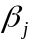 a measure of the contribution of investment j to the risk of a well diversified portfolio, 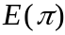 the expected rate of inflation, and 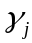 the marginal cost of supplying intermediation services to the jth borrower. A commonly used estimate of the cost of capital in western financial markets is the augmented capital asset pricing model given by

. (5)

A bank that handles a large volume of loans and deposits can gain an advantage in price discovery in an inefficient market because it sees a sizable portion of the market supply and demand schedules for credit. Thus, it has information on what market clearing yields should be. Banks may have an information economy between project valuation and price discovery. Through project valuation banks estimate cash flows and gain evidence on the costs of capital for which projects have positive net present values. They become knowledgeable about the range of marginal rates of return across projects, and the amount of positive net present value investments at each internal rate of return.

In Figure 1, price discovery refers to the intersection of the investment and saving schedules. It gives the one interest rate at which saving equals investment.

Monitoring. After a borrower has received financing, he has an incentive to use the money in a way that benefits him, possibly to the detriment of the lender. To counter this moral hazard the loan contract specifies many actions that the borrower must perform to maintain the credit quality of the loan. Once the lender has delivered the money to the borrower, the lender must monitor the borrower's actions to reduce the chance that the borrower takes actions that transfer wealth from the lender to the borrower. Banks may have an economy in monitoring if the borrower keeps its payroll, accounts receivable, and accounts payable accounts with the bank. This provides it with a low cost source of information how the borrower is managing the enterprise. Banks also have economies of specialization in monitoring since they learn what data, for example, financial ratios, best describes borrower behavior and the best way to analyze these data. If the cost of signaling is less than the cost of monitoring, banks have an economy of specialization since they incur monitoring cost just once and signal their continuing confidence in the project to depositors by maintaining their at-risk position in the project.

3.2 Transaction services. Financial contracts must be structured so they are mutually acceptable to both borrowers and lenders. In indirect financing, intermediaries make one set of contracts with borrowers and another set with different terms with lenders. These contracts provide the following services.

Denomination intermediation. Investment projects usually require more credit than can be supplied by one saver. A bank makes few large loans and breaks the financing into small denominations so pieces of it can be sold to each of many limited wealth savers. There may be an economy between search and denomination intermediation. Since banks are the market maker, both borrowers and savers deal with them and they have the necessary large numbers of small savings accounts to aggregate into large loans.

Maturity intermediation. Borrowers usually have a continuing demand for credit since they are going concerns, while lenders want to have their money returned so they can spend it on consumption goods in the future. Financial intermediaries must be able to supply loans with maturities that best serve borrowers, and saving instruments with the maturities that best serve savers. Banks are able to fund long-term, but not necessarily fixed-rate, loans with short-term deposits because the withdrawal behavior of their pool of deposits is more predictable than the behavior of any single depositors. This is because absent an economy-wide disturbance, individual depositors deposit and withdraw money at times and in amounts that are unique to each depositor. Additions to and withdrawals from deposit accounts tend to offset each other leaving smaller and more predictable changes in aggregate deposits.

Diversification. A portfolio of loans, bonds, and stocks issued by a wide variety of enterprises in many different industries and regions, has less risk than a portfolio concentrated in one region or industry. Banks have economies of specialization in diversification both through learning by doing and by spreading fixed costs over many loans and over large size loans. Portfolio management includes estimating efficient amounts of each of the assets to be held in the portfolio from the vector of expected rates of return and their variance/covariance matrix. Banks gain expertise in generating estimated returns and their risk, and in using these data to construct efficient frontiers.

Banks may have economies between their search, denomination intermediation, and diversification activities. Being the center of search exposes the bank to a pool of loans which begets diversification, and to a pool of depositors each of whom buys a small share of the diversified portfolio of loans. Banks have a conflict between diversification and project valuation. To gain expertise in project valuation banks evaluate loans in the same region or in the same industry. But this concentrates their loan portfolio in a few assets and reduces its risk diversification. Loan sales among banks allow them to keep the economies from search and diversification. Both these economies serve to reduce the bid/ask spread.

Hedging. Individuals and enterprises differ in their desires and abilities to hold and manage risk. Costs of capital are lowest in financial markets where the risk that remains after diversification is transferred to those most willing and able to bear it. Risk management using forward contracts, futures, options, swaps and securitization require well-developed secondary markets and expertise in measuring risk exposures. In inefficient financial markets where these derivative instruments are not supplied, banks provide hedging services by offering loans with the durations that best serve borrowers and deposits with the durations that best serve savers. This transfers their customers' interest rate risk to themselves. Banks manage their resulting exposure to unexpected changes in the level or term structure of interest rates by holding sufficient capital to absorb losses during periods when the yield curve moves up sharply or is inverted. This additional capital is costly and must be part of the bank's spread.

Liquidity. In well functioning secondary financial markets, trading occurs in response to news about the prospects of an enterprise or the economy, to changes in peoples' plans, and to rebalancing to maintain well diversified portfolios. Liquidity is the ability to conduct a trade in a short period of time at a price close to the currently quoted price. Liquidity depends on the price elasticity of demand. In intermediated markets banks are low cost suppliers of liquidity to savers and borrowers because of economies of scope and specialization. Scope economies may exist between liquidity and the bank's search/valuation/monitoring/denomination/maturity activities. The bank's search activities give it a large base of diversified borrowers and savers whose aggregate transactions are more predictable than their individual transactions. In addition through their valuation and monitoring activities banks can learn to anticipate the liquidity demands of their borrowers. This leaves deposit flows as the less predictable component of the bank's net cash flow. However, the maturity of the bank's deposits gives it some clues to depositors' likely liquidity demands. In addition because banks have many deposits of small denominations, it gains evidence through time on the flows into and out of its deposits. This economy of specialization increases the bank's ability to predict its deposit flows.

Payments system. Both primary and secondary financial transactions entail frequent payments of large sums of money. Borrowers and lenders must be confident that the money they part with will reach the intended counterparty. Banks have large volumes of transactions that reduce their average fixed costs of supplying a payment system. Borrowers and depositors have confidence in the payment system because the bank has an at risk position in the system.

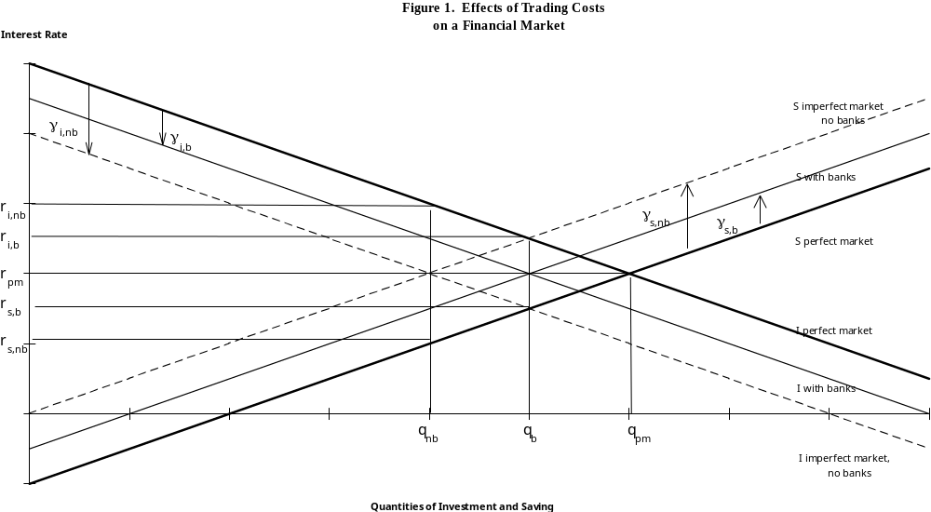

Table 1. Services Supplied by Financial Intermediaries

Stage of financial intermediation | Reduce Information Costs | Reduce Transaction Costs
Originate financial assets | Reduce search costs of bringing borrowers and savers together | Denomination intermediation
 | Independent valuation to reduce adverse selection | Maturity intermediation
 | Price discovery | Provide payments system
Own financial assets | Monitoring to reduce moral hazard | Diversify risk
 |  | Hedge risk
 |  | Liquidity including providing payments system

A Model of Market Makers

Alan C. Hess
November 1992

Market makers consist of brokers and dealers who facilitate the trading of securities by savers, corporations, financial institutions, and governments. Brokers bring buyers and sellers together, help them find mutually agreeable prices and quantities to trade, charge a commission for these services, but do not hold inventories of securities. Dealers hold inventories of securities so they can immediately service customers' desires to buy and sell, they quote prices at which they will buy and sell these securities, and they receive revenues based on the spread between the asked price at which they will sell and the bid price at which they will buy.

Revenues

Let Pa be a dealer's asking price of a security, Pb its bid price, Qs the quantity of the security the dealer sells during a period of time, and Qb the quantity of the security bought by the dealer during the same time interval.

Net trading revenue = PªQ^{s} -P^{b}Q^{b}. (1)

This net revenue must cover all of the dealer's costs including a risk-adjusted, expected rate of return to its invested capital. The dealer incurs three kinds of costs.

Costs

1. Order processing costs. These are the costs of the inputs used to effect transactions. The main components are personnel costs and equipment costs. Personnel costs are the unit cost w per hour of labor N, and equipment costs are uK where u is the unit cost of renting communications equipment, computer hardware and software, office space, and record keeping equipment, and K is the number of units of capital that the market maker rents.

Order processing costs = wN + uK. (2)

The spread (Pª - P^{b}) is the market maker's revenue per round trip transaction. In a round trip transaction the market maker buys the asset from a seller and later sells it to a buyer. For the market maker not to lose money, it must set its spread to cover its average order processing costs.

Average order costs = (wN + uK)/Q. (3)

Average order costs consist of

Average variable order costs = wN/Q

Average fixed order costs = uK/Q.

Since capital is assumed fixed in the short run, average fixed costs per trade decline as the number of trades increases. This is not the case for average variable costs. The response of average variable costs to changes in the number of trades depends on the process by which traders execute trades. We assume this process satisfies the standard laws of production. We next review some features of the production function that we use in the subsequent analysis.

The number of trades Q that the market maker can process in a period of time depends on the number of labor hours worked and the amount of equipment used. The market maker's short-run production function relates the number of trades that the market maker can execute to the number of labor and capital hours it employs.

Q = F(N:K) (4)

The colon means that we are holding capital fixed and are meeting changes in trading volume by changing the amount of labor hours used.

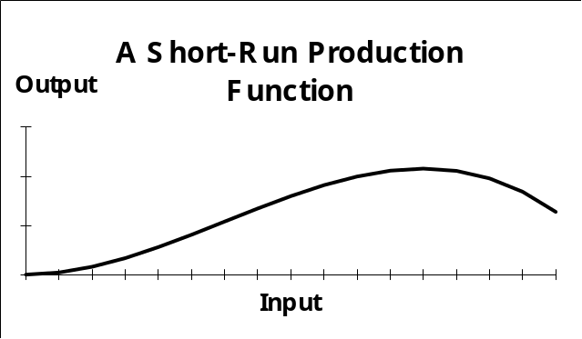

Holding fixed the amount of equipment such as computer hardware and software, as the market maker increases the amount of labor hours used, output initially increases at an increasing rate, it then increases at a decreasing rate, and eventually it decreases.

The average product of labor, the ratio of Q/N, is the slope of the ray to the production function. As labor input increases, the slope of this ray at first increases and then decreases. The slope of this ray is plotted as the average product in the next figure.

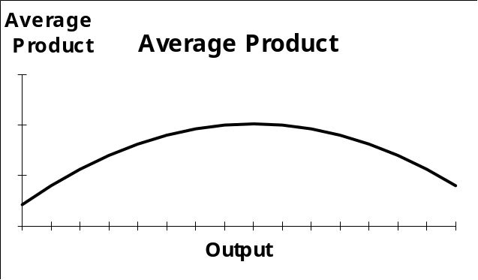

For the market maker to be able to produce trades at a lower cost than its customers can through direct trading with each other, it must have some economies that they do not have. We can identify two kinds of economies: spreading of fixed costs over a large trading volume, and potential initially increasing returns. The next figure shows each of these.

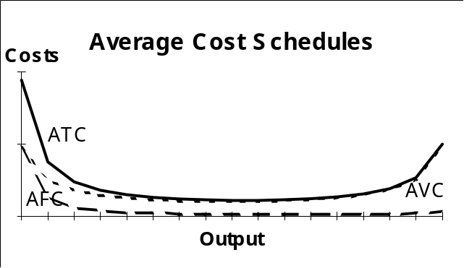

Average fixed costs are the ratio uK/Q which declines to zero as output increases. Average variable costs are the ratio of wN/Q which is the constant wage rate w divided by the average product of labor Q/N which is shown in the Average Product figure. Since the average product of labor first increases and then decreases, average variable costs first decrease and then increase. Adding average fixed costs to average variable costs gives average total costs ATC.

If a trader tried to trade directly with other traders instead of going through a market maker, the trader's trading volume would be small and his average total costs would be high. The market maker's higher volume lowers its average fixed costs by spreading its fixed costs over a larger volume, and it lowers its average variable costs if there are initially increasing average returns. As the market maker's trading volume increases, its average costs eventually increase due to the law of diminishing marginal and average returns. If there is competition among market makers, average variable order costs will be at the minimum of the average total cost schedule. We represent the minimum average order costs by g.

Minimum average total order costs = g. (5)

2. Inventory carrying costs. In order to gain the lower order costs from high volume, market makers concentrate trading volume by making markets in a few securities. Consequently, they hold poorly diversified portfolios. Their portfolios consist primarily of the closely related securities in which they make markets, cash, and short-term debt to finance their assets. Their portfolios lie below the Capital Market Line as shown in the next figure.

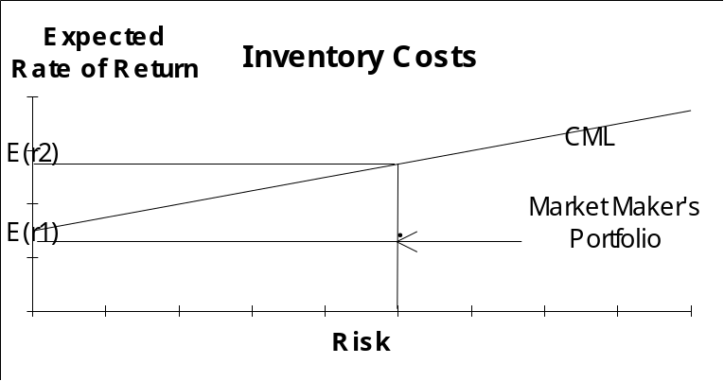

Instead of being a market maker, the dealer could withdraw its equity from market making and use it to buy a well diversified portfolio of securities. If the portfolio is chosen so that its risk is the same as the risk of being a market maker, the portfolio would yield an expected rate of return of E(r₂). The opportunity cost of being a market maker is

Inventory cost = [E(r₂) - E(r₁)] A. (6)

Here, A is the value of the market maker's assets.

3. Adverse information costs. A market maker posts it bid and asked prices and accepts all trades at those prices. Secondary market trades consist of liquidity trades, rebalancing trades, and information trades. A liquidity trade is a trade which changes the size of the trader's portfolio but not its composition. If the trader is a saver, he buys securities and if he is a dissaver he sells securities.

A rebalancing trade changes the composition of the trader's portfolio without changing its size. Rebalancing trades occur in response to price changes. Savers attempt to hold efficient portfolios which maximize expected return for a given level of risk, or minimize risk for a given expected rate of return. The composition of the saver's optimal portfolio depends on the risks and expected returns of the securities in the portfolio. If risk or expected rates of return change, the optimal portfolio composition changes. Savers must then buy and sell securities to make the composition of their portfolio equal to the composition of the new optimal portfolio.

An information trade occurs when a trader has information about the true value of the security that is not reflected in the price of the security. If the trader thinks the security is underpriced, he will buy it from the market maker. If the trader thinks the security is overpriced, he will sell to the market maker. If traders have better information than the market maker about the true value of the security, they will prosper at the market maker's expense. Market makers are aware of their information disadvantage and must set their bid/ask spread high enough to compensate them for the losses they incur in trading with better informed traders. Let E(r/I^{s}) be the true expected rate of return on the security based on strong form information Is. Let E(r/I^{m}) be the market maker's expected rate of return on the security based on the information I^{m} available to the market maker.

Adverse information costs = [E(r/I^{s}) - E(r/I^{m})] A. (7)

Profits

The market maker's profits are revenues less costs.

Profit = (PªQ^{s}-P^{b}Q^{b}) - gQ - [E(r₂)-E(r₁)]A - [E(r/I^{s})-E(r/I^{m})]A (8)

If there is freedom of entry and exit into the market making business, profits will be driven to zero. If profits are positive, more firms will become market makers. If profits are negative, some market makers will go out of the business. To control its inventory, the market maker will set its bid and ask prices so that the quantity it buys on average equals the quantity it sells, Q^{s} = Q^{b} =Q.

With zero profits and equilibrium trading volume, the bid/ask spread is

P_{a} - P_{b} = g + [E(r₂) - E(r₁)]A/Q + [E(r/I^{s}) - E(r/I^{m})]A/Q (9)

The first term of the spread is the average order cost, the second term is the average inventory cost, and the third term is the average information cost.

To be competitive with other market makers, a market maker must strive to reduce each of the cost components. Order costs are reduced by improved technology and smarter employees which increase the average products of capital and labor. Inventory costs are reduced by decreasing the size of the inventory required to handle a given order flow, and by using derivative instruments to reduce the market maker's risk exposure. The market maker faces both systematic and unsystematic risk. It is compensated for the systematic risk it faces by the expected returns it receives from the securities in its portfolio in which it makes markets. To reduce its unsystematic risk it could be part of a large firm which makes markets in many securities and thus is diversified at the firm level. To reduce its information costs it could be part of a firm that produces research on the securities in which it makes markets. It could also try to separate the liquidity and rebalancing trades from the information trades. If it could, it could set lower spreads for its liquidity and rebalancing trades than for its information trades.
Campbell and Kracaw’s Theory of Financial Intermediation

The economic profit equation for a bank.
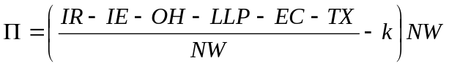
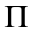: economic profit. The difference between the realized return on invested capital and the return investors require to own the bank’s stock.
IR: interest revenue
IE: interest expense
OH: overhead expenses
LLP: loan loss provisions
EC: employee costs
TX: taxes
NW: net worth, which is paid-in capital
k: investors’ required rate of return. This is the rate of return they require to willingly hold the bank’s stock.
- Valuation is on of the ten financial services a bank offers to borrowers and savers. Valuation means determining the present value of the project the borrower is financing with the bank loan. The bank hires skilled personnel (graduates of F423) and buys data and computers to value projects. These costs are components of the bank’s employee costs and overhead costs. As costs increase, ceteris paribus, the bank’s VA decreases. The return to the bank is a reduction in loan loss provisions as valuation hopefully reduces the number of loans the bank makes to borrowers who will default. The challenge to the bank is to have loan loss provisions decrease more than operating costs increase.
- Campbell and Kracaw use game theory to develop the conditions under which it is likely that the bank’s loan losses decrease more than their operating costs increase. At the end of today’s class you should be able to list and explain the conditions that increase the chance that the bank provides value-adding valuation services.

Situation 1

Assumptions:

A1. There are N_{A} firms of type A with true value V_{A}, and N_{B} firms of type B with true value V_{B}, V_{A}>V_{B}.

A2. Investors only know the average value, 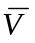, of all firms. 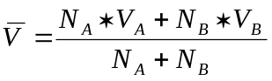

A3. There are no gains from diversifying across A and B.

A4. Market trading discloses bids of all traders.

Implications

- What is the market value of an A-type firm?

- Are they over or under valued?
The market undervalues them, 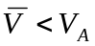.

- What is the market value of a B-type firm?

- Are they over or under valued?
The market overvalues them, 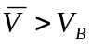.

- What do owners of the A firms do?
Announce that they are type A firms.

- What do owners of the B firms do?
Announce that they are type A firms.

- Is investment efficiently allocated between A and B?
No, investors cannot tell the type of any firm. They invest too much in B-type firms and too little in A-type firms. The market fails to allocate investment optimally because the B-type firms are dishonest..

- Is there a way an intermediary can create value?

Yes, if they can identify which firms are type A and which firms are type B. This is the financial service known as project valuation
Situation 2
Assumptions:

A1. There are N_{A} firms of type A with true value V_{A}, N_{B} firms of type B with true value V_{B}, V_{A}>V_{B}.

A2. Investors only know the average of all firms.

A3. There are no gains from diversifying across A and B.

A4. Market trading discloses bids of all traders.

A5. Investors can obtain information on the true values of all firms at a cost of C_{i} for saver I.

Implications

- What is the return from investing in information?

Is it 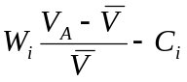 or is it 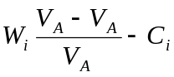 where W_{i} is the wealth of investor i?

- Will anyone be willing to produce information?

No. The return from producing information is negative because of assumption 4, which is the assumption of perfect price discovery. Information in this situation is a public good. It is non-exclusive, once it is produced it is freely available to all, and it is non-rival, once it is produced one person using it does not preclude another person from using it.

- Is investment efficiently allocated between A and B?

No. Because investors are unable to identify which firms are of each type there is too much investment in the B-type firms and too little investment in the A-type firms. Investors cannot trust the B-type firms to identify themselves, and no investor will incur the costs of producing a public good.

- Is there a way an intermediary can create value?

Yes, if it can identify the type of each firm.
Situation 3
Assumptions:

A1. There are N_{A} firms of type A with true value V_{A}, N_{B} firms of type B with true value V_{B}, V_{A}>V_{B}.

A2. Investors only know the average of all firms.

A3. There are no gains from diversifying across A and B.

A4. Market trading discloses bids of all traders.

A5. Investors can obtain information on the true values of all firms at a cost of C_{i} for saver I.

A6. Firms offer side-payments to investors to induce them to invest in information.

A7. There is a lowest-cost, monopoly information producer for whom C_{i}<C_{j}.

Implications

- What is the net return to producing information?

The maximum amount that the A-type firms will collectively pay to have information produced about their true values is 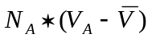. The cost of producing information is C_{i}. Therefore, the net return to producing information is 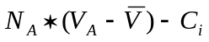.

- What is the net return to not producing information?

The B-type firms will pay the monopolist information producer up to N_{B}*V_{B} if he promises not to produce information. He has the same revenue but lower costs for a higher net return if he does not produce information.

- Will information be produced?

No, as is seen by comparing the net returns from producing and not producing information.

- Is investment efficiently allocated between A and B?

No, because investors cannot identify the type of each firm.

- Is there a way an intermediary can create value?

Yes, if it can identify the true type of each firm.
Situation 4
Assumptions:

A1. There are N_{A} firms of type A with true value V_{A}, N_{B} firms of type B with true value V_{B}, V_{A}>V_{B}.

A2. Investors only know the average of all firms.

A3. There are no gains from diversifying across A and B.

A4. Market trading discloses bids of all traders.

A5. Investors can obtain information on the true values of all firms at a cost of C_{i} for saver I.

A6. Firms offer side-payments to investors to induce them to invest in information.

A7’. There are competitive, honest information producers, C_{i}=C_{j}.

Implications

- Will information be produced?

Yes. The A-type firms randomly select one of the competitive information producers and offer to pay him to produce information. The B-type firms pay him a bit more than not to produce information. The potential information producer chooses not to produce information.
The A-type firms then randomly select a second competitive information producer and offer to pay him to produce information. The B-type firms have already spent most of their money on the first information producer and cannot make a viable counteroffer. Thus, the second chosen information producer produces information on the true value of every firm.

- Is investment efficiently allocated between A and B?

Yes, because investors know the true value of each firm.

- Is there a way an intermediary can create value?

The second information producer is the intermediary. He produces project valuation. He has added value by providing information that correctly allocates investment to the two types of firms. The market requires competitive, honest, low-cost information producers.
Situation 5
Assumptions:

A1. There are N_{A} firms of type A with true value V_{A}, N_{B} firms of type B with true value V_{B}, V_{A}>V_{B}.

A2. Investors only know the average of all firms.

A3. There are no gains from diversifying across A and B.

A4. Market trading discloses bids of all traders.

A5. Investors can obtain information on the true values of all firms at a cost of C_{i} for saver I.

A6. Firms offer side-payments to investors to induce them to invest in information.

A7”. There are competitive, dishonest information producers.

Implications

- Is information produced?

No. After the same sequence of offer and counter-offer as in the previous case, the second information producer takes the money from the A-type firms, ostensibly to produce information, but instead randomly selects firms and declares that they are type A firms. In a rational expectations economy, the A-type firms would have anticipated this action and not have made an offer to anyone to produce information.

- Is investment efficiently allocated between A and B?

No, because information is not produced.

- Is there a way an intermediary can create value?

Yes, if it is a low cost, honest information producer.
Situation 6
Assumptions:

A1. There are N_{A} firms of type A with true value V_{A}, N_{B} firms of type B with true value V_{B}, V_{A}>V_{B}.

A2. Investors only know the average of all firms.

A3. There are no gains from diversifying across A and B.

A4. Market trading discloses bids of all traders.

A5. Investors can obtain information on the true values of all firms at a cost of C_{i} for saver I.

A6. Firms offer side-payments to investors to induce them to invest in information.

A7”. There are competitive, dishonest information producers.

A8. Information producers must invest in their information.

Implications

- Will information be produced?

The A-type firms require that the information producer invest his own money in the firms that he declares to be type A. The information producer, who we assume is potentially dishonest, compares the net return from being honest and dishonest.
The net return from being honest is .
The net return from being dishonest is 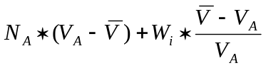.
The information producer will be honest if 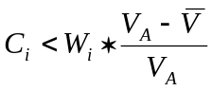.

- Is investment efficiently allocated between A and B?

It is if the cost of producing information is low compared to the loss from investing in overvalued firms.

- Is there a way an intermediary can create value?

Yes, if it has low costs of producing information, it increases the incentive to be honest instead of dishonest.
Situation 7
Assumptions:

A1. There are N_{A} firms of type A with true value V_{A}, N_{B} firms of type B with true value V_{B}, V_{A}>V_{B}.

A2. Investors only know the average of all firms.

A3. There are no gains from diversifying across A and B.

A4. Market trading discloses bids of all traders.

A5. Investors can obtain information on the true values of all firms at a cost of C_{i} for saver I.

A6. Firms offer side-payments to investors to induce them to invest in information.

A7”. There are competitive, dishonest information producers.

A8. Information producers must invest in their information.

A9. Investors pool their wealth to form an intermediary that produces information and buys securities.

Implications

- Will information be produced?

It is more likely to be produced. The cost comparison between honesty and dishonesty is now 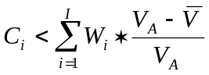. As the amount of their own money the information producers invest in the firms they identify as type A increases, 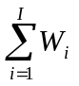, so does their cost of being dishonest.

- Is investment efficiently allocated between A and B?

It will be if the cost of dishonest exceeds the cost of honesty.

- Is there a way an intermediary can create value?

Yes, if it has low costs of producing information and a high at-risk position in the firms it is valuing. If the intermediary is a bank, it compares its additional operating costs to its additional loan losses.
Financial Markets, Test 3 Preparation Questions, Professor Hess
- Why do bid/ask spreads differ across financial assets?

- What are the relative sizes of bid/ask spreads for each of the ten financial services?

- A pair of identical twins was separated at birth. Twin A grew up in a nation with efficient financial markets. Twin B grew up in a country with primitive financial markets. Except for the structure of financial markets the two countries have identical natural resources.
  - Which twin is richer? Why?
  - Which twin has the more variable consumption stream? Why?
  - Which twin faces the greater risk of starvation? Why?

- Regulated utilities that announce increases in capital expenditures suffer decreases in their stock prices. When they announce decreases in capital expenditures they experience increases in their stock prices. How can this be? Explain using Fisher’s analysis of optimal investment.

- (PhD students and mathematically skilled MBAs) As a person’s wealth increases, his or her risk aversion can be constant, increase or decrease. It can be described in absolute terms or in relative terms.
  - Write a formula for total utility for each possible type of risk aversion. Using Excel or some other plotting software, plot the total utility line for each type of risk aversion. What patterns do you observe in these plots?
  - For each total utility function derive the formula for the risk versus expected return indifference curve. Plot these indifference curves in risk and expected return space. What patterns do you observe in these plots?
  - Do any of the total utility curves seem more representative of individual behavior than others? Which ones? What are their characteristics that you deem desirable?

- First I said there were four ways that financial markets add value. Then I said there were ten financial services. How do the ten financial services relate to the four ways that financial markets add value? Be sure to include information and transaction costs in your analysis.

- Using the risk versus expected return diagram and the Fisher two-date analysis, explain how an increase in the economy’s risk (as represented by a rightward shift in the Markowitz Efficient Frontier) affects the aggregate saving schedule and the value added by financial markets. Value added includes both savers’ and investors’ surpluses. Be sure to have consistent changes in certainty equivalents, surpluses, the price of risk, and the risk free rate.

- Assuming that an increase in the economy’s risk is due to an increase the variance of payoffs to real investments, explain how increased risk affects the economy’s investment schedule and the value added by financial markets. Value added includes both savers’ and investors’ surpluses. Be sure to have consistent changes in certainty equivalents, surpluses, the price of risk, and the risk free rate.

- Using the tools of the class, especially the Fisher two-date diagram, explain why you would rather live in an economy governed by the permanent income hypothesis than the Keynesian model of consumption. Explain how financial markets with well functioning financial intermediaries cause economies to look more like a permanent income economy.

BE 420, Financial Markets, Test 1, Spring 2004, Professor Hess

- Consider a pure exchange, two-date economy that has no productive opportunities.
  - If the endowment is larger in the future than in the present and people lack time preference proper, is saving positive, negative or zero? Explain.
  - In the above economy, is the interest rate positive, negative or zero? Explain.
  - In the above economy, does a perfect financial market add value? Explain.
  - Based on your answers above, what relationship if any do you see between the timing of income and the interest rate?
- In a multi-period economy with forward-looking consumers, why might a person’s consumption depend on his or her permanent income but not his or her transitory income? In answering this question you should explain what consumption smoothing is, why people want to smooth consumption, how people are able to smooth consumption, what wealth is, what permanent income is, and what transitory income is.
- Assume there is a technological innovation that increases the marginal rate of return on every increment of investment. A perfect financial market exists.
  - At each interest rate, what happens to the amount invested?
  - At each interest rate, what happens to the amount borrowed?
  - What happens to permanent income?
  - What happens to consumption?
  - What happens to saving?
  - What happens to the interest rate?
  - Are people collectively better off or worse off? Explain.
- Questions on savers’ surplus.
  - What is savers’ surplus?
  - How is savers’ surplus related to risk?
  - How is savers’ surplus related to diversification?
  - How is savers’ surplus related to hedging?
- Assume that in one group of people, called the outsiders, no one has perfect knowledge about the potential future cash flows of any business, and in another group of people, called the entrepreneurs, each person has perfect knowledge about the potential future cash flows of just one business. Assume that a business is either a high cash flow or a low cash flow business. Assume the outsiders have cash and each entrepreneur owns shares in the one company whose potential future cash flows he or she knows. Assume the companies have just investment potentials but no cash to finance them.
  - Will the outsiders be willing to buy shares from the insiders? Explain.
  - How could a financial intermediary add value?
  - Why should the outsiders trust the intermediary?
  - What will determine the value added by the intermediary?

Sample paper topics and test questions for Test 2
- Using daily data from FRED http://www.stls.frb.org/fred compute the monthly average and standard deviation of an interest rate. Plot the standard deviation on the horizontal axis and the average on the vertical axis. Estimate the regression between them. What patterns do you detect between the size of the average interest rate and its standard deviation? Explain the patterns using the theories presented in class.
- Obtain data on the inflation-indexed bonds that the U.S. treasury issues, on nominal bonds that match the indexed bonds, and on inflation. Can you use the real and nominal yields to predict inflation? Do the inflation-forecast errors satisfy the efficient market conditions? Compare the variability of the real and nominal rates. How much of the variation in the nominal rate seems to be due to variation in inflation?
- Consider the interest rate on U.S. 3-month Treasury bills for each week since 1954. Data are at http://research.stlouisfed.org/fred/data/wkly/wtb3ms
  - Calculate the change in the interest rate from one week to the next.
  - The average weekly change is not different from zero. (Better check my calculations). Using the theories developed in class and the readings explain why.
  - For each year calculate the standard deviation of the weekly change in the interest rate. If you were to plot the annual standard deviations you would observe that they fluctuate through time. (You may want to check my calculations). Using the theories developed in class and the readings explain why.
- Using the theories developed in class and the readings, explain how changes in real GDP affect real and nominal interest rates. Using the explanation you develop tell how real GDP might explain the observed behavior of the average and standard deviation of interest rates.
- Using the theories developed in class and the readings, explain how monetary policy affects real and nominal interest rates. Using the explanation you develop tell how monetary policy might explain the observed behavior of the average and standard deviation of interest rates.
- Using the theories developed in class and the readings, explain how fiscal policy affects real and nominal interest rates. Using the explanation you develop tell how fiscal policy might explain the observed behavior of the average and standard deviation of interest rates.
BE 420 and 520, Financial Markets, Autumn 2003, Test 2, Professor Hess

- The attached table shows the annual holding period rates of return on several assets for the years 1978 through 2003. Use the formula for the holding period rate of return to explain why the standard deviation of Long Term Gov’t Bonds exceeds the standard deviation of Three Month T Bills.

Jan 1978 - Dec 2003. DFA Data | U.S. 3 Month  T-Bill | Long Term  Gov't Bonds
Annualized Return | 7.03 | 9.79
Total Return | 484.88 | 1034
Growth of $1/CUR | 5.85 | 11.34
Annual Standard  Deviation | 3.52 | 12.97
Annual Average  Return | 7.08 | 10.5

- Use the theory of the natural interest rate to explain why realized real interest rates are trend-less over periods of time 30 years and longer.

- Fiscal policy question.
  - If the government spends more than it receives in taxes, what happens to the market demand for credit?

  - Explain what the Keynesian model predicts would happen to real interest rates.

  - Explain what the Ricardian model predicts would happen to real interest rates.

  - Explain why the two models give different predictions.

  - Using the data in the attached table titled “Table 2” explain which of the two models better aligns with how financial markets set asset prices.
- Monetary policy question
  - Explain the liquidity effect of a change in the money supply on interest rates.

  - Explain the income and price effects of a change in the money supply on interest rates.

  - What is the net effect of the liquidity, income and price effects on interest rates?

  - Do the liquidity, income and price effects relate to real interest rates, nominal interest rates, or both?

  - Explain the Fisher effect of a change in the growth rate of the money supply on interest rates.

  - Does the Fisher effect relate to real interest rates, nominal interest rates, or both?

  - How might monetary policy explain how observed interest rates can deviate from any sustainable estimate of the rate of time preference?

  - Using the results reported in “Table 2” which of the effects listed in this question do you think dominates interest rates?
- Go to http://fairmodel.econ.yale.edu/rayfair/pdf/1999E.PDF and find “Table 1.” Ray Fair provides empirical evidence on the relationships between interest rates and macroeconomic variables. Use the theory of interest rates to explain his results for the period 1954:1 through 1999:3 with regard to inflation, the unemployment rate and the money growth rate.

- Use the theory of interest rates to explain the results reported in the following table, which is Table 2 of the Balduzzi et. al paper.

You may think this is a rather short horizon because surely most of us with live many periods in the future. We would need to use algebra and calculus to analyze a multi-period plan. We get the main results with a two-period plan.
In “The Demand for Treasury Debt”, NBER Working Paper No. 12881, January 2007, Arvind Krishnamurthy and Annette Vissing-Jorgensen show that part of the spread between the yields on AAA corporate bonds and Treasury securities is due to the high liquidity and consequently low yield on Treasury securities. This is evidence that investors value liquidity.

