COGNITIVE WORK ANALYSIS

- Work Domain Analysis identifies the high-level purposes, priorities and values, functions, and physical resources of a work domain.
- Activity Analysis focuses on the work that is carried out in the work domain.
- Strategies Analysis identifies different strategies for carrying out the work.
- Socio-organizational Analysis focuses on who carries out the work and how it is shared.
- Worker Competencies Analysis identifies the competencies required by workers to carry out the work of the system.
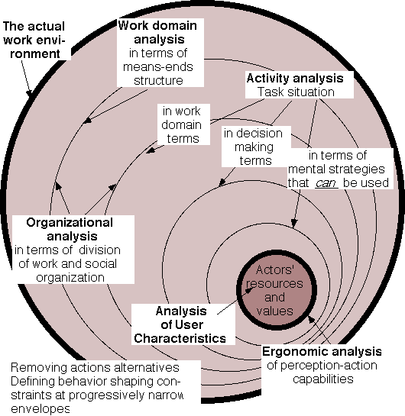

COGNITIVE WORK ANALYSIS

Definition and History:

Cognitive Work Analysis as a methodology and conceptual framework for information science research was developed by Jens Rasmussen and Annelise Mark Pejtersen from the Risoe National Laboratory in Denmark. The intellectual foundations of this framework were further developed by Kim Vicente in a 1999 publication: Cognitive work analysis: Towards safe, productive, and healthy computer-based work. The focus of the CWA framework is an analysis of the complex interactions between humans and their cognitive processes, technology (information systems) and work domains (work environments and tasks).

The CWA framework grew out of field studies that attempted to analyze complex, modern work domains. These domains can involve multiple, evolving systems and often require that workers rapidly adapt to those systems. Cognitive Work Analysis breaks down the total work environment and identifies constraints that affect all aspects of the system. Major areas that are subject to analysis are included in the chart above.

Cognitive Work analysis is sometimes called socio-technical analysis because it deals with social, cognitive and technological systems and their interactions.

Relevance to Information Science:

ECOLOGICAL INFORMATION SYSTEMS: Information science deals with multiple, dynamic and unpredictable systems – systems that consist of users, interfaces, technology, tasks and information grounds and environments. These elements are in a state of near constant evolution. An analysis of such systems in terms of linear sequences of behavior, or isolated technological functions, is inadequate for information science. The CWA framework provides a way to treat the information system, the user and the information environment as an ecological whole, with all parts interacting and working together. It is based on the assumption that information systems should be, and are, integrated into every aspect of the life of the user (Raya Fidel).

USER CENTERED DESIGN/DESIGN FOR ADAPTATION: CWA uses a Constraint based analysis. This is probably the most important concept in CWA and the one most relevant to Information Science as a discipline. Simply put - Constraints specify what cannot be done rather than what can be done. When information interactions become intensely complex and dynamic, and when they include multiple factors (user, interface, task etc.), it is impossible to create a system that will anticipate all possibilities. CWA identifies constraints that shape behavior, rather than trying to predict the behavior itself. The CWA framework is able to support the design of systems that allow the user to do what is possible by identifying and making visible known limitations. The constraints limit possible solutions, but do not impose any particular solution on the user. The resulting system doesn't tell you what to do. The user is not forced to adapt to the system; rather, it creates a defined space within which the user can operate. Information systems designed in this way foster adaptation and creativity and are able to accommodate individual differences between users.

References

Vicente, K.J. (1999). Cognitive work analysis: Towards safe, productive, and healthy computer-based work. Mahwah, NJ: Lawrence Erlbaum Associates, Inc.

A thorough introduction to the Cognitive Work Analysis framework

Rasmussen, J., Pejtersen, A., & Goodstein, L. P. (1994). Cognitive systems engineering New York: Wiley.

A comprehensive description of Rasmussen and Pejtersen’s work on Cognitive Work Analysis

You might also be interested in the following paper:

Collaborative information retrieval (CIR)
The New Review of Information Behavior and Research
Volume 1 , Issue January 2000 Pages: 235 - 247
H. Bruce, R. Fidel, A.M. Pejtersen, S. Dumais, J. Grudin

Or link to:

http://www.ischool.washington.edu/cir/ISICtextWeb.doc

This paper describes the application of the Cognitive Analysis Framework to the study of information behavior and information seeking in work-teams.

LIS 570 – ROBERTA E MUNOZ

[Asis-l] Raya Fidel's talk on Nov. 22

