Graphical Presentation Techniques

The study of graphical presentation is a subfield of Statistics, and concerns the visual representation of the numerical statistical data that most often appears in tables. Graphical presentations perform many functions better than tables, including: conveying a message clearly and memorably; providing a comprehensive grasp of the essential meaning of large masses of data; and creating interest and attracting attention.
One expert, writing in the 1950’s, identified graphical presentation as “a functional form of art as much as modern painting or architectural design.” In the past, creating accurate and appealing charts required a draftsperson and, sometimes, a specialized visual information specialist. Today, software packages enable anyone who can create a spreadsheet to make charts, although often this democratizing effect has served merely to encourage the proliferation of good-looking but distorted or misleading charts. Some of the elements of a good chart, such as maintaining proper perspective when projecting in three dimensions, are taken care of automatically nowadays. Others, like choosing the proper type of chart for the data to be presented, using the proper scale (see Fig. 1), and minimizing optical illusions through proper understanding of color/shading/line weight, are just as troublesome today as they were in a pre-computer world.
Charts and graphs can appear in many forms. The traditional types generally fall into five format-based categories: line charts, surface charts, column charts, bar charts, and map charts (see Fig. 2 for examples of each type). As with most creative objects, though, many chart types don’t fit neatly into any category. Charts will often combine two or more traditional types, or incorporate non-statistical pictures or symbols to clarify data or heighten visual impact. Some very common chart types like the pie chart and the scatter diagram are relegated to the ‘miscellaneous’ category as well (see tables of contents in Schmid and Spear).
Dramatic developments in computing technology in the past 3 decades have brought about many new ways to present data graphically. Animation and hyperlinking have pushed the upper limits of layering and detail higher than ever before (see Figs. 3 & 4), which is ironic given that computer CRT displays typically function at data densities only 1/10 to 1/1000 of a printed page.
Along with these new charting types and techniques has come an explosion of new academic subfields in graphic presentation, or as it is often called nowadays, statistical graphics. Statistical shape analysis, for instance, is the “geometrical study of random objects where location, rotation and scale information can be removed.” But, in the end, all graphical presentation techniques stand or fall on their ability to accurately and efficiently convey information to a viewer. Or, as expressed by one expert practitioner:

Confusion and clutter are failures of design, not attributes of information. And so the point is to find design strategies that reveal detail and complexity – rather than to fault the data for an excess of complication. Or, worse, to fault viewers for a lack of understanding.

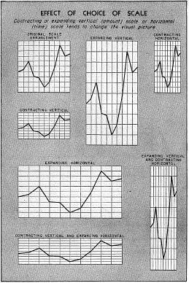
Figure 1

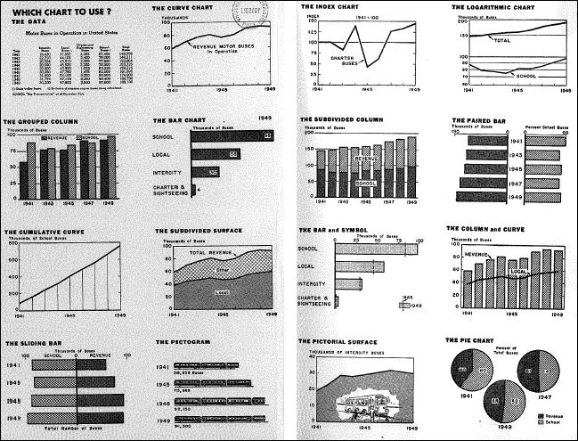
Figure 2
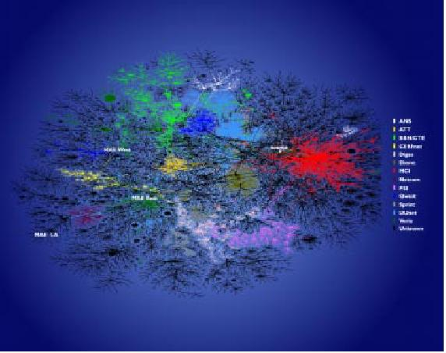
Figure 3
Two-dimensional image depicting global connectivity among ISPs.

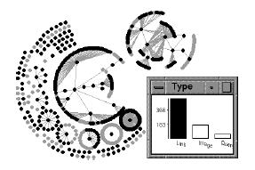
Figure 4
A graph with 2 components representing sets of URLs and their interconnections, linked to a bar chart describing the type of URL. The largest bar, representing ‘normal’ pages (not images or queries/scripts) has been selected.

Handbook of Graphic Presentation, Calvin Schmid, John Wiley & Sons, 1979, p. 1
Charting Statistics, Mary Eleanor Spear, McGraw-Hill, 1952, p. 3
Envisioning Information, Edward Tufte, Graphics Press, p. 89
Statistical Computing & Graphics Newsletter, vol. 10, no. 1, p. 34
Envisioning Information, Edward Tufte, Graphics Press, 1990, p. 53
Spear, p. 32
Spear, front matter
“Internet Measurement and Data Analysis: Topology, Workload, Performance and Routing Statistics”, kc claffy and Sean McCreary, Statistical Computing & Graphics, Vol. 10, No. 1, p. 8
“Linked Data Views”, Graham Wills, Statistical Computing & Graphics, Vol. 10, No. 1, p. 23

