Another interesting problem using stuff we've learned
A classic “weighing problem” goes as follows:
You have 13 red coins, numbered 1-13. They all appear to be identical except that one of them is an “oddball.” The oddball has a different weight from the 12 normal coins: it’s either heavier or lighter, but you don't know which.
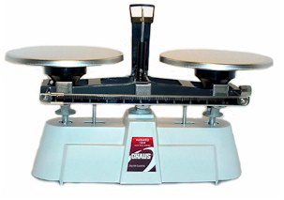
You have available to you the following:
A balance scale as shown at the right. A balance scale has two pans. So you can put two objects, Object A and Object B on the two pans and one of three outcomes will ensue: (1) the pans will balance, indicating that the two objects weigh the same, (2) Object A’s pan will be lower, indicating that Object A is heavier than Object B or (3) Object B’s pan will be lower, indicating that Object B is heavier than Object A.
An unlimited number of green coins, each of which is known to weigh exactly the same as one of the 12 normal red coins.
The problem is: using only three successive weighings with the balance scale, determine which red coin is the oddball and whether it is heaver or lighter than the normal coins.
Here are some possible steps to a solution of this problem:
- How many possible “solution states” are there, where a “solution state” is a combination of which red coin is the oddball and whether the oddball is heavier or lighter?
- How would you represent these solution states in a contingency table?
- How many outcomes are there of the allowable three weighings?
- Using all this, how would you solve the problem?

