Attachment 3
Payloads 9.8 Role Playing Information Handouts

Five functional roles follow for each team. They should be distributed after the introduction of the game, each in a sealed labeled envelope to a different team member.

Customer (NASA Representative), Team____

You will play the role of the customer. You are working with your team’s firm as a NASA-designated member. You may contribute by advocating actions based on the following information and, in general, playing the role of customer. Beyond that, you may contribute according to your abilities.

You are very concerned about some of the historical failures associated with NASA’s Mars program. It has been an embarrassment to the agency that expensive pieces of equipment, the product of thousands of human work hours and untold dollars, have wound up floating in space somewhere, far from their intended destinations. Some of those that have reached their destinations have been damaged upon impact. And, the deaths of dedicated astronauts in the 2003 Columbia disaster have raised many questions about the agency’s viability. In spite of several disappointments, there have been a few triumphs, including the Sojourner vehicle carried to Mars by Pathfinder in 1997, and the more recent success with the Mars Rover in 2004. The photo below shows how large balloons cushioned the landing for Sojourner:

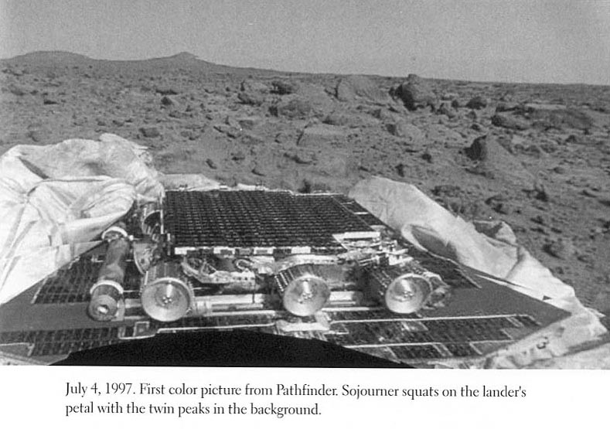
It is imperative that your payloads are not cracked or broken during delivery. They will be dropped from a height of about 50 feet. They also must be delivered accurately. If they are not on or near their intended targets, they will be unable to transmit valuable data back to Earth. The product’s usefulness drops off steadily with lower accuracy. Visual inspection of the payload is essential; the instructors must be able to see half of it without opening the package. Smaller is better than larger. Bright colors are appealing. Novelty of design is appealing. Of course, less expensive is better—all things being equal, you’ll definitely buy the least expensive product. You’ll also likely sign a longer-term contract with the company that creates an acceptable payloads device in a timely fashion. You have future work involving similar technology, in mind.
Remember the importance of performance—safe and accurate delivery, plus functional performance and aesthetics.

Payloads Business Development Representative, Team____

You will play the role of the business development representative. You are interested in your firm’s competitiveness with respect to this project, and also with your firm’s longer-term relationship with NASA. You may contribute by advocating actions based on the following information and, in general, playing the role of business development representative. Beyond that, you may contribute according to your abilities.

You have completed interviews with nine key decision-makers at NASA and you have run a series of concept tests (although the concept definition lacked specific details). The following are your conclusions:

Your firm will receive more revenue from NASA if your landing devices hit the target accurately. (See chart below for contractually based revenue specifications.)

So, for example, if your large payload is unbroken and lands 1.5 meters from the center point, you will earn $700,000.

Payloads Business Development Representative
(continued)

Here are some additional things you need to keep in mind as the Business Development Representative. Again, these are based on your interviews with NASA representatives:

- Most claimed it was “very important” that most of the egg be visible.
- Most wanted the product to be easy to grasp.
- A few didn’t like balloons because they worried that they might not be dependable, but others liked the idea.
- Some wanted the package to be reusable, perhaps for different applications, and, therefore, wanted easy installation and removal.

In addition to your role on the prototype design, you should play an important part in writing a brief concept statement describing your product, identifying its important features. Be prepared to read this to the audience before the launch.

Incentive: You will personally receive a fabulous gift if your team earns the highest total revenue. Thus, accuracy is very important to you.

Payloads Marketing Representative, Team____

You will play the role of marketing representative. You work for the firm developing the product and you represent the marketing function on the new product team. You may contribute by advocating actions based on the following information and, in general, playing the role of marketing representative. Beyond that, you may contribute according to your abilities.

You are aware that payload safety and accuracy are very important. You are also a creative type, so you like designs that are attractive. You know that a good-looking design may receive more attention. Additionally, as a marketing person, you wish to encourage the team to develop both of your Payloads products as soon as possible. You know development time will seriously affect your competitive position with the customer, and that it also has a strong influence on total cost. Development time is a function of real time (see table below). Based on your extensive knowledge, along with recent analysis of NASA data, you have determined these costs to be as follows:
1 minute = 1 week

Note: consider these costs to be accurate.
So, as you can see in the table, if you finish in 10 minutes (the equivalent of 10 weeks) your team will have incurred a development cost of $10,000. If you finish in 20 minutes your cost will be $50,000. At the end of 60 minutes (your limit), the cost will be up to $2,000,000. The image on the next page highlights the time/cost relationship graphically.

Marketing Representative (continued)

Incentive: If your team finishes in the least amount of time, you will personally receive a fabulous gift. Thus, product development time should be very important to you.

Payloads Design Engineer, Team____

You will play the role of design engineer. You work for the firm that is developing the product and you represent the design function on the new product team. You may contribute by advocating actions based on the following information and, in general, playing the role of design engineer. Beyond that, you may contribute according to your abilities.

The design group has conducted interviews with NASA engineers and has studied recent Mars programs, examining reasons for success and failure. The following summarizes their findings

Technical design issues:
- A square or rectangular shape facilitates stacking and storing in the transportation pod.
- Smaller is better; space and weight are at a premium
- NASA officials insist on being able to see 50% of each egg while it is in the package. They don’t need to see the entire 50% from a single view, but in all views combined. This allows them to determine whether or not the payload is safe following the drop test. In the Martian environment, it will allow for monitoring from cameras housed in other equipment on the surface. Your team will not be allowed to participate in the launch if 50% of the egg is not visible.
- You definitely prefer a design that will protect the payload from breakage.

Aesthetic issues:
- NASA officials are always under pressure from Congress. They must continuously ‘sell’ what they are doing to those who provide funding. A more attractive package will give them something to show members of the House and Senate when they give presentations at budget time
- NASA officials have shown somewhat favorable reactions to graceful, arcing, and floating deliveries.

Remember that your team is rewarded on performance—safe delivery and aesthetics.

Payloads Manufacturing Engineer, Team____

You will play the role of manufacturing engineer. (Note that all manufacturing engineers will stay in the classroom for a few minutes for further instruction before joining their groups in the Design Center.) You work for the firm that is developing the products and you represent the manufacturing function on the new product team. You can contribute by advocating actions based on the following information and, in general, playing the role of manufacturing engineer. Beyond that, you may contribute according to your abilities. Materials at your development work station (table) are provided to you in three forms: tools, non-discrete parts, and discrete components. The specifics about materials and quantity limits are provided in the enclosed inventory list. There is no charge for tools (scissors, ruler, markers, bag), but they must not be used in the product. Non-discrete parts (duct tape, rubber cement, string) are provided in prescribed amounts. Each non-discrete part used in the product costs $20,000, no matter how much is used. Your primary concern is to minimize the total cost of non-discrete parts and discrete components used in your product. The first unit of each discrete component type has the same cost—$20,000. But, the costs go down with volume as follows:

Units used | 1st | 2nd | 3rd | 4th | 5th | 6th | 7th | 8th
Cost per unit | $20,000 | 10,000 | 5,000 | 2,000 | 2,000 | 2,000 | 2,000 | ...

The repeated use of a discrete component leads to lower marginal costs. For example, if your team uses a second Popsicle stick, it will cost only half what the first one cost. These cost advantages are gained through purchasing and manufacturing economies, costs of inventory control systems, and the benefits of standardized assembly.

As part of your role, you should play an important part in the completion of the enclosed Cost Worksheet.

Incentive: you will personally receive a fabulous gift if your team has the lowest overall parts cost.
Manufacturing Engineer (continued)

Inventory List (limit of these quantities)

Discrete Parts

- balloons—6
- Styrofoam cups—8
- plastic—2 sheets (11”x11”)
- newspaper—2 single-sheet sections
- straws—6
- paper clips—4
- rubber bands—4
- pipe cleaners—6
- eggs—2 chicken eggs and 2 quail eggs
- pop sickle sticks—8
- typing paper—2
- bubble gum sticks—6
- hole reinforcers—8

Non-discrete Parts – parts continuous in measure, but limited in supply
- duct tape—1 meter
- string—2 meters.
- rubber cement – 1 bottle.

The following tools/overhead items, may not be incorporated into the product:
- scissors
- ruler
- markers (assorted colors)
- zip-style plastic bag (the materials are contained in this bag)

Manufacturing Engineer (Continued)
Cost Worksheet

Your team name________

1. Development Time Cost

Development time________ (filled in by the instructor at Payloads Center)

Development time cost____________________

2. Material Costs

Part count__________________ (Each single piece counts as a part, except for non-discrete materials, which count as one if any amount is used.) The manufacturing engineer has this information.

Part type | Number used | Costs for this part
Total number of  part types | Total number of parts | Total parts cost

Total Material Cost________________

