Supplemental Material

Contents
LC-MS/MS conditions.
Supplemental Table 1.
Supplemental Table 2.
Supplemental Figure 1.
Supplemental Figure 2.
Supplemental Table 3.
Supplemental Table 4.
Supplemental Figure 3.
LC-MS/MS Assays with B-Lymphocyte Cell Lines.
Supplemental Table 5.
Fluorometric assay conditions.
Supplemental Table 6.
Supplemental Table 7.
Purity of ethyl acetate.

LC-MS/MS conditions
The LC gradient, started with 40% B, was increased linearly to 95% B from 0 to 1.85 min, decreased linearly to 80% B from 1.85 to 3 min, and then increased linearly again to 95% B from 3 to 7 min and held until 13 min. A 1.5 min post time was included to equilibrate back to the initial condition for the next injection.
The flow rate was 0.45 mL/min from 0-1.85 min and 7-13 min, and 0.3 mL/min from 1.85-7 min. The injection volume was 0.2 μL. Solvent A was 95% water/5% acetonitrile containing 0.1% formic acid, and solvent B was 50% methanol/50% acetonitrile containing 0.1% formic acid. The auto sampler temperature was 10°C.

MS/MS Source conditions and multiple reaction monitoring parameters
The mass spectrometer was operated in positive jet stream ESI mode. Nitrogen was used as nebulizer gas, turbo (heater) gas, curtain, and collision-activated dissociation gas. The capillary voltage was +3500 V and the nozzle voltage was +500 V. The ion source gas temperature was 225°C with a flow rate of 5 L/min. The sheath gas temperature was 150 °C with a flow rate of 10 L/min. The nebulizer gas was 45 psi. The source conditions are listed in Supplemental Table 1, and the optimal multiple reaction monitoring parameters for the products and internal standards of GAA, GLA and IDUA are listed in Supplemental Table 2. During the LC time 0-0.9 min, the LC eluent was diverted by a valve to waste. The GAA, GLA and IDUA products and internal standards eluted during the second time segment from 0.9-4.5 min. The products and internal standards of the enzymes of Niemann-Pick A/B (ASM), Krabbe (GALC) and Gaucher (ABG) eluted during the third time segment from 4.5-13 min (Supplemental Figure 1).

Supplemental Table 1. Source parameters.

Parameter | Value (+)
Gas temp (°C) | 225
Gas flow (l/min) | 5
Nebulizer (psi) | 45
Sheath gas heater | 150
Sheath gas flow | 10
Capillary (V) | 3500
V Charging | 500

Supplemental Table 2. Multiple reaction monitoring parameters of internal standards and products.

Name | Precursor ion | Product ion | Dwell | Frag (V) | CE (V) | Polarity
IDUA-IS | 377.2 | 277.1 | 100 | 52 | 3 | +
IDUA-P | 391.2 | 291.1 | 100 | 55 | 6 | +
GLA-IS | 489.3 | 398.3 | 75 | 60 | 9 | +
GLA-P | 484.3 | 384.3 | 75 | 55 | 9 | +
GAA-IS | 503.3 | 498.3 | 55 | 60 | 9 | +
GAA-P | 498.3 | 398.3 | 75 | 55 | 9 | +
ASM-IS | 370.3 | 264.2 | 50 | 55 | 3 | +
ASM-P | 398.4 | 264.2 | 50 | 60 | 3 | +
GALC-IS | 426.4 | 264.2 | 50 | 50 | 5 | +
GALC-P | 454.4 | 264.2 | 50 | 50 | 5 | +
ABG-IS | 482.5 | 264.2 | 50 | 65 | 6 | +
ABG-P | 510.4 | 264.2 | 50 | 60 | 7 | +

Supplemental Figure 1. Extracted Ion Chromatogram of internal standards and products for 6 lysosomal enzymes.

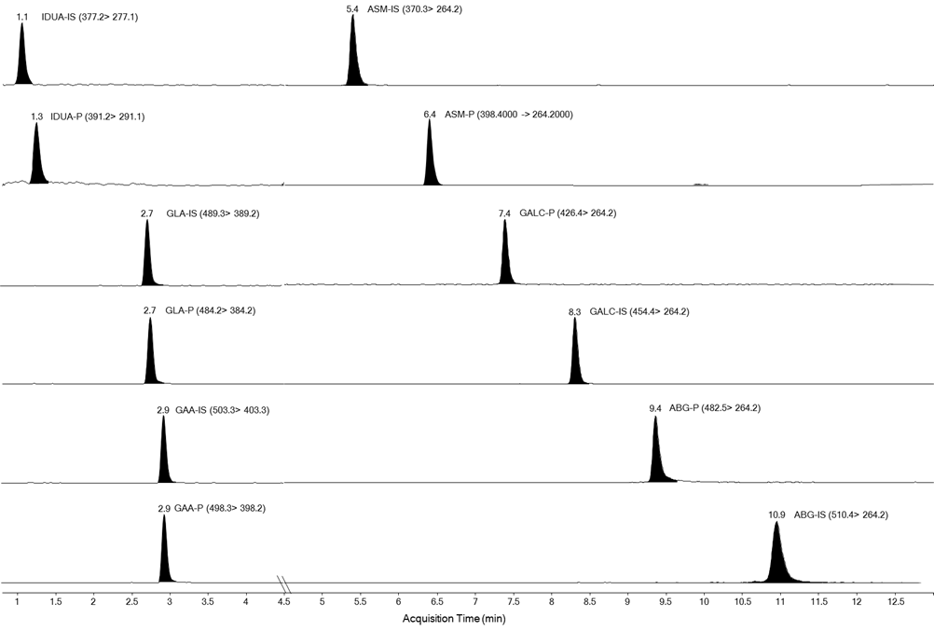
IDUA, α-L-iduronidase; GLA, α-galactosidase A; GAA, α-acid-glucosidase; ASM, acid-sphingomyelinase; GALC, galactocerebrosidase; ABG, acid β-glucosidase

Supplemental Figure 2. Time course study with five leukocyte lysates from non-Pompe patients. The R² values are shown at the bottom of the data table below the figure.

Min | Sample 1 | Sample 2 | Sample 3 | Sample 4 | Sample 5 | Mean
15 | 10.71 | 3.63 | 3.96 | 9.30 | 2.36
30 | 19.77 | 8.32 | 6.81 | 16.43 | 3.97
60 | 37.86 | 10.75 | 12.52 | 33.26 | 8.28
90 | 54.66 | 19.31 | 18.85 | 52.64 | 8.31
120 | 75.54 | 23.33 | 25.68 | 104.64 | 14.92
R² | 0.999 | 0.974 | 0.999 | 0.922 | 0.924 | 0.964

Supplemental Table 3. Analytical Range (AR) and Inter-assay reproducibility were performed using normal control leukocyte lysates. Each assay was carried out in duplicate. Multiple reaction monitoring ion counts were obtained by integration of the peaks.

 | Blank |  |  | Normal lysate |  |  |  |  | GAA
ID | Product | IS | P/IS | Product | IS | P/IS | AR | AR Mean | Activity (nmole/hr/mg)
NC-1 | 94 | 96178 | 0.001 | 151437 | 109768 | 1.38 | 1412 | 1444 | 52.2
 | 122 | 125231 | 0.001 | 162767 | 113172 | 1.44 | 1476
NC-2 | 247 | 106055 | 0.002 | 125902 | 95622 | 1.32 | 565 | 547 | 52.4
 | 241 | 92572 | 0.003 | 133572 | 96983 | 1.38 | 529
NC-3 | 74 | 107897 | 0.001 | 161965 | 117700 | 1.38 | 2006 | 1897 | 50.7
 | 90 | 118327 | 0.001 | 152108 | 111902 | 1.36 | 1787
NC-4 | 304 | 111603 | 0.003 | 151809 | 87106 | 1.74 | 640 | 652 | 58.3
 | 231 | 87727 | 0.003 | 138490 | 79256 | 1.75 | 664
NC-5 | 56 | 61972 | 0.001 | 51683 | 31888 | 1.62 | 1778 | 1603 | 58.7
 | 63 | 54044 | 0.001 | 64696 | 38862 | 1.66 | 1428
NC-6 | 159 | 75731 | 0.002 | 141046 | 68078 | 2.07 | 987 | 1060 | 68.2
 | 127 | 71690 | 0.002 | 147028 | 73216 | 2.01 | 1134
NC-7 | 126 | 98319 | 0.001 | 126413 | 86105 | 1.47 | 1146 | 1339 | 55.8
 | 99 | 100705 | 0.001 | 126382 | 83873 | 1.51 | 1533
NC-8 | 246 | 88307 | 0.003 | 127845 | 77348 | 1.65 | 593 | 539 | 62.5
 | 301 | 88190 | 0.003 | 120522 | 72899 | 1.65 | 484
Mean |  |  |  |  |  |  |  | 1135 | 57.3
SD |  |  |  |  |  |  |  | 518 | 5.9

Supplemental Table 4. Fluorometric assay of the same normal control leukocyte lysates that was used in the LC-MS/MS assay using 4-methylumbelliferyl-α-glucoside substrate. Measurements in triplicate. The control reflected all non-enzymatic signals from buffer, substrates and lysates (see fluorometric assays section below and Clin Chem 2015; 61:1363-71 for a complete discussion of the fluorometric controls).
Run | Fluor. (Complete Assay) | Fluor. (Control) | Specific Activity  (nmol/hr/mg) | Analytical Range
1 | 16784 | 11151 | 6.3 | 1.5
2 | 16977 | 10484 | 7.2 | 1.6
3 | 17578 | 11313 | 6.9 | 1.6
Mean ± Std | 17113 ± 414 | 10983 ± 439 | 6.8 ± 0.5 | 1.6 ± 0.1

Supplemental Figure 3. Linearity study with CDC P/IS calibrators. Plotted is the observed ratio of the integral of the GAA product (P) multiple reaction monitoring peak divided by the corresponding integral for GAA internal standard (IS) versus the expected ratio (provided by the CDC).

LC-MS/MS assays with B lymphocyte cell lines
Immortalized B lymphocytes (LCL cells) from Pompe disease patients were obtained from the Coriell Institute (Camden, NJ). Cells were grown according to the supplier instructions. Cells were collected by centrifugation and washed several time with Dulbecco’s phosphate-buffer saline (DPBS). Cell suspensions in DPBS were stored at -80 °C. For assays of GAA, a tube of frozen cell suspension was thawed on ice. An aliquot was used for protein assay (Pierce BCA, ThermoFisher Cat. 23252, BSA standard). For the blank the DPBS supernatant above the last cell centrifugation was used (although this read the same as pure DPBS). Studies showed that freeze-thaw of cell suspensions produced the same amount of GAA enzymatic activity as sonication (not shown). Cell lysates were diluted with DPBS to give a protein concentration of 0.2 μg/μL.
For LC-MS/MS GAA assays, reactions contained 10 μL of thawed cell suspension (2 μg of protein) and 30 μL of citrate phosphate buffer containing 0.56 mM of GAA substrate, 5.61 μM of GAA internal standard, and 12 μM acarbose in a 96-well, polypropylene microtiter plate. Citrate phosphate buffer was made by adding 0.4 M citric acid to 25 mL of 0.4 Na₂HPO₄ until the pH dropped to 4.20 (pH meter) and then adding water to bring the volume to 50 mL. The plate was sealed with a reusable plate-sealing cap (Sigma Micro Mat Cat. Z374938) and incubated for 16 h at 37°C with orbital shaking (200 rpm). To each well was added 0.2 mL of acetonitrile (Fisher Optima grade), and the well contents mixed by pumping up and down 20 times with a pipette. The plate was centrifuged for 5 min at room temperature at 2000 x g. A portion of the supernatant (0.12 mL) was transferred with a multi-channel pipette to a new 96-well, microtiter plate, and 80 μL of water was added to each well. After mixing 10 times with the pipette, the plate was covered with aluminum foil and placed on the auto sampler (cooled to 8°C) of the LC-MS/MS (Waters Xevo TQ with an Acquity UHPLC system). Ten μL of each well was injected (full loop type, strong needle wash acetonitrile/0.1% formic acid, weak needle wash 10% acetonitrile in water with 0.1% formic acid). The LC column was an Acquity CSH C18, 2.1 x 50 mm, 1.7 μM with an Acquity UPLC CHS C18 VanGuard pre-column (all from Waters). The flow rate was 0.8 mL/min with solvent A (water with 0.1% formic acid, all Fisher Optima grade) and solvent B (acetonitrile/methanol, 50/50 with 0.1% formic acid, all Fisher Optima grade). The program was 50 to 100% B (0 to 1.49 min), then to 50% B at 1.50 min, then hold 50% for 0.5 min.
Mass spectrometer instrument settings were as published (Clin Chem 2013; 59: 502-11). Using the Waters MassLynx software package, multiple reaction monitoring peaks for GAA product and GAA internal standard were integrated, and the nmol of GAA product was obtained as [(GAA product peak integral)/(GAA internal standard peak intregal)] x (nmol of GAA internal standard added to the assay). Blank assays were prepared in the same way using DPBS instead of cell lysate. The specific activity of GAA (nmol/hr/mg) were calculated as [(nmol GAA product in assay with cell lyate) – (nmol GAA product in blank)] divided by the [(incubation time) x (mg cell protein in the assay)].
Supplemental Table 5. LC-MS/MS assay of GAA activity in B-Lymphoblasts (Coriell Institute) from early-onset Pompe (EOPD) and LOPD.
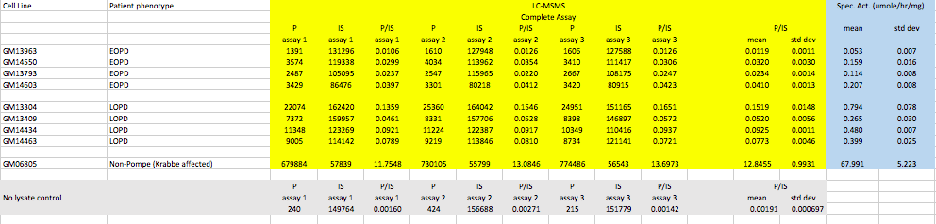

Fluorometric assay conditions
Fluorometric assays were carried out as follows. The assay cocktail was 1 mM 4-methylumbellifery α-D-glucoside (Toronto Research Chemicals 334495) in citrate phosphate buffer with acarbose (see above). To each well of a 96-well, black, microtiter fluorimeter plate we added 30 μL of assay cocktail and 10 μL of cell lysate. Each cell lysate was submitted to triplicate assays and triplicate control assays. The latter were carried out by mixing 15 μL of buffer (no substrate) with 10 μL of cell lysate in one well (well A) of the plate. In a second well (well B) we placed 30 μL of buffer containing 2 mM substrate. The plate was sealed and incubated as above. After incubation, 15 μL of well B was transferred to well A, and then 200 μL of stop buffer (100 mM NaHCO₃, pH 10.7) was added. In this way the control contained all components of the complete assay, but the substrate was incubated separately from GAA enzyme. Stop buffer (200 μL) was also added to the complete assay wells. The plates were centrifuged at 3000 x g for 5 min at room temperature. The plate was then placed in a Victor 1420 Multilabel counter (Victor3V, PerkinElmer) fluorimeter plate reader and the fluorescence read with 355 nm excitation and 460 nm emission filters (no difference was observed if the supernatant after centrifugation was transferred to a new plate before reading). A calibration curve was prepared by mixing standard amounts of 4-methylumbelliferone (0-10 μM) into assay buffer containing cell lysate in the absence of protein. The fluorescence response from the control was subtracted from that of the complete assay, and the calibration curve was used to convert the response to nmol of 4-methylumbelliferone product. The latter was divided by (incubation time x mg protein) to give the specific activity (nmol/hr/mg).

Supplemental Table 6. Analysis of GAA activity in B-Lymphoblasts (Coriell Institute) from early-onset Pompe (EOPD) and LOPD patients by fluorometry.

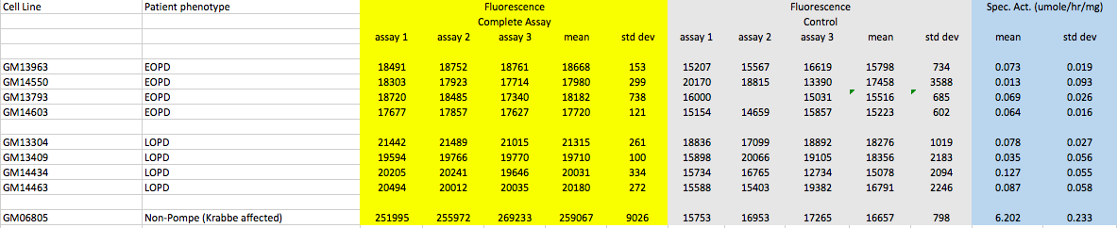

- Supplemental Table 7. Information on the B-lymphoblast cell lines from the Coriell database.
Coriell Cell Line Number | Classification | Age at onset of symptoms | Genotype | Coriell Commentary
GM13963 | EOPD | 3.5 months | p.Arg854X/p.Arg854X | Classical infantile Pompe
GM14550 | EOPD | ? | c.525delT/p.T737N | Probable classical infantile Pompe
GM13793 | EOPD | ? | c.-32-2A>G/p.G293R | Early onset Pompe
GM14603 | EOPD |  | R224W/ c.2481+102_2646+31del | Probable classical infantile Pompe
GM13304 | LOPD | ? | c.-32-13T>G/p.W516X | Patient was 27 yr at time of sampling
GM13409 | LOPD | ? | c.-32-3C>A/p.Glu176fsX45 | Patient was 28 yr at time of sampling
GM14434 | LOPD | ? | IVS1-13T>G/p.G293R | Patient was 27 yr at time of sampling
GM14463 | LOPD | ? | IVS1-13T>G/p.Gln124SerfsX18 | Patient was 26 yr at time of sampling

Purity of ethyl acetate
The quality of ethyl acetate used in the GAA assay protocol must be considered. Trace amounts of oxidizers (e.g., peracetic acid) from ethyl acetate manufacturing have been found to lower the GAA product and internal standard intensities. The lowering of these signals can affect the accurate measurement of low-activity samples. We found HPLC and LC-MS/MS grade ethyl acetate from J.T. Baker (Avantor) to be routinely of good quality for this application (undetectable amount of oxidizers). Ethyl acetate with trace oxidizer contamination can be cleaned by treatment with anion exchange resin (such as Dowex-1). If needed one can swirl 10 g of Dowex-1 in an Erlenmeyer flask with 50-100 mL of ethyl acetate, then decant, repeat 3 times (to remove contaminants that may be present on the surface of commercial Dowex-1). Then the washed Dowex-1 is transferred to a glass bottle of ethyl acetate (1-2 liters), swirled briefly, and then used for the assay. There is no need to remove the Dowex-1 beads, which will remain at the bottom of the bottle.

