
Directions to Ed Walker’s Office H-660 or the I-Wing Rotunda Cafe
(and a picture in case you’re looking for me in the Rotunda cafe)

Come to the west end of campus and follow 15th NE southbound (yellow arrows) across NE Pacific Street and it will lead you to the S1 parking area behind the Health Sciences complex. You are entering Gatehouse 6 (next to the yellow circle). Park as close to the west end of the S1 parking as you can, and then walk back toward the Gatehouse. As you walk back on your right you'll see a set of wide steps (yellow circle) going up to a courtyard leading straight ahead to a round cafe seating area called the I-Wing Rotunda.

If you’re meeting me in the I-Wing Rotunda, proceed straight ahead. If you’re coming up to my office, turn right just before you enter the Rotunda double doors, and enter the H-Wing building (near the “$” on the map). Take the elevators up to the 6th floor and H-660 is right in front of you as you leave the elevator.

Note: if you’re coming for less than 2 hours, you might want to check out the metered parking on the street (see map below) just before you enter. The university parking is often full and significantly more expensive.

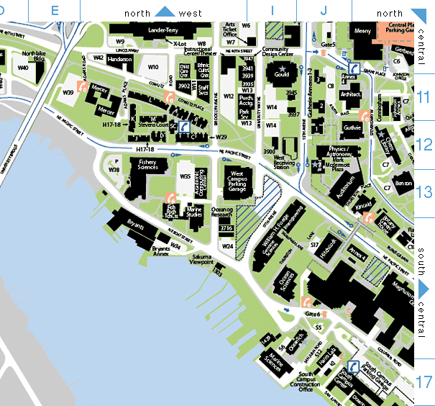
Street Parking

