Worksheet: The Case(s) of the Mysterious T₃/T₄ ratio!

Goals
- Identify limitations of textbook-level explanations of thyroid hormone transport.
- Describe how normal processing of thyroid hormone enables changes in gene expression.
- Explain why a patient’s T₃ levels might not track with his/her T₄ levels (e.g., one is high while the other is low).
- Explain why patients with mutations in MCT8 have some symptoms of hypothyroidism, but not others.
- Offer ideas to advance research in this area.

Reference
- Edith C. H. Friesema et al., “Association between mutations in a thyroid hormone transporter and severe X-linked psychomotor retardation,” Lancet 364: 1435-1437, 2004

Group roles to assign
- Discussion leader: introduces questions, gathers input
- Lifeline: looks things up, gets instructor’s attention
- Equity officer: ensures equal participation
- Digression manager: keeps discussion on track

I. How do thyroid hormones (T₃ and T₄) get in and out of cells?

1. Would you describe the overall structure of T₃ and T₄ as hydrophilic or hydrophobic?  2. Are cell-membrane transporters necessary for T₃ and T₄ to get in and out of cells? (Check p. 300 of your textbook.)  3. The assigned paper (Friesema et al.) discusses mutations in the monocarboxylate transporter 8 (MCT8). | 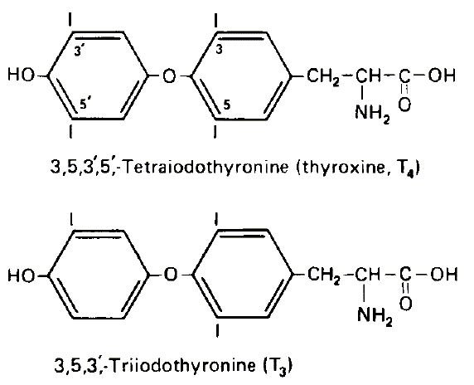  Figure: Anaesthetist.com
(a) What is a monocarboxylate?

(b) Are T₃ and/or T₄ monocarboxylates?

(c) What is known about the function of MCT8?

4. What effects (symptoms) did mutations of MCT8 have in human patients, according to Friesema et al.?

5. Considering your answer to #4, reconsider your answer to #2.

6. Friesema et al. blame the symptoms you listed in #4 on problems with thyroid hormones. Describe an experiment that you could do to show that the problem really does involve thyroid hormones rather than something else transported by MCT8.

II. What specific mutations in MCT8 were discovered?

7. Genetics review.

(a) What is an exon?

(b) What is an intron?

(c) Can a mutation in either an exon or an intron impair the function of a protein? Why/why not?

8. Look at Figure 2 of the Friesema et al. paper. Why are PCR products on gels shown for patient 1 (P1) and patient 4 (P4), while DNA sequencing data are shown for patients 2, 3, and 5?

9. Do you think all five mutations are equally detrimental to function? Why or why not?

III. Thyroid hormone pharmacokinetics

10. Here are some important facts:
- T₄ is more concentrated in the blood than T₃, but T₃ has stronger effects on gene expression.
- Inside cells, T₄ can be converted to T₃ (the more active form) by deiodinases DIO1 or DIO2. Deiodinase DIO3 does not appear to create active T₃.
Given these facts and the figures on the next page (from J. Bernal et al., Nature Reviews Endocrinology 11: 406-417, 2015), why might an MCT8 mutation affect neurons in the brain more than other tissues that require thyroid hormone for proper development?
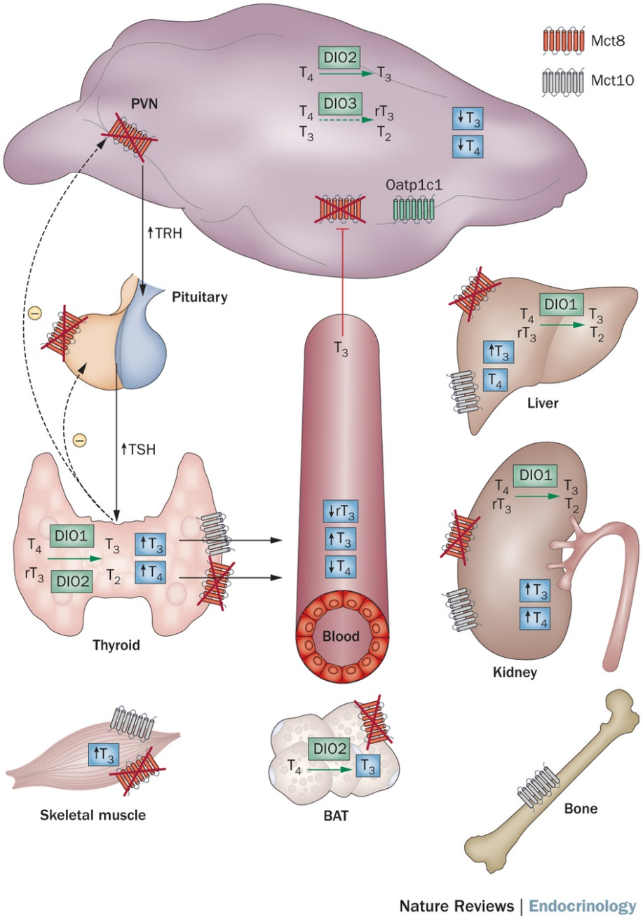
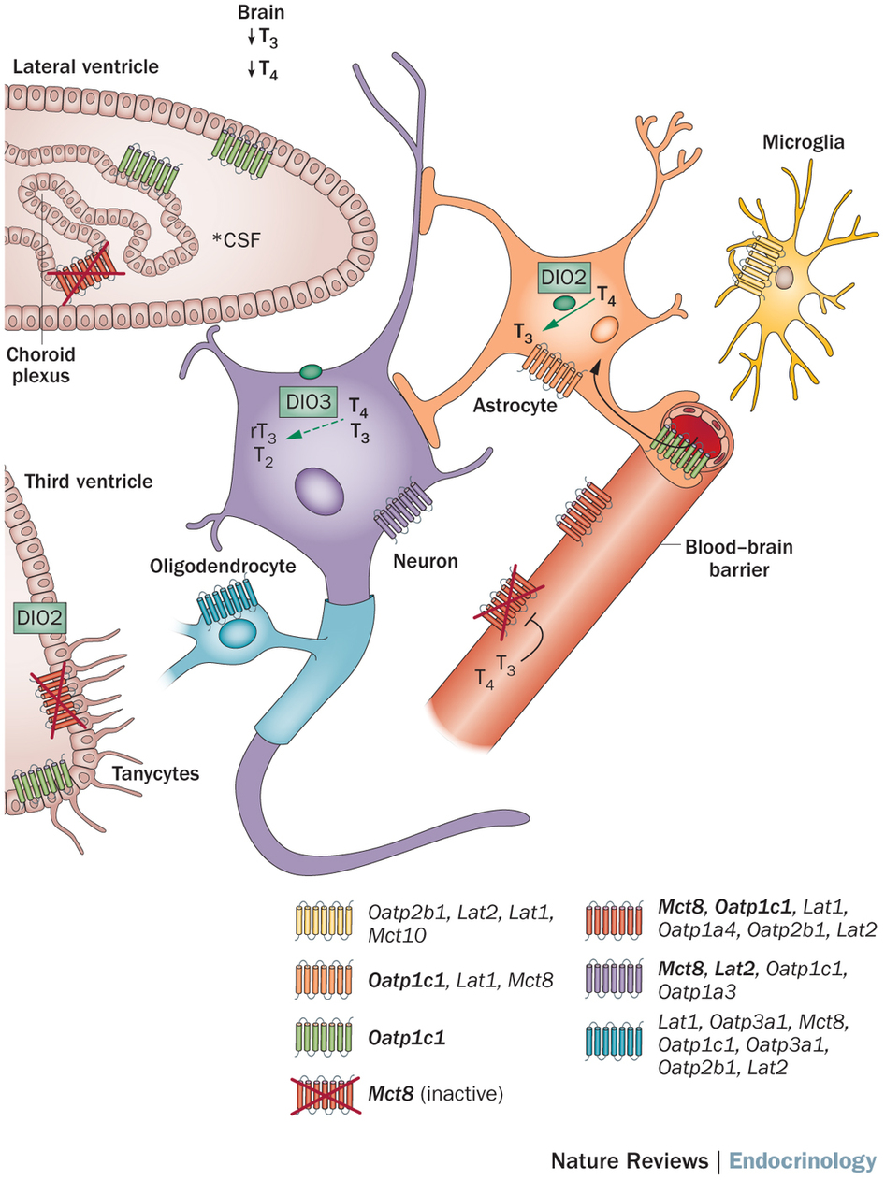
Top/right: Changes in thyroid hormone concentration in Mct8 knock-out mice.
Bottom/left: Thyroid hormone transport in the mouse brain.
11. Explain how mutations in MCT8 may disrupt interactions of astrocytes and neurons in the CNS, according to Friesema et al.

12. What further experiments could be done to further test the above hypothesis?

13. Based on this exercise, do you think MCT8 normally is important in transporting T₃, T₄, both, or neither? Explain.

