Worksheet: how neurons communicate

Goal

The goal of this worksheet is to help you understand how information is transmitted from one neuron to the next neuron in the nervous system. This can be summarized as follows:
- Communication through the nervous system involves changing the membrane potential (voltage) of neurons.
- Changes in membrane potential occur when some ions move from one side of the membrane to the other.
- Ions cannot diffuse freely across the membrane; they can only pass through open ion channels.
- Therefore, understanding neurons is basically a matter of which ion channels are open when, where, and why.

(0) Overview and context

The process of neuron-to-neuron communication involves several steps, each of which is covered in a separate section below: (1) neurotransmitter release at synapses, (2) post-synaptic potentials (PSPs), (3) passive spread of PSPs, (4) summation of PSPs at the axon hillock, and (5) action potentials along the axon.

Before running through the process in detail, it may be helpful to review or learn the building blocks listed below, all of which come into play during the process.

(A) Neuron anatomy
- Draw a “generic” neuron and label the following parts of a “generic” neuron: dendrites, cell body (soma), axon, axon hillock, axon terminal.
(B) Membrane potential
- What is the definition of membrane potential?
- What is a typical membrane potential for a “resting” neuron? Does this mean that the inside of the cell membrane is negative relative to the outside, or positive relative to the outside?
- In the context of membrane potential, what does depolarization mean? Repolarization? Hyperpolarization?
(C) Electrochemical gradients
- What is a chemical (concentration) gradient, in general?
- What is an electrical gradient, in general? Which of the following phrases captures it better: “like attracts like,” or “opposites attract”?
- Which molecular species, in general, are simultaneously governed both by their electrical gradients and their chemical gradients?
- Na⁺, K⁺, and Cl⁻ are each subject to their own electrochemical gradient. Which way – into cells, or out of cells – is each one driven by this gradient?
(D) Ion channels
- The three major types of ion channels in neurons are ligand-gated (or chemically gated) channeled, voltage-gated channels and non-gated (leakage) channels. Explain the differences.
- Where along a typical neuron (dendrites, soma, and/or axon) are most ligand-gated channels found? Where are most voltage-gated channels found?

(E) Spread of electrical signal: passive vs. active
- If an ion channel opens, and ions enter or exit the cell, they will diffuse away from the channel, so the change in membrane potential will propagate along the cell membrane. However, this change will decay over distance if not actively regenerated. This is called “passive spread” of an electrical signal.
- If a depolarization of a section of cell membrane and diffusion of the ions open voltage-gated channels, leading to the influx of more ions and further spreading of the depolarization, this is called “active spread.”
- Note that this use of the terms “active” and “passive” is not exactly the same as their use in discussions of transport across cell membranes.
(F) Exocytosis (via vesicles)
- What does the term exocytosis mean in general?
- Where in neurons does exocytosis occur?
- What do neurons release via exocytosis?

(1) Neurotransmitter release at synapses

1.1. By looking at how motor neurons activate skeletal muscle cells, we have already seen how synapses work. Let’s solidify our understanding by making a simple sketch of each step. Try to capture the key points using as few lines/shapes as possible!

A. Resting state. The axon terminus membrane potential is negative. Ca²⁺ is more concentrated outside the cell.  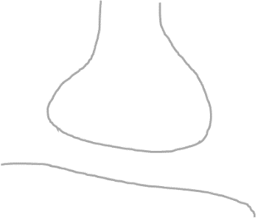 | B. Depolarization from the axon spreads to the axon terminus. | C. Voltage-gated Ca²⁺ channels in the axon terminus membrane sense the depolarization and open.

D. A few of the Ca²⁺ ions enter the axon terminus. | E. Ca²⁺ binds to a protein on the membrane of synaptic vesicles, which hold neurotransmitter. | F. The vesicles fuse with the cell membrane and dump the neurotransmitter into the synaptic cleft.
1.2. How is the above process similar to and different from calcium’s role in skeletal muscle contraction?

SIMILAR:

DIFFERENT:

1.3. How will step F above affect the post-synaptic neuron?

(2) Post-synaptic potentials (PSPs)

Neurotransmitters released by the pre-synaptic cell bind to receptors in the membrane of the post-synaptic cell. These receptors either serve as ion channels – for example, acetylcholine receptors often serve as Na⁺ channels, as we saw with skeletal muscle cells – or they generate intracellular signals (2nd messengers) that cause ion channels to open.

Which ion channels open depends on which neurotransmitter is being used and sometimes which receptor binds to it (as discussed below). Regardless, the inward or outward movement of ions changes the membrane potential. Since this change occurs in the post-synaptic cell, it is called a Post-Synaptic Potential, or PSP. If the PSP brings the membrane potential closer to 0 mV, it is called an Excitatory Post-Synaptic Potential (EPSP); if it makes the membrane potential more negative, it is called an Inhibitory Post-Synaptic Potential (IPSP).

2.1. Complete the following table.

Ion channel | Ion movement, if channel is open | EPSP or IPSP?
Na⁺ | Na⁺ enters cell
K⁺ | K⁺ exits cell
Cl⁻ | Cl⁻ enters cell

2.2. Regarding the “Ion movement” column of this table, what determines whether a given ion moves into the cell or out of the cell?

2.3. Below is a table of some common neurotransmitters and the ion channels they open (directly or indirectly). Based on the table above, determine whether the release of these neurotransmitters leads to EPSPs or IPSPs in the post-synaptic cell.

Neurotransmitter | Ion channel(s) opened by this neurotransmitter | EPSP or IPSP?
Acetylcholine | Na⁺
Glutamate | Na⁺
Gamma-aminobutyric acid (GABA) | K⁺ or Cl⁻
Glycine | Cl⁻
(3) Passive spread of PSPs

After ions enter or exit the cell, they continue to diffuse, so changes in membrane potential (EPSPs or IPSPs) spread to the rest of the cell. However, as shown in Figure 4.4 by Sherwood et al. (2013), these changes decay over distance; that is, more distant areas of the membrane aren’t changed as much as the part where the ion channels opened.

3.1. Consider a neuron with a resting membrane potential of -70 mV. A portion of this neuron is shown at right along with 2 of its dendrites, each of which forms a synapse with another neuron.  A. Let’s say that neuron 1 releases glutamate as a neurotransmitter, while neuron 2 releases glycine. Add the release of these compounds to the picture, using different icons (say, diamonds and circles) to show that the two neurotransmitters are different.  B. Draw specific ions entering or exiting the dendrites at locations A and B. Consult the tables above to find out which specific ions are involved. | 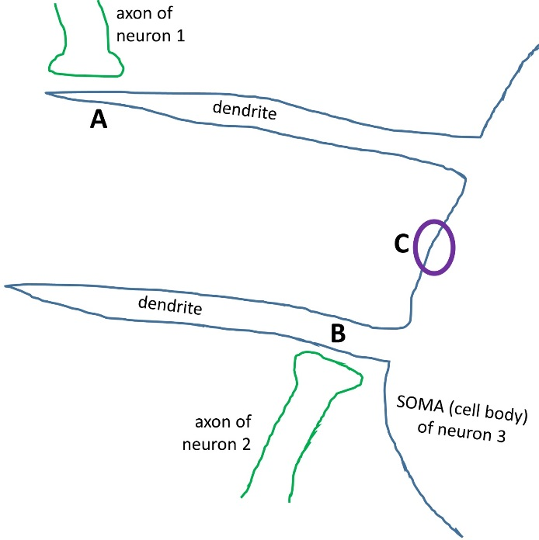
C. Let’s say that the membrane potential at location A changes from -70 mV to -60 mV as a result of the release of neurotransmitter, opening of ion channels, and flow of ions. Meanwhile, the membrane potential at location B changes from -70 mV to -80 mV due to the same factors. Carefully describe how the membrane potential at location C will be affected.

3.2. Now consider an alternative scenario (at right). Here neurons 1 and 3 both release glutamate, while neuron 2 releases glycine.  A. Add neurotransmitter symbols and ion flows to the picture, as before.  B. If neurons 1, 2, and 3 all release similar amounts of their neurotransmitters simultaneously, how will the membrane potential of the soma of neuron 4 be affected? | 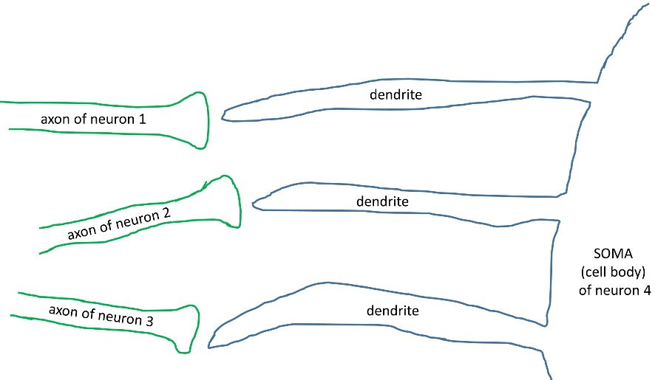

(4) Summation of PSPs at the axon hillock

The axon hillock is the “start” of the axon where the axon meets the soma. Unlike the dendrites and soma – but like the rest of the axon – it has a high density of voltage-gated ion channels. These ion channels open NOT in response to the binding of a certain ligand, but because the membrane potential has reached a certain critical value, called the threshold. For our purposes, we can consider the threshold to be -55 mV, i.e., about 15 mV more depolarized than the resting membrane potential of -70 mV.

It may seem odd to think of an ion channel as sensing and responding to a membrane potential. However, remember that the R groups of certain amino acids (arginine, aspartate, glutamate, histidine, lysine) are charged, so proteins containing these amino acids are also charged, and the exact 3D shape of these proteins can thus be affected by the relative charges in their local environment.

4.1. Consider the picture above in which neurons 1, 2, and 3 all connect to neuron 4. Let’s say that neuron 1 releases enough neurotransmitter to depolarize the nearby membrane of the dendrite of neuron 4 to -55 mV. Will this be sufficient to open voltage-gated ion channels at the axon hillock? Explain.

4.2. Considering the terms spatial summation and temporal summation, explain two different ways by which input of neurons 1 and/or 3 might cause the opening of voltage-gated ion channels at the axon hillock of neuron 4.

4.3. Once the threshold value of -55 mV is reached, voltage-gated Na⁺ and voltage-gated K⁺ channels will both open, though not at the same time. The resulting changes in membrane potential are called an action potential. These changes are shown in the curve at right (from Freeman et al., 2014).  Label the part of this curve that is attributable to the voltage-gated Na⁺ channels (V-G Na⁺) and the part that is due to the voltage-gated K⁺ channels (V-G K⁺). | 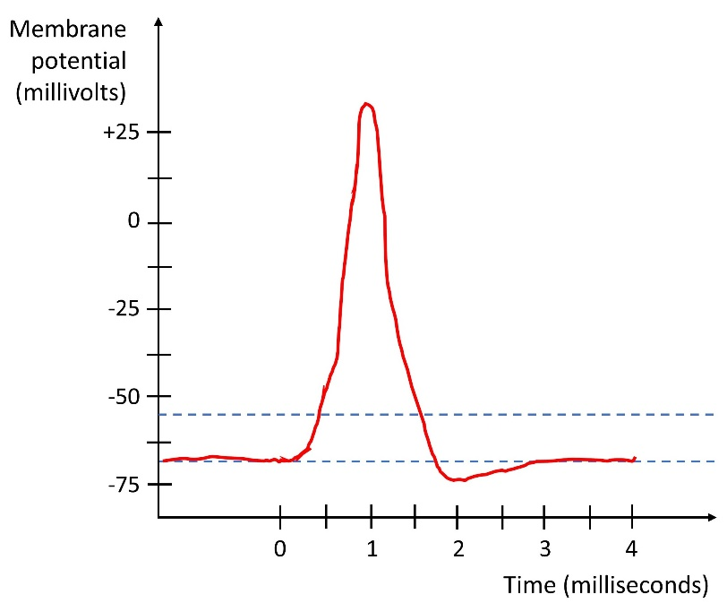
(5) Action potentials along the axon

Once an action potential occurs at the axon hillock, it spreads along the axon. From the axon hillock, some of the Na⁺ ions entering the cell will diffuse a little way down the axon, depolarizing that part of the cell membrane and activating the voltage-gated channels there, causing another action potential there, leading to the entry of more Na⁺ ions, which diffuse further down the axon, etc. That is, there are voltage-gated channels all along the axon (or at least at the nodes of Ranvier), in the case of myelinated axons) to regenerate the action potentials.

5.1. In brief, what is myelin? (Use any resources you need to answer this question and the following ones.)

5.2. Are all axons coated in myelin?

5.3. How does the presence of myelin enhance or alter the process described in the paragraph above?

5.4. Consider a depolarization of the cell membrane up to a peak voltage of +40 mV. This could happen anywhere in a neuron, including at a dendrite or at an axon.  Now consider the spread of this depolarization away from where it initially occurred. In the figure at right, draw one curve showing the spread of this depolarization along a dendrite, and another curve showing the spread of this depolarization along an axon. If the two curves are different, why are they different? | 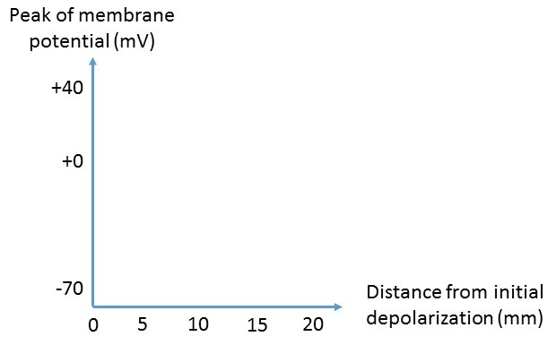

5.5. What happens when the action potential reaches the end of the axon?

(6) Alterations of neuronal communication

Based on the information above, and any additional (e.g., online) resources you wish to consult, explain how normal neuron-to-neuron communication is affected by each of the following factors:

6.1. Trauma, in which neurons’ axons are severed

6.2. Lidocaine (an anesthetic)

6.3. Cocaine

6.4. Serotonin-Specific Reuptake Inhibitors (SSRIs; used to treat depression; serotonin is a neurotransmitter)

6.5. Tetrodotoxin (from pufferfish)

