Note to instructors: This worksheet represents a way that I have taught this material, which incorporates figures created by others. I have cited these figures’ sources, but I have not formally obtained permission to use the figures in this way. As far as I’m concerned, you’re welcome to modify this worksheet or use it as is; if you do so, please continue to cite the sources of these figures – and be aware that the figures’ inclusion here may or may not be permissible under “fair use” doctrine.
--Greg Crowther, Everett Community College (gcrowther@everettcc.edu)

Worksheet: Digestive Disorders

Goals:
- Deepen our understanding of “normal” digestive physiology by examining what happens when things go wrong.
- Learn a bit about the following specific disorders: (A) gastritis/ulcers, (B) gastroesophageal reflux disease (GERD), (C) lactose intolerance, and (D) obesity.

(A) Gastritis/ulcers

Have you ever heard someone say, “All this stress is going to give me an ulcer?” Such statements reflect the once-prevalent idea that ulcers – breaks in the lining of the stomach – were caused by stress (or spicy food, or too much acidity in the stomach).

In the early 1980s, Australian researchers Barry Marshall and J. Robin Warren began to think that ulcers and related diseases like gastritis might be caused by a particular species of bacteria known as Helicobacter pylori (H. pylori for short). In one of their early experiments, they find that patients who were suffering from gastritis almost always had H. pylori in their stomach.

1. What does “gastritis” mean, based on its roots (gastr- + -itis)?

2. The fact that H. pylori was usually present in cases of gastritis is a correlation; it does not prove that H. pylori causes gastritis (or ulcers). What additional experiments could be done to prove this? Take a guess, then search the Internet to find out what Marshall & Warren actually did (including one amazing experiment that Marshall performed on himself!).

3. If H. pylori survives in the stomach, one might assume that it is acidophilic or at least acid-tolerant. Is this idea consistent with the data shown at right (from R.L. Ferrero & A. Lee, Microbial Ecology in Health and Disease 4: 121-134, 1991)? Explain. The Y axis is a measure of the density of surviving bacteria. Urea is a compound that H. pylori can use to produce ammonia, a base that removes protons from solution.  4. Predict the acid tolerance of bacteria that can cause food poisoning, such as Clostridium botulinum and Salmonella. Why is food poisoning often caused by undercooked food? | 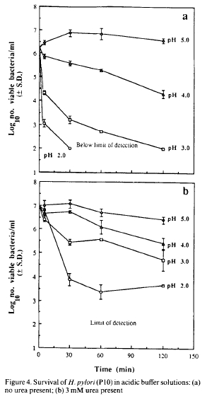

(B) Gastroesophageal reflux disease (GERD)

5. What, in general, does “reflux” mean?

6. Patients with GERD often report a burning sensation in the area of their esophagus. Why would contents of the stomach cause this sensation when they didn’t cause it on the way down (from the mouth to the stomach)?

7. What kinds of receptors (baroreceptors, chemoreceptors, mechanoreceptors, nociceptors, photoreceptors, proprioceptors…) are most likely responsible for this burning sensation?

8. Problems with which sphincter are often responsible for GERD?

9. Treatments for GERD include antacids and proton pump inhibitors (PPIs). How do these help?

(C) Lactose intolerance

The structure of lactose is shown at right (figure from rpi.edu).  10. What type of carbohydrate is this? (Hint: it is 2 sugars linked together.)  11. From what dietary sources is lactose normally obtained? (Hint: consider the root lact-.) | 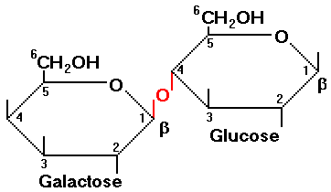

12. What is the name of the enzyme that normally breaks lactose into galactose and glucose?

13. This enzyme is almost always expressed highly in babies, but, in many people, it drops to much lower levels after that. The persistence or nonpersistence of enzyme expression over time has been linked to specific mutations in the corresponding gene. Do you think these mutations are most likely in the gene’s coding region or its regulatory region? Briefly explain.

14. Consider the figure at right (from lifeextension.com). CO₂, H₂, and CH₂ are gases produced by lactose-digesting bacteria. Why do  symptoms of lactose intolerance include flatulence after consuming dairy products? | 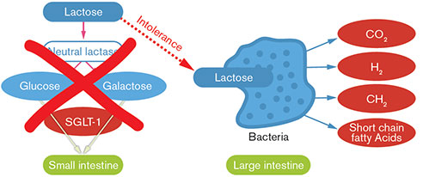

15. Symptoms of lactose intolerance also include diarrhea. How can undigested lactose lead to diarrhea? (Hint: think of osmotic pressure.)

(D) Obesity

Here we define obesity as a state of being very overweight due to intake of calories exceeding expenditure of them.

16. Briefly explain how the hormone ghrelin normally limits consumption of food.

17. In gastric bypass surgery, the stomach is “stapled” so that a much smaller portion than normal is available to receive food. Explain how this would affect ghrelin secretion and food intake.

18. In some versions of gastric bypass surgery, most of the small intestine is bypassed as well. Explain how this might help a person lose weight.

19. When gastric bypass surgery is performed, do you think it is important to preserve the connections between the pancreas and the small intestine? Explain.

