Worksheet: Understanding Membrane Potential

Goals
- Review fundamental information about cell membranes, ions, and electrochemical gradients.
- Understand and apply the Nernst equation.
- Determine whether an ion will go into or out of a cell if given the ion’s concentration gradient and the cell’s membrane potential.

General background

Fundamentally, the nervous system is an electrical system, i.e., messages are transmitted via the movement of charged particles (ions). As you may already know, the movement of a cation (such as Na⁺) into a neuron has consequences very different from the movement of a cation out of that neuron. Since such ion movements underlie the functioning of the entire nervous system, it is vital to understand exactly why ions move in the directions that they move.

I. Two sides of the membrane

1. In Figure 1, place a large plus sign on the side of the membrane with the most positive charges and a large minus sign on the side of the membrane with the fewest positive charges.  2. A membrane potential can be defined simply as the difference in electrical charge between the two sides of a membrane (inside vs. outside). Based on #1 above, is the inside of a typical cell more negative or more positive than the outside? | 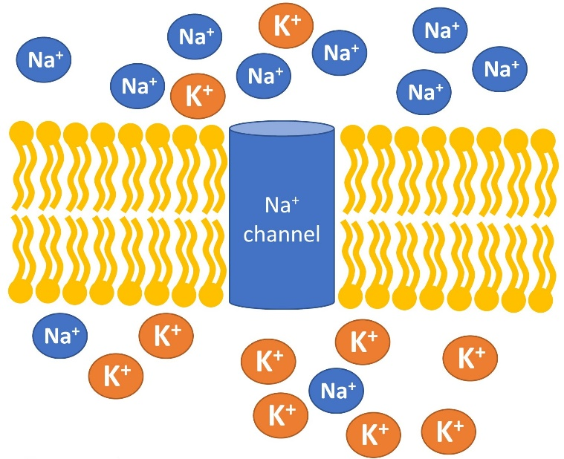  Figure 1: A polarized membrane. Based on a figure from Patrick J.P. Brown (2016), Anatomy & Physiology: A Guided Inquiry.

3. Figure 1 does not show any anions (negatively charged ions) on either side of the membrane.
Name at least one anion that contributes to the overall charge on one or both sides.

II. Electrical and chemical gradients

4. Does the membrane potential in #2 above – that is, the charge difference between the inside and outside of the cell – pull K⁺ ions into the cell, or push them out of the cell? (This assumes that K⁺ has open channels through which it can go in or out.)

5. Now consider potassium’s concentration gradient, as depicted in Figure 1. Does this concentration gradient, in and of itself, attract K⁺ ions into the cell, or push them out of the cell?

Notice that your answers to #4 and #5 are opposites; that is, the electrical gradient (membrane potential) favors movement of K⁺ in one direction, while the concentration gradient (chemical gradient) favors movement of K⁺ in the opposite direction. We have arrived at the fundamental concept that ions are governed by both gradients … and the fundamental dilemma that an ion’s direction of movement can be tricky to predict when the two gradients oppose each other.

III. The Nernst equation: balancing electrical and chemical gradients

To figure out which gradient will “win” in a given situation, we have the Nernst equation. For a given ion, the Nernst equation tells us the membrane potential (that is, the electrical gradient) that perfectly counterbalances that ion’s chemical gradient, so that there is no net movement of the ion into or out of the cell. This special membrane potential is called that ion’s equilibrium potential (abbreviated E for equilibrium) or Nernst potential.

The Nernst equation can be written in several forms, depending on one’s assumptions. Figure 2 shows a “full” version and a simplified version, along with) the lyrics for a Nernst equation jingle.

Note the logarithm in the equation. A logarithm is another word for exponent. For example, 1000 may be written as 10³, so log₁₀(1000) is 3.

6. If the ratio [ion]_{extracellular}/[ion]_{intracellular} is less than 1, the log₁₀ of this ratio will be _________. Therefore, any cation that is more concentrated inside the cell than outside (e.g., K⁺) will have an equilibrium potential (E) that is _______.

7. If the ratio [ion]_{extracellular}/[ion]_{intracellular} is greater than 1, the log₁₀ of this ratio will be _______. Therefore, any cation that is more concentrated outside the cell than inside (e.g., Na⁺) will have an equilibrium potential (E) that is _______.

8. Chloride (Cl⁻), like Na⁺, is more concentrated outside the cell than inside, but its valence (z) is negative (-1, to be exact). What can you conclude about chloride’s equilibrium potential (E_{Cl})?

9. Use the Nernst equation to find E_{Cl} for a cell whose extracellular [Cl⁻] is 110 mM and whose intracellular [Cl⁻] is 5 mM. You may use a calculator. Does your answer match your conclusion in #8 above?

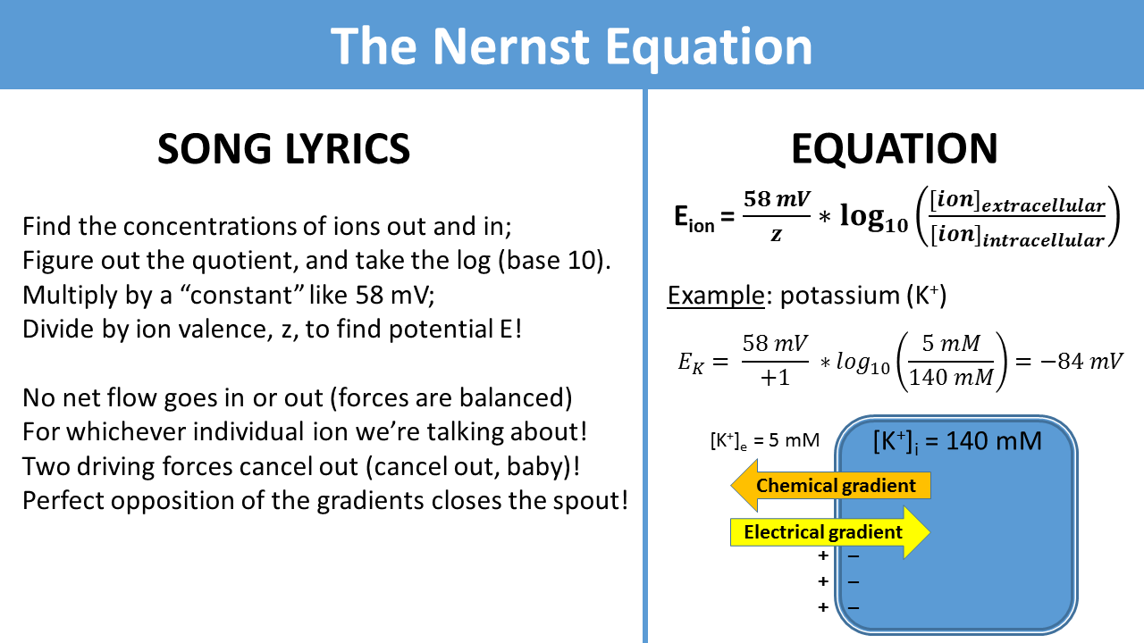
Figure 2: Nernst equation and song lyrics. From https://www.youtube.com/watch?v=XfxwK9mTlkw.

IV. A graphical approach to electrochemical gradients

The Nernst equation tells you the membrane potential at which the electrical and chemical gradients are exactly counterbalanced. Generally, though, we will want to know whether a specific ion will flow in or out at a specific membrane potential that is not the equilibrium potential.

Here is Dr. Crowther’s recommended method for determining the direction of an ion’s flow at any membrane potential:
- Find the ion’s equilibrium potential (E).
- Set up a graph with membrane potential on the X axis and overall driving force on the Y axis.
- Plot 2 easy points: the X-intercept (when Y=0) and the Y-intercept (when X=0).
- Connect the dots!

The chemical gradient is assumed to be constant throughout this process.

To see how this method actually works, let’s do an example with Cl⁻ ions, using the information given above.

Step A: See #9 above. (Did you get -78 mV?)

Step B. Note that “net driving force” (Y axis) represents the combined influence of the electrical and chemical gradients. | 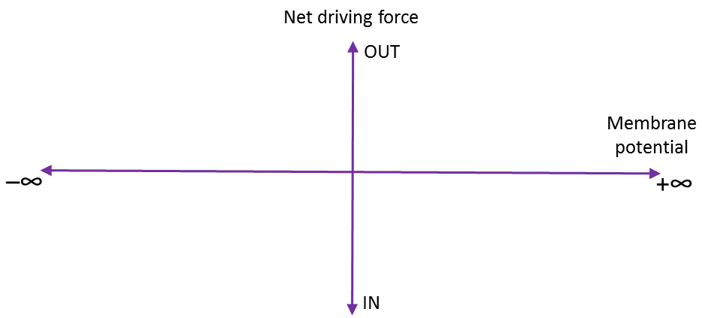
Step C. The X-intercept, when Y=0, is simply the E_{Cl} you calculated from the Nernst equation. The Y-intercept is the point representing the net driving force when there is no electrical gradient, i.e., when the membrane potential is 0 mV. In this case, there is only a chemical gradient, and since you know that Cl⁻ is more concentrated outside the cell, that gradient drives Cl⁻ inward. | 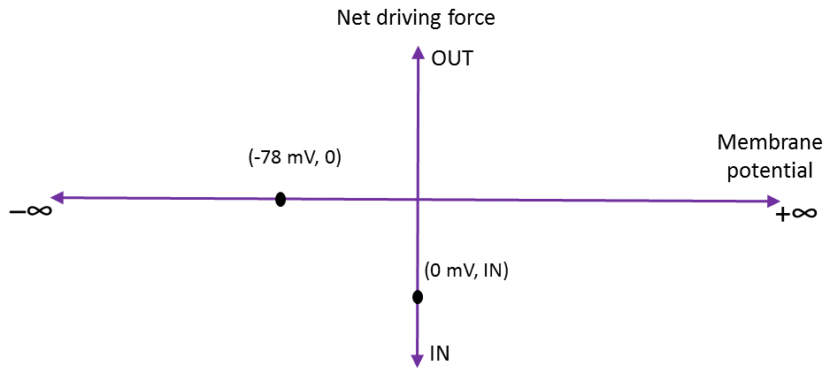
Step D. Once you draw a line through the 2 points, this line will show you the direction of the ion’s flow (in or out) at any membrane potential. Notice that all possible membrane potentials can be divided into the 3 regions labeled at the bottom. | 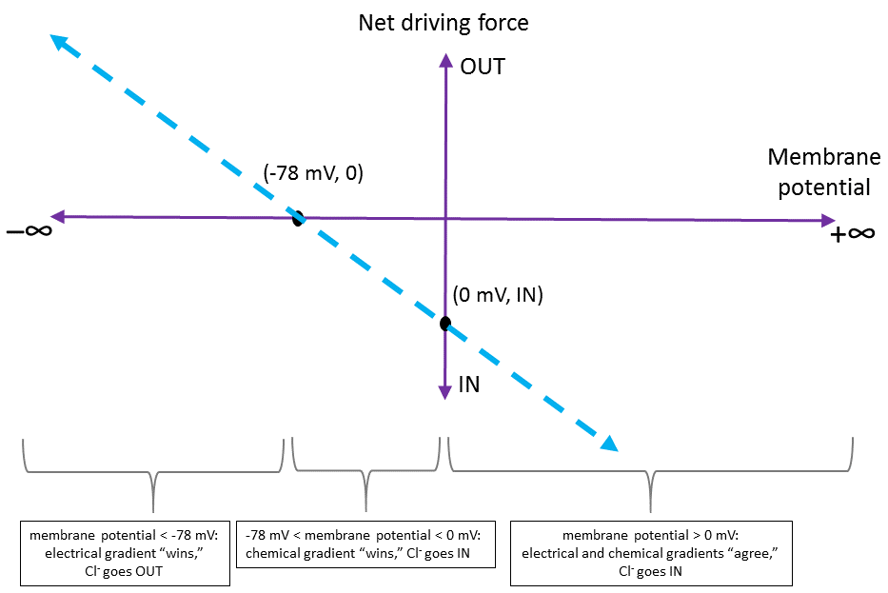

10. Based on the method and data above, which way will Cl⁻ flow (into the cell or out of the cell) at a membrane potential of +78 mV?

11. Based on the method and data above, which way will Cl⁻ flow (into the cell or out of the cell) at a membrane potential of -90 mV?

12. Now use this method to solve the following problem.

Imagine an alien animal with neurons like ours except with different ions, different ion channels, and a resting membrane potential of -100 mV. The Nernst equation still holds true.

If ion X²⁺ is at a concentration of 10 mM inside the cell and 100 mM outside the cell, fill in each empty box of the following chart with INTO CELL, OUT OF CELL, or NEITHER. You may use IN/OUT/NEITHER for short. Note that log₁₀(1/10) = -1 and log₁₀(10) = 1.
Membrane potential | Direction X²⁺ is driven, considering only the electrical gradient | Direction X²⁺ is driven, considering only the chemical gradient | Direction X²⁺ is driven, considering the overall electrochemical gradient
-100 mV
-58 mV
-29 mV
0 mV
29 mV
58 mV
100 mV

Reference for Part IV: G.J. Crowther (2017). Which way do the ions go? A graph-drawing exercise for understanding electrochemical gradients. Advances in Physiology Education 41(4): 556-559.

