Stiff Shoulder

Tips for decreasing your pain
and increasing movement
Your stiff shoulder may be painful and limit your movement. There are many causes of shoulder stiffness. Most times stretching exercises can help. This booklet explains shoulder stiffness and gives tips to help you reduce pain and increase shoulder movement.

Your doctor, the physical therapist, and the information in this booklet will help you understand the problem with your shoulder. This booklet also gives you tips and exercises to help you decrease your pain and make moving your shoulder easier.
Pain and Movement
No matter what the cause, your painful shoulder gives you trouble reaching and moving. You may have difficulty getting to sleep lying on your bad side or even on your good side. If your shoulder is very painful, lying on your back may be hard. To be comfortable, you may need to sleep in a reclining chair.
Because you have lost movement in your shoulder, it is hard to reach:
- Over your head to comb your hair
- Across your body to the other shoulder
- Behind your back to tuck in clothes.
Treating the Stiffness
Stretching Exercises
You need to work on your shoulder stiffness first, even if you end up having surgery. Getting more motion in your shoulder will make surgery unnecessary or more successful. All stiff shoulders need stretching. (The only exception might be stiffness due to a break that is not healing correctly.)

Your doctor will talk with you about doing stretching exercises and a physical therapist will show you how. Then it is up to you
to do them 5 times a day, every day. You are the best person to
feel the point when stretch is occurring. Hold that point—just before you feel pain. You will have visits with the therapist to be sure you are doing the exercises correctly and your shoulder is improving. But working on your stiffness every day is up to you. Stiffness must be corrected before any strengthening can be done. The exercises are explained in the last section of this booklet: pages 4-6.
Anti-inflammatory Medicines
Working on your stiffness every day is up to you. Stiffness must be corrected before any strengthening can be done.
Anti-inflammatory medicines (NSAIDS, such as Ibuprofen and Naproxen) may be prescribed for two to three weeks only.
Injection
Occasionally your doctor will inject your shoulder with a steroid and an anesthetic to reduce inflammation and give you temporary pain relief.
Alternative Treatment
Acupuncture may give you relief from pain or reduce it. For acupuncture to work, however, you need many treatments.
Doing Nothing
Not moving or stretching your shoulder will usually increase pain and stiffness.
Causes of Stiff Shoulder
There are many causes of stiffness. Your doctor will check to be sure your shoulder problem is not due to arthritis, diabetes, or another underlying cause. The most common reasons for stiffness affecting only your shoulder are:
Frozen Shoulder (adhesive capsulitis) comes on slowly and without a clear reason but is probably due to wear and tear over time and with increasing age. It affects all degrees of motion and may cause severe stiffness. It will eventually get better, but it may take up to two years.
Post traumatic shoulder stiffness is loss of movement due to an injury. It is most likely to happen after a period of not moving, because the arm has been in a sling or is painful from the injury. The stiffness and pain are often more of a problem than the injury.
Post surgical shoulder stiffness is loss of motion due to scarring after shoulder surgery. This tightening of the healing tissues can make stretching very difficult.
Calcific tendonitis is a deposit of calcium among the four tendons that connect your upper arm bone to muscle for moving the shoulder. The hard calcium makes the normally flexible tendons stiff. The severe pain keeps you from using your shoulder, which leads to stiffness.
Rotator cuff tears are when one or more of the four tendons that cover the shoulder joint and allow it to rotate is pulling off its attachment to the bone. Tears themselves do not cause stiffness. You may even have a lot of motion, because torn tendons do not work well to hold the shoulder in place. If you do have stiffness with a tear, the stiffness must be treated first. Movement must be regained before surgery for the tear, because only fixing the tear will result in even more stiffness.
Abnormal healing after breaking some part of the arm or shoulder may cause a piece of bone to block movement. Usually this can only be fixed by surgery.
Stretching Exercises
These four exercises will be the most helpful if you do them 5 times every day. Do each exercise, one of the ways explained, 5 times each session. Do each one slowly, relaxing your shoulder muscles. Remember you are trying to stretch, not build strength. When your arm reaches the position where movement becomes limited but before you feel pain, relax your muscle and try to stretch a bit further. Then hold the position, relaxing your shoulder muscles, while counting to 30.
1. Overhead Reach (forward elevation)
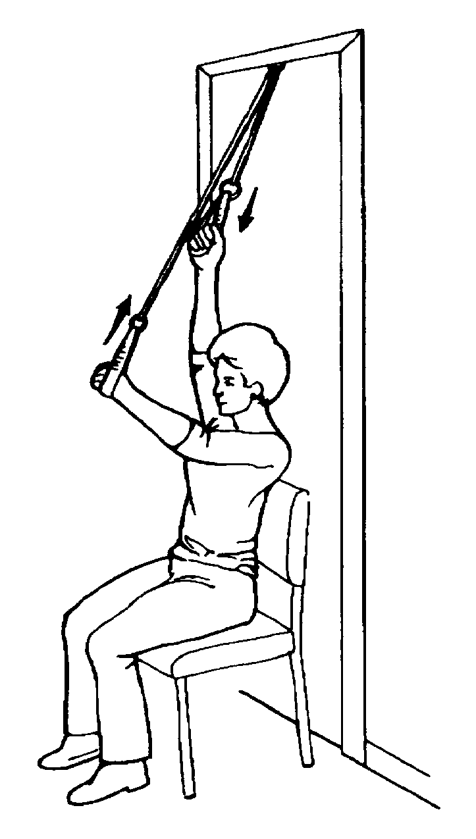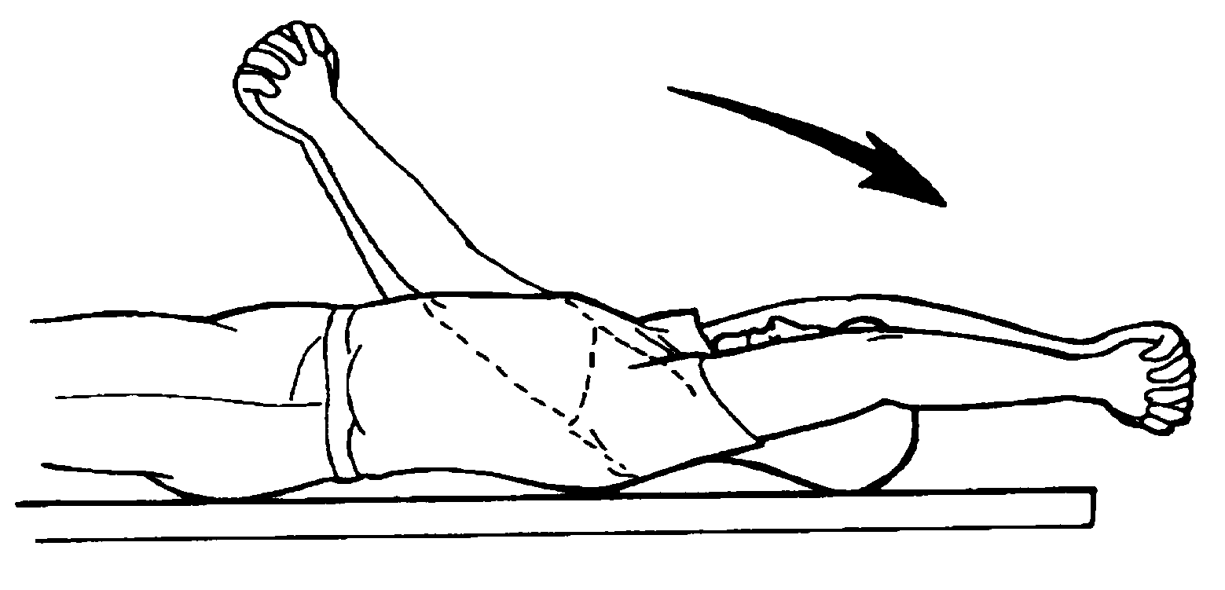Do this exercise lying flat on your back. With the hand of your other arm, grasp the wrist or elbow of your stiff shoulder. Slowly pull your arm up toward the ceiling, reaching it over your head as high as you can. When your arm is stretched as much as possible, but not to the point of pain, hold it for 30-60 seconds. Lower it down and raise it again—5 times.
Remember you are trying to stretch, not build strength. When your arm reaches the position where movement becomes limited but before you feel pain, relax your muscles and try to stretch a bit further.
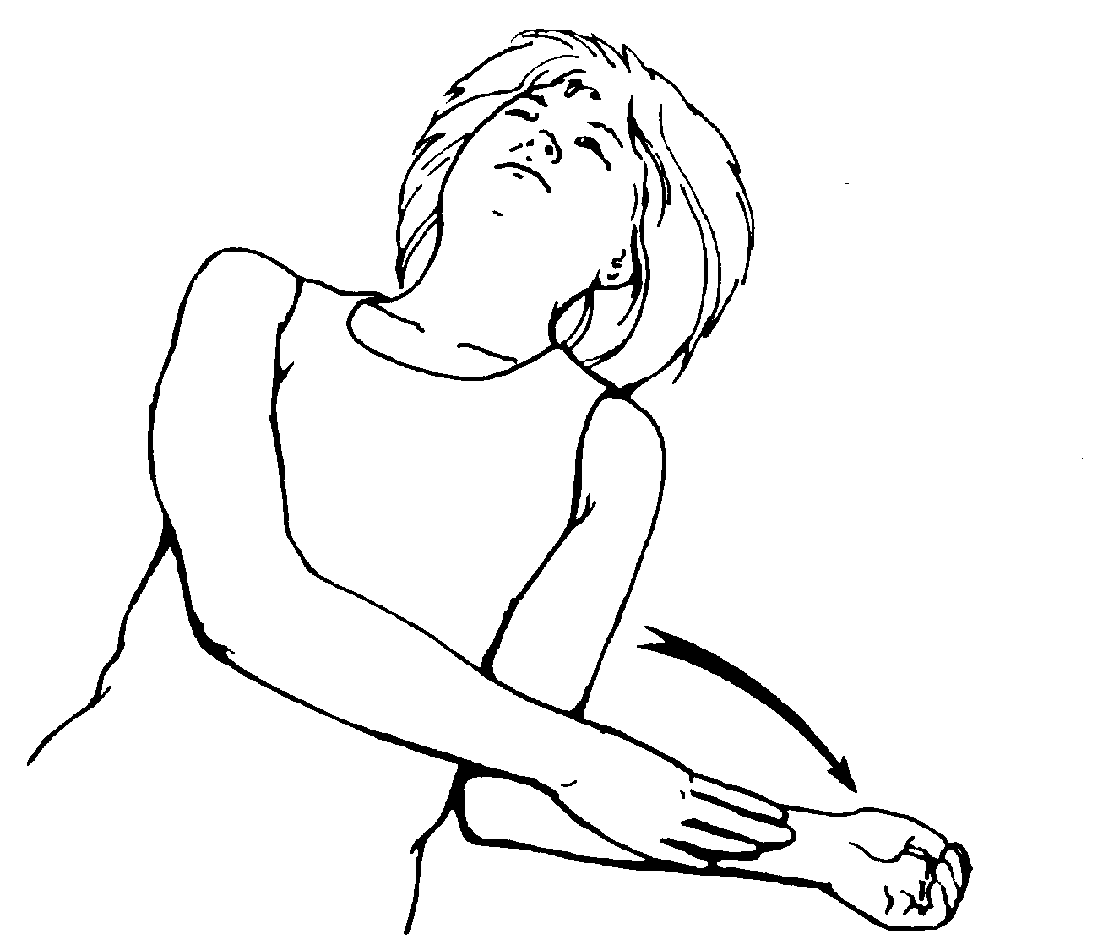2. Roll Outward (external rotation)
Do this exercise lying flat on your back. Hold your stiff side elbow against or close to your side and bend your elbow 90 degrees so your lower arm is straight up. Push the stiff shoulder wrist outward as far as you can while keeping your elbow at your side. You can push your wrist with your other hand or hold a stick across your chest, pushing the stiff side hand. Relax as you slowly push your lower arm outward. When it is as far as it will go, hold it for 30-60 seconds. Slowly bring it back toward your stomach and push outward again—5 times.
3. Roll Inward (internal rotation)
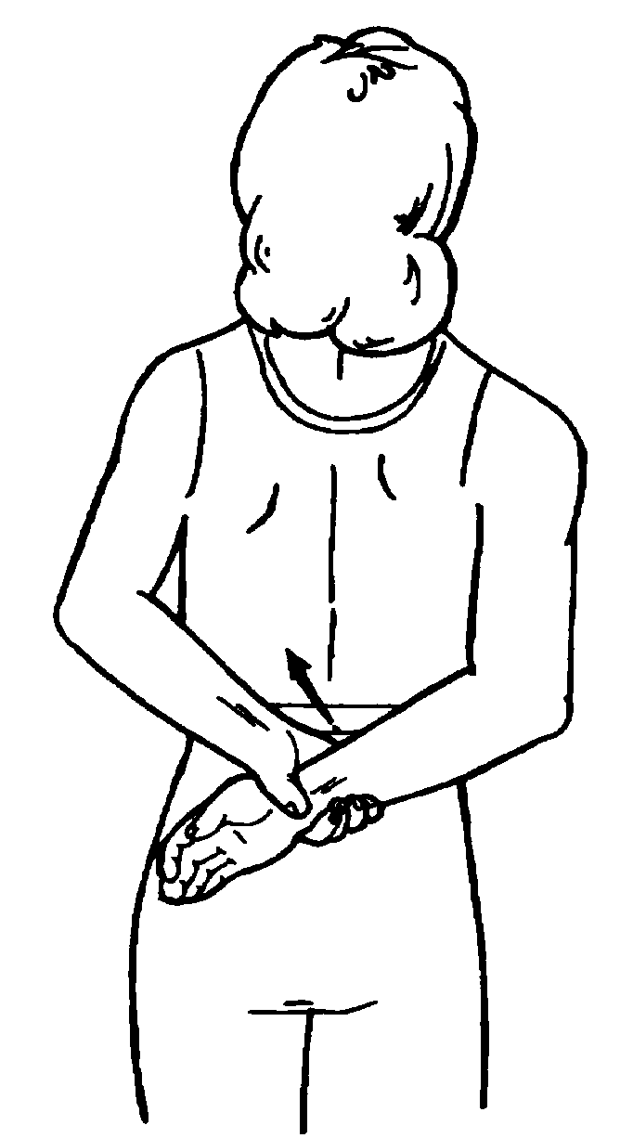Do this exercise standing. Behind your back, grasp the stiff side wrist with your other hand. Relax and slowly pull your stiff arm up your back as high as you can. Hold for 30-60 seconds. Lower your arm and pull it up again—1-3 times. If you cannot reach your hands together, hold a towel between both hands to do this exercise.
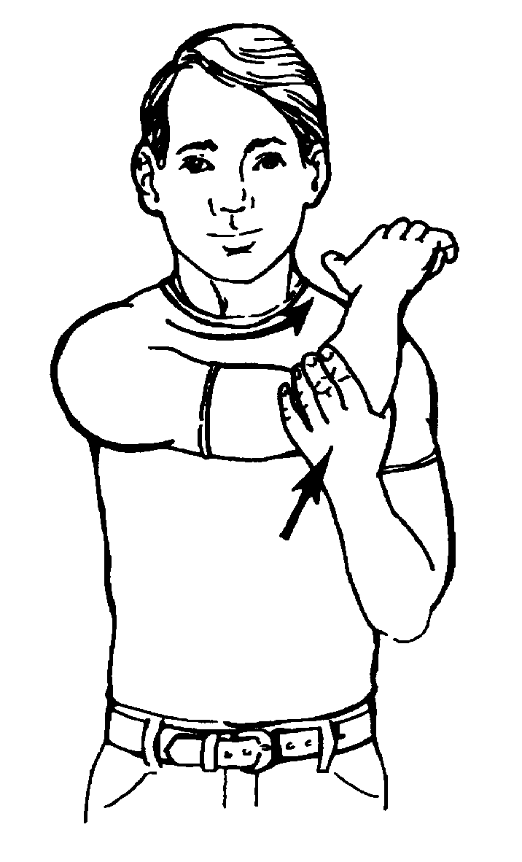
Doing each exercise 5 times, 5 times a day is the best thing you can do for your stiff shoulder. Make them a part of your daily routine, setting certain times during the day.
4. Pull Across (cross body adduction)
Do this exercise sitting or standing. Grasp the stiff side elbow with your other hand. Straighten and relax your stiff arm. Slowly pull it across your body at 3 different levels—wherever it feels stiff or restricted to you. Move it back and pull across your body at the 3 levels again—1 time at each level. Hold for 30-60 seconds at each level.
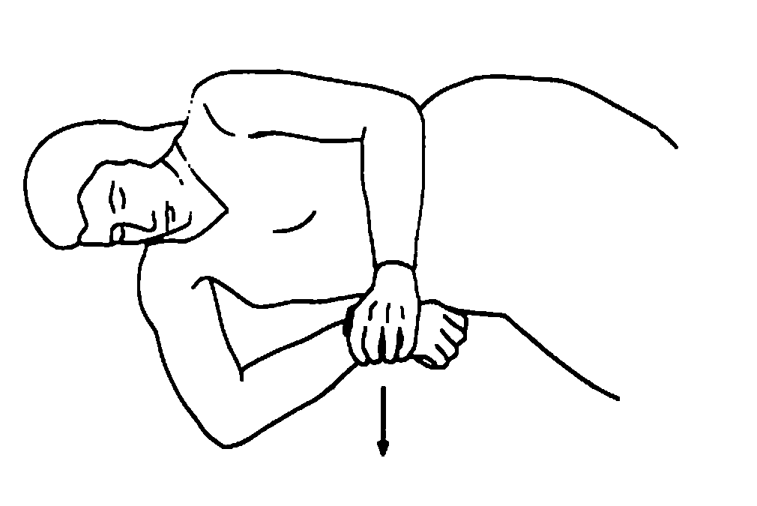5. Combination Stretch
Do this exercise lying on your side, the same side as your stiff shoulder. Slide your arm up so it is at a right angle with your body and bend your elbow to a right angle. Then use your other hand to gently press down on the back of your wrist until you feel a stretch. Hold for 30 seconds. Repeat this exercise twice.
Part of Your Routine
Doing each exercise 5 times, 5 times every day is the best thing you can do for your stiff shoulder. The exercises are easy and can be done anywhere, but it is also easy not to bother. However, these exercises are very important. Make them a part of your daily routine, setting certain times during the day.
Remember not to stretch to pain. Your shoulder will get irritated, more painful, and you won’t be able to do all the exercises 5 times a day. If your shoulder feels worse after stretching, do not stretch as far the next time. It is better to go easy than to skip a session.
It may take a few weeks for your shoulder to get better. Do not give up—you may need to do these exercises for 6 weeks. You need to give them a good chance to help. If they are not helping, after you have worked hard, surgery may be necessary. Your doctor will discuss surgery with you.
Questions?
Your questions are important. Call your doctor or health care provider if you have questions or concerns. The UWMC clinic staff are also available to help at any time—
Bone and Joint Center
(206) 598-4288
Exercise Training Center
(206) 598-2888
Bone and Joint Center
Box 354740
1959 NE Pacific St. Seattle, WA 98195
(206) 598-4288

