Rotator Cuff
Tear Surgery

Understanding your treatment plan
You tore a tendon (tough cord or band) in your shoulder. Tendons help your shoulder joint move. You may have torn one or more of the four tendons in your shoulder. This is called a rotator cuff tear. It may be causing pain and weakness in your shoulder. You either injured your shoulder or this tear happened slowly over time. This booklet gives tips about what you can do to improve your shoulder and explains treatment options.
Treatment is important because the tear can get worse and your muscles weaker. You may also have other problems, such as shoulder stiffness, which need to be treated. This booklet will help you understand your treatment choices and what you can do to improve your shoulder.
Non-Surgical Treatment
For an acute injury, prompt surgery may be best. However, if your rotator cuff tear has happened slowly over time, surgery may not be the first choice. You may not have enough good tissue for a successful repair. There are four choices other than surgery:
- Rest and not use your shoulder to let the torn tendons stabilize.
- Use medicines that reduce inflammation in your shoulder.
- Exercise to stretch and increase the flexibility of your shoulder muscles. Your muscles have probably weakened, if you have not been able to fully use your shoulder for a long time. Stretching and strengthening exercises can make surgery unnecessary or more successful. These exercises are explained in the last section of this booklet on pages 5-6.
- Get injections of cortisone to reduce inflammation. This may also weaken the tendons further.
Surgical Treatment
Your choice for surgical repair and recovery is best if your rotator cuff tear is fairly recent and due to an injury. Surgery will reconnect the torn tendon(s) to the bone, so the force of your muscle will move your arm without pain. If other treatment choices will not, or have not, helped your shoulder, surgery may be your best treatment. The extent of the tear and the work you do after surgery will determine how well your shoulder recovers.
Before Surgery
Talk with your doctor about the expected improvement of your shoulder after surgery compared to possible risks. The risks include:
Right after surgery, your arm will be less useful that it is now. For example, you will not be able to drive for 6 weeks.
- Infection
- Injury to nerves, blood vessels and some blood loss
- Muscle weakness
- Stiffness of the shoulder joint
- Pain
- A re-tear of the tendon and need for more surgery.
Since rotator cuff surgery is not an emergency, take time to get in the best possible condition for your surgery:
- Stop smoking as smoking decreases your ability to heal.
- Get over any cold, flu, or infection.
- Tell your doctor everything about your health. Be sure to include allergies, reactions to medicines, and medicines you take. Some medicines may affect your surgery. For example, aspirin and anti-inflammatory medicines can affect blood clotting.
- Plan how to manage your daily life after surgery. Right after surgery, your arm will be less useful than it is now. For example, you will not be able to drive for 6 weeks.
- Talk with your doctor about your risks for surgery, such as smoking, your age, diabetes, your physical activities, and size
of the tear.
Surgical Repair
Once you have decided on surgery, you will meet members of your surgical team: doctors, physician assistants, physical therapists and the anesthesiology team. The Patient Care Coordinator will decide with you the best date for your surgery. Your surgeon manages this team and all aspects of your care.
The goal of surgery is to reattach the tendon or tendons to the rounded top of your upper arm bone (humerus). A tear from an injury is usually easier to repair because there has not been the wasting away of muscle and tissue that occurs with a long-term problem. If a good attachment cannot be made, your surgeon will smooth the rough surfaces on your bone from the long-term wear and tear and will trim the frayed edges of the torn tendon. This will improve your shoulder motion and reduce the pain.
After Surgery
To repair your tendons, an incision (cut) is made in the top of your shoulder. After surgery you will have a gauze bandage taped to your shoulder. A small piece of rubber tubing may be in your incision for 1-2 days to drain out fluid that collects.
Tight stockings (ted hose) and squeezing devices may be put on your legs during surgery to help prevent blood clots. You will also need to be up and walking after surgery to increase your circulation.
If you have a shoulder nerve block, you will not feel pain for the first 12 to 18 hours after surgery. With other types of anesthesia, your shoulder will probably be painful after the anesthesia used during surgery has worn off. Then medicine given into your vein (IV) may be used to prevent pain. However, pain medicine pills are usually enough to control your pain.
Your doctor may want you to use a continuous passive motion (CPM) machine for a few days after surgery. It slowly moves your arm for you to help prevent tissue scarring and stiffness. A physical therapist will teach you exercises for passive movement that raises your arm to 140 degrees and rotates it out 40 degrees.
Exercising Your Shoulder
If your rotator cuff tear is not repaired, you can move your shoulder right after surgery. This will prevent tightening of the tissues during healing. For 6 to 8 weeks, you will need to be careful of your shoulder. However, you can slowly increase its use with activities that don’t cause pain. This set of exercises may be referred to as 40/140.
If the torn tendon(s) has been reattached to the bone, healing will be slow. Your body needs time to complete bonding of the tendon to the bone and your tendons and muscles must regain strength. It is important to keep your shoulder from getting stiff after surgery. To keep your shoulder flexible you will need to do passive motion exercises using your other arm as the power. Do not use the muscles of your repaired shoulder for 6-8 weeks to push, pull or rotate your arm under its own power.
Do not use the muscles of your repaired shoulder for 6-8 weeks to push, pull or rotate your arm under its own power.
After your surgery, do the passive exercises described below 5 times every day. Tell your physical therapist or our staff, if doing them causes you pain or trouble. Be sure not to use the shoulder muscles of your repaired arm. Try to relax the muscles of your affected shoulder when you do your passive motion exercises.
Passive Exercises
The following exercises are for you to learn and do as part of your home care plan. Your physical therapist will work with you as your teacher of these exercises and to answer your questions about activity level. This set of exercises may be called the “40/140” program.
- Arm Dangle
Stand and bend over at your waist, letting your operated arm relax and dangle down.
- Overhead Reach (forward elevation)
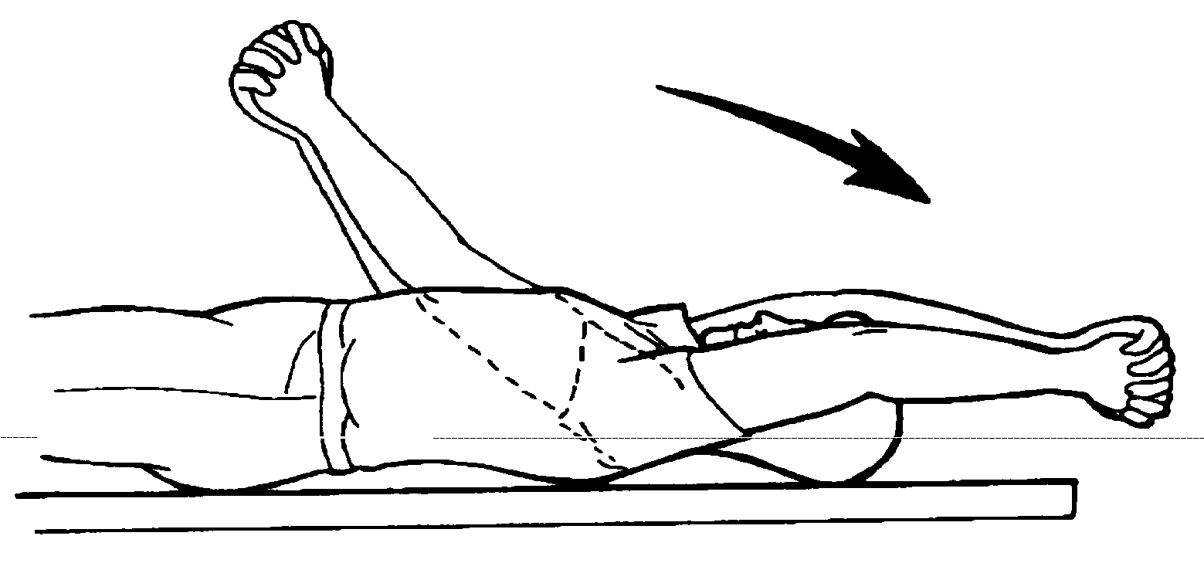Lie on your back. With the hand of your other arm, grasp the wrist or elbow of your operated shoulder. Slowly pull your arm up toward the ceiling, and stop when your arm points upward towards 140 degrees. When your arm is stretched as much as possible, but not to the point of pain, hold it for a count of 30. Lower it down and raise it again 5 times.

- Roll Outward (external rotation)
Do this exercise lying flat on your back. Hold the operated side elbow against or close to your side and bent 90 degrees, so your lower arm is straight up. Then push the operated shoulder to 40 degrees out to your side, while keeping your elbow at your side. You can push your wrist with your other hand or hold a stick across your chest, pushing the operated side hand. Relax as you slowly push your lower arm outward. When it is as far as it will go without pain, hold it for a count to 30. Slowly bring it back toward your stomach and push outward again 5 times.
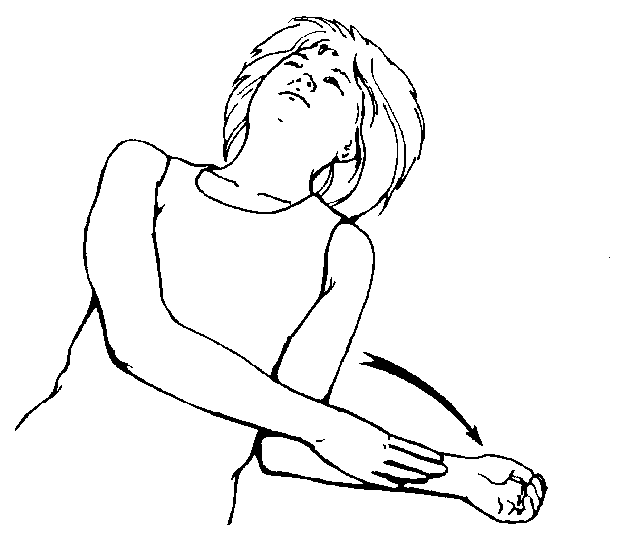

Your surgeon or physical therapist will tell you when you can move on to new exercises. You need to stay on your plan for slowly increasing your shoulder movement and strength. Your hard but careful work will help your shoulder recover after surgery.
Your surgeon or physical therapist will tell you when you can move on to new exercises. You need to stay on your plan for slowly increasing your shoulder movement and strength. Your hard but careful work will help your shoulder recover after surgery. Depending on the extent of your rotator cuff repair, you can start active exercises 3, 6 or 12 months after surgery. In active exercise, you use the muscles of your affected shoulder.
Notes

Questions?
Your questions are important. Call your doctor or health care provider if you have questions or concerns. The UWMC clinic staff are also available to help at any time—
Orthopaedic
Resident Doctor: (206) 598-6190
Elizabeth Crouch,
Physician Assistant
(206) 598-5875
Sarah Jackins
Physical Therapist:
(206) 598-2888
Bone and Joint Patient Care Coordinator:
(206) 598-6922
Your Surgeon:
(206) 598-6190
Bone and Joint Center
Box 354740
1959 NE Pacific St., Seattle, WA 98195
(206) 598-4288

