Rotator Cuff Tear

Non surgical treatment
The weakness and pain in your shoulder is caused by a torn tendon. A tendon is a tough cord or band that connects a muscle to a body part. In this case,
it is your shoulder joint.
A tendon also helps to transmit force when a muscle is used. You tore one or more of the four tendons that help your shoulder move.

This booklet gives tips
on how to improve your shoulder.
This rotator cuff tear may have happened suddenly due to an injury, or may have been slowly occurring over time. Treatment is important, because the tear can get worse and your muscles weaker. You may also have other problems, such as a bone spur or shoulder stiffness, which need to be treated. This booklet will help you understand your treatment choices and what you can do to improve your shoulder.
Your Treatment Options
For an acute injury, surgery may be best. But because it is likely the tears to your rotator cuff have happened over time, surgery is not the first choice for treatment. You may not have enough good tissue for a successful surgical repair. Instead, your treatment will be directed toward rehabilitation. This means rest, medicines, and exercise will be used to restore function to your shoulder. Your care provider will work with you to:
- Decrease your pain
- Increase the strength of your surrounding muscles so you can use your arm better.
Resting Your Shoulder
Every time you use your shoulder, the torn ligaments are irritated causing inflammation. Inflammation is pain, heat, and swelling caused by irritating the tear. In addition, the torn tendon cannot repair itself. Not using your shoulder for a period of time will decrease the inflammation and therefore your pain. Hopefully, it will also help the tendon to heal.

Exercises for Strengthening Your Shoulder
Several groups of muscles work in your shoulder so you can raise, lower and rotate your arm. To fully use your shoulder again, you need to build up the strength of these muscles. Your muscles have probably weakened because you have not been able to fully use your arm. The rest of this booklet explains exercises that will give you the best chance of regaining good use of your shoulder. Your comfort level and how hard you work your shoulder muscles will control your progress.
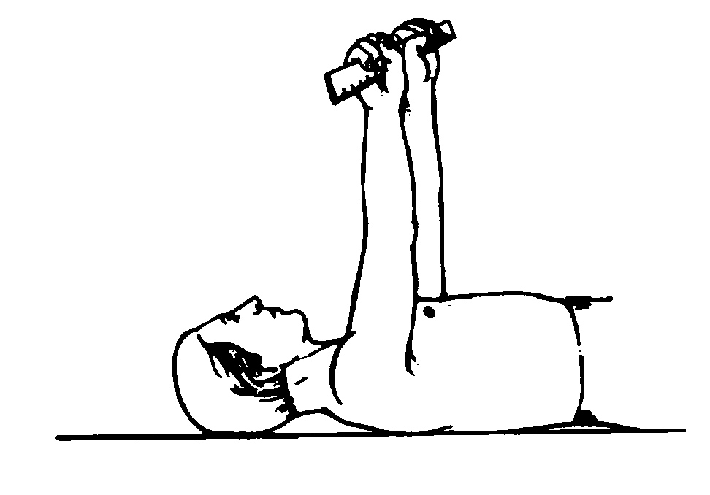Exercise 1
- Lie on your back.
- Hold a stick, such as a cane, with your hands close together, resting on your chest.
- Raise your arms, slowly pushing the stick up toward the ceiling.
- Keep pushing, so you lift your entire shoulder off the bed or floor at the end of each push.
- Lower your arms and push up again. Work up to doing 20 pushes, 5 times a day.
When you can do this easily 20 times, separate your hands about an inch. This puts more of the load on the muscles of your weak shoulder. As the exercise gets easier, separate your hands more, until you can push your weak arm toward the ceiling by itself. Then do the same exercise using a washcloth. Because the washcloth is not rigid, your weaker side will have to work harder. Then with nothing in your hand, work on slowly raising only your weak arm 20 times.
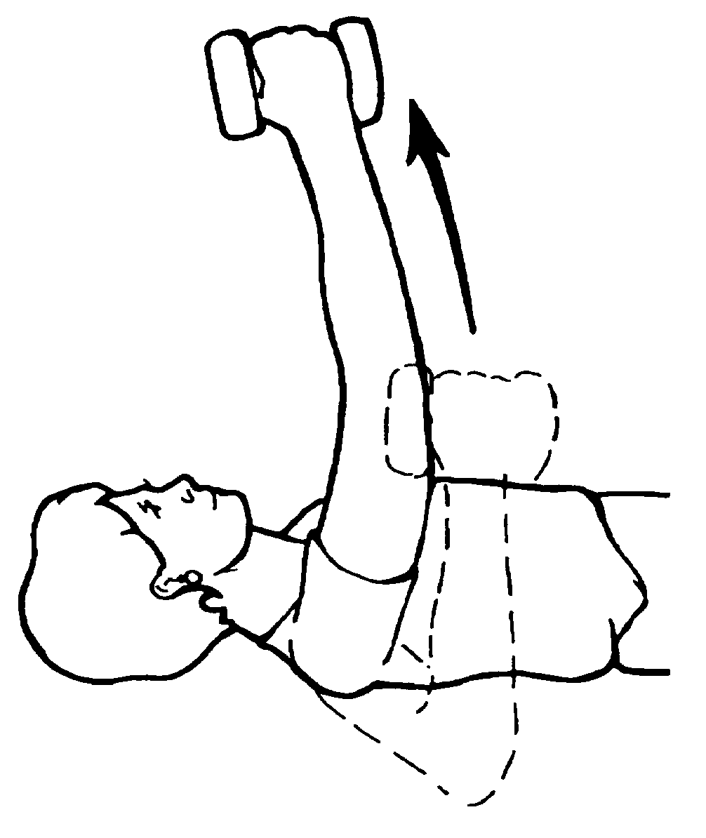Exercise 2
- Take an empty plastic container that will hold two cups of water. Hold it with the hand of your weak shoulder.
- Lie on your back. Raise your arm, lifting the container up toward the ceiling.
- To increase the weight, add a small amount of water at a time. This puts resistance against your shoulder muscles to build their strength. When full, the container weighs about a pound.
- Be sure to lift your shoulder blade off the bed or floor at the end of each push.
- Do this exercise until you can do it comfortably 20 times, 5 times a day.

Exercise 3
This exercise is like exercise 2, but your body is in a different position.
- Prop your back up slightly with pillows or a reclining chair.
An adjustable garden chair may work well.
- Push up the same way, holding the full container with your weak shoulder hand.
- Remember to push up all the way, so your shoulder blade lifts.
- 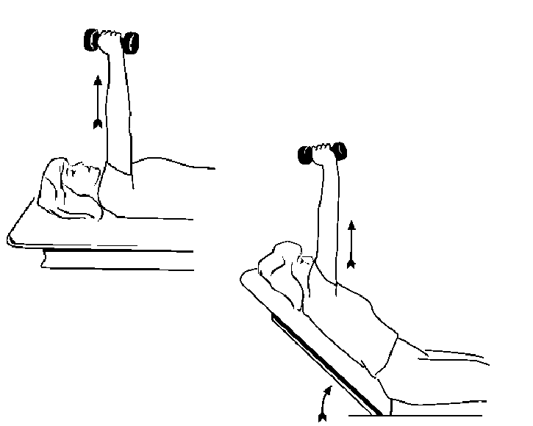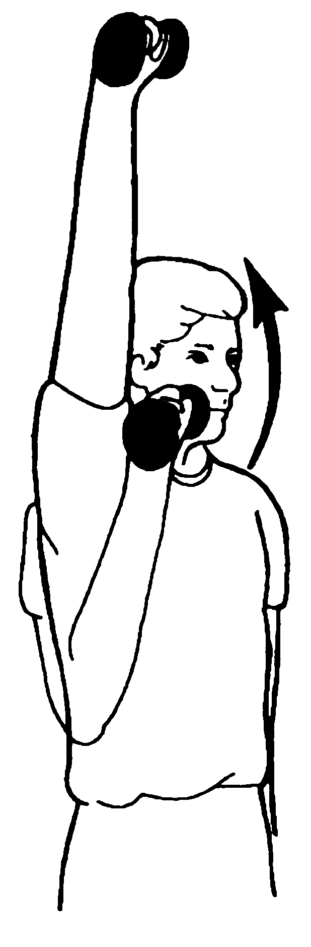When you can do this comfortably 20 times, raise your back up higher.
- Gradually increase your back height, until you are sitting upright and can push up the 1 pound weight 20 times.
Exercise 4
The final step is to do this upward push exercise, with the filled water container, 20 times while you are standing.
More Shoulder Exercises
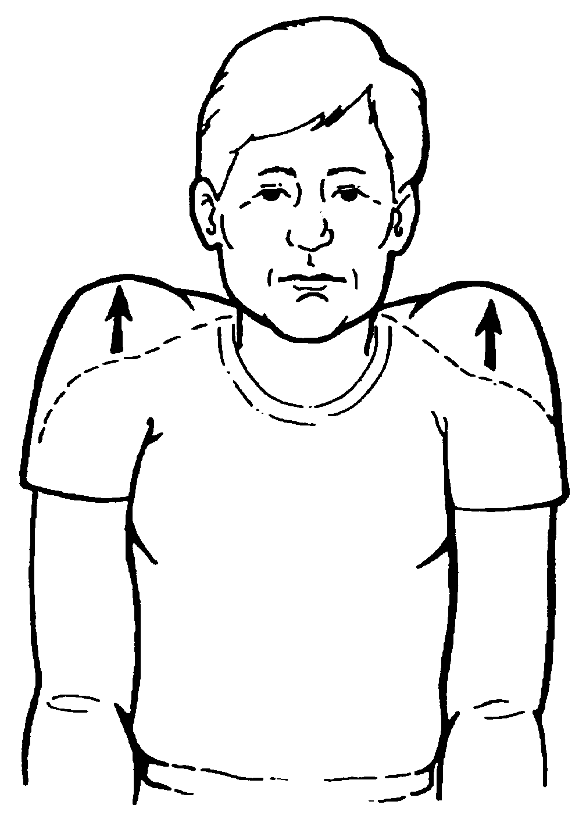As your shoulder improves, you can move on to the strengthening exercises listed below. Talk with your physical therapist about which of these you can start doing every day.
Shoulder Shrugging
Standing and with your arm at your side, hold some weight.
Lift and slowly lower your shoulder. This strengthens the trapezius muscles, which is across the back of your neck and shoulder.
Shoulder Rotation
External rotation
- 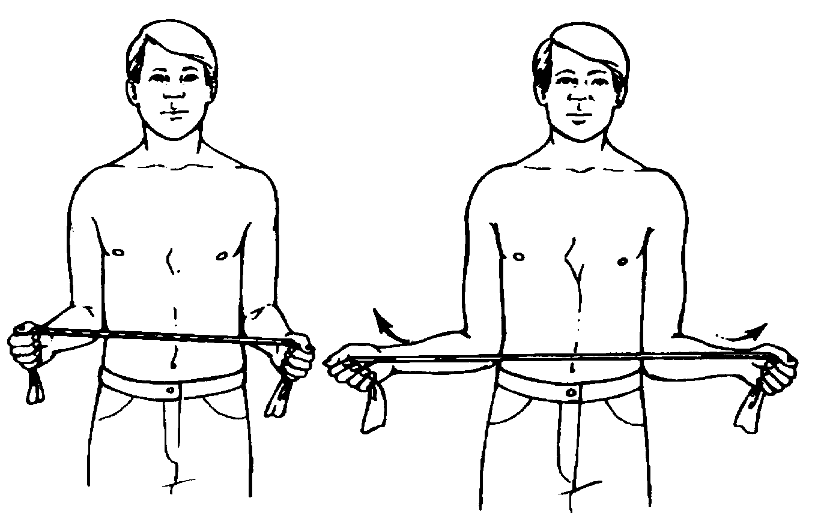With your elbows bent at a right angle, grasp the tubing
in your hands, with your hands about a foot apart.
- Holding your good arm straight out, rotate your bad shoulder outward, stretching the tubing.
- Hold 3 seconds and slowly relax inward.
- Start by doing the exercise 5 times and work up to 20 times, 5 times each day.

Internal rotation
In this exercise, you use a piece of rubber tubing. Stretching it strengthens the rotator cuff muscles that rotate your arm in. These muscles help to hold your shoulder in place as well as rotating and lifting it overhead.
- Anchor the rubber tubing to a solid object.
- Sit or stand with your weak arm at your side and the elbow bent at a right angle.
- Rotate your arm inward across your stomach, stretching
the tubing.
- Hold 3 seconds and slowly relax outward.
- Start by doing the exercise 5 times and work up to 20 times, 5 times each day.
General Exercising
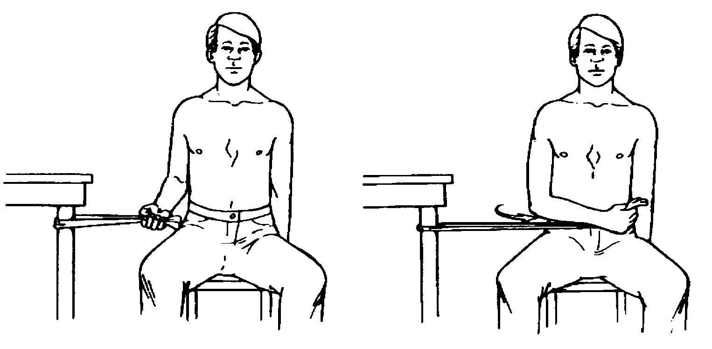

Swimming, using light resistance on a rowing machine, using a cross-country ski machine, and brisk walking are activities that build up shoulder strength, coordination, and your general
well-being.
Questions?
Your questions are important. Call your doctor or health care provider if you have questions or concerns. The UWMC clinic staff are also available to help at any time—
Bone and Joint Center
(206) 598-4288
Bone and Joint Center
Box 354740
1959 NE Pacific St., Seattle, WA 98195
(206) 598-4288

