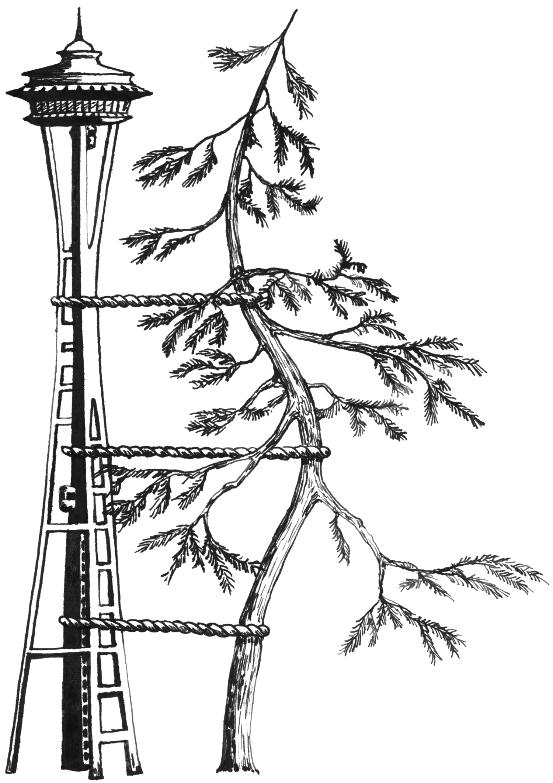
University of Washington
Affix Pt Label Here
Name:
U Number:
DOB:
DOS:
Department of Orthopaedics & Sports Medicine
Surgical Worksheet

Surgery Date__________________________
Surgeon: Winston J Warme □See surgeon prior to surgery
□Pav or Main Only □R2 OK □Complex Case
Dx:
Surgical Procedure: □Scope□Open □Possible Open

PREOP | Interpreter: □No □Language:  Diabetic: □No □Yes  Latex allergy: □No □Yes  Transmission Issues: □No □(MRSA TB)  Sleep Apnea: □No □Yes | Developmental Delay: □No □Yes  Pacer or defiber: □No □Yes  Pt > 400 lbs: □No □Yes  Mobility/transportation issues: □No □
PREOP | Issues impacting Pre-op prep time day of surgery:

PCC | Length of Stay: (OP 1-2 Days 2-3 Days) Length of Surgery: (1 Hour 1.5 Hours 2 Hours 2.5 Hours 3 Hours)  Admission: □ OP □LS □ AM Admit □ IP □Day Before Surgery  First Post-op: □2 Week □1 Week □Same Week □No □Other:  Anesthesia: □Choice □ Interscalene Block □ No Block □ Other:  Labs: □Routine: CBC □Arthroplasty or >40y/o: CBC/CMP/COAGS/Hep C/HCG/UAcC&S □Sed/CRP  Transfusion: □None □T + S Units (Arthroplasty) T + C Units (2 if Arthroplasty and pt of concern)  Consult: □None □Medicine □Social Work □ ID □Other:

OR | PAT Position: □Lateral □Beach Chair □Supine □Prone □Other:  O/R Table: □Regular □Fx Table □RA Table □Beach Chair Attach □Other:  O/R X-ray: □None □C-Arm □Mini C-Arm □Other:  Special Equip: □Scope Boom □CPM Bed □ None □ McConnell Arm Hldr □Other:  □ Arm Holder □Radiolucent Arm □Cardiac Board □Hand Table

BRACE: □Shoulder S M L □ Ultrasling □Other:

IMPLANTS/ Special Instruments:
Depuy  Global Advantage  □ TSA □ Ream and Run □ CTA □ Fx  □ Proximal Humerus Plate  Exactech  □ Equinoxe Shoulder Fracture System  □ InterSpace Shoulder Cement Spacer  Encore  □ Reverse Shoulder Prosthesis System  Wright Medical  □ Evolve Radial Heads  Zimmer  □ Coonrad-Moorey Elbow Implant  □ Olecranon Elbow Plate  □ Periarticular Prox Lat Humeral Locking Plate  Clavicle  □ Acumed Locking Clavicle Plate  □ Synthes Clavicle Hook Plates  □ Synthes Locking Clavicle Plate Set  □ Synthes Small Frag Set  □ Synthes Pelvic Recon Screws & Plates: 3.5  □ Synthes Long 2.7 Plates and Screws (3 sets)  □ DePuy Rockwood Clavicle Pin  NW Tissue Center  □ Allograft(s):  □ Hamstring Allograft | Synthes  □ Locking Prox Humerus Plate (Sm Lock Frag)  □ X-Long LCP Proximal Humerus Plate Set  □ Locking Olecranon Plate Set  □ Locking Distal Humerus Plate Set  □ Mini Frag Set: 1.5, 2.0, 2.7 mm Screws  □ Sm Frag Set: 3.5 Cortex Screws  □ Lg Frag Set: 4.5 Nar & Brod, 6.5 Cancellous  □ Locking Mini Fragment (2.0, 2.4, 2.7)  □ Locking Small Fragment Set  □ Locking Large Fragment Set  □ Pelvic Recon Screws & Plates 3.5 & 4.5 mm  □ Recon Plate Set(s) 2.7 mm & 3.5 mm  □ X- long 2.7 mm Screw Rack  □ 2.7 mm DCP plate Set  □ 2.5mm term thread K Wires (Sm Ext Fixator Set)  □ Kirschner “K” Wires – single ended  Hardware Removal Tools  □ Snap-On Extraxtion Set (drivers) 50057  □ Spine Implant Removal Set (easy outs) 50319  □ Broken Screw Removal Set 50077  □ DePuy Cement Removal Set 40047  □ Ultra Drive Cement Remover 50472  □ Big Bertha (slap hammer set) 50083  Grafting  □ ConMed Linvatec Tendon Stripper  □ Arthrex Tendon Stripper  □ Smith & Nephew Acufex Graftmaster II | Arthroscopy Gear  Arthrex  □ 4.5mm FT Bio-Corkscrew Anchor  □ 5.5mm FT Bio-Corkscrew Anchor (RCR)  □ 4.5mm PushLocks  □ 3.0mm Bio-SutureTak (Bankart/SLAP)  □ STaR Sleeve  □ Biotenodesis Set and screws  □ Biceps buttons  □ 4.75 Bioswivelocks  ConMed Linvatec  □ DryDoc Cannula 8.0mm x 75mm (red)  □ DryDoc Cannula 8.0mm x 85mm (yellow)  □ Suture Saver Kit  Smith & Nephew  □ 4.5 Full Radius Bonecutter (Yellow)  □ 5.5 Full Radius Bonecutter (Orange)  □ 4.5mm Synovator (Forest green)  □ 5.5mm Synovator (Melon yellow)  □ 4.5mm Helicut Burr  □ Endobuttons: (CL) (Free)  □ RCI Bioscrews  Arthrocare  □ 90º Turbovac  Other Tools  □ Midas Rex c Metal Burrs and “Midas Wheel”  □ Sterile x-ray film (protect from metal debris)  □ Sterile lubricant

PLEASE COMPLETE BOTH SIDES Filled out by/Date:
Please circle all Procedures that apply
CPT | Common Open Procedures |  | CPT | Common Open Procedures |  | CPT | Common “A” Procedures
23470 | Hemiarthroplasty Shoulder |  | 23020 | Capsular Release Shoulder |  | 29805 | Diagnostic Shoulder Scope
23472 | Total Shoulder Arthroplasty |  | 23700 | MUA Of Shoulder |  | 29827 | RCR
23472 | Reverse Shoulder Arthroplasty |  | 24006 | Capsular Release Elbow |  | 29806 | RIP
23470+23331 | Revision Shoulder Hemiarthroplasty |  | 24300 | MUA Of Elbow |  | 29807 | SLAP/Bankart Repair
23472+23332 | Revision TSA |  | 24149 | Radical Resection Elbow Capsule |  | 29826 | Smooth And Move (Suba Decompression)
23615 | Proximal Humerus ORIF |  | 23515 | Clavicle ORIF |  | 29825 | Lysis/Resection Of Adhesions
23616 | Shoulder Hemiarthroplasty For Fx |  | 23120 | Distal Clavicle Resection
24515 | Humeral Shaft ORIF With Plate |  | 23552 | CCL/AC Recon C Graft |  | 29824 | Distal Clavicle Resection
23800 | Shoulder Fusion |  | 23550 | CCL/AC Acute Repair
23150 | Osteophyte Resection - Humerus |  | 23480 | Osteotomy Clavicle For Non Union |  | 29819 | Shoulder Loose Body Removal
 |  |  | 23485 | Osteotomy Clavicle With Bone Graft
24363 | Total Elbow Arthroplasty |  |  |  |  | 29999 | Capsular Release Shoulder
24363+24160 | Revision Total Elbow Arthroplasty |  | 23430 | Biceps Tenodesis (Long Head)
24685 | Olecranon Fracture Treatment |  | 24342 | Reinsertion Distal Biceps |  | 29830 | Diagnostic Elbow Scope
 |  |  | 24341 | Pectoralis Repair |  | 29834 | Elbow LB Removal
64718 | Ulnar Nerve Transposition/Decompression |  | 24342 | Triceps/Distal Biceps Repair |  | 29838 | Elbow Debridement, Extensive
 |  |  | 23395 | Single Tendon Transfer |  | 29999 | Capsular Release Elbow
23455 | Open Bankart Repair |  | 23397 | Multiple Tendon Transfer
23515 | Open Bankart Repair With ICBG
 |  |  | 20902 | Bone Graft Major Or Large
23412 | Open RCR - Chronic |  | 20924 | Tendon Harvest
23410 | Open RCR - Acute |  | 20900 | ICBG (Iliac Crest Bone Graft)
23130 | Smooth And Move (Acromioplasty) |  | 20680 | Hardware Removal

Please also circle all Diagnoses that apply
Icd-9 | Common Diagnosis | Icd-9 | Common Diagnosis
 | Arthritis |  | Stiffness
715.91 | DJD/OA Shoulder | 726.0 | Adhesive Capsulitis Of Shoulder "Frozen Shoulder"
716.11 | Traumatic OA Shoulder | 718.41 | Contracture Of Shoulder
715.32 | DJD/OA Elbow | 718.42 | Contracture Of Elbow
714.0 | Rheumatoid Arthritis - Any Joint | 719.51 | Stiffness Of Shoulder, Not Elsewhere Classified
733.41 | AVN Shoulder | 719.52 | Stiffness Of Elbow, Not Elsewhere Classified
716.91 | Cuff Tear Arthropathy
 |  |  | Infections
 | Sprains And Strains | 711.9 | Unspecified Infective Arthritis
840.4 | Rotator Cuff | 996.66 | Infected Total Joint
840.6 | Supraspinatus | 998.59 | Post Op Infection
840.3 | Infraspinatus
840.5 | Subscapularis |  | Other
840.7 | SLAP | 726.10 | Rotator Cuff Syndrome NOS
840.8 | Pectoralis | 718.81 | Shoulder Instability
841.8 | Distal Biceps/Triceps | 726.11 | Calcifying Tendinitis Of Shoulder
 |  | 726.12 | Bicipital Tenosynovitis
 |  | 718.11 | Loose Body In Shoulder
 | Nontraumatic Rupture Of Tendon | 729.5 | Pain In Limb
727.61 | Complete Rupture Of Rotator Cuff, Nontraumatic | 726.91 | Subacromial Bursitis
727.62 | Tendons Of Biceps (Long Head)
 |  | 996.47 | Failed Total Joint (See Long List Below)
 | Closed Dislocation Of Shoulder |  | Failed Arthroplasty
718.31 | Recurrent Dislocation Of Shoulder | 996.41 | Mechanical Loosening Of Prosthetic Joint
831.00 | Shoulder, Unspecified | 996.42 | Dislocation Of Prosthetic Joint
831.01 | Anterior Dislocation Of Humerus | 996.43 | Prosthetic Joint Implant Failure
831.02 | Posterior Dislocation Of Humerus | 996.44 | Peri-Prosthetic Fracture Around Prosthetic Joint
831.03 | Inferior Dislocation Of Humerus | 996.45 | Peri-Prosthetic Osteolysis
831.04 | Acromioclavicular Joint | 996.46 | Articular Bearing Surface Wear Of Prosthetic Joint
839.61 | Sternoclavicular Joint | 996.47 | Other Mechanical Complication Of Prosthetic Joint Implant
718.81 | Shoulder Instability | 996.49 | Other Mechanical

